Flying Tigers

From Wikipedia, the free encyclopedia

|  |  |
| --- | --- |
| **1st American Volunteer Group** | |
| [Flying Tigers personnel](https://en.wikipedia.org/wiki/File:Flying_Tigers_personnel.jpg) | |
| **Active** | 20 December 1941 – 4 July 1942 |
| **Country** | https://upload.wikimedia.org/wikipedia/commons/thumb/7/72/Flag_of_the_Republic_of_China.svg/23px-Flag_of_the_Republic_of_China.svg.png [China](https://en.wikipedia.org/wiki/Republic_of_China_(1912%E2%80%9349)) https://upload.wikimedia.org/wikipedia/commons/thumb/1/1a/US_flag_48_stars.svg/23px-US_flag_48_stars.svg.png [United States](https://en.wikipedia.org/wiki/United_States) |
| **Allegiance** | [United States](https://en.wikipedia.org/wiki/United_States) American volunteers |
| **Branch** | Army Air Corps |
| **Type** | [Fighter group](https://en.wikipedia.org/wiki/Group_(air_force_unit)) |
| **Size** | 3 [squadrons](https://en.wikipedia.org/wiki/Squadron_(aviation)); 60 aircraft average |
| **Nickname(s)** | "The Flying Tigers" |
| **Commanders** | |
| **Notable commanders** | [Claire Chennault](https://en.wikipedia.org/wiki/Claire_Chennault) |

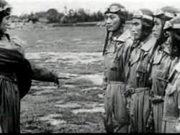

US Air Forces video:Flying Tigers Bite Back

The **1st American Volunteer Group** (AVG) of the [Chinese Air Force](https://en.wikipedia.org/wiki/Republic_of_China_Air_Force) in 1941–1942, nicknamed the ***Flying Tigers***, was composed of pilots from the [United States Army Air Corps](https://en.wikipedia.org/wiki/United_States_Army_Air_Corps) (USAAC), [Navy](https://en.wikipedia.org/wiki/United_States_Navy) (USN), and [Marine Corps](https://en.wikipedia.org/wiki/United_States_Marine_Corps) (USMC), recruited under [presidential](https://en.wikipedia.org/wiki/President_of_the_United_States) authority and commanded by [Claire Lee Chennault](https://en.wikipedia.org/wiki/Claire_Lee_Chennault). The shark-faced [nose art](https://en.wikipedia.org/wiki/Nose_art) of the Flying Tigers remains among the most recognizable image of any individual combat aircraft or combat unit of World War II.

The group consisted of three [fighter](https://en.wikipedia.org/wiki/Fighter_aircraft) [squadrons](https://en.wikipedia.org/wiki/Squadron_(aviation)) of around 30 aircraft each. It trained in [Burma](https://en.wikipedia.org/wiki/Burma) before the American entry into World War II with the mission of defending China against [Japanese](https://en.wikipedia.org/wiki/Empire_of_Japan) forces. The group of volunteers were officially members of the Chinese Air Force. The members of the group had contracts with salaries ranging from $250 a month for a mechanic to $750 for a squadron commander, roughly three times what they had been making in the [U.S. forces](https://en.wikipedia.org/wiki/United_States_Armed_Forces). While it accepted some civilian volunteers for its headquarters and ground crew, the AVG recruited most of its staff from the U.S. military.

The group first saw combat on 20 December 1941, 12 days after [Pearl Harbor](https://en.wikipedia.org/wiki/Attack_on_Pearl_Harbor) (local time). It demonstrated innovative tactical victories when the news in the U.S. was filled with little more than stories of defeat at the hands of the Japanese forces, and achieved such notable success during the lowest period of the war for both the U.S. and the [Allied Forces](https://en.wikipedia.org/wiki/Allies_of_World_War_II) as to give hope to America that it might eventually defeat the Japanese. AVG pilots earned official credit, and received combat bonuses, for destroying 296 enemy aircraft,[[1]](https://en.wikipedia.org/wiki/Flying_Tigers#cite_note-Ford_pp._30.E2.80.9334-1) while losing only 14 pilots in combat.[[1]](https://en.wikipedia.org/wiki/Flying_Tigers#cite_note-Ford_pp._30.E2.80.9334-1) The combat records of the AVG still exist and researchers have found them credible[[*citation needed*](https://en.wikipedia.org/wiki/Wikipedia:Citation_needed)] . On 4 July 1942 the AVG was disbanded. It was replaced by the [23rd Fighter Group](https://en.wikipedia.org/wiki/23d_Fighter_Group) of the [United States Army Air Forces](https://en.wikipedia.org/wiki/United_States_Army_Air_Forces), which was later absorbed into the U.S. [Fourteenth Air Force](https://en.wikipedia.org/wiki/Fourteenth_Air_Force) with General Chennault as commander. The 23rd FG went on to achieve similar combat success, while retaining the [nose art](https://en.wikipedia.org/wiki/Nose_art) on the left-over P-40s.

In the [Second Sino-Japanese War](https://en.wikipedia.org/wiki/Second_Sino-Japanese_War) prior to [World War II](https://en.wikipedia.org/wiki/World_War_II), foreign volunteer pilots of [Flying Tigers](https://en.wikipedia.org/wiki/Flying_Tigers) carried notices printed in Chinese that informed the locals that this foreign pilot was fighting for [China](https://en.wikipedia.org/wiki/China) and they were obliged to help them.[[3]](https://en.wikipedia.org/wiki/Blood_chit#cite_note-3) A text from one such blood chit translates as follows:

"I am an American airman. My plane is destroyed. I cannot speak your language. I am an enemy of the Japanese. Please give me food and take me to the nearest Allied military post.

You will be rewarded."

## [Burma Road](http://www.dangerousroads.org/asia/china/321-burma-road-china.html)

http://www.dangerousroads.org/asia/china/321-burma-road-china.html

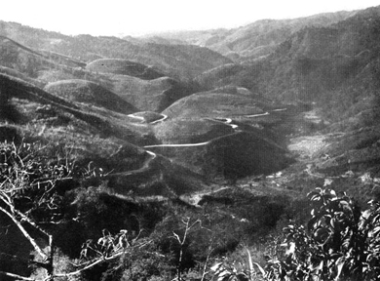

The Burma Road was a very important road during the WW2 linking Lashio, in eastern Burma (now Myanmar), with Kunming, in Yunnan province, China.

The road was 1,154 km (717 miles) long and was built during World War II to bring supplies to beleaguered China, to help them resist the Japanese invasion. Not much of the original road survives today, but parts of the route can still be travelled. Some parts of the old road are still visible today.

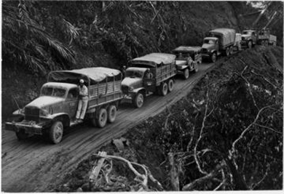

It was built as a gateway between Myanmar and the southwest of China, the rising empire on its border. It was one of the most remarkable engineering achievements of all time. Avalanches, heavy snowfalls and landslides were occuring anytime and could sometimes block some sections of the road, being extremely dangerous due to frequent patches of ice. More than 200,000 Chinese laborers embarked on a seemingly impossible task: to cut a 700-mile overland route -- the Burma Road -- from the southwest Chinese city of Kunming to Lashio, Burma. But when Burma fell in 1942, the Burma Road was severed. As the first step of the Allied offensive toward Japan, American general Joseph Stilwell reopened it, while, at the same time, keeping China supplied by air-lift from India and simultaneously driving the Japanese out of Burma.

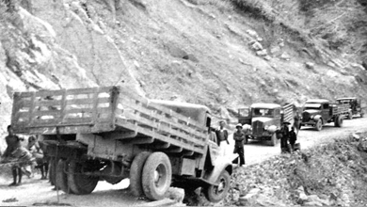

It was a real challenging road and a true test of the vehicles because the road abounded in twists and turns with wheels sometimes hanging above the precipice.  It is the central trade route feeding China’s voracious appetite for the resources — including energy, natural resources and food — it desperately needs to sustain its population of 1 billion people. Here China’s pervasive presence, its sophisticated exertion of soft power, is evident at every turn.

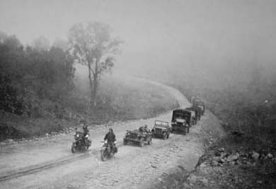

The unpaved sections of the road were impassable when wet. After rain, sections of road became decidedly hazardous when fast-flowing creek crossings and slippery mud caused road closures. Built to provide logistic support from India for China in their struggle against the Japanese, it penetrated impenetrable jungles and crossed uncrossable mountains. When the project started it was widely considered to be a fool's mission, but it was completed and did contribute to the war effort.

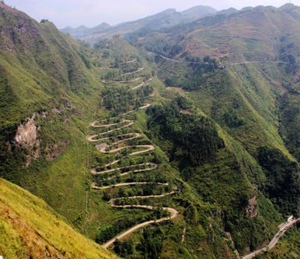

Many Internet sources show pictures of the [**24-Zig Road**](http://www.dangerousroads.org/asia/china/4630-24-zig-road.html) as a part of the Burma Road. But this is a mistake. During the Second Sino-Japanese War, the war supplies first arrived at Kunming by the Burma Road, then went through the "24 Turns" to arrive at Chongqing, the provisional capital, and reach the front-line troops.

