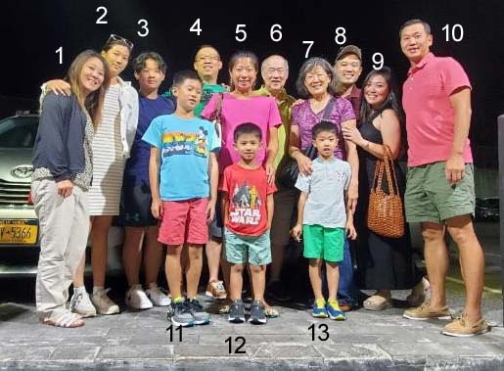

1. Elizabeth  
2. **Christine**, according to your chart or **Christina** according to your email.  
3. Ryan 4. Ken 5. Nicole 6. Patrick 7. Anne 8. Michael  
9. Christina 10. Wesley 11. Ethan 12. Ian 13. Joshua

Question: Who is older, Ian or Joshua? Are they twins?  
Answer: not twins; **Ian is the youngest.**

**2 is Elizabeth and 1 is Christine.**