Follow today’s class instructions (dbt only. No need to run it as a DAG)
- Create a dbt project with snowflake connector (1 pt)
dbt init HW4
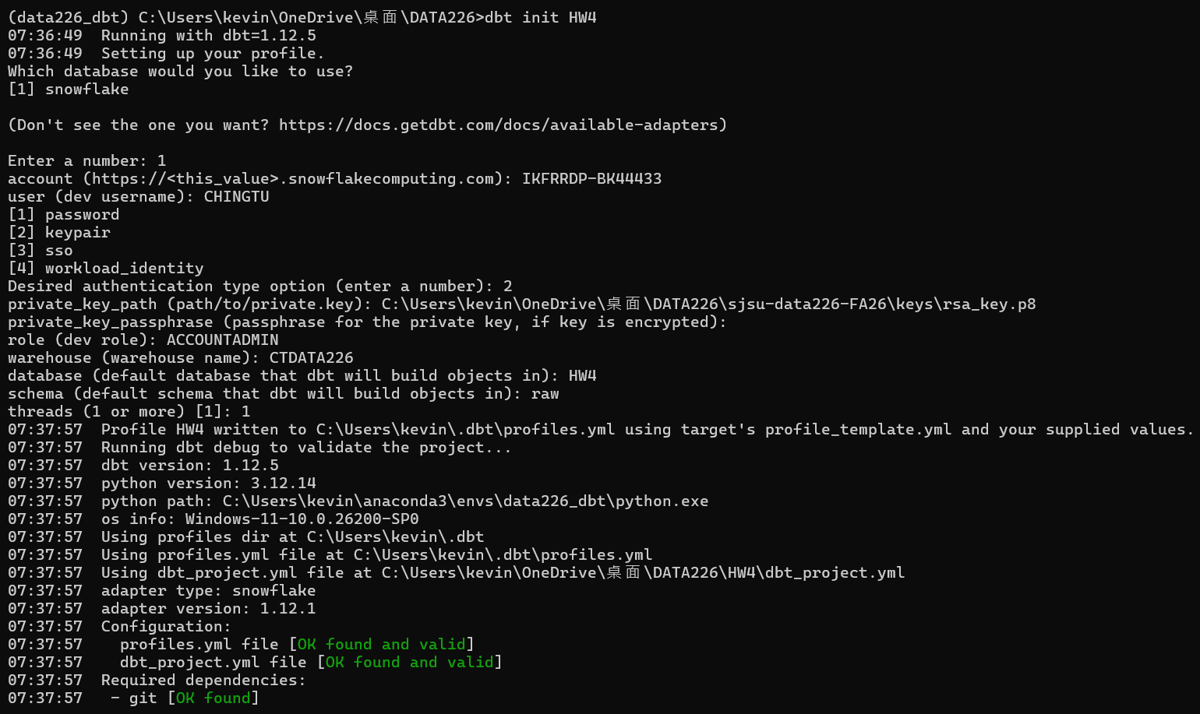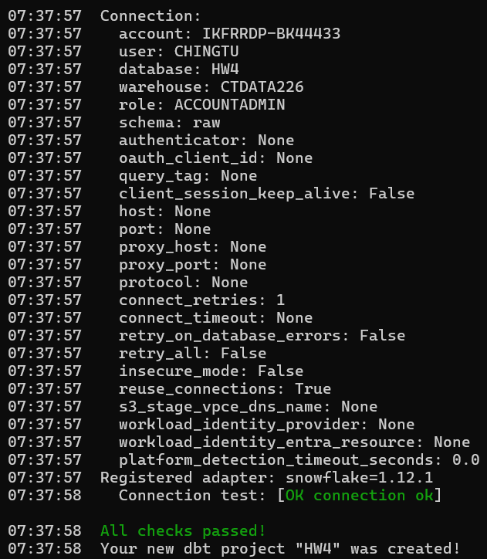
dbt debug
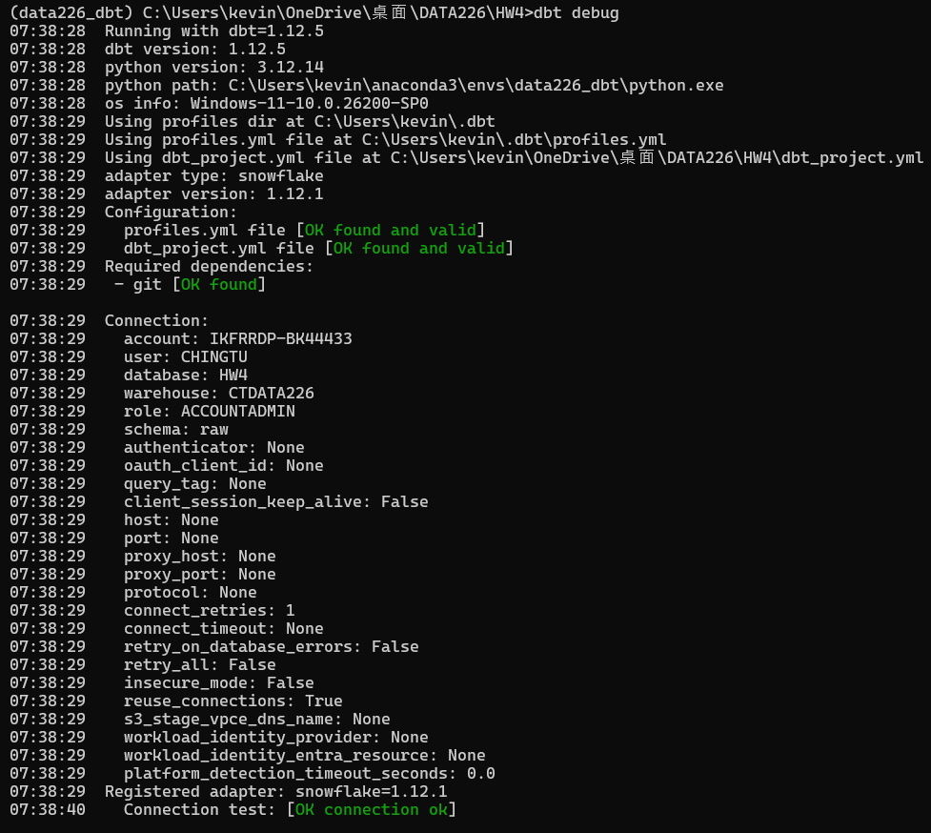

- Set up transform models (2pt)
Dummy data build using snowflake
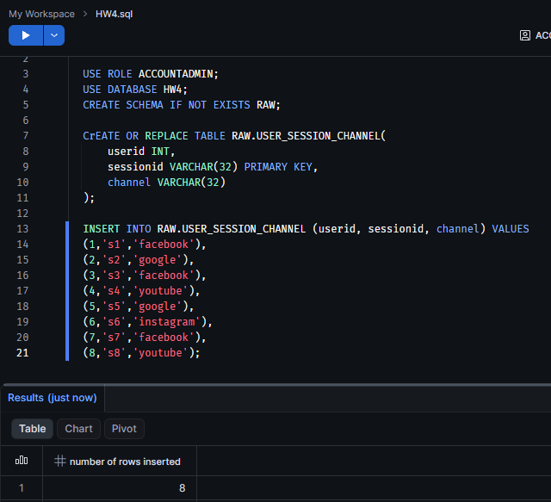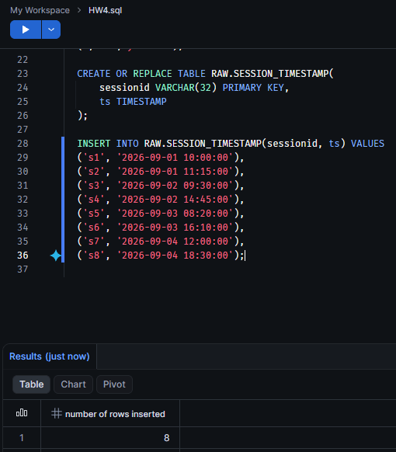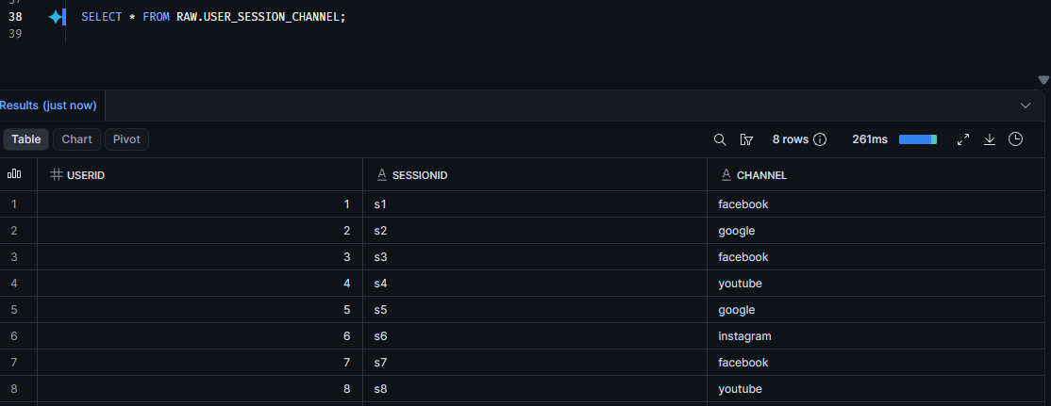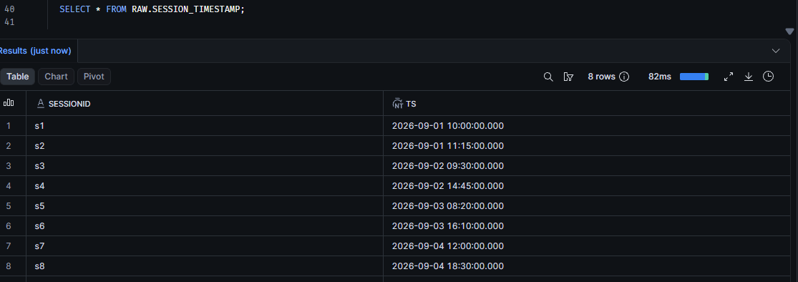
Making folder of transform and analytics
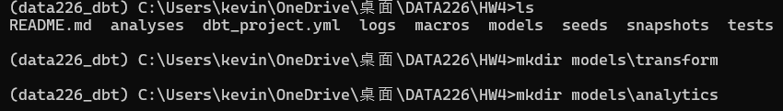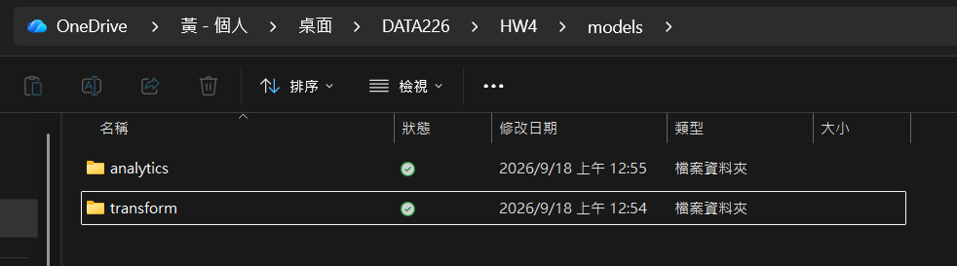

  - Input (transform) tables should be built as CTE (involves changes to dbt_project.yml)
  - Show contents of models/transform/user_session_channel.sql and transform/session_timestamp.sql
models\source.yaml and dbt_project.yml
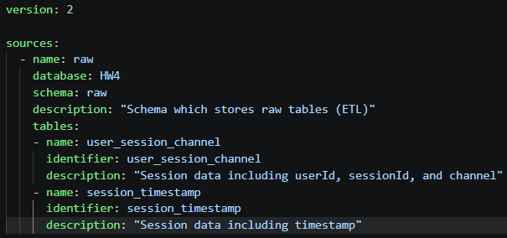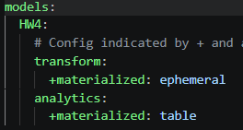
models\transform\user_session_channel.sql
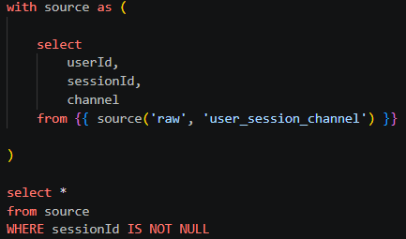
models\transform\session_timestamp.sql
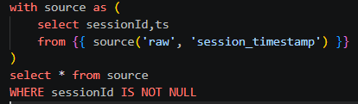
dbt run (Note: I set ephemeral to transform models to output CTE instead of view)
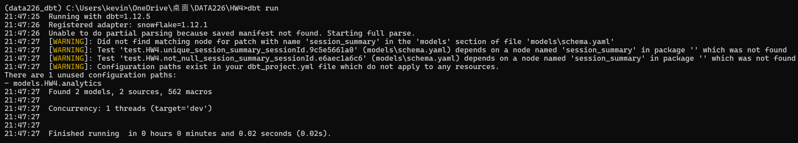

- Set up analytics models (1pt)
  - Show contents of models/analytics/session_summary.sql
models\analytics\session_summary.sql
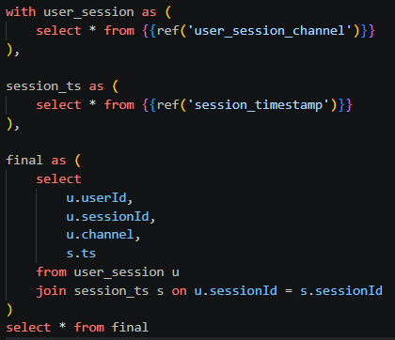
dbt run
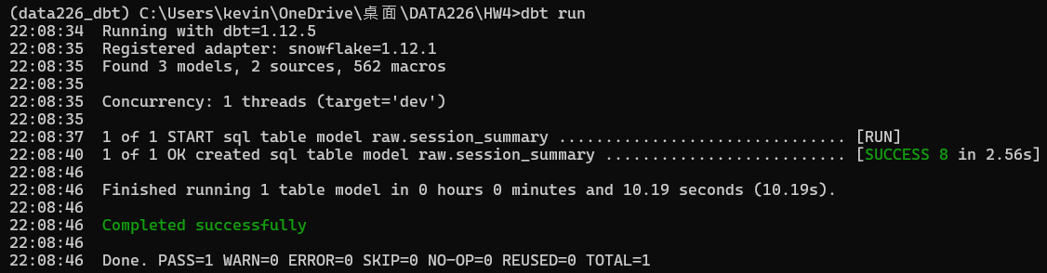
Result table on snowflake
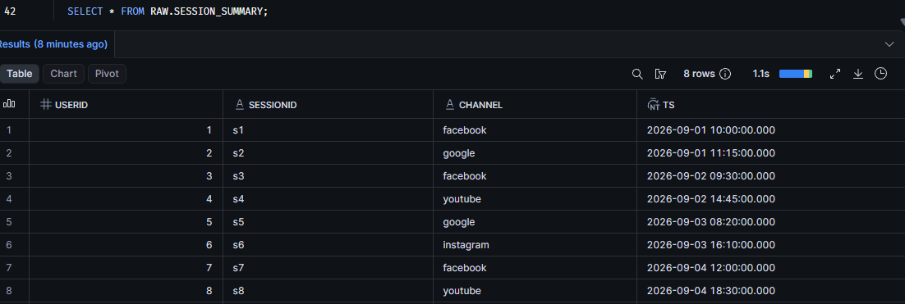

- Add Snapshot to the analytics table (session_summary) (2pt)
  - Show contents of snapshots/snapshot_session_summary.sql
snapshots\snapshots_session_summary.sql
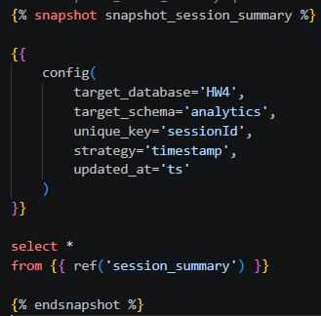
dbt snapshot
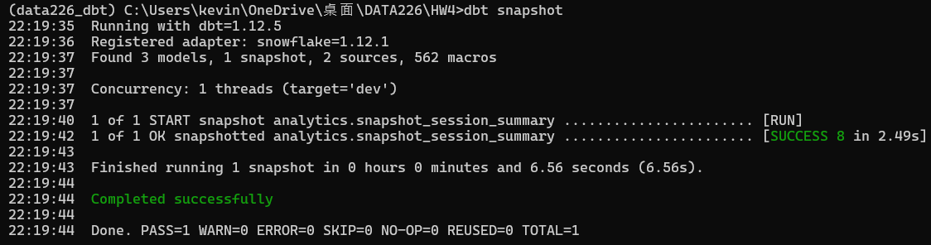
Result table on snowflake
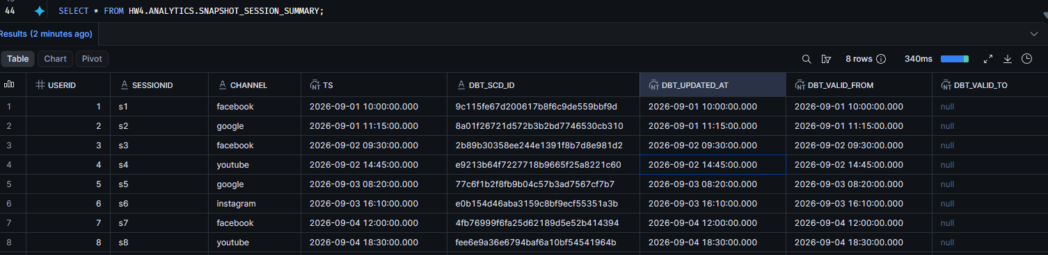

- Add at least 2 tests to sessionId field of session_summary (2pt)
  - Show contents of models/schema.yml
models/schema.yml
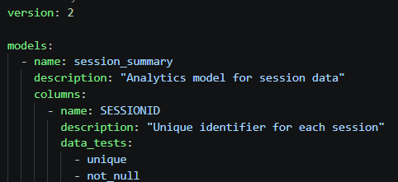
dbt test
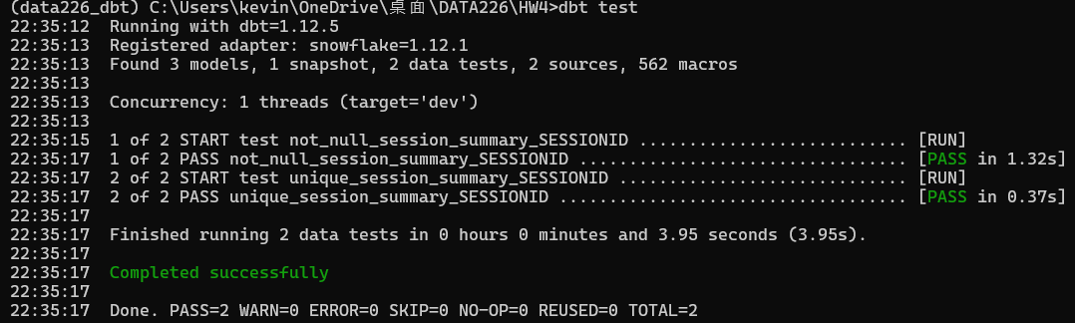
- For each step, capture screenshots accordingly (examples to follow)
- Create a github repo for this and add the link to the report
https://github.com/ching-tuhuang/data226_FAL26_HW4.git

