Purpose

The purpose of our site is to promote and provide information on Terrelli Coffee, a company that roasts and sells wholesale coffee to various stores and cafes in Vancouver. It will provide a valuable resource where customers and curious coffee enthusiasts can find relevant information. In addition to this, the website will have social aspects such as a forum, where people who have had great experiences with Terrelli Coffee can share stories and write reviews. This will be a professional website made for customers to view the Terrelli brand and its products. As such, it should be user friendly, and all the information on the various roasts of coffee should be readily available.

Goals

Our goal is to create a professional website catering to customers where they can view information about the Terrelli brand and its products. As well as providing information about the business and products, the website should be a place where Terrelli customers can mingle and discuss their enjoyment of the company’s products as well as their general love of coffee.. We hope that our website will attract many new customers who are not yet familiar with the product. The target demographic is people who enjoy coffee. The demographic ranges from young adults, such as students (who need the energy!), to people with a disposable income and a more discerning coffee palate interested in high quality coffee. In order for this site to be successful it will need:
- information about the Terrelli Coffee company to build trust and brand loyalty;
- a list of all Terrelli products with information about available quantities and prices;
- where to purchase the products in store;
- if possible, a transaction to purchase coffee directly from the website; and
- a forum encouraging customers to review and talk about Terrelli Coffee.

Content

The content of the website will mostly focus on the products provided by Terrelli Coffee. We will provide lists of all Terrelli products and different kinds of roasts and represent each with large visuals. Detailed descriptions will be provided on all the different roasts, including the pricing and quantity sizes available.
To make the website a little more personal, we want to include a section on the background of Terrelli Coffee. We will outline the development of this family run “mom and pop” business, characterizing the owners as local entrepreneurs and artisans.
Knowing where you can find the product is extremely important, so lists of all the retail locations where Terrelli products are sold will be displayed, possibly using a Google Maps insert.
Finally, we will create a forum for the website where customers can create profiles and view user created content.

Success Factors

There are certain key aspects that will make the Terrelli Coffee website successful.
It is important that we make the website very user friendly; navigation should be as intuitive as possible. Ideally, customers with any amount of internet experience will be able to navigate our website without difficulty or frustration.
Another key to success is the quality of the information on Terrelli products. The differences between the various roasts and flavors should be made explicit to the customer in their descriptions and accompanying visuals, creating distinct product concepts.
The third important factor for our website is the visual theme that will be consistent throughout. The overall look, including the colour scheme, fonts and visuals, will complement the company’s existing branding.
Finally, the website should be easy to find on a search engine. Accessibility is obviously very important to the volume of traffic the website sees.

Similar sites

Maxwell House
http://www.kraftbrands.com/maxwellhousecoffee/Pages/default.aspx

Maxwell House uses a very consistent colour scheme (blue and yellow) and large visuals that draw your eyes to important parts of their website. They provide a quiz that determines one’s optimal roast. We like that they have all the links to their pages in a directory at the bottom of the site if you want to quickly navigate to a page. The information on their different products is well presented.

Nabob Coffee
http://www.nabob.ca/

We did not like that two pages pop up to navigate to their main page. We found this redundant. We noted that the colour on their page is not consistent on different computer screens (on one computer the colours seem teal while on another they seem green), something for us to consider with our own website design. We like that the website has an organic feel with lots of greens and visuals of blue skies. It has quite a few fun interactive elements and provides a lot of information on the individual products. They include a page for upcoming events, making the company appear to be an active part of the community.

Form

Our website will have a “Give us feedback” button linking to a page where the viewer can send comments to the company. Our goals for the form are to provide feedback on the website as well as gather information for the company. Questions on the form might include:
-Have you ever had our product before?
-How long have you been aware of our company?
-Are you particular about your roast of coffee?
-Which roast is your favorite?
-How often do you drink coffee?

On our main website, a user registration button will link to the user registration page. On this page, new users can enter their username, password and contact information in a text box to register. Deregistration will be possible via the user deregistration button on the member homepage. This links to a form where they will enter their username and password and click the “deregister” button to confirm. Lastly, they will be linked to another form that will notify them of their successful deregistration.

Along with a login button, two textboxes that require a username and password input will be placed at the top of the website. After users have logged in, a logout button will appear and the customer’s username will be shown on the top right of the website.

A button will link to the forum page where users may comment or post messages in the forum. After a user has commented, their username and a timestamp will appear beside their posting.

Lists

The list will include a price table detailing all the products and their prices. Product names will link to product descriptions. A sitemap, or table of contents, at the bottom of the page will include links to the relevant parts of the website.

Workplan

The workplan consists of having group meetings at least once a week to discuss what needs to be done for the website, as well as talk through D2L and/or email to work on the project outside of school. Each task will be divided equally among group members for subsequent milestones. Additionally, the group will come together to discuss the current work to date and come to a consensus on the final version of each section of the project. We will agree on a date to complete each milestone, usually a few days before the milestone is due.

Milestone 2

Design

Site Map
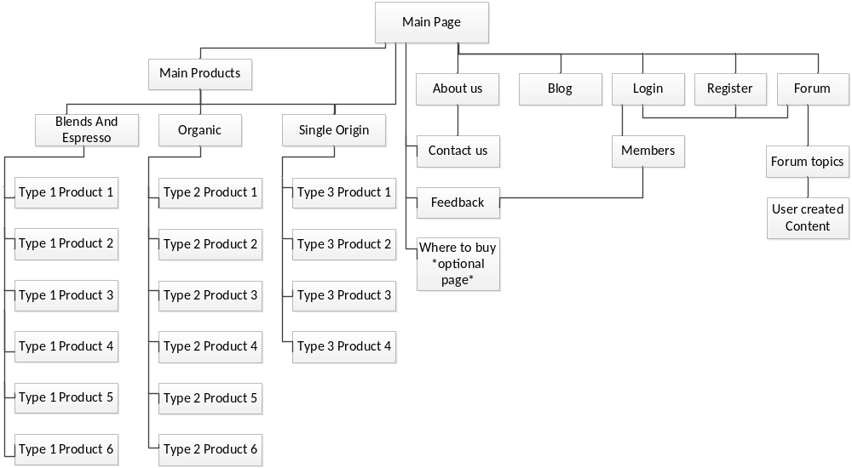

For our site map, though we had many pages, we wanted to make each easily available with just a few clicks. All of the buttons on the main navigation bar will have menus that drop down when moused over so that a customer who knows exactly what he or she is looking for can navigate to it quickly. If, on the other hand, the customer is unfamiliar with Terrelli coffee, they can go to the main products page from the main menu and read a short description to prompt their decision.

General Design

For the main design of the Terrelli website, the “Jell-O design” is most appropriate. As most of the page is centered, adding margins down the side will help users focus in on the information.

Page Layout

Main Page: Our main page will have a similar layout to all of the other pages, with the exception of a slide show which will take up a large portion of the page. The Terrelli banner image will be the logo. The navigation bar will be located below that section. Three image buttons below the slideshow will lead directly to the products subcategories.
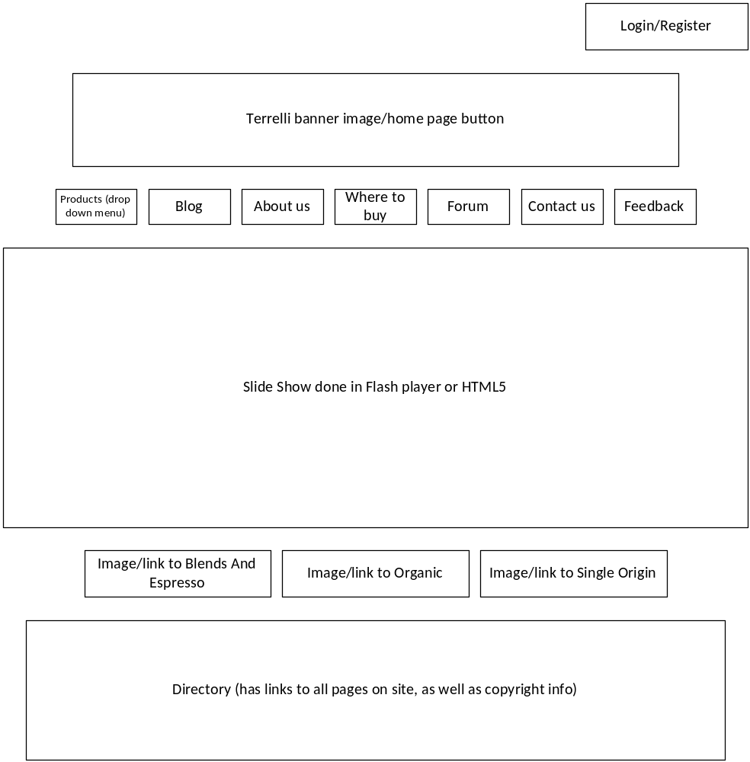

Main Products Page: The main products page will have a short description of the subcategories of coffee products. Each column will have a header that will link to that category’s page which displays the individual products. On the left is a list of all of the products.
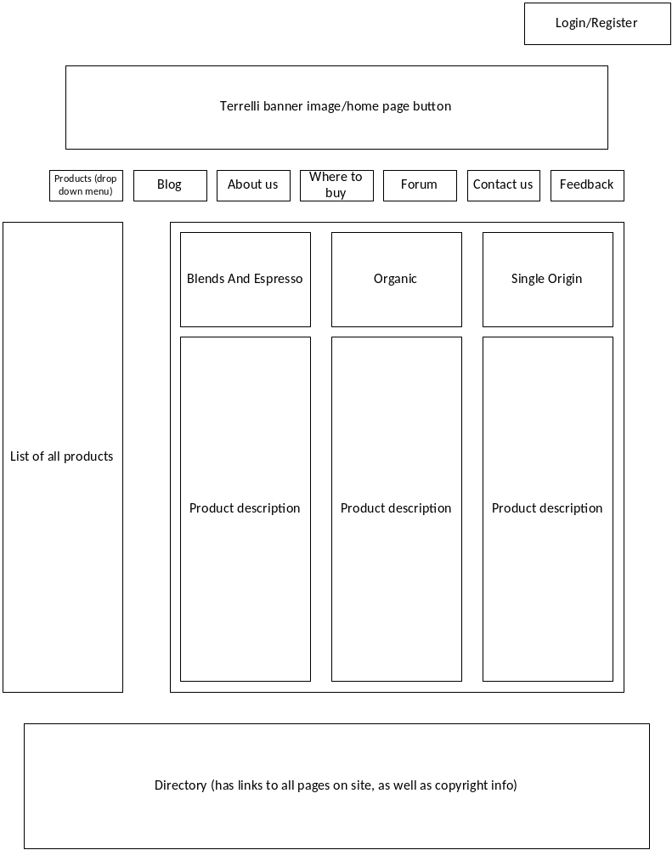

Subcategories Main Page: This page displays all the individual products of a certain category. If the category is Single Origin we will only have four products and the page will be formatted for four products.
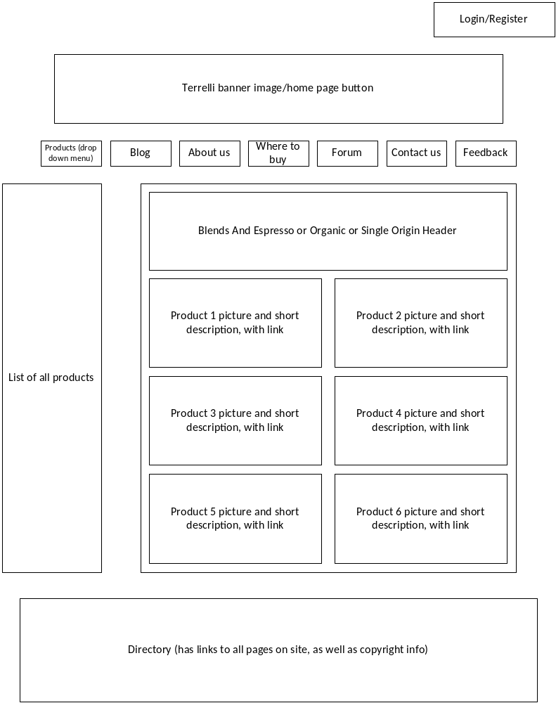

General Page Layout 1: This will be the layout for the individual products’ pages, the about us page, blog, contact us and the “where to buy” page (if we decide to use that page). If this layout is being used for the products’ individual pages, there will be a meter on the bottom of the page showing a bar that has links to all of the products. If the page is not an individual product page, we will not use this bar and we will eliminate the table on the left and center the main content box.
General Page Layout 2: We will use this general page layout for the login page, registration page, membership page and feedback page. As we are not currently sure of what we will learn and how we will be able to utilize certain elements, we have left this page fairly open.
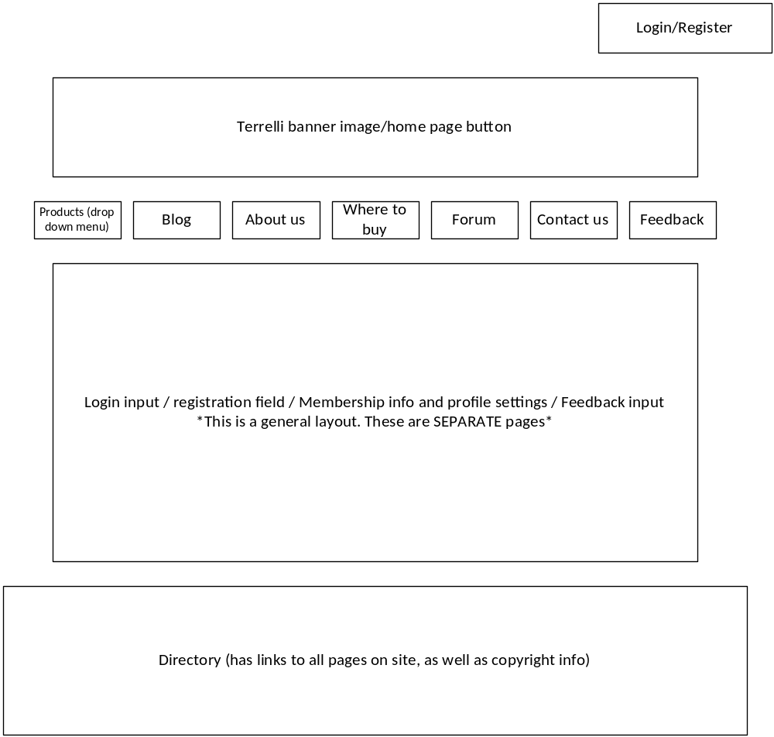

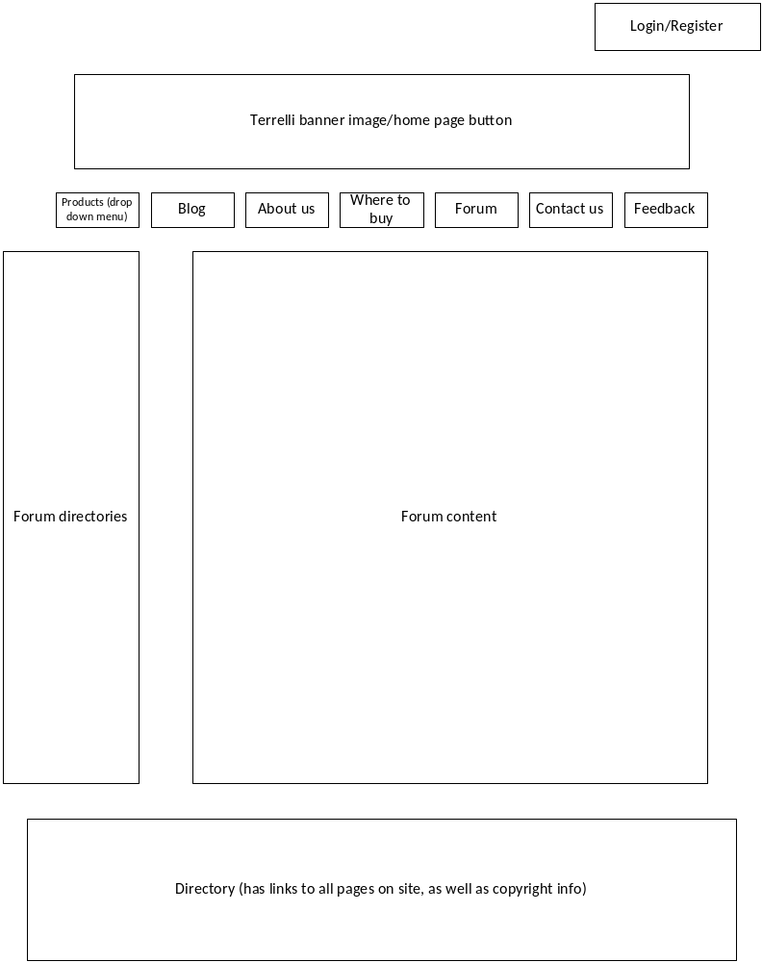
Forum Page: We have left the format of this page fairly open, similar to the “general layout 2” page, because we have not yet learned how to properly make and use forums in web development. The page will have a forum directory on the left.

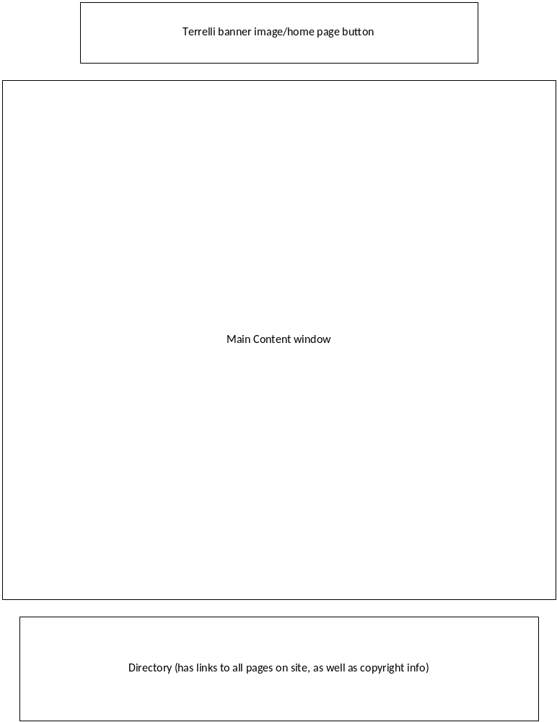Print Page Layout: The print page version of any page will look like the following. We eliminated the buttons because we feel that people will want to print the main content information.

Colour Scheme

HEX #D02433 Red RGB 208,36,51

HEX #D84519 Orange RGB 216,69,25

HEX #fffad9 Cream RGB 255,250,217

HEX #6D4921 Brown RGB 109,73,33

HEX #ffffff White RGB 0,0,0

The background will consist of the red and orange colours shown above. The text boxes will be cream (shown above) and most, if not all, of the text will be brown (shown above). This colour scheme was chosen because it applies the concept of repetition. It is Terrelli Coffee’s colour scheme, so customers who have purchased the product will recognize the website visually with this scheme. Moreover, the colours complement one another well, in addition to providing a great contrast for text.

Milestone 4

Form Validation

FORM on page: Register.html
Field ID Data Format or RegExp Explanation
firstName Not empty First name is required.
lastName Not empty Last name is required.
email Not empty Email is required.
accountName Not empty Account name is required.
password Not empty Password is required.
address Not empty Address is required.

FORM on page: Form.html
Field ID Data Format or RegExp Explanation
firstName Not empty First name is required.
lastName Not empty Last name is required.
hadProduct No requirements User can choose one of the two.
often Not empty Often cannot be left blank.
roast Not empty Roast choice cannot be left blank.
addComments No requirements User can choose to type nothing.

FORM on page: All pages
Field ID Data Format or RegExp Explanation
login Not empty Login is required.
password Not empty Password is required.

Milestone 5

Php and Database

A basic forum is set up that people who are registered and logged in can use to post about anything (though we want the forum to stay coffee related). Anyone can see the threads and who created them, but only members can respond to posts.

Group Members
Ian Davidson, Cory Thomas, Francesca Andrea Ching, Sasha-Blue Delaney

