

MINISTRY OF HEALTH AND SOCIAL WELFARE
AND
DEPARTMENT OF COMPUTER SCIENCE - UDSM
______________________________________________

TECHNICAL USER MANUAL
FOR
HUMAN RESOURCE FOR HEALTH INFORMATION SYSTEM (HRHIS)



Table of Contents
1. INTRODUCTION 3
LOGIN 4
2. DESCRIPTION OF SYSTEM FUNCTIONALITIES AFTER SUCCESSIFUL LOGIN 5
2.1 Form Management 5
2.1.1 Fields 5
2.1.2 Field Groups 5
2.1.3 Field Option Groups 5
2.1.4 Forms 6
2.2 Organization Units Management 7
2.2.1 Organization Units 7
2.2.2 OrgUnits Groups 9
2.2.3 OrgUnit Group Sets 10
3. Users Administration 11
3.1 System Roles 11
3.2 System Users 12

- INTRODUCTION
The Ministry of Health and Social Welfare (MOHSW) has developed the Human Resource for Health Information System in collaboration with the University of Dar es salaam, Department of Computer Science. The objective of developing Human Resource for health database is to address and strengthen the existing information system through coordination and networking of existing human resource data collection systems.
This system has been developed by a group of developers, a combination of Systems Analysts and Programmers, from the department of Computer Science, University of Dar es Salaam. A strong and reliable participation of the staff from the Ministry of Health and Social welfare has made the system not only reliable but also addressing key issues related to Human resource in the health sector. The system, therefore, has been developed to assist in capturing, storing, processing, and analyzing data.

As for any big system development the process is not an overnight thing. HRHIS is evolving, though with a remarkable speed, its absolute completion is not expected soon as the requirements keep increasing and the zeal to make it appear the best is all overpowering. The inputs of stakeholders, therefore, are all-time required.
This manual outlines the systematic procedures for accessing and using various parts of the system. In case you do not get the assistance you expected from the manual please consult your system administrator or any person authorized to work as the member of the help desk team at your organization.

LOGIN
Open the browser and type the following address: http://localhost/hrhis (or the address of the server if you are accessing it from the network compute, eg http://192.168.1.100/hrhis ) then the page similar to the one shown in the screen shot below will be displayed whereby you will be required to type the correct username and password. The choice of the browser, though, has always been Mozilla Firefox, Google Chrome or Opera because of some problems with others to this system. Henceforth, the mention of the browser will mean these. Fig 1 shows the appearance of a login screen
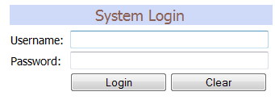

- Login interface

Up on successful login you will be directed to the page with the menu on the left hand side through which you can access various parts of the system. However, on unsuccessful login an error message will be displayed whereby you will be required to retype the username and password. The unsuccessful login window will look as follows:
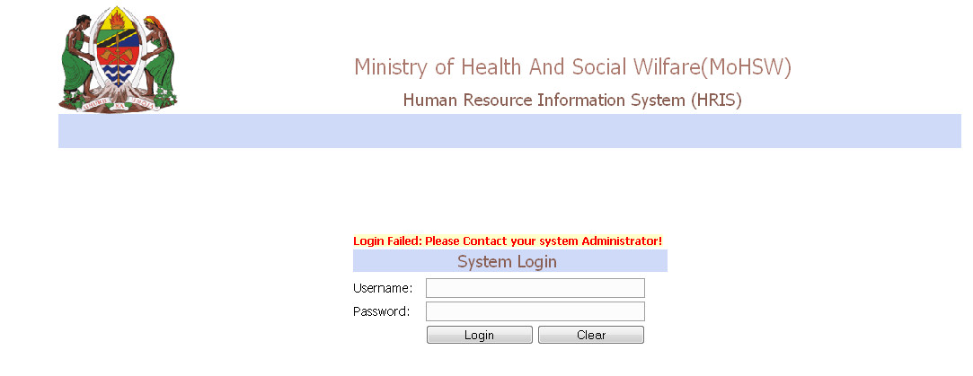
- Unsuccessful login interface

There is a systematic way of managing all the accounts and their respective privileges within this system, a thing that will also be detailed in this document shortly.

The following is the main interface with the left menu displayed after a successful login
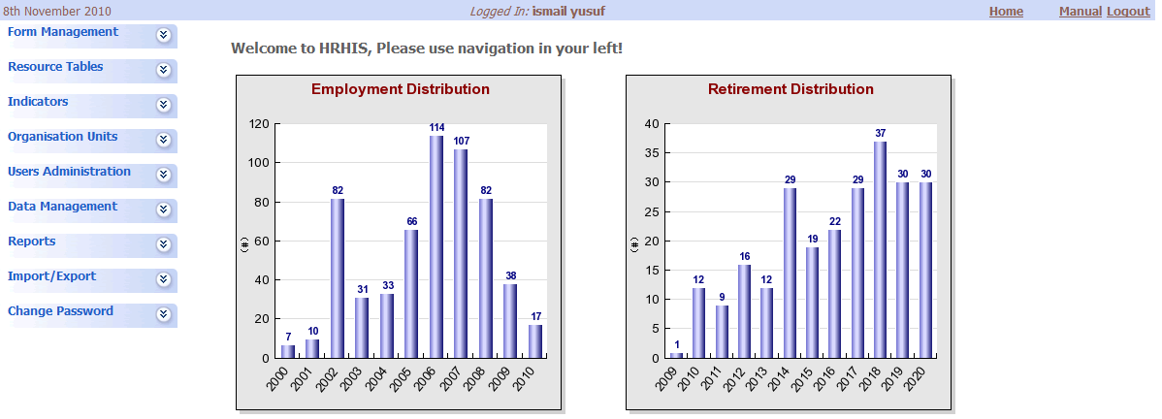

- Interface displayed after a successful login
- DESCRIPTION OF SYSTEM FUNCTIONALITIES
In an administrative perspective, the system has a number of functionalities which enable the flexibility to an administrator(s) to set up the environment necessary for the proper running of the system. There are, therefore, ways to define which data to be collected, the forms appearance, organization units, users’ administration and others. The subsequent sections detail of these functionalities.

  - Form Management
This section deals with the management of the forms and their contents from conception to operation of the forms. It has four sub-items; fields, field groups, field option groups and forms. It is a functionality that is rarely used, as after the definition of a form a while passes by for data management. It is also advisable, for the users, not to engage themselves very much with this section

    - Fields
This part of the system is used to add, edit and delete database fields which are used to hold data supplied by the user. Examples of the fields include fname (stands for first name), lname (stands for last name), etc.
The table shown in the above screen shot shows a specific field, its input type, data type, caption, a mark to show whether it is compulsory or not, and options to add, edit or delete.

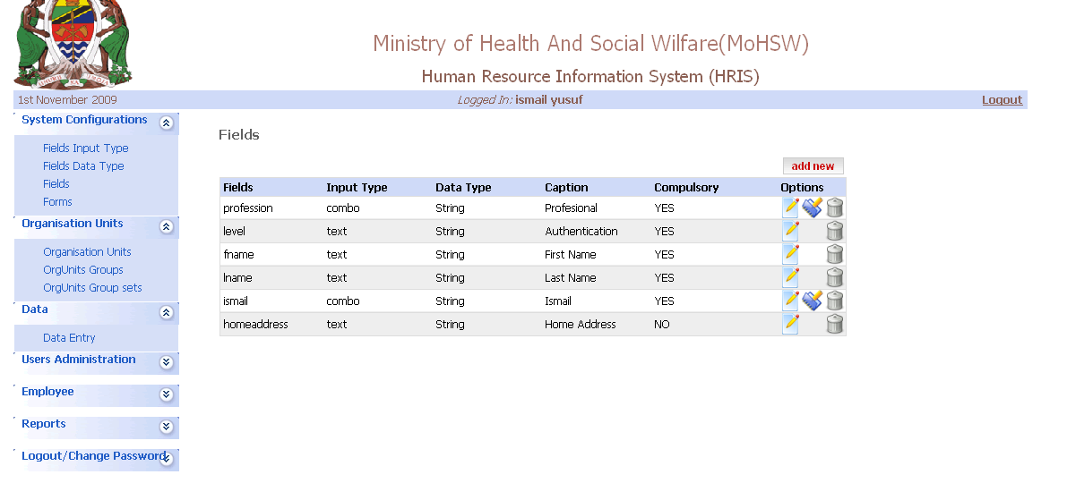
- Field Interface
Note: For the fields with the combo input type click on the icon in between the “edit” and “delete” options to assign more options.

    - Field Groups
When we have different forms for data collection, each form will have a certain number of fields. At the end, there will be many different fields posing hardness in managing them. This option gives a simple way of managing them by combining the related fields into one group. The commonest way of doing it is by combining all the fields for one form as one group.

    - Field Option Groups
This mostly refers to the different options available in a single field. For example, Medical Doctor is a profession inside which there are consultant doctors, and Principal medical doctors. So these field options are put in one group known as Medical Doctors.

When one selects the field option groups a list of available option groups appear and a button that allows the user to add more. On clicking the add new button the following window will appear
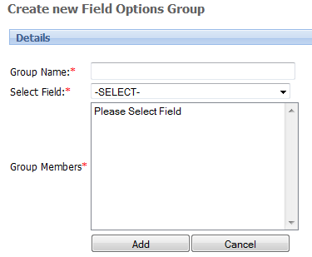
- Creating New Field

The Group Name stands for the name of the group, and there is also an option to select the category of fields for your option groups.

    - Forms
The interface displayed after clicking the form option looks as follows: 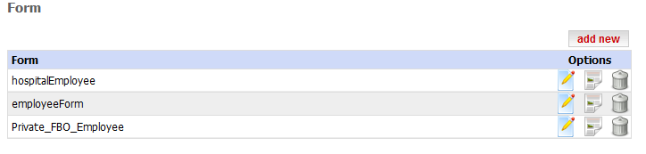
- Forms interface

It displays a list of forms already added into the system. On the right hand side of each form are the options to edit form details, design the form and assign it the fields you want and the delete option. On clicking edit, the following screen appears

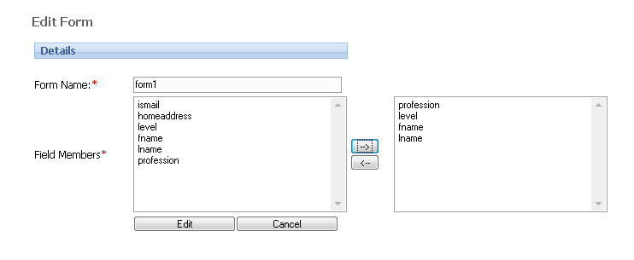
- Interface for editing the form and adding details

Click the specific field on the left to add it on the form. Use → to add a specific field on the form and ← to remove the field from the form.

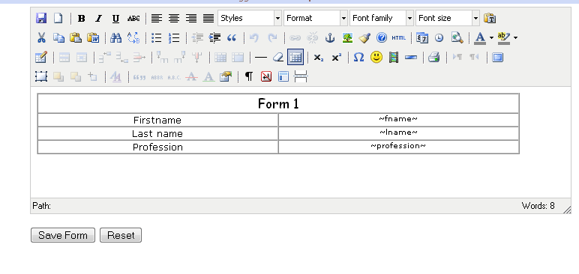
- Interface for designing the form and assigning it the fields you want.

On the second option, design, the above screen should appear. Put the names of the form fields you want and for each field assign the database field corresponding to it and then click on the “Save Form” button to save the form. At any point during the design of the form, clicking the “Reset” button should instigate clearing.

  - Organization Units Management
This section of the system has four main parts: Organization Units, orgUnits Groups, OrgUnits group sets and Generate Structure

    - Organization Units
This part of the system displays all organization units (e.g. regions) with options to see all the children which fall under a particular organization unit (e.g. districts). On the right hand side of each organization unit displayed there are also options to edit and delete a specific organization unit.
An interface for displaying organization units looks as follows:
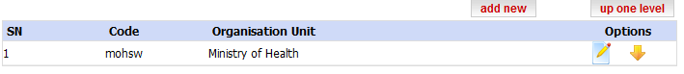
- Interface to display organization units
If you opt for the down arrow then they get the children of that particular organization unit. In the above case, the following will appear
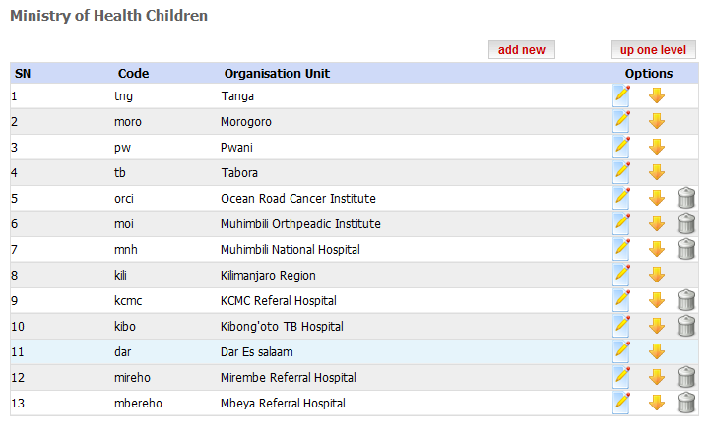
- Interface for the MOHSW Children
The following is the brief description of the icons displayed in front of each organization unit
Icon | Description
 | Edit
 | View Children
 | Delete

Click on the “” option to edit information under a particular organization unit, “” to display children under a particular organization unit and “” to delete a specific organization unit.
To edit information under the particular organization unit click on the edit option and the form similar to the one shown below will be displayed where you will be required to fill the details and click the “Edit” button to commit the changes.

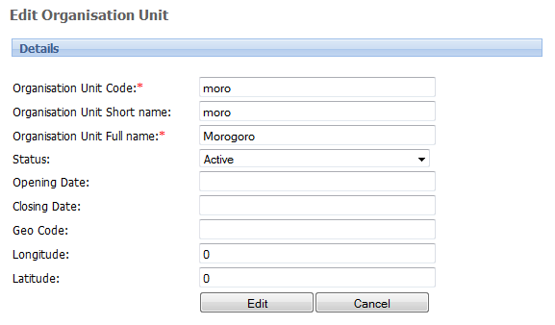
- Form for editing organization unit details

    - OrgUnits Groups
Related organization units can be grouped together to help with the analysis and use of data. With this option, one can add as many organization units groups as possible. Example of the organization units groups can be hospitals, health centers, dispensaries and others.

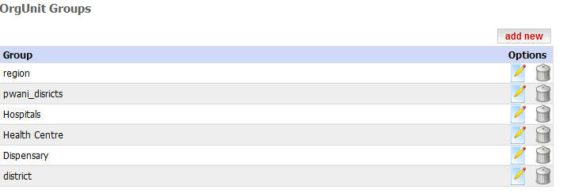
- interface for displaying organization unit groups

You can edit or delete the details under a specific organization unit group by clicking the correct option. Click on the options as the ones shown in the previous section to edit, delete or add new organization unit group. See the following screen shots: This screenshot is the same as the one to be used in the course of creating a new group
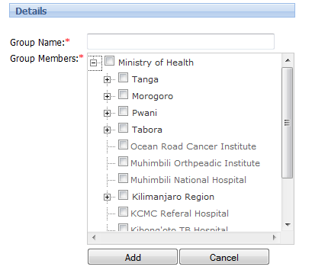
- Editing organization unit group details.

    - OrgUnit Group Sets
OrgUnit Group Sets are meant to group the groups, again, for analysis and use of data. This part of the system is used to create and edit organization unit group sets.
The procedure and interfaces used are as shown in the figure below:

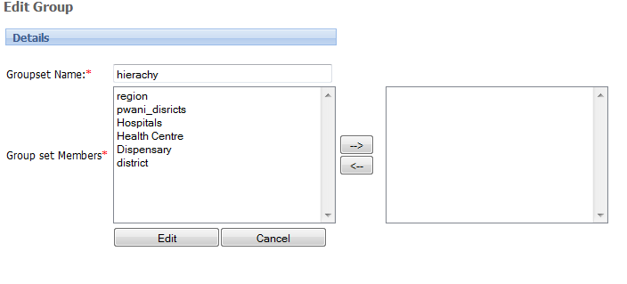
- Creating new organization unit group set

Enter the group set name then select appropriate group set members on the left; Using the → or ← add or remove the group set member to/from the box displayed on the right hand side. Having selected the group set members click the “Add” button to submit the group set to the system.
- Users Administration
To properly manage the system, there is a need to maintain security by levels. Letting each user access relevant data and not otherwise. This part of the system is used to define, edit and delete various system access levels and the users who can access those levels. The following section provides the way to create these roles and assign each role with what it can access. If one opts for add new, the following interface occurs
  - System Roles
The first thing is to create the roles which define what can be done on which data. An example of these could be data clerks, data managers, etc. This is so that whoever comes later is only assigned to the existing roles.

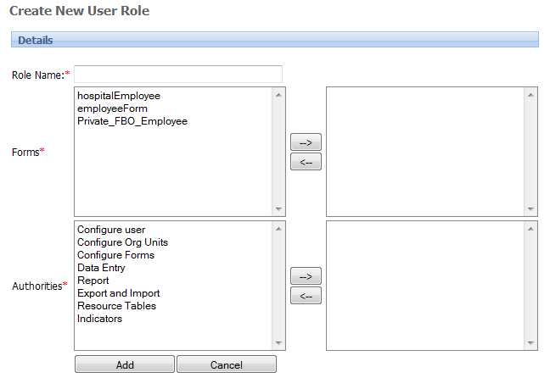

- Interface for editing user role.
It starts with the kind of forms which a person can access in the system. Use the left ← and right → arrows to move what you want to. The list below consists of the functionalities that one is allowed to do/perform. Again, use arrows to move whatever you want to use.

  - System Users
After the user role is created, then users who will belong to that role have to be created
as well. Suppose we created data entry role, then each new user coming is to be allocated which role will they take. The following is the interface for the new user registration

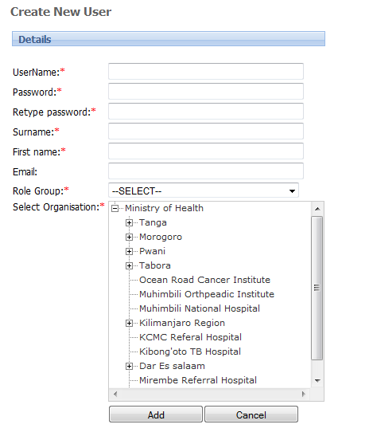
- Interface displaying available system users
Using options available on the interface you can add new users, edit user details or delete a specific user from the system.

