

MINISTRY OF HEALTH AND SOCIAL WELFARE
AND
DEPARTMENT OF COMPUTER SCIENCE - UDSM
_________________________________________

OPERATIONAL USER MANUAL

FOR

HUMAN RESOURCE FOR HEALTH INFORMATION SYSTEM (HRHIS)



Table of Contents
1. INTRODUCTION 3
LOGIN 4
2. DESCRIPTION OF SYSTEM FUNCTIONALITIES AFTER SUCCESSIFUL LOGIN 5
2.1 Data Management 5
2.1.1 Data Entry 5
2.1.2 Records 6
2.2 History Management 7
2.3 In service training 9
3. Reports 9
4.1 Records Report 10
4.2 Aggregated Reports 12
4.3 Other Reports 15
4. Import/Export 16
5.1 Export 16
5.2 Import 17
5.3 Export to DHIS 17

- INTRODUCTION
The Ministry of Health and Social Welfare (MOHSW) has developed the Human Resource for Health Information System in collaboration with the University of Dar es salaam, Department of Computer Science. The main objective for developing the Human Resource for health database is to address and strengthen the existing information system through coordination and networking of existing human resource data collection systems.
This system has been developed by a group of developers, a combination of Systems Analysts and Programmers, from the department of Computer Science, University of Dar es Salaam. It has been developed to assist in capturing, storing, processing, and analyzing data. All these functionalities are a result of the need assessments conducted by the department every now and then, in the course of training, information dissemination and other contacts.

As for any big systems development the process is not an overnight thing. HRHIS is evolving, though with a remarkable speed, its absolute completion is not expected soon as the requirements keep increasing and the zeal to make it appear the best is all overpowering. The inputs from stakeholders, therefore, are all-time required. From July 2009 to the time of writing, the system has improved remarkably. A full time team is there, in the University of Dar es Salaam to make sure that all the concerns from the researchers and implementers are addressed by the system.

This manual, in particular, outlines the systematic procedures for accessing and using various parts of the system in a manner thought suitable for the implementers to understand. However, in case you do not get the assistance you expected from the manual please consult your system administrator or any person authorized to work as the member of the help desk team at your organization.

LOGIN
Open the browser and type the following address: http://localhost/hrhis then the page similar to the one shown in the screen shot below will be displayed whereby you will be required to type the correct username and password. The choice of the browser, though, has always been Mozilla Firefox, Google Chrome or Opera because of some problems with others to this system. This is quite technical, so do not bother to seek for the details. Henceforth, the mention of the browser will mean the ones listed above with the most recommended being Mozilla Firefox. Fig 1 shows the appearance of a login screen
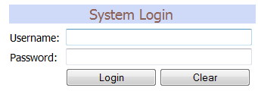

- Login interface
Up on successful login you will be directed to the page with the menu on the left hand side through which you can access various parts of the system. However, with an unsuccessful login an error message will be displayed whereby you will be required to retype the username and password. The unsuccessful login window will look as follows:
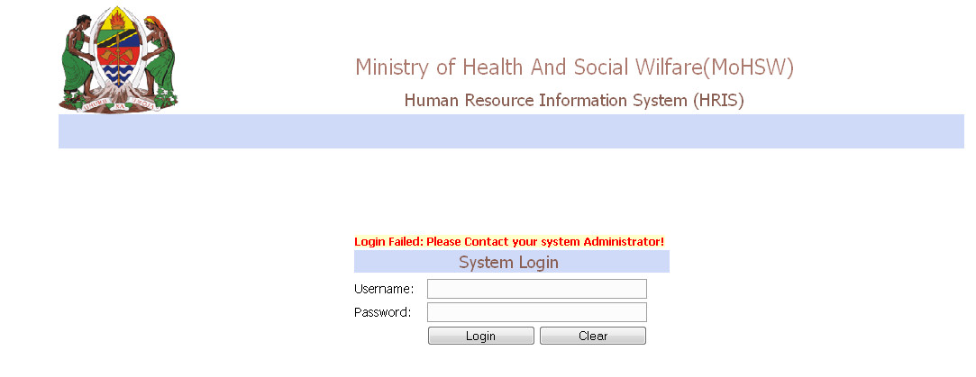
- Unsuccessful login interface

The following is the main interface with the left menu displayed after a successful login
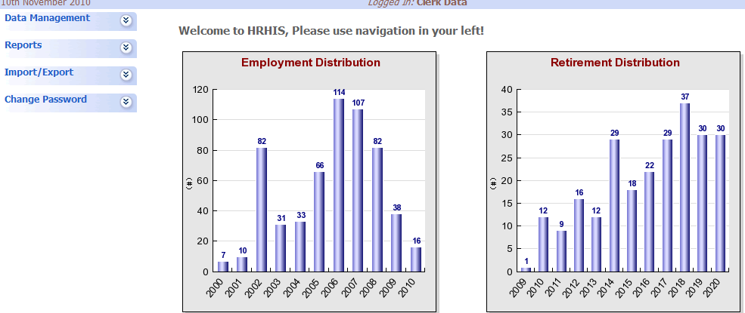
- Interface displayed after a successful login
The menus on the left, while at the center, the different presentations for indicators of significance are displayed. These charts are changeable, subject to administrative privileges. Commonly found are those for retirement distribution (for the next ten years), employment distribution (for the last ten years), age distribution and sex distribution.
- DESCRIPTION OF SYSTEM FUNCTIONALITIES AFTER SUCCESSIFUL LOGIN
The main menu displayed upon successful login has the following:
  - Data Management
This is the part where every day uses of the system depend. It contains the functionalities which involve the regular management and use of Human Resource data. It contains the data entry and preliminary reports.
    - Data Entry
In here you can select the forms designed in the previous part so that you can populate data.
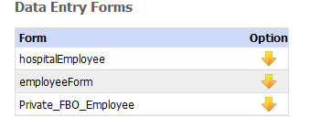
- List of form available for entering data
By clicking on a yellow down arrow, the data entry form for populating data will be opened as displayed in the figure below.
An example of the form ready for data entry is as follows:

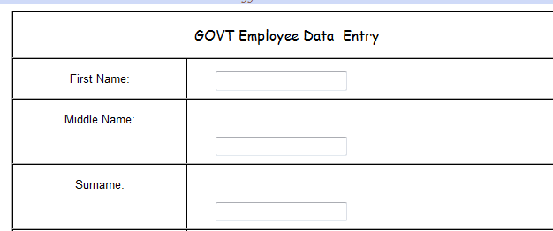

- Form ready for data entry

Fill the form with the appropriate data then click on the “Save Data” button to submit data to the database. There are a few things to notice, though.
Of these fields there are compulsory ones which need to be filled in for any data entry to be successful. The best way for a new user is to put a cursor in each field and read the message that pops up as shown in the figure below

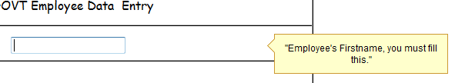

- A message to describe the data field
    - Records
This option allows you to view the records that you have already entered into the system. If records option is selected, it will list available forms, with two options in each form. “View All” records and “search” record option
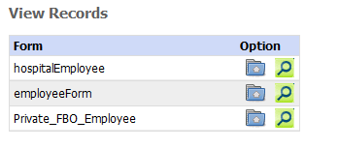
- View records options

If you select search records, the lens-like button, the system will provide you with a text box to enter your search key. The records can be searched using any of the available fields, for instance firstname, middle name, surname, employee check number, etc.

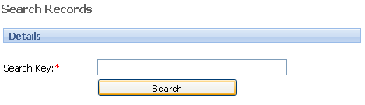
- Search record option

On the other hand if View all records options is selected, the system will output all records that has already been entered into the database. This is a representation of raw data only
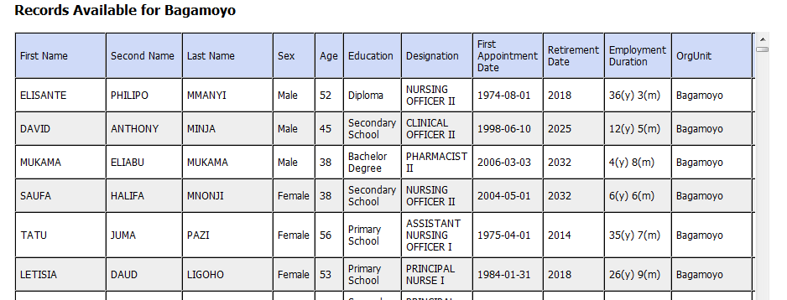

- A list of records in the system
At the end of each record row, there are four options, things to do to that record.
There is the Edit option. If one wants to edit data, update some information of a particular record, then they have to select edit record option, and the form will be opened for you to update the selected record.

There is the History option. This is where history of an employee is managed as will be explained in section 2.2.

There is also In – Service Training option. This is where all the important training conducted in service, including the HRHIS training are recorded into the system. This will be addressed in section 2.3, next.

The last one is Delete Record Option. This is the button that allows the user to delete a record

  - History Management
By Selecting History option of a particular record, that record’s history will be displayed as it has been added before. The following figure indicates how history of a particular record is displayed. In case there is no history for that particular record, only one option “Add history” will be displayed for you to add history of that record if any.

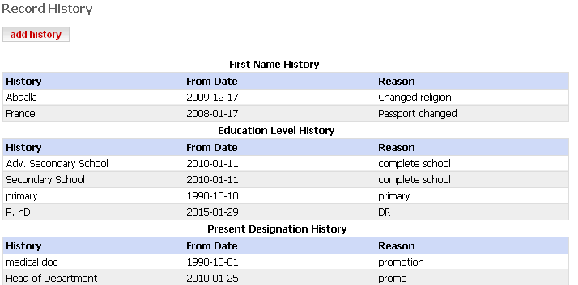

- History Information of a record

If add history is selected, a form for adding record’s history will be opened, for you to add history.
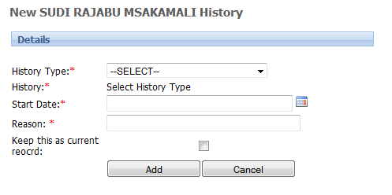
- Add history
In the history type one selects whether it is a history related to “Education Level” (if a staff has just completed some studies or “Terms of Employment” (for example from volunteering to contractual). It depends on what history is to be added.
After filling in the record, one has to select the “keep this as current record” check box. This will change the record of an individual to include the just entered changes.

  - In service training
This refers to different courses, mostly short courses taken by staff in the institution. This, HRHIS training is one of those courses. As in history management, there is a button for add new, which leads to the recording of these in service training. The following is the interface after “add new”
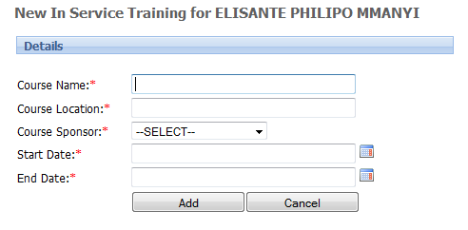
- Adding In Service Training

As the form says by itself, there will have to be a name of that course, where was it taken, when did it start and when did such course end. All these information are to be filled in using the text boxes as shown above.
- Reports
Report Management, is the most important part in many systems. This allows users to generate some reports from data that has already been entered in the system. From our case, there are three types of reports that can be generated, “Record report” which is basically a report which outputs the list of required records as specified by the user. Another type of report is “Aggregated Report” which outputs the required aggregated data as specified by user. The third is a group of reports just called “other reports”

  - Records Report
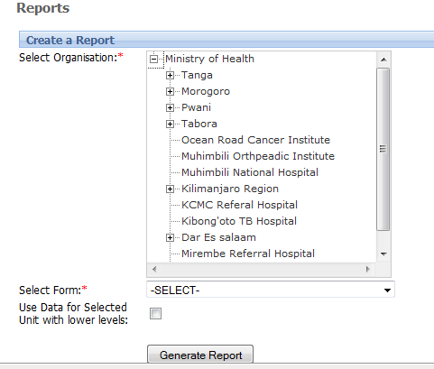
- Record Report Generation

There are only two items to select from, where the report is for – the organization unit and what kind of data to be included – the form. These will provide us with the raw data of the records we have in the system. There is also a checkbox, very important. If we select a district without this check box, we will get data for staff working in the district. If we want records of staff from the health facilities as well, we need to click this – check.
After generating a report, the system will filter the available data and display them according to your specifications.
Below is an example of a record report generated from Mafia District with its lower levels, the facilities. Only a part of it is taken to paper sizes

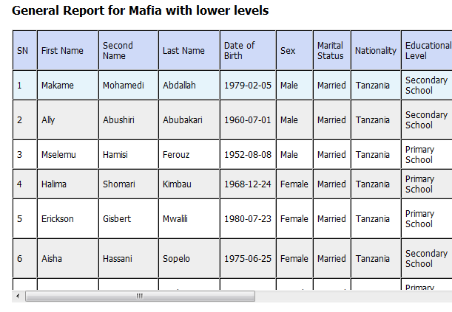
- An example of Record Report

When the report has been generated, “Export to EXCEL” option, found at the lower left corner of the screen will enable you to export your report to excel sheet (spreadsheet) for further personal manipulation without affecting the data in the system.

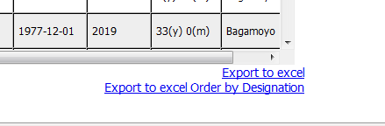
Click it and see the results – the spreadsheet
There is also another option just below it. This is even disaggregating the personnel according to their designation. In this way it is easy to track where the shortages are and where the excesses are, if at all there are excesses. It produces a spreadsheet as shown in the figure below
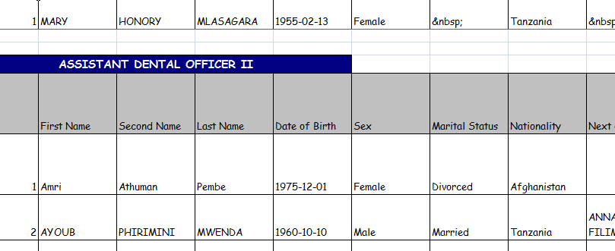
  - Aggregated Reports
These are the reports where there is no mention of the staff in the records. They help with the management of the sector as opposed to the individual staff, and therefore they speak aggregated values. The same procedures of generating a record report are used, but in this case you have to select Field Option for your aggregated data to be grouped with. For example if you want to generate a report based on marital status, you select marital status as your option, and generated report will count the data based on their marital status.
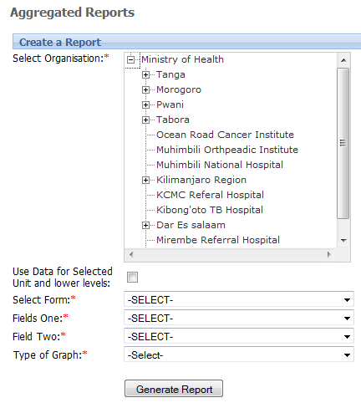
- Generating aggregated report

The aggregated data, in this new release gives the user more ways to explore the data that are in the system already. It needs a user to specify the organization nit they want the report for, select the form in which the data will be chosen for report and then select the data to view. These data are in two fields, field one and field two.

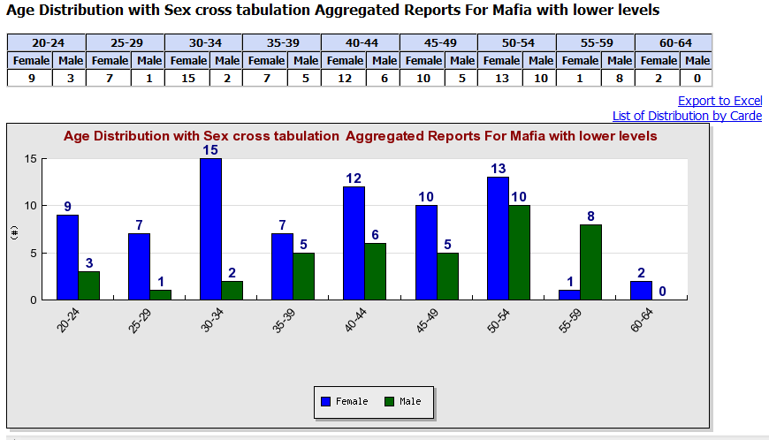

- An aggregated report (field one: age distribution, field two: sex)

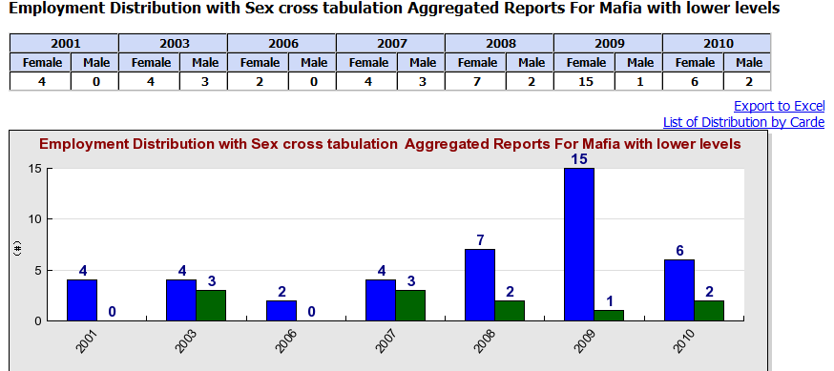

- An aggregated report (field one: employment distribution, field two: sex)

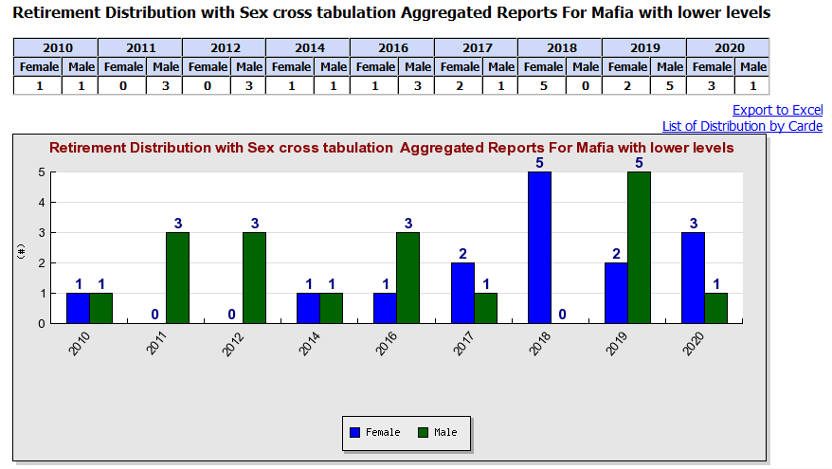

- An aggregated report (field one: Retirement distribution, field two: sex)
  - Other Reports
These are the reports related to the “History Management” and “In service Training management”. The following the 19th figure shows the interface to other reports. After selecting an organization unit from which to produce report, the user will have to specify which report they want to generate, “History management” report or “In service Training” report. If one selects the “In Service Training” report they will just have to select the form to use while selecting the “History Management” report, there will be a need to select the form to fill in and also, what record from which the history is sought.
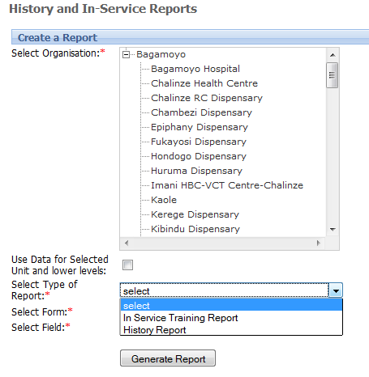
- History and In Service Training Report

- Import/Export
This system functionality enables you to either export data already in your system so that a person at another location using HRHIS (or other systems communicating with HRHIS) can import them, or import data from other systems into HRHIS
  - Export
This is easy, one just selects the forms they want and send them, using the arrows to the right side. Then clicking on the “Export Data” button the data will be exported and you will be required to save your export file to a location you prefer.
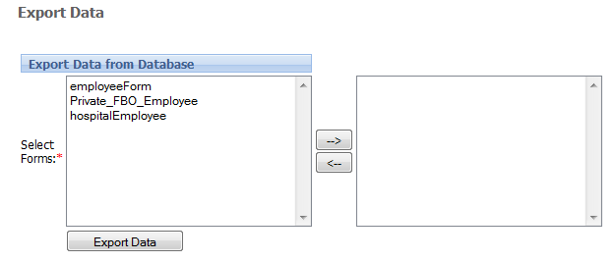
- Exporting the HRHIS data
  - Import
This enables you to import data from other systems (HRHIS and other related ones) into the HRHIS. You will need to locate the file containing data to be imported before you can click the “Import File Command”. See the following interface:
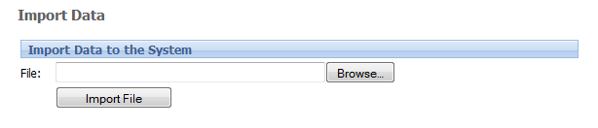
- Interface for importing the data into the system

  - Export to DHIS
This functionality will enable you to export data which will then be imported into DHIS. The procedures are the same as those in the export described above.

