Answers to questions in

Lab 2: Edge detection & Hough transform

Name: _____Ching-an Wu____Program: _Systems, Control and Robotics______________

**Instructions**: Complete the lab according to the instructions in the notes and respond to the questions stated below. Keep the answers short and focus on what is essential. Illustrate with figures only when explicitly requested.

Good luck!

___________________________________________________________________________

**Question 1**: What do you expect the results to look like and why? Compare the size of *dxtools* with the size of *tools*. Why are these sizes different?

Answers:

Edges arises when the intensities of the pixels change significantly. We can find the intensity change by applying difference operator (deltax and deltay) in order to compute the gradient in the x and y direction.

In order to find the vertical edges, we convolve the image with the x-direction gradient operator. The gradient image shows several extreme values, either positive or negative, which present in black line and white line. Similarly, when it comes to the horizontal edges, the same rule applies.

___________________________________________________________________________

**Question 2**: Is it easy to find a threshold that results in thin edges? Explain why or why not!

Answers:

No, it is not easy to find an explicit threshold from the histogram. It is because in order to find a clear-cut threshold, we need to be able to indicate the peaks and valleys in the histogram of the image. However, it is difficult to differentiate them from the resulting histogram.

___________________________________________________________________________

**Question 3**: Does smoothing the image help to find edges?

Answers:

Yes, smoothing the image help find the edges. It is because the second-order derivative is sensitive to noise, and smoothing the image with the Gaussian filter prior to computing the gradient magnitude suppress the noise. Theoretically, it should help us detect the real edges instead of the noise.

**Question 4**: What can you observe? Provide explanation based on the generated images.

Answers:

In order to detect the edges by finding the local maxima in gradient direction, we have to compute the second order derivative first and plot the contour where the values are equal to zero. Based on the generated images, it can be easily noticed that the number of the zero crossing boundaries which are caught decreases as the scale of the Gaussian filter changing from 0.0001 to 64.0.

___________________________________________________________________________

**Question 5**: Assemble the results of the experiment above into an illustrative collage with the *subplot* command. Which are your observations and conclusions?

Answers:

I found out that it does not show up a good result when we use the third order derivative to generate the edge map due to its sensitivity to noise. The third order derivative is even more sensitive to noise than the second derivative. Thus, we can see that there are lots of noises also show up in the background in the resulting images. Although the Gaussian filter starts to suppress the noise as its scale increases, it does not help much because it also distort the original structure in the image.

___________________________________________________________________________

**Question 6**: How can you use the response from *Lvv* to detect edges, and how can you improve the result by using *Lvvv*?

Answers:

By using Lvv, we find the all the zero crossings and regard them as edge points. By using

Lvvv, we simply find the negative values, which denote there are zero crossings happening at those points. However, these two methods have a common problem: they are all sensitive to noise. After several trials, I found out that we can improve the result of using Lvvv by simply lower the threshold instead of just zero. We can find the points which have even more negative third order derivative (say, Lvvv < -500), and the result seems to be improved. The theory behind the method is that the real edges correspond to a significant change in intensity of the original image. In other words, the variance of the zero crossings caused by the true edges tend to be higher than those caused by the noise and the texture in the original image.

___________________________________________________________________________

**Question 7**: Present your best results obtained with *extractedge* for *house* and *tools*.

Answers:

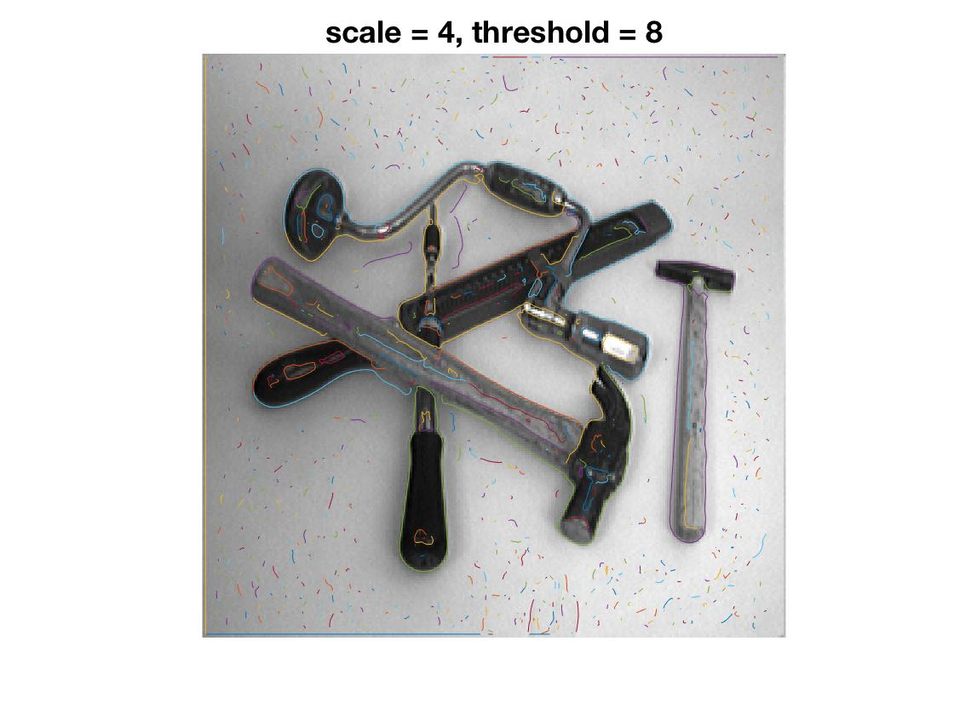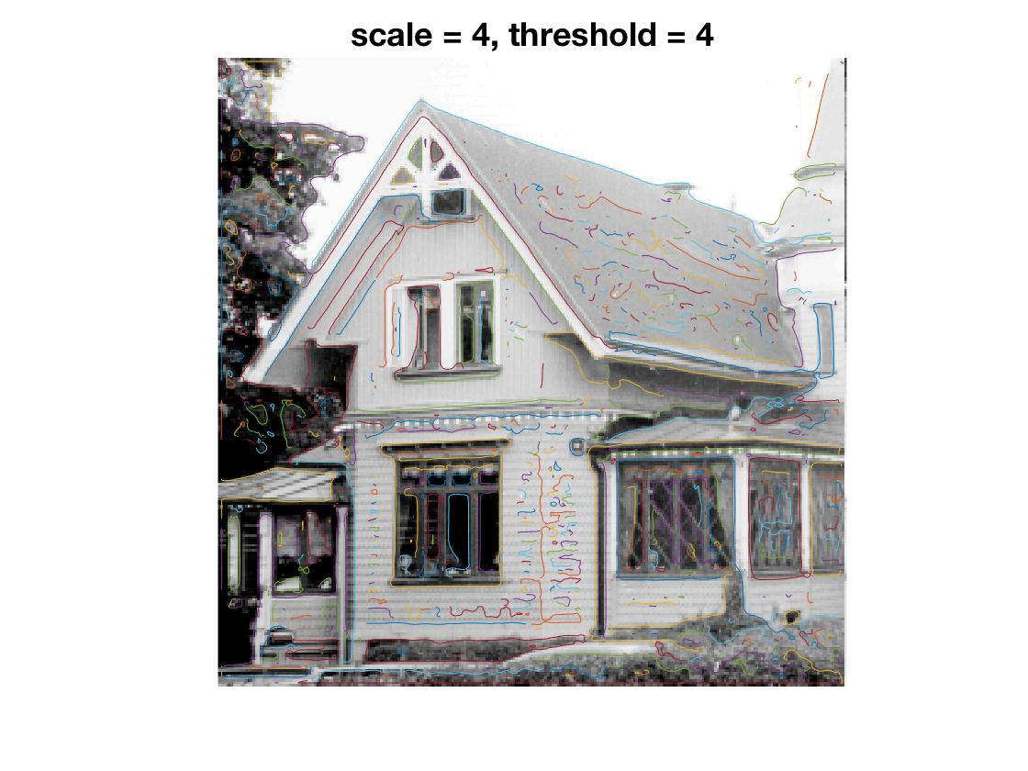

___________________________________________________________________________

**Question 8**: Identify the correspondences between the strongest peaks in the accu-mulator and line segments in the output image. Doing so convince yourself that the implementation is correct. Summarize the results of in one or more figures.

Answers:

___________________________________________________________________________

**Question 9**: How do the results and computational time depend on the number of cells in the accumulator?

Answers:

___________________________________________________________________________

**Question 10**: How do you propose to do this? Try out a function that you would suggest and see if it improves the results. Does it?

Answers:

___________________________________________________________________________