Lab #2: Population Control

Ching An Yang, Danial Welling

Climate/Earth 410: Earth System Modeling

09/22/2025

# **Introduction**

The population of two species can be described by two Lotka-Volterra equations. If one species is predator and the other is prey, the change of population over time can be shown as

$$\frac{dN_{1}(t)}{dt}=aN_{1}-bN_{1}N_{2}$$

$$\frac{dN_{2}\left(t\right)}{dt}=-{cN}_{2}+dN_{2}N_{1}$$

where N1 is the population density of prey, N2 is the population density of predator, and t is time. The coefficients $a$, $b$, $c$, and $d$ represent the growth rate of prey, the death rate of prey due to the number of predators, the death rate of predators, and the grow rate of predators due to the number of prey, respectively. If the two species are not predators and prey but rather compete for same resources, the change of population over time can be described by a pair of similar formula

$$\frac{dN_{1}(t)}{dt}=aN_{1}\left(1-N_{1}\right)-{bN}_{1}N_{2}$$

$$\frac{dN_{2}(t)}{dt}=cN_{2}\left(1-N_{2}\right)-dN_{1}N_{2}$$

where N1 and N2 are the population densities of the two species, the coefficients $a$ and $c$ represent the growth rates, and $b$ and $d$ describe the negative effect of one species on another. The $(1-N)$ terms limit the growth of one species, as the resources are limited and the growth rate slows down as the population approaches carrying capacity.

The two pairs of equations above are coupled and nonlinear. Obtaining an analytical solution is difficult – or the analytical solution may not even be existed. Therefore, numerical methods may provide a better approach to the problem, allowing us to predict how the populations of the two species change over time and how one population impacts the other. In this lab, two ordinary differential equations (ODE) solvers will be implemented to approximate solutions to the equations: a first-order Euler method with a constant forward time step and an eighth-order Runge–Kutta (RK8) method. In addition to addressing the population questions, we will also investigate how the behavior of the Lotka–Volterra equations depends on the initial conditions and the four governing coefficients.

# **Methodology**

A common way to approximate a function $f(x)$ near some point $a$ is the Taylor Series Expansion:

$$f\left(x\right)=f\left(a\right)+\frac{f^{'}\left(a\right)}{1!}\left(x-a\right)+\frac{f^{''}\left(a\right)}{2!}{\left(x-a\right)}^{2}+…+\frac{f^{n}\left(a\right)}{n!}{\left(x-a\right)}^{n}$$

Building upon this, Euler’s method is a simple numerical technique in which

$$Δt=t-t_{0}$$

$$f\left(t_{0}+Δt\right)=f\left(t_{0}\right)+\frac{f^{'}\left(t_{0}\right)}{1!}\left(Δt-t_{0}\right)+\frac{f^{''}\left(t_{0}\right)}{2!}{\left(Δt-t_{0}\right)}^{2}+…$$

where the first two terms correspond to Euler’s method with first order accuracy and a constant forward time step. The remaining terms (shown in blue) represent the truncation error. On the other hand, the RK8 includes the first nine terms of the expansion, giving a higher order of accuracy and significantly smaller error terms compared to Euler’s method.

Serial questions and tests were conducted as listed in the following:

1. Keeping everything else constant, how does varying time steps influence the performance of Euler method solver and the RK8 method?
2. For the competition model, how does varying initial conditions and coefficients impact the performance of Euler method solver and the RK8 method?
3. For the predator-prey model, how does varying initial conditions and coefficients impact the performance of Euler method solver and the RK8 method?

## **GitHub Folder Setup**

In this lab, Python and the Python Scipy package of the Dormand-Prince embedded 8th-order Runge-Kutta method called DOP853 was used for RK8 method. There are four python files in the author’s GitHub repository:

## **Scientific Question #2: Using the same model, how many atmospheric layers do we expect on the planet Venus?**

In this experiment, the same model that was used for the Earth would be used for Venus with the following assumptions:

* Surface temperature = ∼ 700K
* Incoming solar radiation is 2600 W m-2
* N atmospheric layers where N > 1
* Atmosphere is transparent to shortwave radiation but opaque to longwave radiation. Emissivity = 1

The number of layers was varied to determine how many atmospheric layers are needed to have a surface temperature of approximately 700 K, similar to the observed in Venus.

## **Scientific Question #3: What would the Earth’s surface temperature be under a nuclear winter scenario?**

In this experiment, a “nuclear winter” was assumed. Large amount of ashes and smoke would fill the atmosphere, resulting in an opaque atmosphere to shortwave radiation. Only the topmost layer of the atmosphere would absorb all incoming solar flux. The following assumptions were made:

* Incoming solar radiation is 1350 W m-2
* 5 atmospheric layers
* Atmospheres are graybody with emissivity of 0.5

This experiment would determine the resulting surface temperature under a nuclear winter scenario.

There are four python files in the [author’s GitHub repository](https://github.com/chingy053/clasp410_chingy/tree/main/Labs/Lab1_Energy_Balance_Atmospheres):

1. *lab1_1_nlayer.py*

This file contains all the functions that are used in other files. The functions include using matrix and inverse matrix to solve for N-layer atmosphere model, converting fluxes to temperatures, and an N-layer atmosphere model for nuclear winter scenario.

1. *lab1_2_Q3.py*

This file answers the first question of “*How do the number of layers and emissivity of the atmosphere affect the surface temperature of a planet?”,* with two experiments. The code will call for the functions defined in *lab1_1_nlayer.py*. Two plots will be produced.

1. *lab1_3_Q4.py*

This file answers the second question of “*How many atmospheric layers do we expect on the planet Venus?”*. The code will call for the functions defined in *lab1_1_nlayer.py*. One plot will be produced.

1. *lab1_4_Q5.py*

This file answers the third question of “*What would the Earth’s surface temperature be under a nuclear winter scenario?”*. The code will call for the functions defined in *lab1_1_nlayer.py*. One plot will be produced.

# **Results**

The result section will be separated into three parts, corresponding to the three scientific questions.

## **Scientific Question #1: How do the number of layers and emissivity of the atmosphere affect the surface temperature of a planet?**

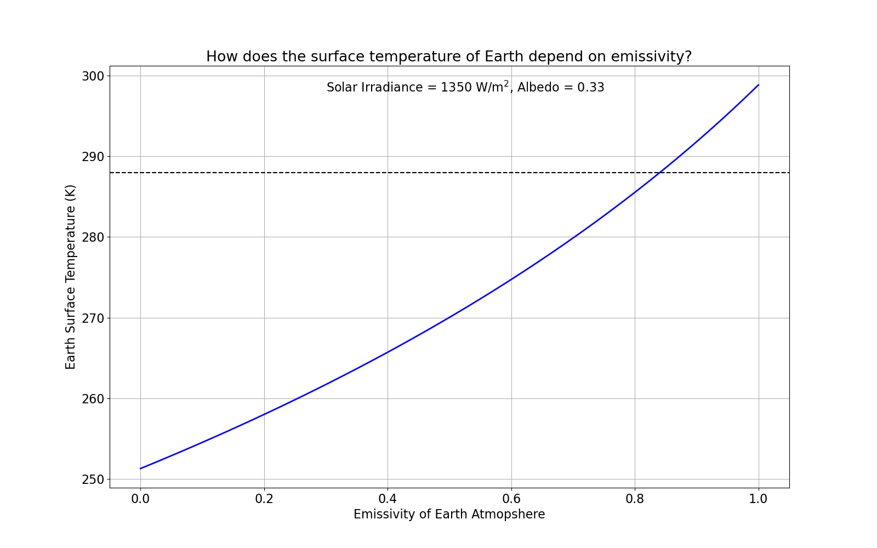

Figure 2. Change of Earth’s surface temperature with emissivity of Earth’s atmosphere, assuming a solar flux of 1350 W m-2 and surface albedo of 0.33. The dashed line marks the observed mean global surface temperature of 288 K.

Figure 2 shows the results of the first experiment, determining how Earth’s surface temperatures vary with the emissivity of the atmosphere under fixed solar irradiance and albedo. As the emissivity increases from 0 to 1, the surface temperature also increases nonlinearly (concave up) from 251 K to 298 K. According to Kirchhoff’s Law, higher emissivity also means higher absorptivity, meaning that the atmosphere becomes a better absorber and emitter of longwave radiation. At low emissivity, most of the surface’s outgoing radiation escapes directly to space, resulting in colder surface temperatures. At high emissivity close to 1, the atmosphere traps more outgoing radiation and re-emits it back to the surface, warming the Earth. The latter case corresponds to the modern-day scenario, where increasing greenhouse gas concentrations make the atmosphere more opaque to longwave radiation, leading to warmer surface temperatures.

The model also predicts that an emissivity of Earth’s atmosphere of about 0.84 is required to reproduce an observed temperature of 288K (as shown in the dash line in Figure 2) under a single layer atmosphere assumption. An emissivity of 0.84 seems to be opaque. Although using single layer is a simplified approach, this result does highlight the importance of atmosphere in terms of regulating Earth’s surface temperature. Without the atmosphere, the surface temperature would be 251.3 K, as previously mentioned in the introduction.

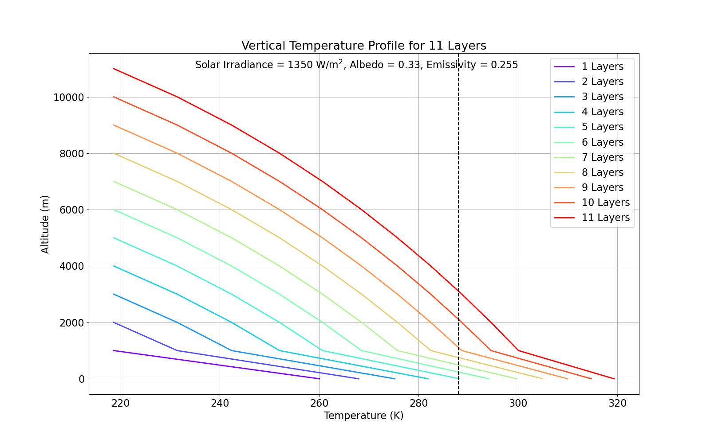

Figure 3. Vertical temperature profiles for atmospheric models with 11 layers, assuming a solar irradiance of 1350 W m−2, albedo of 0.33, and emissivity of 0.255. The color gradient from purple to red corresponds to an increasing number of layers. The dashed line marks the observed mean global surface temperature of 288 K.

In the second experiment, the emissivity of the atmosphere was kept at a constant of 0.255, a number that some studies suggested. Keeping the same solar irradiance and albedo as Experiment 1, increasing the number of layers also increases surface temperatures and vertical temperature gradient (Figure 3). The surface temperature would reach 288 K if 5 layers are included in the system. This result is consistent with author’s expectations: adding more layers to the atmosphere would result in more trapping and re-emitting of longwave radiation back to the surface, warming the Earth.

In Figure 3, the y-axis is plotted as altitude in meter. Here, the author assumes that the atmosphere layers are added to the troposphere, where the temperature decreases with height. Although the atmospheric lapse rate (change of the temperature with height) in reality is not constant, the author evenly divided an average height of the troposphere (~12 km) by the number of layers. The number of layers in Figure 3 is set to be 11, where each layer is 1000 m away from the previous layer for easier visualization.

Along with Experiment 1, both experiments showed the importance of emissivity and the number of layers matter. Both higher emissivity and more layers would lead to higher surface temperature. To have a surface temperature close to the observed mean global surface temperature of 288 K, however, increasing the number of layers seems to be more realistic than having a surface albedo of 0.84. A multi-layer model better represents how radiation is absorbed, transmitted, or re-emitted at different altitudes in the real atmosphere. Simply changing emissivity in a single-layer model may oversimplify the problem.

## **Scientific Question #2: Using the same model, how many atmospheric layers do we expect on the planet Venus?**

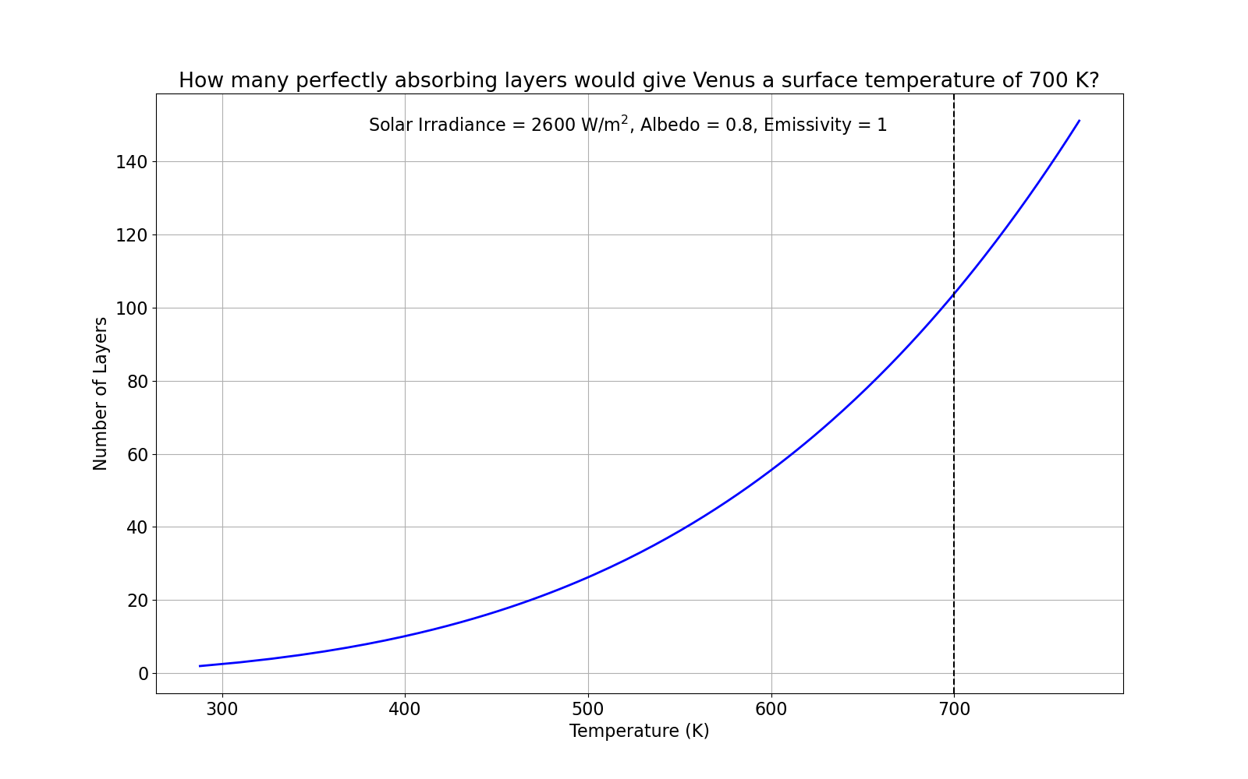

Figure 4. Relationship between surface temperature and the number of layers in Venus, assuming a solar irradiance of 2600 W m-2, albedo of 0.8, and emissivity of 1. The dashed line marks an observed surface temperature of 700 K.

The same model was utilized to simulate Venus. The solar irradiance of Venus was assumed to be 2600 W m-2 with the atmospheric emissivity of 1. The albedo was set to 0.8, a reasonable estimate given by internet searches. Figure 4 shows the relationship between surface temperature and the number of layers in the model. The surface temperature shows an exponential-like growth as the number of layers increases. Due to the high albedo of 0.8, only 20% of the solar irradiation would reach the surface of Venus. Under the single layer assumption, the model predicted surface temperatures below 300 K. For the surface temperature to be around the observed temperature of 700 K, approximately 104 layers are needed. Considering the fact that Venus has higher observed surface temperature, higher albedo, and much greater greenhouse gases concentration than the Earth, it is reasonable that more layers are needed to accommodate the warming, especially since this model does not account for the chemical composition in the atmosphere. The increase of temperature as the number of layer increases is consistent with the Earth’s simulation.

## **Scientific Question #3: What would the Earth’s surface temperature be under a nuclear winter scenario?**

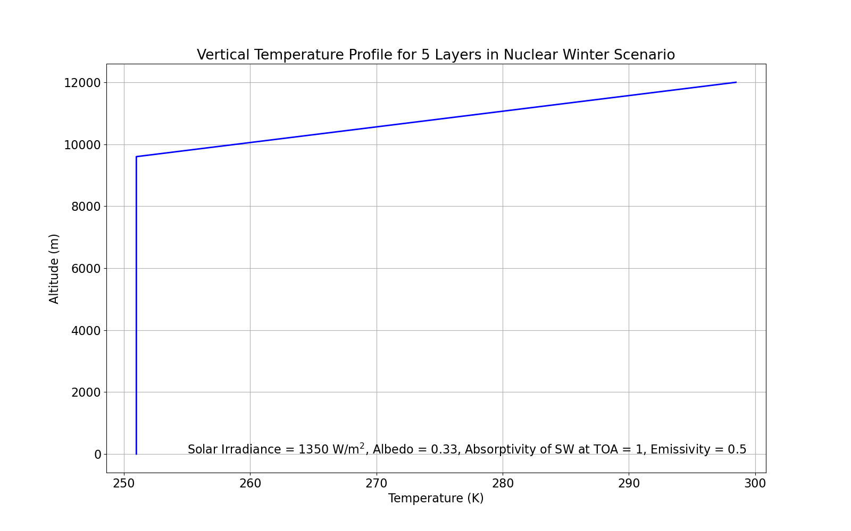

Figure 5. Vertical temperature profile for a five-layer atmosphere under a nuclear winter scenario, where all incoming shortwave radiation is absorbed by the topmost layer. Solar irradiance set to 1350 W m-2, surface albedo of 0.33, and emissivity of 0.5.

An interesting scenario of nuclear winter was tested by slightly modifying the model used in the previous questions. Under a nuclear winter scenario, ash and smoke would fill the atmosphere and block shortwave radiation from reaching the surface. All the incoming shortwave radiation would be absorbed by the topmost layer. In this case, the vector b was modified in the model so that the Fsolar would correspond to the topmost layer. Assuming that the topmost layer would absorb all the solar irradiance, the albedo of the topmost layer was set to 0. In addition, all atmospheric layers were treated as graybodies with emissivity of 0.5.

The result is shown in Figure 5 (using the same altitude assumptions as described earlier). The vertical profile shows an isothermal surface and lower atmosphere layers, with extreme warming to the topmost layer where shortwave radiation absorption occurs. The identical temperatures at the surface and in the lower layers may be explained mathematically. Because these layers only absorb longwave radiation and emit the same amount of longwave radiation they have received (b = 0), the same equilibrium temperature is reached as each layer just emits what it absorbs. Conceptually, having solar radiation directly reaching the ground would create a warmer surface, which heats up the atmosphere above gradually. If this system shuts down, the disappearance of the vertical temperature gradient seems reasonable.

This simulated result provides as important warming to humankind. Nuclear weapons should never be used recklessly. A large-scale nuclear war could lead to a dramatic change of the environment and might eventually result in the extinction of life on Earth.

# **Discussion and Conclusions**

In this lab experiment, a simple N-layer atmospheric model using matrix was created to answer the following questions:

1. How do the number of layers and emissivity of the atmosphere affect the surface temperature of a planet?
2. Using the same model, how many atmospheric layers do we expect on the planet Venus?
3. What would the Earth’s surface temperature be under a nuclear winter scenario?

The experiment results show that both increasing emissivity and adding more atmospheric layers in the model would increase the surface temperatures. Having solar radiation heating the Earth surface is extremely important for the Earth to have a suitable environment for the life on Earth. In the nuclear winter scenario, where no solar radiation penetrates to the surface, would result in freezing surface temperatures and isothermal vertical temperature profile with no temperature gradient with heights. From the Venus simulation, we see that hundreds of layers are required to reproduce the observed surface temperature of ~700 K, largely due to its high albedo and warmer environment compared to the Earth.

The Venus simulation also reflects the limitation of this simple model. Although Venus has much higher greenhouse gas concentrations than the Earth, this information cannot be incorporated in the model. The model excludes atmospheric dynamics, chemical processes, and biological components, all of which influence energy transport. In addition, the atmosphere is much more complex: the actual solar irradiation and emissivity are functions of time, not a constant; temperatures may be increased with height due to other factors such as ozone layer in the stratosphere; and different gases absorb radiation selectively at different wavelengths. Moreover, the energy system is not always in radiative balance. Nevertheless, this simple N-layer atmospheric model offers a useful framework for understanding the fundamental processes that govern Earth’s energy balance.