Lab #3: Permafrost Thawing

Ching An Yang, Daniel Welling

Climate/Earth 410: Earth System Modeling

10/22/2025

# **Introduction**

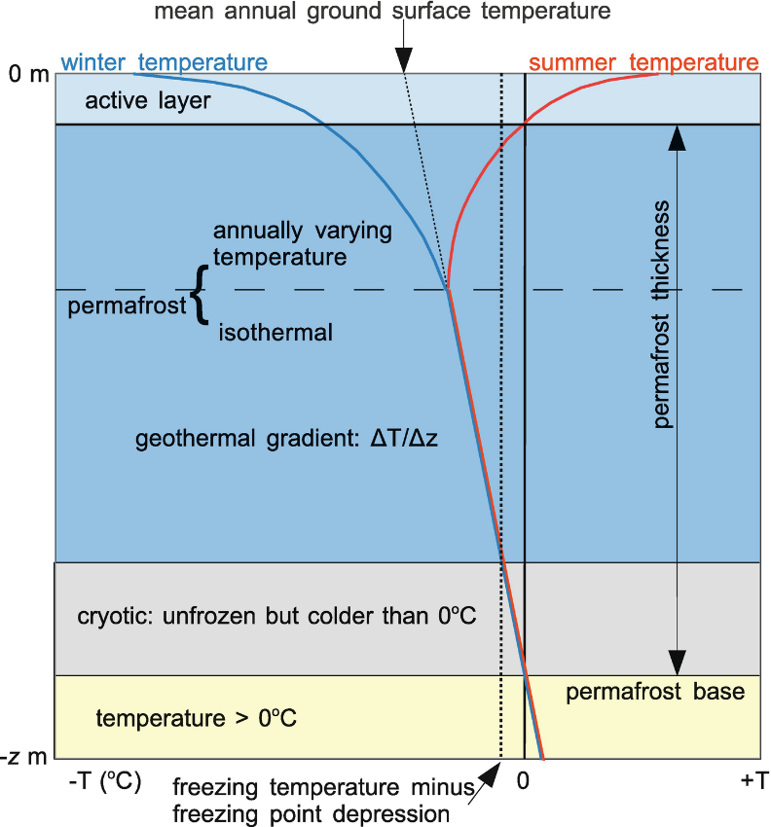 Permafrost, a ground layer that remains frozen for multiple years, is a feature commonly seen in the cold regions such as Arctic, and sub-Arctic. Figure 1 illustrates the vertical temperature profile and subsurface structure of the ground. The permafrost layer is beneath the active layer, a layer that is typically less than 10 m thick and may reach temperatures above 0°C during summer. The permafrost layer can be tens or a hundred meters below the active layer, with temperatures remaining below 0°C. At a greater depth, geothermal heat causes temperatures to rise above 0°C, marking the base of the permafrost.

Permafrost is important because of several reasons, one of the most critical being its carbon storage. Permafrost in the Northern region alone has 1460 – 1600 metric tons of carbon, twice as much as the amount in the atmosphere. With global warming, the active layer deepens and the permafrost begins to thaw. This not only releases large amounts of greenhouse gases into the atmosphere, but also changes ground structure, soil chemistry, and runoff patterns.

Figure 1. Vertical temperature profile of permafrost ground, adapted from Figure 1.2 in Thawing Permafrost by Huissteden. Blue and red lines are winter and summer temperature profiles, respectively. The thin dashed line is the geothermal temperature gradient. The thick dashed line is the freezing temperature corrected for freezing point depression.

This lab utilizes the heat diffusion equation to describe temperature variations of the ground over time. A numerical solver for the heat equation would be developed and applied to simulate the permafrost in Kangerlussuqa, Greenland. This simulation aims to investigate how climate change impacts the thickness of the active layer and the permafrost, as well as the time required for the ground to reach a steady state.

# **Methodology**

The physics of permafrost temperature profiles can be described by the heat diffusion equation, a parabolic partial differential equation:

$$\frac{∂U}{∂t}=c^{2}∇^{2}U$$

where $U(x,t)$ is the temperature as a function of space and time, $c^{2}$ is the thermal diffusivity (or the rate of diffusion), and $∇$ is the Laplacian Operator such that $∇=\hat{x}\frac{∂}{∂x}+\hat{y}\frac{∂}{∂y}+\hat{z}\frac{∂}{∂z}$ and $∇^{2}=∇⋅∇=\frac{∂^{2}}{∂x^{2}}+\frac{∂^{2}}{∂y^{2}}+\frac{∂^{2}}{∂z^{2}}$. In one dimension, this diffusion equation is

$$\frac{∂U(x,t)}{∂t}=c^{2}\frac{∂^{2}U(x,t)}{∂x^{2}}$$

Since this equation has a first derivative with respect to time that depends on the second derivative with respect to space, it can be approximated numerically using Taylor series expansions on both sides. By taking a forward difference approximation on the left-hand side and subtracting the forward and backward Taylor expansions on the right-hand side:

$$\frac{U\left(x,t+Δt\right)- U\left(x,t\right)}{Δt}=c^{2}\frac{U\left(x+Δx,t\right)-2U\left(x,t\right)+U\left(x-Δx, t\right)}{Δx^{2}}$$

$$U\left(x,t+Δt\right) =\frac{c^{2}Δt}{Δx^{2}}\left(U\left(x+Δx,t\right)-2U\left(x,t\right)+U\left(x-Δx, t\right)\right)+U(x,t)$$

$$U\left(x,t+Δt\right) =\left(1-2r\right)U\left(x,t\right)+r\left(U\left(x+Δx,t\right)+U\left(x-Δx, t\right)\right)$$

where $r≝c^{2}\frac{Δt}{Δx^{2}}$

In Python, each step in space can be represented by $i$ and each step in time can be represented by $j$, so that

$$U_{i,j+1} =\left(1-2r\right)U_{i,j}+r\left(U_{i+1,j}+U_{i-1,j}\right)$$

$$r≝c^{2}\frac{Δt}{Δx^{2}}$$

Some initial and boundary conditions may be applied depending on the problems. Please note that different initial and boundary conditions will be used for the validation case and the permafrost simulation case in this lab, which will be described in the following.

**Validation Case**

To verify that the solver works, the following initial and boundary conditions were applied to test the solution:

$$U\left(0,t\right)=U\left(L,t\right)=0$$

$$U\left(x,0\right)=4x-4x^{2}$$

where $L$ is the last spatial point or boundary. The following setup was also used:

$0≤x≤1 m$ with $∆x=0.2 m$

$0≤t≤0.2 s$ with $∆t=0.02 s$

$$c^{2}=1 m^{2}/s$$

**Permafrost in Kangerlussuaq, Greenland**

The numerical solver for the heat equation was applied to create a model to simulate the temperatures of the permafrost layer in Kangerlussuaq, Greenland. A typical thermal diffusivity for the permafrost is $c^{2}=0.25 mm^{2}/s$. The average climatological temperatures in Kangerlussuaq are given by

$$T= [-19.7, -21.0, -17., -8.4, 2.3, 8.4, 10.7, 8.5, 3.1, -6.0, -12.0, -16.9]$$

which is used to generate a seasonal oscillation representing the annual temperature cycle as the boundary condition for the ground surface:

$$T\left(t\right)=T_{mean}+A·sin⁡(\frac{π}{180}t-\frac{π}{2})$$

where $A$ is the amplitude, calculated as the maximum deviation from the mean temperature. Another boundary condition, representing geothermal heating, was set to 5°C. The initial temperature was set to 0°C throughout the entire vertical layer.

**Figures and Plotting**

For each case, two types of figures would be plotted. The first is a 2-dimensional heat map, showing time versus ground depth. This plot presents the temporal evolution of temperatures and helps identify the time at which the system reaches steady state. The second figure is a seasonal temperature profile, plotted as temperature versus depth, which can be used to distinguish different ground layers.

## **Code and GitHub Folder Setup**

In this lab, there are four python files in the [author’s GitHub repository](https://github.com/chingy053/clasp410_chingy/tree/main/Labs/Lab2_Prey_and_Predator):

1. *lab3_1_functions.py*

This file is a module which contains all the functions used in other files, including solver to the heat diffusion equation and a function that calculates the annual temperature cycle for the Kangerlussuaq boundary condition.

1. *lab3_2_Q1_validation.py*

This file is used to verify the solver of the heat diffusion equation. It does not produce any plot but outputs the computed temperature values.

1. *lab3_3_Q2.py*

This file provides a simulation for the permafrost in Kangerlussuqa, Greenland. The code calls for the functions defined in *lab3_1_functions.py* and produces one plot with 2 panels:

* *plot_lab3_3_Q2.png:* left panel is the 2D heat map and right panel is the seasonal vertical temperature profile

This code will also print out a statement.

1. *lab3_4_Q3.py*

This file provides a simulation for the permafrost in Kangerlussuqa, Greenland, but under global warming conditions. The code calls for the functions defined in *lab3_1_functions.py* and produces three plots, each with 2 panels. Left panel is the 2D heat map while the right panel is the seasonal vertical temperature profile:

* *plot_lab3_4_Q3_shift_0.5C.png*
* *plot_lab3_4_Q3_shift_1.0C.png*
* *plot_lab3_4_Q3_shift_3.0C.png*

This code will also print out 3 statements.

Again, the main functionality is contained within the module (*lab3_1_funtions.py*). To re-produce the figures in this report, please run the respective scripts (e.g., *lab3_2_Q1_validation.py* for Q1, etc.) in iPython by commanding “run [.py file name]”. Note that all figures will be saved to the current directory, but a display window may not appear since the figures are set to close automatically. Statements will be printed in the terminal.

# **Results**

The result section will be separated into three parts, corresponding to validation, permafrost in Kangerlussuaq, Greenland, and permafrost under global warming conditions.

## **Code Validation**

Figure 2. Solution for the validation problem.

Figure 3. Screenshot of the printed statement by running lab3_2_Q1_validation, showing the solution computed by the heat diffusion solver.

To verify the accuracy of the solver, a validation test was performed using a specific case, where the initial condition is $U\left(x,0\right)=4x-4x^{2}$ and both upper and lower boundaries are set to 0s. The solution for this validation case is shown in Figure 2. Consistent with the upper and lower boundary conditions, the values are 0s when $i=0 and i=5$. The computed result of the heat diffusion solver is shown in Figure 3. The computed result from the heat diffusion solver is shown in **Figure 3**. The calculated values match the solution in Figure 2 perfectly, confirming that the solver is functioning correctly.

## **Permafrost in Kangerlussuaq, Greenland**

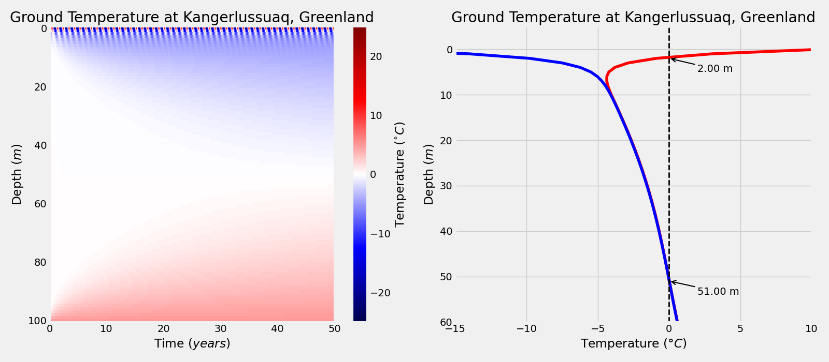

Figure 4. Heat map (left) and seasonal vertical temperature profile (right) for permafrost in Kangerlussuaq, Greenland. The blue and red lines represent winter and summer temperatures, respectively. The dashed line indicates 0°C.

The left panel of Figure 4 shows the simulated thermal behavior of permafrost in Kangerlussuaq, Greenland over a 50-year period. In the near surface, temperatures oscillate between approximately -20°C and 20°C due to the seasonal cycle. As the depth increases, the temperature variation gradually diminishes. In shallower water < ~50 m, the temperature remains slightly below 0°C, indicating the permafrost layer. At 40~60 m depth, ground temperatures are about 0°C with minimal variation over time. At depth deeper than ~50m, the temperature rises above 0°C due to geothermal heat. Since the initial temperatures are set to 0°C at time $t=0$, surface cooling and geothermal heating gradually create a vertical temperature gradient over time, resulting parabolic patterns in the heat map. After about 40 years, the temperature at all depths stabilized, indicating a steady state.

The right panel of Figure 4 shows the vertical ground temperature profiles for both winter and summer. Since permafrost is defined as the layer that always remains below 0°C, a dashed line is drawn to indicate the intersection between the temperature profiles and the freezing point. Based on the typical thermal diffusivity of 0.25 mm2/s climatological conditions in Kangerlussuaq, Greenland, the active layer is about 2 m deep, while the permafrost layer is between about 2 m and 51 m (49 m in thickness).

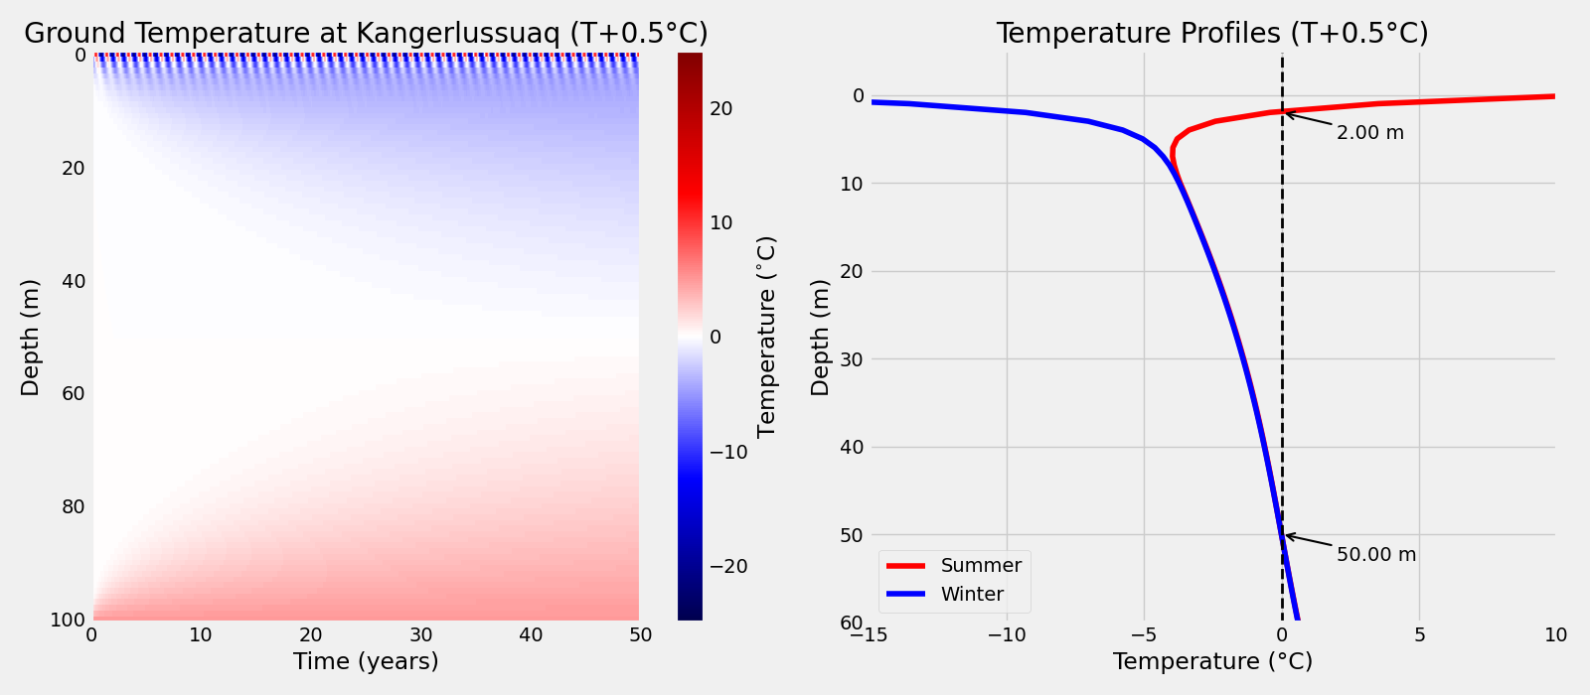

Figure 5. Similar to Figure 4 but for global warming case where temperature increases of +0.5°C.

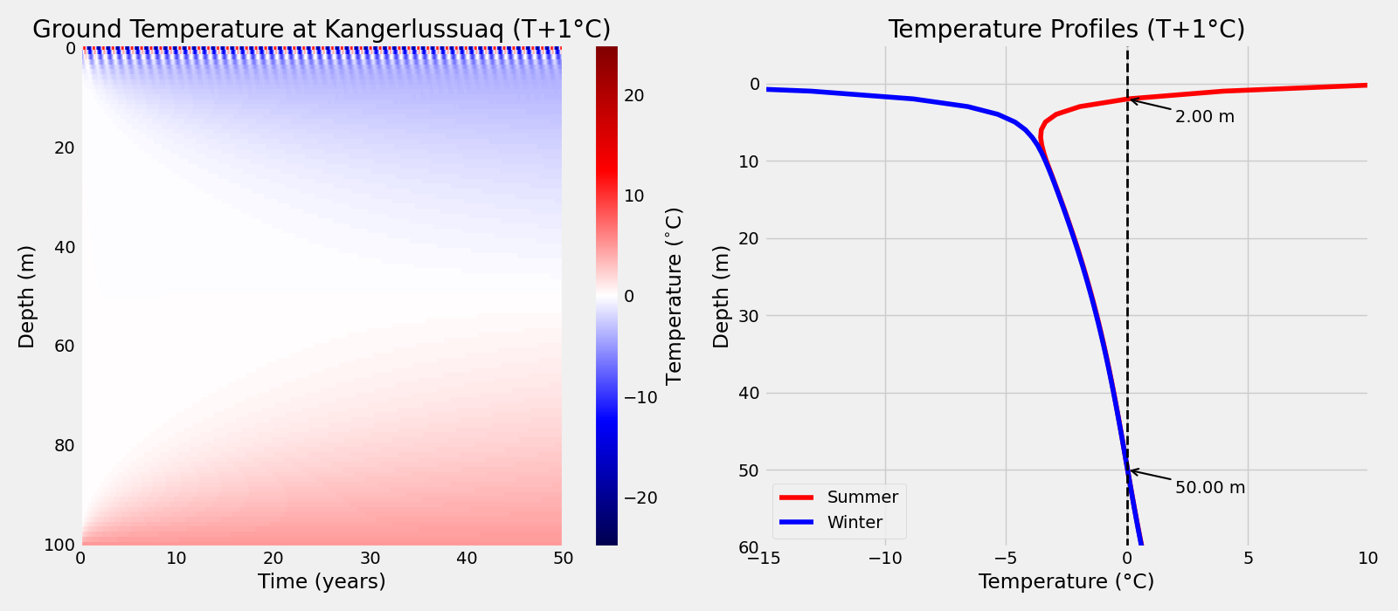

Figure 6. Similar to Figure 4 but for global warming case where temperature increases of +1°C.

Figure 7. Similar to Figure 4 but for global warming case where temperature increases of +3°C.

Figure 5, 6, and 7 show cases of global warming, where climatological temperatures in Kangerlussuaq, Greenland shifted by +0.5°C, +1°C, and +3°C, respectively. Small increases (+0.5°C and +1°C) in temperature may have minor changes, yet they are difficult to spot when compared with the baseline case in Figure 4. Larger increase of +3°C results in more noticeable differences. The blue shading in the heat map gradually fades as the temperature offset increases. This indicates a warmer permafrost, with reduction in the extent of the frozen layer. Near the surface, the transition between the dark blue and dark red obviously shifts downward in the +3°C case, reflecting stronger seasonal thawing. The red shading associated with geothermal heating, however, remains affected.

The seasonal vertical temperature profiles in the right panels show a consistent result as described above. The “Y” shape slightly shifts to the right with increasing temperature offset. Both +0.5°C and +1°C cases show a decrease of permafrost thickness by 1 m, from the 51 m baseline to 50 m. The active layers remain at a depth of 2 m, unchanged from the baseline case. This is probably because of the 1 m vertical resolution in the model, which cannot capture changes smaller than 1 m. However, the +3°C case shows clear changes in both the active layer and permafrost depths – the active layer increases from 2 m to 3 m and the permafrost base rises from 51 m to 46m (compared with Figure 4). In total, the permafrost thickness decreases from 49 m to 43 m, with a loss of about 6 m.

# **Discussion and Conclusions**

In this lab, the forward difference and central difference methods were used to solve the heat diffusion equation numerically. The solver was then applied to simulate the changes of permafrost in Kangerlussuaq, Greenland. Under the defined initial and boundary conditions, increasing surface temperatures associated with global warming would lead to a thicker active layer, more intense and deeper seasonal thawing, and a thinner permafrost layer. The simulation results are consistent with observed permafrost responses to warming.

Multiple assumptions were made in this simulation. The seasonal temperature variation over 50 years was represented by a sine function derived from climatological mean temperatures with a fixed amplitude. In reality, surface temperatures have much greater variability. The geothermal heating at the lower boundary was assumed to be constant at 5 °C. Also, the vertical resolution of the model grid may be too coarse to capture small changes associated with +0.5 °C and +1 °C temperature offsets.

Additional processes could be included to enhance the model complexity and improve accuracy. For example, soil properties can affect thermal conductivity. Latent heat effects during freezing and thawing, as well as hydrological processes such as groundwater movement can affect heat transfer within the ground. Including these factors would allow for a more realistic representation of permafrost dynamics.