Lab #4: Universality Sick or Burning
Ching An Yang, Daniel Welling
Climate/Earth 410: Earth System Modeling
11/13/2025

Introduction
Pseudo-stochastic process is an event that appears to be random (like a stochastic process) but is actually deterministic, where there are factors that control the behavior. Two good examples of pseudo-stochastic processes are forest burning and disease transmission. The spread of wildfires is highly dependent on weather conditions (wind, moisture, lightning etc.), topography, and available fuel (vegetation), together forming what is known as the wildfire behavior triangle. The epidemiological triangle, on the other hand, consists of the host (immune status, age, genetic profile etc.), the agent (bacteria or viruses), and the environment (temperature, humidity, etc.).
In this lab, a simple stochastic model for wildfire and disease spread will be created by defining probabilities to certain events, such as the likelihood of fire ignition/infection and chances of spreading. This model simulation will help us to investigate how different factors influence the dynamics of spreading.

Methodology
This simple stochastic model demonstrates the aspect of universality, meaning that the same underlying model can be applied to both the spread of wildfire and disease. A space is represented by a 2D grid, where the initial fire or infection can occur randomly (probability defined by $P_{ignite}$) or at a specified location. The fire or disease then propagates to its neighboring grids in the next timestep based on the probability of spreading ($P_{spread}$), while the areas that have already burned or been infected turn into bare land or immune state. This assumes that no fire or disease continues to affect the same area beyond one timestep. In addition to the disease model, infected individuals can either recover from the disease or die, determined by the fatality probability, $P_{fetal}$. In a more advanced setting, an additional probably ($P_{bare}$) can be introduced to represent areas that are initially bare land in the wildfire model, or the pre-vaccinated population who are immune to the disease. A simple validation case is set up below to test the functionality of the model.
Validation Case
To validate the model, a test simulation was conducted using a 3 by 3 grid, 100% chance of spread, and zero initial bare spots to run for 4 timesteps. The fire would start at the center of the grid. Each cell in the grid would be in one of the three states – burnt, forest, or burning which were represented using numbers 1, 2 and 3, respectively, in the model.
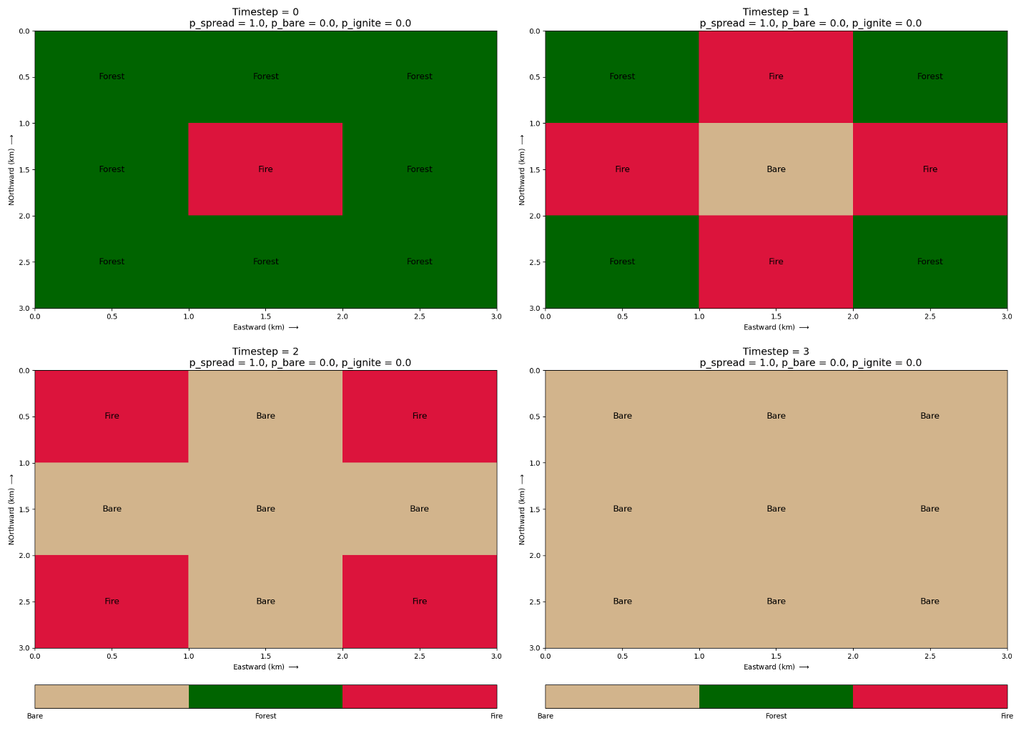
Figure 1. Forest fire model simulation for the validation case using 3×3 grid 7 timesteps with the fire initialized at the center. The four timesteps ($t=0,1,2,3$) are shown from top left to bottom right. Tan, green, and red represent bare land, forest, and burning areas, respectively.
In this case, Figure 1 shows the ignition of the fire at the center of the grid at $t=0$ (Figure 1, top left). Because the probably of spread was set to be 100% ($P_{spread}=1$), the fire propagates in all four directions at $t=1$ (top right). The center cell where the fire originated then turned into bare land as everything was burnt. At $t=2$, the fire continued to propagate to the corner cells. Eventually, all the cells were burnt, leaving the entire grid as bare land ($t=3$, bottom right).
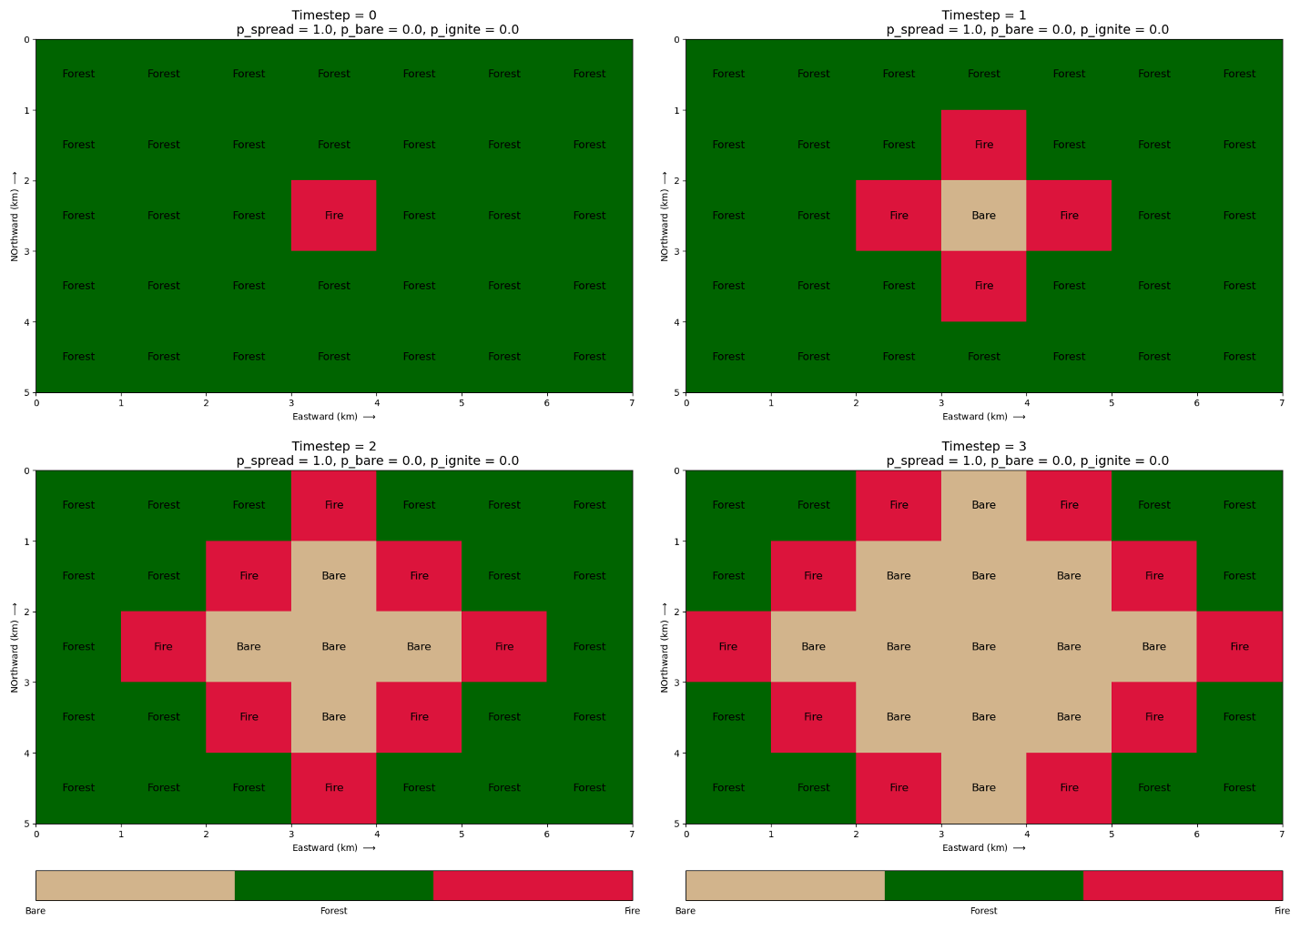
Figure 2. Similar to Figure 1 but using a 5×7 grid and timestep of 7. Only the first four timesteps are shown here.
A similar test simulation was conducted using a larger 5×7 grid, which was wider than it was tall. The fire shows similar behavior to that shown in Figure 1.

Code and GitHub Folder Setup
In this lab, there are six python files in the author’s GitHub repository. There are more python files for this lab because the plotting and GIF generator often crash matplotlib, giving an error message of “segmentation fault (core dumped)”, which is an indication of memory overflow (talked to Dan about this and it could not be resolved). Usually, the figure can be generated on the first run but encounters the memory issue on the second run. If this error message occurs, it will exit iPython mode. Please restart IPython and rerun the code.
- lab4_1_functions.py
This file is a module which contains all the functions used in other files, including a solver for the fire spread and disease transmission problems, as well as three plotting functions. The plotting function, plot_progression, is defined but not used in any of the codes. The plotting function, plot_forest2d_animation, is used to visualize the spread over multiple timesteps. However, the GIF output is not included in this report since GIF files may not display properly on Canvas.

- lab4_2_Q1_validation.py
This file is used to verify the solver for fire spread. It produces 4 plots and 1 GIF file for the 3×3 validation case (shown in Figure 1).
- Lab4_2_Q1_veri_3x3_fire_at_center_{0~4}.png: Figure 1 in this report.
- Lab4_2_Q1_veri_3x3_fire_at_center.gif: Figure 1 in animation form.

- lab4_3_Q1_validation.py
This file is used to verify the solver for fire spread. It produces 4 plots and 1 GIF file for the 5×7 validation case (shown in Figure 2).
- Lab4_3_Q1_veri_5x7_fire_at_center_{0~6}.png: Figure 2 in this report.
- Lab4_3_Q1_veri_5x7_fire_at_center.gif: Figure 2 in animation form.

- lab4_4_Q2_1.py
This file runs a forest fire simulation with various value of $P_{spread}$ to test how $P_{spread}$ affects the spread of wildfire. The code calls for the functions defined in lab4_1_functions.py and produces one plot with 4 panels:
- plot_lab4_4_Q2_f1_varying_pspead.png: Percentages of burnt, forested, and burning areas relative to the total area are plotted against timesteps and colored by the $P_{spread}$. The last panel shows the time of containment, when no more fire remains. This is Figure 3 in this report.
- lab4_5_Q2_2.py
This file runs a forest fire simulation with various value of $P_{bare}$ to test how $P_{bare}$ affects the spread of wildfire. The code calls for the functions defined in lab4_1_functions.py and produces one plot with 4 panels:
- plot_lab4_5_Q2_f2_varying_pbare.png: Percentages of burnt, forested, and burning areas relative to the total area are plotted against timesteps and colored by the $P_{bare}$. The last panel shows the time of containment, when no more fire remains. This is Figure 4 in this report.
- lab4_6_Q3_1.py
This file runs a disease spread simulation with three experiments: varying $P_{spread}$, $P_{bare}$, and $P_{fetal}$ to test how each probability affects the spread of disease. The code calls for the functions defined in lab4_1_functions.py and produces one plot with 5 panels:
- plot_lab4_6_Q3_f1_varying_pspread.png: Percentages of deceased, immune, healthy, and sick individuals relative to the total population are plotted against timesteps and colored by the $P_{spread}$. The bottom panel shows the time of containment, when no more active infection remains. This plot is not used in the report.
- plot_lab4_6_Q3_f2_varying_pbare.png: Percentages of deceased, immune, healthy, and sick individuals relative to the total population are plotted against timesteps and colored by the $P_{bare}$. The bottom panel shows the time of containment, when no more active infection remains. This is Figure 5 in this report.
- plot_lab4_6_Q3_f3_varying_pfetal.png: Percentages of deceased, immune, healthy, and sick individuals relative to the total population are plotted against timesteps and colored by the $P_{fetal}$. The bottom panel shows the time of containment, when no more active infection remains. This is Figure 6 in this report.

Again, the main functionality is contained within the module (lab4_1_funtions.py). To re-produce the figures in this report, please run the respective scripts (e.g., lab4_2_Q1_validation.py for Q1 part 1, etc.) in iPython by commanding “run [.py file name]”. Note that all figures will be saved to the current directory, but a display window may not appear since the figures are set to close automatically. Statements will be printed in the terminal.

Results
The result section will be separated into two parts, corresponding to Question 2 of forest fire problem and Question 3 of disease spread problem.

Forest Fire Spread
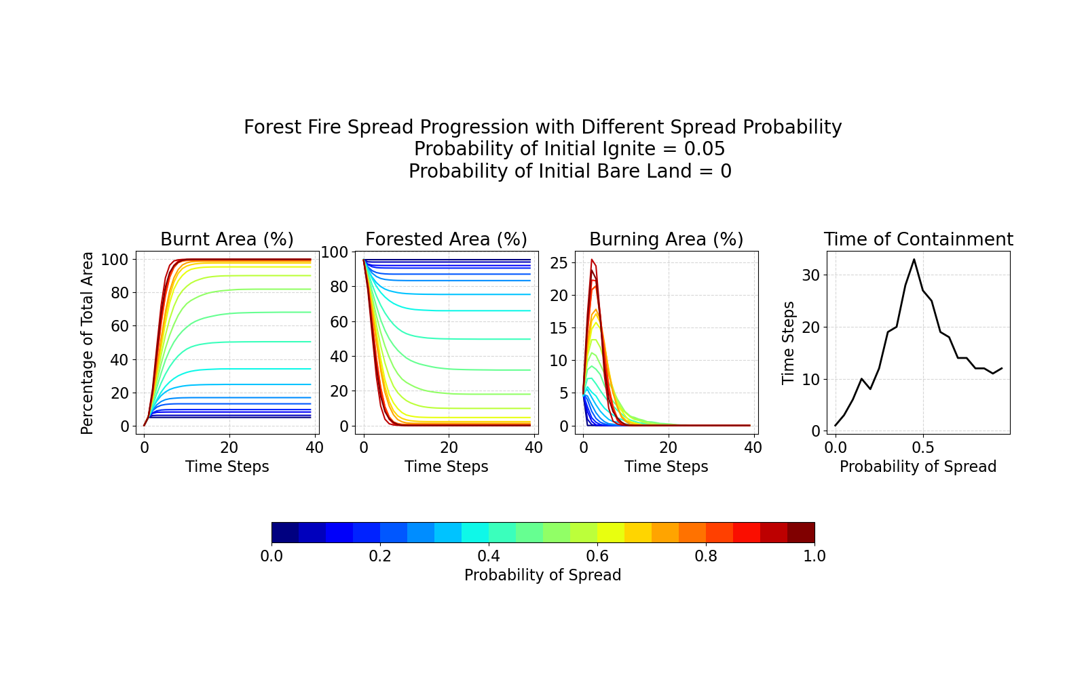
Figure 3. Forest fire model simulation using 100×100 grid and 40 timesteps. Figure shows the changes of burnt, forested, and burning areas as percentages of total area over timesteps with varying probabilities of spread (left 3 panels). The rightmost panel shows the time of containment, defined as the time step when no active burning remains. The simulation assumes a probability of initial ignition of 0.05 and no initial bare land.
Figure 3 shows the significance of probability of fire spread ($P_{spread}$) in influencing the burnt, forested, and burning areas, as well as the time of containment over time. When $P_{spread}≤0.2$ (dark blue lines), the fire is under control, with approximately less than 10% of the total area burned and more than 90% of the forest area remained. The fire is usually contained within 10 timesteps. A dramatic increase occurs in fire propagation and total burnt area when the $P_{spread}$ increases to 0.5. About 70% of total area burned, with maximum burning area of ~10% at about $t=4$ and the longest time in fire containment of 35 timesteps. Further increase in $P_{spread}$ leads to quicker burning, where nearly 90% of the area are burned within 10-15 timesteps. The curve of the burning area also becomes narrower, with maximum area reaching ~25%. Overall, the model shows that moderate spread probabilities ($P_{spread} \sim 0.5$) would result in the longest fire, while low or high spread probabilities have faster fire containment.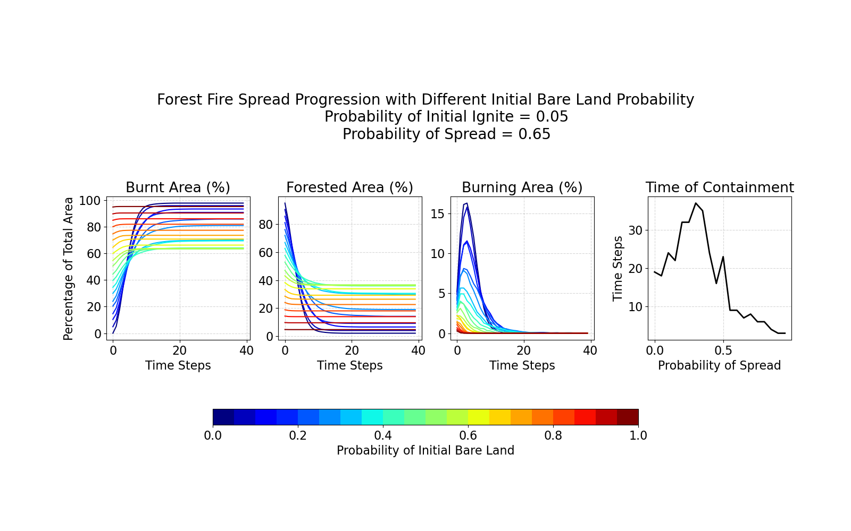
Figure 4. Forest fire model simulation using 100×100 grid and 40 timesteps. Figure shows the changes of burnt, forested, and burning areas as percentages of total area over timesteps with varying probabilities of initial bare land (left 3 panels). The rightmost panel shows the time of containment, defined as the time step when no active burning remains. The simulation assumes a probability of initial ignition of 0.05 and a probability of spread of 0.65.
Figure 4 shows the impact of varying probability of initial bare land ($P_{bare}$) in the burnt, forested, and burning areas, as well as the time of containment over time. When $P_{bare}≤0.3$ (dark blue lines), the fire spread rapidly with burning area reaching maximum of 18% at $t=5$ and burnt area increases from 0 – 20% to 70 – 90% within 10 timesteps. The containment occurs after approximately 30 – 35 timesteps, highest among all. This is probably because minimum initial bare land indicates higher forest area coverage. When $P_{bare}$ is between 0.3 and 0.5, the total burnt area decreases notably to 60–70%, while the time of containment decreases but remains relatively high (around 20 – 30 timesteps). Higher values of $P_{bare}>0.5$ leads to a dramatic decrease in fire containment (<10 timesteps) due to the lack of fuel (forest area). The burning area is often less than 10%, with peaks shifting to earlier timesteps. Overall, the model shows that increasing the initial proportion of bare land also decreases the initial area of forest, leading to shorter and less fire spread. The longest containment time occur when $P_{bare}\sim 0.3$. Similar to $P_{spread}$, both very low and very high $P_{bare}$ values lead to faster containment. This is probably due to either faster spread with higher fuel (more forest area) or insufficient fuel (limited forest area).

Disease Spread
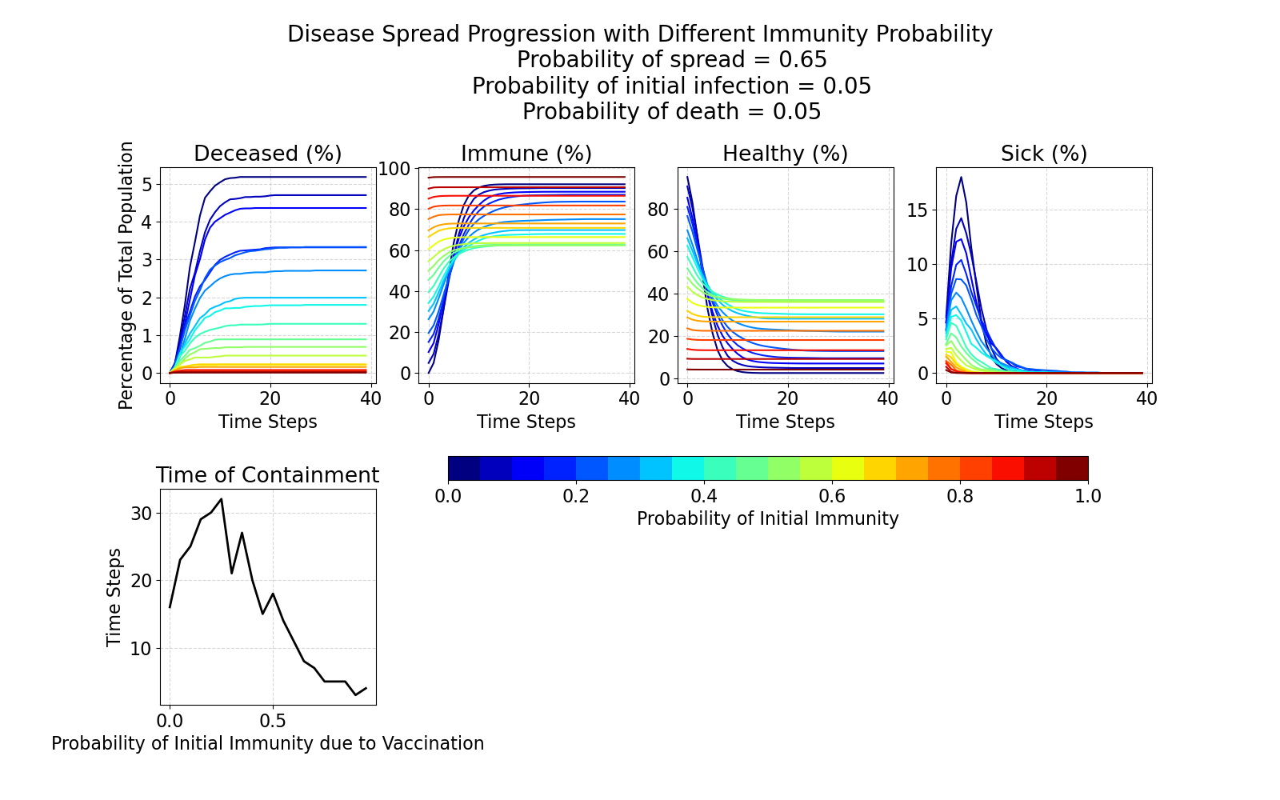
Figure 5. Disease spread model simulation using 100×100 grid and 40 timesteps. Figure shows the changes of deceased, immune, healthy, and sick populations as percentages of total populations over timesteps with varying probabilities of initial immunity (top 4 panels). The bottom panel shows the time of containment, defined as the time step when no active infection remains. The simulation assumes a probability of initial infection and death of 0.05 and a probability of spread of 0.65.
Figure 6 shows the effect of varying the probability of initial immunity ($P_{immunity}$, used $P_{bare}$ in the code) on the progression of disease spread across a simulated population distribution. When $P_{immunity}$ is less than 0.3, the disease spreads rapidly. The proportion of sick population peaks at maximum of 15–17% near t = 6, with highest death rate of approximately 2.5–5% and only 10–25% of the population remaining healthy. The disease persists for around 30 timesteps before a final containment. As $P_{immunity}$ increases to 0.5, the spread becomes less extensive. The total number of deaths notably decreases to about 1–2%. The time of containment decreases to 15–25 timesteps, with healthy population finalize at around 40% and total immune population reaching 60–80% of the population at about t = 15.
With more population getting vaccinated earlier, $P_{immunity}$> 0.5, the spread of infection is strongly suppressed. The sick and deceased proportions remain below to 1 – 2%, while nearly 60–100% of the population is immune and small groups of individuals stay healthy by the end of the simulation. The disease dies out within 5 timesteps or fewer. This definitely shows the significance of earlier vaccination. Higher immunity reduces both the fatality and duration of disease outbreaks. The longest containment times occur when $P_{immunity}$= 0.3. Again, both low and high immunity probabilities lead to faster containment, due to either high fatality and rapid spread of the disease or the other way around.
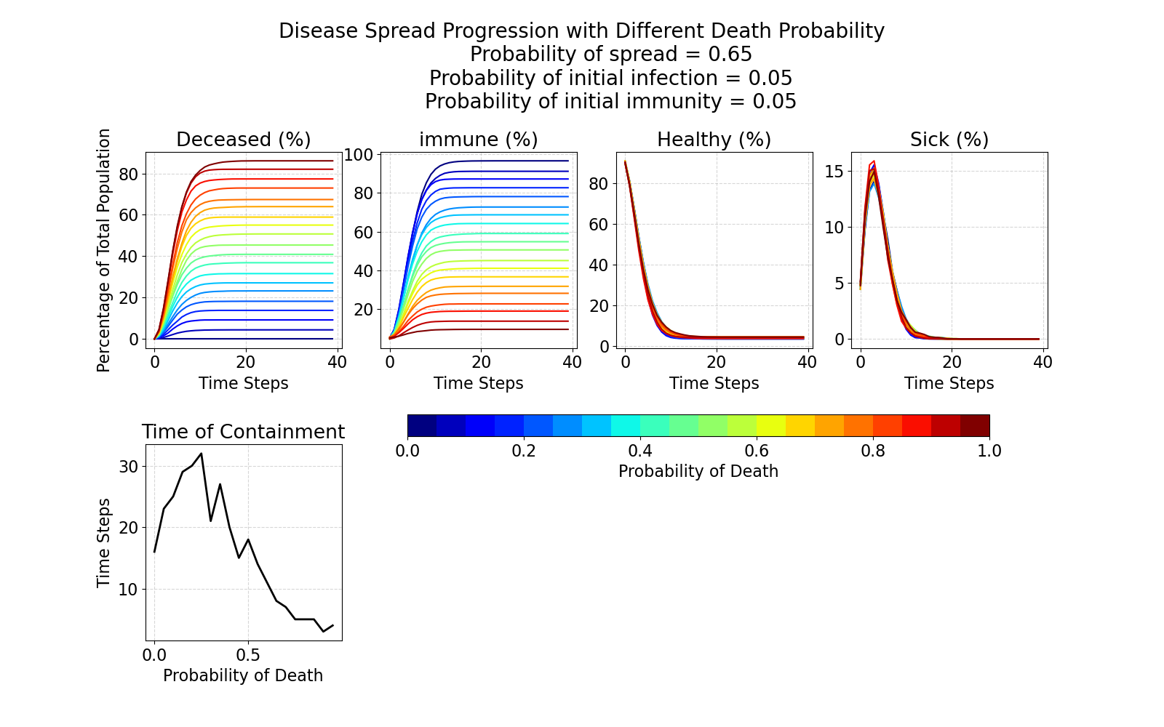
Figure 6. Disease spread model simulation using 100×100 grid and 40 timesteps. Figure shows the changes of deceased, immune, healthy, and sick populations as percentages of total populations over timesteps with varying probabilities of death (top 4 panels). The bottom panel shows the time of containment, defined as the time step when no active infection remains. The simulation assumes a probability of initial infection and immunity of 0.05 and a probability of spread of 0.65.

Discussion and Conclusions
In this lab, the forward difference and central difference methods were used to solve the heat diffusion equation numerically. The solver was then applied to simulate the changes of permafrost in Kangerlussuaq, Greenland. Under the defined initial and boundary conditions, increasing surface temperatures associated with global warming would lead to a thicker active layer, more intense and deeper seasonal thawing, and a thinner permafrost layer. The simulation results are consistent with observed permafrost responses to warming.
Multiple assumptions were made in this simulation. The seasonal temperature variation over 50 years was represented by a sine function derived from climatological mean temperatures with a fixed amplitude. In reality, surface temperatures have much greater variability. The geothermal heating at the lower boundary was assumed to be constant at 5 °C. Also, the vertical resolution of the model grid may be too coarse to capture small changes associated with +0.5 °C and +1 °C temperature offsets.
Additional processes could be included to enhance the model complexity and improve accuracy. For example, soil properties can affect thermal conductivity. Latent heat effects during freezing and thawing, as well as hydrological processes such as groundwater movement can affect heat transfer within the ground. Including these factors would allow for a more realistic representation of permafrost dynamics.

