 

|  |
| --- |
| **FPT- APTECH COMPUTER EDUCATION** |
| eProject Report |
| <ICE Cream> |
|  |
| |  |  | | --- | --- | | **<Group 3>** | | | **Group Member** | * Kiều Tiến Anh * Trần Minh Hiếu * Nguyễn Văn Hoàng * Triệu Cao Chinh * Vũ Đình Hiếu | |
|  |

|  |
| --- |
| - Hanoi, 08 /2021 - |
|  |

**Contents**

1. Acknowledgements

2. Introduction

3. Problem Definition

4. Requirements and Business Flows

4.1. Customer Requirements

4.2. Activity Diagram(Optional)

4.3. Use Case Diagram

5. Design

5.1. System Architecture

5.2. Class Diagram

5.3. Class Diagram Explanation

5.4. Sequence Diagram

5.5. Collaboration Diagram (Optional)

5.6. State Diagram (Optional)

6. System Prototype

7. Checklists

7.1. Check List of Validation

8. Check List of Validation

9. Coding Convention

10. User Guide

11. Other Concerns<Optional>

# Acknowledgements

****After studying at FPT Aptech, being able to impart knowledge and help from teachers is a valuable asset for our understanding and understanding today. We would like to extend our sincere thanks to the teachers and especially Ms. Nguyen Tuan who wholeheartedly guided us to complete this project.****

****Due to the limited knowledge and the lack of ability to absorb, the project still has many shortcomings, we hope to receive the suggestions and help from the teachers.****

# Introduction

**Mr. “A” is the owner of the big Ice-cream parlor shop. He is famous for the taste and quality of the product they provide. As the number of customer is increasing day by day, the branches of the shop keeps on increasing. To popularize it more the owner of the company has decided to go for making the website of his shop. For this he has approached you to make the website. He also wants to distribute his recipe to the registered customer by charging the appropriate fees. Those customers who had registered in the web site are able to see the entire recipe. For unregistered user the page will have following link access but the recipe of the desert will not be activated. He has also written various recipe books for the deserts and ice-cream and now he wishes to sell this book online through his website.**

**He also want the user to provide their own new recipe if it is selected then the user will get the prize money decided by the admin as well as the participation certificate from the shop. The name of the candidate will be enlisted in the Home Page of the Website in one section under the top recipe column**

# Problem Definition

**• Motivation of the Web Application Buy this cake recipe book Online is allowed Users interact with search engines and create various combinatorial searches to perform comprehensive searches.**

**• Provide an Interactive interface through which users can interact with easy application field.**

**• A search engine that provides an easy and convenient way to search specific products for their needs. The search engine will list a set of products based on search terms and users can further filter the list based on parameter.**

**• Provide a Cart feature that allows users to add products to or remove product from cart by dragging product in or out cart.**

**• Provide the correct level of security to be able to make transactions a secret way.**

**• People who don't know much about the system can easily make purchases by Easy to register interface.**

# Requirements and Business Flows

## Customer Requirements

**- In this system, the supplier can present his ice cream recipe book products with detailed information about them on the website.**

**- He can keep these products for sale as well as can update his website with new books from time to time.**

**- Vendors on their servers can receive orders from customers around the world and by confirming order integrity with customer details verification they can send books to customers by post or courier.**

**- The provider can also keep records of all customers in a database on its server.**

**- He can also generate reports on his organization's sales using the database. He can collect customer invoice forms online using credit card numbers from customers.**

**- On the other hand, customers on the client can access the page to buy ice cream recipes online from any part of the world using internet service.**

**- Customers can choose books from the ice cream recipe books on display and can order online to buy.**

**- Customers can provide their specific requirements such as what kind of ice cream, available ingredients, nutritional content, color, etc.**

**- Customers can pay bills by credit card for shopping. Eligible customers can send ice cream recipe books to their relatives and friends on another address through this system.**

**- Site Search option is very useful to quickly find the recipes that customers need. This reduces customer search and browsing time. List of recipe books for customers on this system.**

**- Customers can create their own account with a separate security password for the supplier. Customers who are account holders can log in directly by entering their username and password.**

**- A database should be maintained on the server. The database includes customer details, login details, product list, order details, invoice details, transaction details, etc. useful database in getting quick information report.**

**4.2 Sequence Diagram**

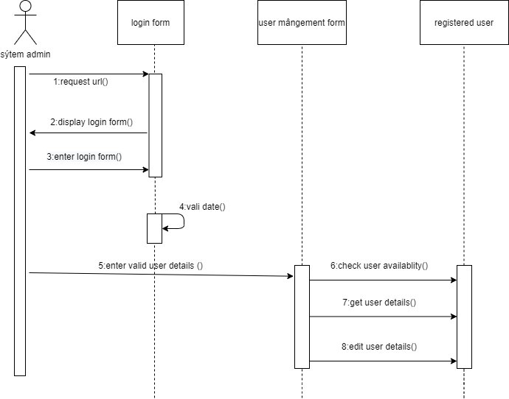

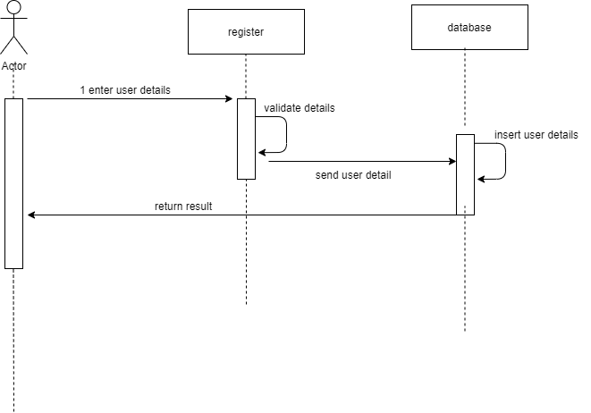

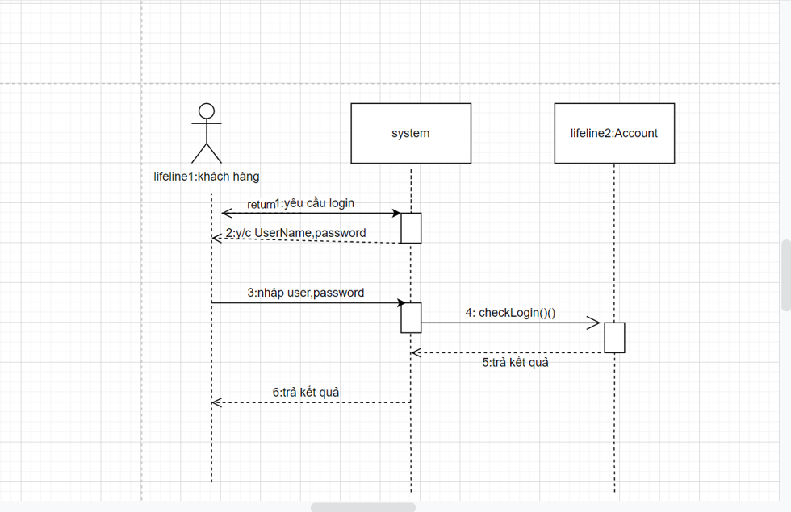

**4.3 Class diagram**

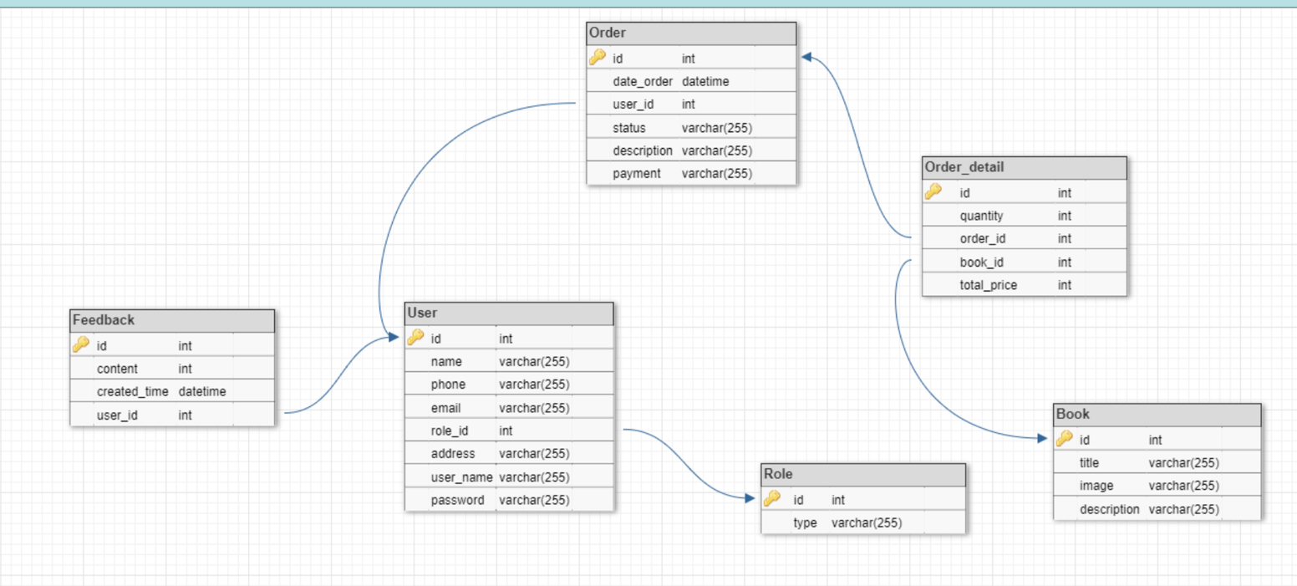

**4.4 Use Case Diagram**

