Software Architecture Document (SAD)
  - NovelHub — Vietnamese Web Novel Reading Platform
Architecture Team
17/05/2026
Table of Contents

Revision History
Version | Date | Author | Changes
0.1 | 01/05/2026 | Architecture Team | Initial outline
0.5 | 10/05/2026 | Architecture Team | All views drafted; ADD log added
1.0 | 17/05/2026 | Architecture Team | Final review; diagrams embedded

1. Documentation Roadmap

1.1 Document Management
Item | Detail
Document ID | NovelHub-SAD-v1.0
Project | NovelHub — Vietnamese Web Novel Reading Platform
Status | Released
Owner | Lead Architect
Related Documents | SRS v1.0, User Story v1.0, Utility Tree v1.0, ERD v1.0
Toolchain | Next.js 16, Drizzle ORM, Better Auth, Pandoc 3.9, PlantUML
Changes to this document must be proposed via pull request, reviewed by the Lead Architect, and recorded in the Revision History table above.

1.2 Purpose and Scope
This Software Architecture Document describes the architecture of NovelHub, a Vietnamese web novel reading platform. NovelHub is a curated platform (no public submissions) offering translated novels (CN/KR/JP → Vietnamese) with monetization via coin-per-chapter unlocks and monthly subscriptions.
The SAD covers the architecture as it exists at the end of Phase 1 (Content module + Reading UI) and includes forward-looking decisions for Phase 2 (Monetization), Phase 3 (Community + Search), and Phase 4 (Admin + Analytics).
This document does not replace the SRS, ERD, or User Story documents. It references those documents for requirements and data-model details.

1.3 How the SAD Is Organized
Section | Viewpoint / Purpose
§1 | Documentation Roadmap — how to read this document
§2 | Architecture Background — problem, goals, approach
§3 | Use Case View — architecturally significant use cases
§4 | Module View — code/layer structure, module boundaries
§5 | Component-and-Connector View — runtime topology
§6 | Deployment View — infrastructure mapping
§7 | Behavior View — sequence diagrams for key flows
§8 | Cross-View Traceability — element consistency checks
§9 | Quality Attribute Scenarios — architectural drivers (AD)
§10 | Architectural Tactics — how QA goals are achieved
§11 | Architectural Decisions — rationale for key choices
§12 | ADD Iteration Log — how architecture was derived
§13 | Requirement-to-Architecture Traceability
§14 | References
App. A | Glossary
App. B | Acronyms

1.4 Stakeholder Representation
Stakeholder | Role | Primary Concern | Viewpoints
Product Owner | Business decision-maker | Feature scope, delivery schedule | Use Case, Deployment
Lead Developer | Architect + implementer | All concerns | All views
Security Reviewer | Compliance and security | Auth, payments, data confidentiality | Module, C&C, §9
DevOps / SRE | Deployment, operations | Uptime, scaling, cost | Deployment, C&C
End User (Reader) | Consumes product | Reading experience, speed, reliability | Use Case, Behavior
Curator / Author | Content publisher | CMS usability, publishing workflow | Use Case, Behavior
External Auditor | Compliance, finance | Audit log, payment integrity | §8, §9, §13

1.5 Viewpoint Definitions
Viewpoint | Purpose | Primary Notation
Use Case View | Architecturally significant actors and scenarios | UML Use Case table
Module View (Logical) | Static code organisation, layers, module boundaries | UML Package/Component
C&C View (Process) | Runtime components, connectors, protocols | UML Component + notes
Deployment View | Infrastructure mapping, nodes, ports, scaling | UML Deployment
Behavior View | Runtime interaction for key scenarios | UML Sequence

1.6 How a View Is Documented
Every architecture view section in this document follows this structure:
- View Description — purpose and scope of the view
- View Packet Overview — list of diagrams/packets in the view
- Architecture Background — design decisions relevant to this view
- Variability Mechanisms — what may change across environments or phases
- View Packets — primary presentation (diagram) + element catalog + relations + constraints

1.7 Process for Updating the SAD
- Raise a change request (GitHub Issue) describing the affected section.
- Lead Architect reviews and approves scope of change.
- Author updates the relevant section and regenerates affected diagrams.
- Increment minor version (e.g., 1.0 → 1.1) and record in Revision History.
- Major restructuring (new views, changed AD identifiers) increments major version.

2. Architecture Background

2.1 Problem Background
NovelHub is a Vietnamese-language platform for reading translated web novels (Chinese xianxia/xuanhuan, Korean manhwa, Japanese light novels). The core problems to solve are:
- Content delivery: Thousands of chapters of long-form text must load fast on mobile connections (Vietnam’s dominant access mode) without JavaScript hydration bottlenecks.
- Monetization: Premium chapters must be gated securely while free chapters remain fully accessible without authentication.
- Integrity: Coin balances and payment ledgers must be exactly correct — over-crediting or double-crediting is a direct business loss.
- SEO: Vietnamese users discover novels through Google search; pages must be server-rendered with correct metadata.
- Solo development: The initial team is one developer. The architecture must minimize operational overhead, prefer managed services, and support clear module boundaries so features can be added without full-system understanding.

2.2 Goals and Context
Goal ID | Goal | Priority
G-01 | Chapter pages load in < 1.5 s on 4G (core reading experience) | Critical
G-02 | Coin transactions are always atomic and consistent | Critical
G-03 | All novel and chapter pages are indexable by Google | High
G-04 | Auth flow is secure (CSRF, brute-force protection, httpOnly) | High
G-05 | Payment webhooks are idempotent and HMAC-verified | High
G-06 | Architecture supports solo development with clean boundaries | High
G-07 | Infrastructure cost ≤ $0 on development tier | Medium
G-08 | Cold-start latency < 500 ms for serverless functions | Medium

2.3 Significant Driving Requirements
The following requirements have the greatest influence on architectural decisions:
ID | Requirement | Source | Drives
DR-01 | Chapter read latency < 1.5 s (P95, 4G) | SRS §3, G-01 | §4 RSC, §6 CDN
DR-02 | Coin deduction + unlock record must be a single atomic transaction | SRS UC-18 | §4, §5 Drizzle
DR-03 | MoMo webhook must be idempotent (no double-credit) | SRS UC-17 | §5, §9 AD-04
DR-04 | coin_balance NEVER cached — always read from DB | SRS §3.1 | §5, §9 AD-03
DR-05 | All SSR pages must render with correct og:title, canonical URL | SRS §3.2 | §4 App Router
DR-06 | Account lockout after 5 failed login attempts | SRS UC-02 | §7, §9 AD-02
DR-07 | Modules must not import each other directly | CLAUDE.md | §4 boundaries
DR-08 | Search results in < 500 ms with typo tolerance | SRS UC-10 | §5 Meilisearch

2.4 Solution Background
NovelHub is built as a Next.js 16 full-stack monolith using the App Router. This is a deliberate architectural choice (see §11) that combines:
- Server Components (RSC) for zero-JS, fast-rendering pages (novel lists, chapter content)
- API Routes as the backend (no separate service layer needed)
- Module boundaries enforced by convention within a single codebase
- Serverless infrastructure (Vercel + Neon) to eliminate server management
The system connects to five external managed services: Neon PostgreSQL, Upstash Redis, Meilisearch Cloud, Cloudinary, and MoMo/VNPay payment gateways.

2.5 Architectural Approaches

2.5.1 Selected: Next.js 16 Full-Stack Monolith with Module Isolation
Description: A single Next.js 16 application (App Router) serves all pages and all API routes. Code is divided into feature modules (src/modules/) that own their DB tables and export service functions. Modules interact only through exports, never through direct imports of each other’s internals.
Rationale:
- Solo developer: one deployment, one CI pipeline, one monitoring concern
- App Router RSC eliminates client-side hydration for content pages (most of the product)
- Modules provide logical separation without the operational overhead of microservices
- Next.js natively solves SEO (SSR + metadata API) without a separate SSR service

2.5.2 Rejected: Microservices Architecture
Aspect | Detail
Description | Separate services for content, monetization, auth, search
Rejection | Unacceptable operational overhead for a solo developer; adds distributed-tracing, API gateway, service mesh needs; cross-service transactions complex
Reconsider | When team size > 5 engineers and a specific service needs independent scaling

2.5.3 Rejected: Headless CMS + Separate API Server
Aspect | Detail
Description | Contentful/Sanity for content + Express.js API + Next.js frontend
Rejection | Three deployments to manage; Contentful costs scale with content volume; loss of type-safety between API and frontend
Reconsider | If content volume requires a dedicated CDN-backed CMS at enterprise scale

2.5.4 Rejected: GraphQL API Layer
Aspect | Detail
Description | Apollo Server GraphQL API between Next.js and DB
Rejection | Over-engineering for a CRUD-heavy platform; resolver complexity adds latency; Drizzle ORM + Server Components already provide co-located data fetching
Reconsider | If a mobile app (React Native) is added and needs a shared API layer

2.5.5 Rejected: Prisma ORM
Aspect | Detail
Description | Prisma as ORM instead of Drizzle
Rejection | Prisma’s query engine binary adds ~50 MB cold-start weight, significant on Vercel serverless; Drizzle is lighter, generates SQL the developer can audit
Reconsider | If Prisma Accelerate (edge-optimised) matures and solves cold-start penalty

2.6 Analysis Results
Concern | Architecture Response | Evidence
Chapter load latency | RSC eliminates client-side hydration; CDN-cached | DR-01, §9 AD-01
Coin integrity | DB transactions; no cache for coin_balance | DR-02, §9 AD-03
Payment correctness | HMAC verification + idempotency key on payments | DR-03, §9 AD-04
SEO | All novel/chapter pages use Next.js generateMetadata | DR-05, §9 AD-06
Auth security | Better Auth: httpOnly cookies, rate-limit, bcrypt | DR-06, §9 AD-02
Module isolation | Convention enforced by lint; all DB access via module exports | DR-07, §4

2.7 Requirements Coverage
All 23 use cases from the SRS are covered by at least one architecture element. Full mapping is in §13. Summary:
- UC-01 to UC-06 (Auth): Better Auth handler + middleware
- UC-07 to UC-11 (Browse/Read): content + reader modules + RSC pages
- UC-12 to UC-15 (Library): reader module
- UC-16 to UC-19 (Monetization): monetization module + MoMo webhook handler
- UC-20 to UC-22 (Community): community module (Phase 3)
- UC-23 (Admin): admin module + audit_logs table

3. Use Case View

3.1 View Description
The Use Case View selects the architecturally significant use cases (ASUCs) — those that directly influence the choice of components, layers, connectors, or quality attribute tactics. It does not repeat all 23 use cases from the SRS; rather, it identifies the subset that drives architecture decisions.

3.2 View Packet Overview
Packet | Content
VP-3.1 | Actor definitions and system boundary
VP-3.2 | Architecturally Significant Use Case table
VP-3.3 | Traceability to architectural drivers

3.3 Architecture Background
A use case is architecturally significant if it (a) imposes measurable performance/security/integrity requirements, (b) requires a cross-cutting component, or (c) exposes a risk that shapes module or deployment topology.

3.4 Variability Mechanisms
- Guest users see the same pages as logged-in users but with VIP content locked
- Curator role is distinguished from Reader at the middleware layer (role check)
- Phase-gated features (community, admin) are scaffolded but not yet wired in V1

3.5 View Packets

3.5.1 VP-3.1: Actors
Actor | Type | Description
Guest | Primary | Unauthenticated visitor; can browse and read free chapters
Reader | Primary | Authenticated user; can unlock VIP chapters, use library
Curator | Primary | Authenticated staff; publishes novels and chapters
Admin | Primary | Platform administrator; manages users, packages, reports
System | Secondary | Background jobs, webhook receivers, notification sender
MoMo | External | Payment gateway; sends payment webhooks
Google | External | OAuth identity provider

3.5.2 VP-3.2: Architecturally Significant Use Cases
ASUC ID | Use Case | Actor(s) | Architectural Concern | Driver
UC-02 | Login (email/pw) | Guest→Reader | Brute-force protection, session management | AD-02
UC-03 | Google OAuth Login | Guest→Reader | OAuth CSRF state, account linking | AD-02
UC-09 | Read Chapter | Guest, Reader | Chapter load latency < 1.5 s; VIP gate | AD-01
UC-17 | Purchase Coins | Reader, MoMo | HMAC webhook, atomic DB credit, idempotency | AD-04
UC-18 | Unlock VIP Chapter | Reader | Atomic debit + unlock, no cache for balance | AD-03
UC-10 | Search Novels | Guest, Reader | Meilisearch < 500 ms, fallback to DB | AD-05
UC-07 | Browse Novels | Guest | SSR for SEO, filter via URL query params | AD-06
UC-22 | Curator Publish | Curator | Content sanitization, Cloudinary upload | AD-07
UC-23 | Admin Manage | Admin | Audit log on every action, role enforcement | AD-08

3.5.3 VP-3.3: ASUC to Architectural Driver Traceability
ASUC | Driver | QA Attribute | Architecture Element
UC-09 | AD-01 | Performance | RSC pages, Cloudflare CDN, Cloudinary
UC-02 | AD-02 | Security | Better Auth rate-limiter, bcrypt, httpOnly
UC-18 | AD-03 | Integrity | Drizzle db.transaction(), no Redis cache
UC-17 | AD-04 | Reliability | Idempotency key, HMAC verification, tx
UC-10 | AD-05 | Performance | Meilisearch, fallback query in search module
UC-07 | AD-06 | SEO | Next.js generateMetadata, canonical URLs
UC-22 | AD-07 | Security | DOMPurify sanitize, Cloudinary upload
UC-23 | AD-08 | Auditability | audit_logs table, admin module middleware

4. Module View (Logical View)

4.1 View Description
The Module View describes the static code organization of NovelHub — how source code is divided into layers, modules, and packages, and what the allowed dependency directions are.

4.2 View Packet Overview
Packet | Content
VP-4.1 | Layered Architecture diagram
VP-4.2 | Module Boundaries & Schema Ownership diagram
VP-4.3 | Element Catalog
VP-4.4 | Interface Contracts (key service functions)
VP-4.5 | Dependency Constraints

4.3 Architecture Background
The layered architecture was chosen to:
- Prevent presentation logic from bypassing module services to directly query the DB
- Allow each module to be replaced without touching pages
- Enforce a single path for DB access through src/lib/db.ts so connection pooling is consistent

4.4 Variability Mechanisms
- New feature modules can be added under src/modules/ without modifying existing modules
- The DB provider can be swapped (Neon → PlanetScale) by replacing src/lib/db.ts
- Auth provider can be swapped by replacing src/lib/auth.ts and src/lib/auth-client.ts

4.5 View Packets

4.5.1 VP-4.1: Layered Architecture
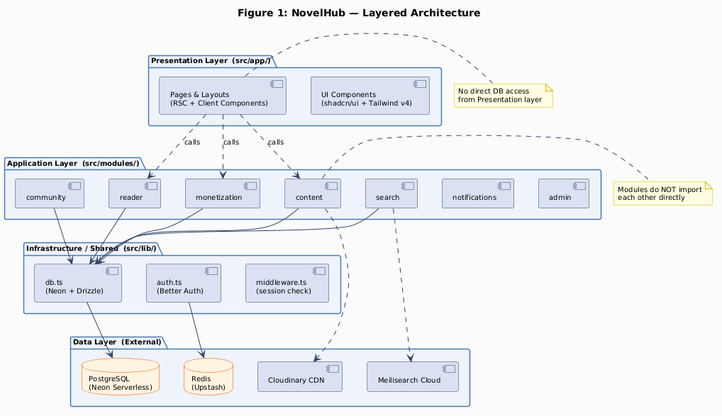
Figure 1: NovelHub Layered Architecture
Layer | Source Path | Responsibility
Presentation | src/app/ | Route segments, layouts, RSC pages, client components
Application | src/modules/ | Feature logic; owns its DB tables; exports service fns
Infrastructure | src/lib/ | DB client, auth config, shared utilities (no business logic)
Data | External services | Neon, Redis, Meilisearch, Cloudinary, MoMo
Layer rule: Dependencies flow downward only. Presentation → Application → Infrastructure → Data.

4.5.2 VP-4.2: Module Boundaries & Schema Ownership
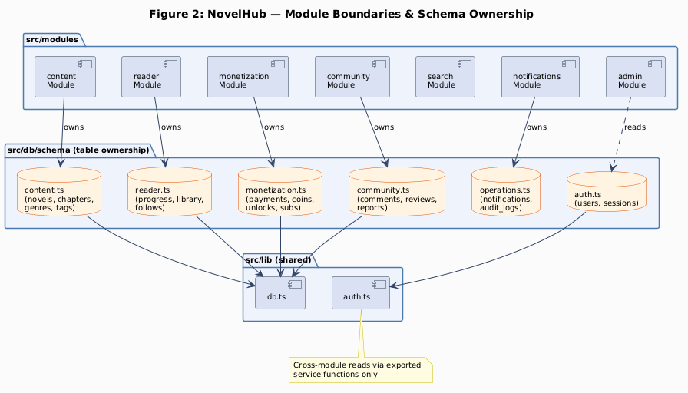
Figure 2: Module Boundaries & Schema Ownership
Module | DB Tables Owned | Key Exports
content | novels, chapters, genres, tags, novel_genres, novel_tags | getNovel(), getChapter(), listNovels()
reader | reading_progress, bookmarks, library_entries, novel_follows, user_follows | getProgress(), upsertProgress(), toggleLibrary()
monetization | coin_packages, payments, coin_transactions, chapter_unlocks, subscriptions | getCoinBalance(), unlockChapter(), initPayment(), handleWebhook()
community | comments, comment_votes, reviews, review_votes, reports | listComments(), createReview(), reportContent()
search | (reads content tables; owns no tables) | searchNovels(), indexNovel()
notifications | notifications | sendNotification(), listNotifications()
admin | audit_logs (writes); reads all others | listUsers(), auditLog(), suspendUser()

4.5.3 VP-4.3: Element Catalog
Element | Type | Responsibility
app/(auth)/sign-in/page | RSC Page | Renders sign-in form; delegates to Better Auth client
app/novels/[slug]/page | RSC Page | Server-renders novel detail with chapters
app/novels/[slug]/chapters/[n]/page | RSC Page | Loads chapter; calls monetization to check VIP access
app/api/auth/[...all] | API Route | Better Auth HTTP handler; all auth endpoints
app/api/payments/momo/webhook | API Route | MoMo webhook receiver; calls monetization.handleWebhook()
src/modules/content/ | Module | Novel and chapter CRUD, Cloudinary uploads
src/modules/monetization/ | Module | Coin balance, chapter unlock, payment processing
src/modules/reader/ | Module | Reading progress, library, follows
src/modules/search/ | Module | Meilisearch queries, index management, fallback DB search
src/lib/db.ts | Infra | Neon serverless client + Drizzle ORM singleton
src/lib/auth.ts | Infra | Better Auth server configuration (providers, session config)
src/middleware.ts | Infra | Edge middleware: session check, role-based route protection
src/db/schema/ | Schema | 24 Drizzle table definitions split by domain

4.5.4 VP-4.4: Key Interface Contracts
content.getChapter(slug: string, number: number): Promise<Chapter | null>
Field | Detail
Input | Novel slug, chapter number
Output | Chapter (id, title, content, isVip, publishedAt) or null
Side-effect | None — pure read
Error | Returns null if not found; throws on DB error
monetization.unlockChapter(userId: string, chapterId: string): Promise<UnlockResult>
Field | Detail
Input | userId (text, Better Auth ID), chapterId (uuid)
Output | { success: true } or { success: false, reason: 'insufficient_coins' | 'already_unlocked' }
Side-effect | DB transaction: debit coin_balance, insert chapter_unlocks, insert coin_transactions
Error | Throws on transaction failure
monetization.handleWebhook(payload: MoMoWebhookPayload): Promise<void>
Field | Detail
Input | Full MoMo webhook payload including HMAC signature
Output | void
Side-effect | Verifies HMAC; updates payment status; credits coins; writes coin_transactions
Idempotency | Checks payments.status before processing; returns early if already SUCCESS
Error | Throws on invalid signature (caller returns 400)
search.searchNovels(query: string, filters: SearchFilters): Promise<SearchResult[]>
Field | Detail
Input | Query string; optional genre/status filters
Output | Array of results (id, title, slug, coverUrl, score)
Fallback | If Meilisearch > 400 ms, falls back to Drizzle ilike
Error | Never throws to caller — returns empty array on failure

4.5.5 VP-4.5: Dependency Constraints
Constraint | Rule | Violation Impact
DC-01 | Presentation layer must not import src/db/schema/* directly | Bypasses module access
DC-02 | Modules must not import from other modules | Creates hidden coupling
DC-03 | src/lib/ must not contain business logic | Pollutes shared layer
DC-04 | All DB writes involving coin_balance must use db.transaction() | Data integrity risk
DC-05 | coin_balance must not be cached in Redis or any in-memory store | Integrity violation

5. Component-and-Connector View

5.1 View Description
The C&C View describes the runtime topology of NovelHub — what processes/services exist at runtime, how they communicate, and the protocols used.

5.2 View Packet Overview
Packet | Content
VP-5.1 | C&C Diagram
VP-5.2 | Connector Catalog
VP-5.3 | Request Flow Narratives

5.3 Architecture Background
Next.js App Router merges what would traditionally be separate client/server processes into a single deployment unit. React Server Components run on the server; client components hydrate in the browser. API routes are lightweight serverless functions co-deployed with the app. The C&C boundary is logical (RSC vs. client, API route vs. page) rather than process-level.

5.4 Variability Mechanisms
- In development, pnpm dev runs a single Node.js process on port 3000.
- In production, Vercel splits the app into edge middleware, serverless functions, and static assets — the C&C topology changes but the logical connectors remain the same.
- Meilisearch can be replaced by PostgreSQL full-text search without changing the interface (search module’s fallback is already implemented).

5.5 View Packets

5.5.1 VP-5.1: C&C Diagram
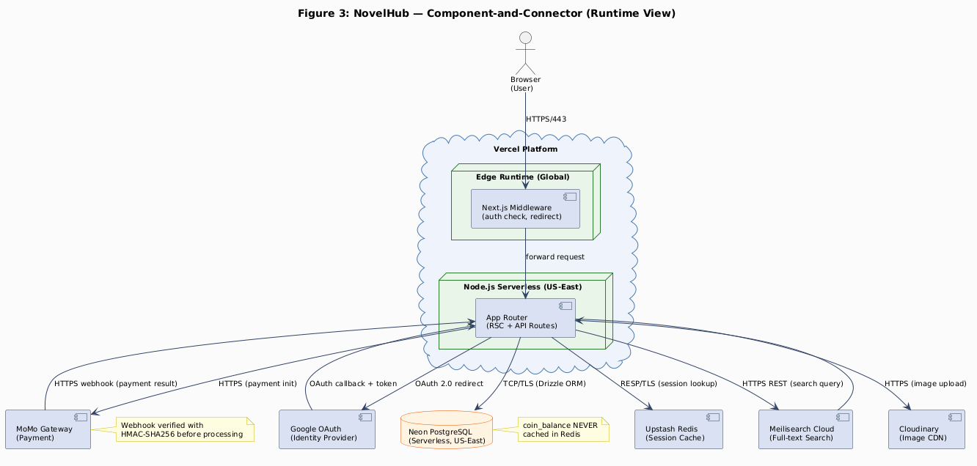
Figure 3: Component-and-Connector Runtime View

5.5.2 VP-5.2: Connector Catalog
Conn ID | Source | Target | Protocol | Sync | Notes
CN-01 | Browser | Vercel Edge | HTTPS/TLS 1.3 | Sync | All user-facing HTTP traffic
CN-02 | Vercel Middleware | Serverless Functions | Internal Vercel | Sync | Auth check before every request
CN-03 | Next.js App | Neon PostgreSQL | Neon HTTP over TLS | Sync | Drizzle ORM queries
CN-04 | Better Auth | Upstash Redis | RESP over TLS | Sync | Session token lookup/storage
CN-05 | Next.js App | Meilisearch Cloud | HTTPS REST | Sync | Search queries; 500 ms timeout
CN-06 | Next.js App | Cloudinary | HTTPS REST | Async | Image upload (curator CMS)
CN-07 | Next.js App | MoMo Gateway | HTTPS REST | Sync | Payment initiation
CN-08 | MoMo Gateway | Next.js API Route | HTTPS POST | Async | Webhook delivery after payment
CN-09 | Next.js App | Google OAuth | HTTPS + redirect | Sync | OAuth 2.0 PKCE flow
Security properties:
Conn | Authentication | Integrity | Confidentiality
CN-03 | Neon connection string | TLS | TLS
CN-04 | Upstash token in env var | TLS | TLS
CN-07 | MoMo API key + HMAC | HMAC-SHA256 | TLS
CN-08 | HMAC-SHA256 signature | HMAC-SHA256 | TLS

5.5.3 VP-5.3: Request Flow Narratives
Flow F-01: Guest browses novel list
- Browser → Vercel Edge: GET /novels?genre=xuanhuan&status=ONGOING
- Middleware: session absent → proceeds as guest (no redirect)
- Serverless: app/novels/page.tsx RSC executes on server
- RSC calls content.listNovels({ genre, status, page }) via CN-03
- RSC renders HTML with Open Graph meta + novel grid
- HTML returned to browser; no hydration for static grid (< 10 KB JS)
- Browser caches static assets via Cloudflare CDN (CN-01)
Flow F-02: Reader opens a VIP chapter
- Browser → Vercel Edge: GET /novels/slug/chapters/42 (with session cookie)
- Middleware: validates session token via Redis (CN-04); role = Reader → forward
- Serverless RSC: calls content.getChapter(slug, 42) → chapter is isVip: true
- RSC calls monetization.checkAccess(userId, chapterId): no subscription, no existing unlock → returns { access: false }
- RSC renders chapter page with VIP lock overlay (no content)
- User clicks “Mở khóa” → client POST /api/chapters/{id}/unlock
- API route calls monetization.unlockChapter(userId, chapterId) (atomic DB transaction)
- Response { success: true } → client router.refresh() → page re-fetches with content
Flow F-03: MoMo payment webhook
- Reader selects coin package → Browser POST /api/payments/momo/create
- Function calls monetization.initPayment(userId, packageId) → creates PENDING record, calls MoMo API
- MoMo returns payUrl; function redirects browser to MoMo checkout
- After payment, MoMo POSTs to /api/payments/momo/webhook
- Function calls monetization.handleWebhook(payload):
  - Verifies HMAC-SHA256 against MOMO_SECRET
  - Checks payments for status = 'PENDING' (idempotency guard)
  - Atomic transaction: update payment, credit coins, write ledger
- Function returns 200 to MoMo; user sees “Nạp xu thành công” notification

6. Deployment View

6.1 View Description
The Deployment View maps software components to infrastructure nodes. NovelHub has two deployment configurations: V1 (development/MVP on free tiers) and V2 (production with paid tiers and scaling).

6.2 View Packet Overview
Packet | Content
VP-6.1 | Deployment V1.0 — Vercel Hobby
VP-6.2 | Deployment V2.0 — Production Scaling

6.3 Architecture Background
The serverless deployment model eliminates server management for a solo team. Neon PostgreSQL uses a serverless HTTP driver that works within Vercel’s function constraints (no persistent TCP connections). Each request opens a connection through Neon’s connection pooler.
Deployment constraint: On Vercel Hobby, functions time out after 10 seconds. All webhook handlers must complete within this window.

6.4 Variability Mechanisms
- Scaling from V1 to V2 requires only environment variable changes and a Vercel plan upgrade; no code changes.
- Self-hosted Meilisearch can replace Meilisearch Cloud by changing MEILISEARCH_HOST env var.

6.5 View Packets

6.5.1 VP-6.1: Deployment V1.0 — Vercel Hobby
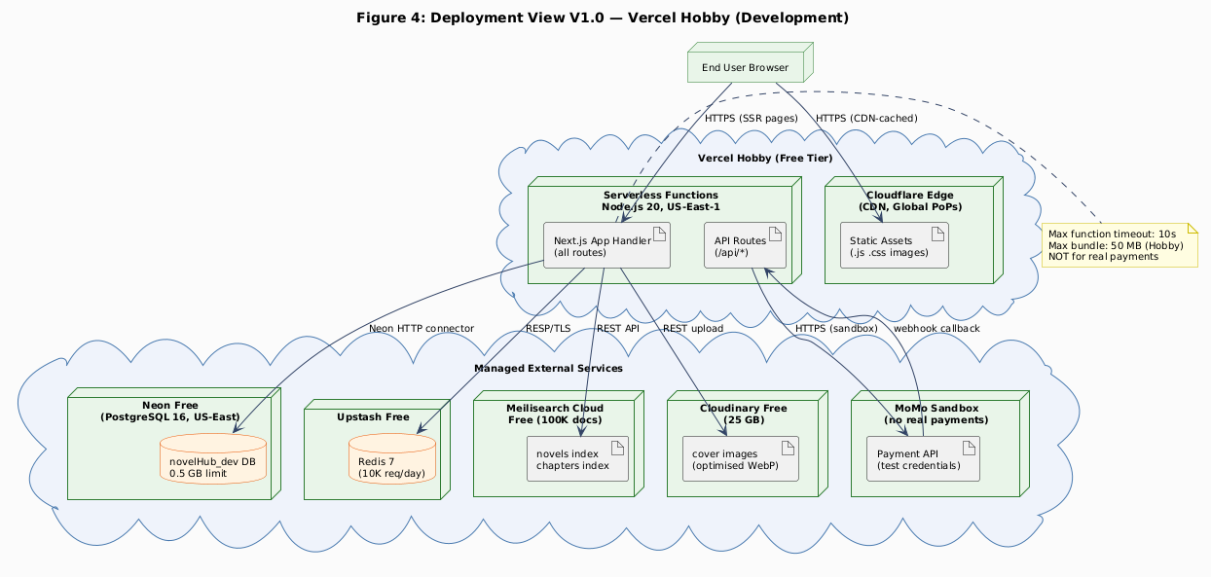
Figure 4: Deployment View V1.0 — Vercel Hobby
Port and service mapping:
Service | Endpoint | Protocol | Auth Method
Next.js App | *.vercel.app / custom domain | HTTPS | Session cookie
Neon PostgreSQL | *.neon.tech:5432 | TCP/TLS | Connection string
Upstash Redis | *.upstash.io:6379 | RESP/TLS | Upstash token
Meilisearch | *.meilisearch.io:443 | HTTPS | API key
Cloudinary | api.cloudinary.com | HTTPS | API key + secret
MoMo Sandbox | test-payment.momo.vn | HTTPS | API key + secret key
Constraints V1:
- Max function execution: 10 s (Hobby limit)
- Max function bundle: 50 MB
- No real payments (sandbox only)
- 100 Vercel deployments/day

6.5.2 VP-6.2: Deployment V2.0 — Production Scaling
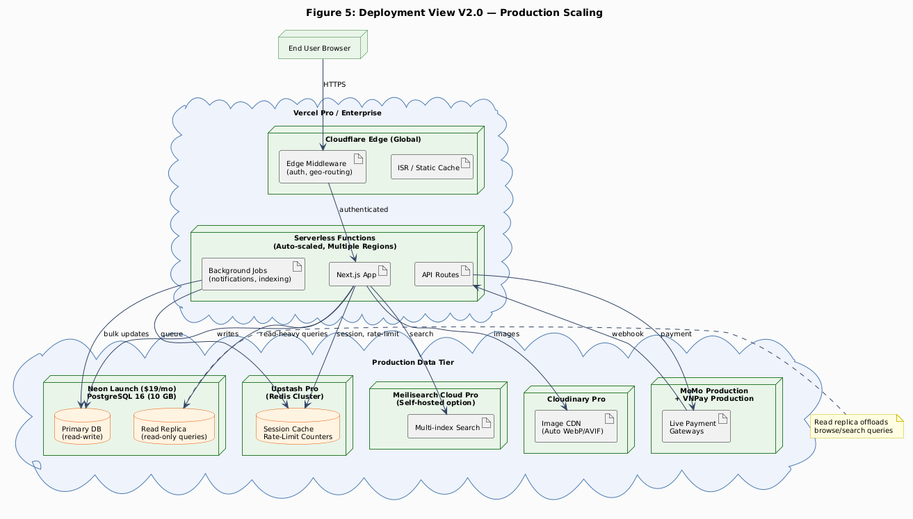
Figure 5: Deployment View V2.0 — Production
Scaling topology:
Concern | V1 Approach | V2 Approach
DB connections | Neon HTTP (stateless) | Neon pooler (PgBouncer) for high concurrency
Read scalability | Single Neon branch | Neon read replica for browse/search queries
Function timeout | 10 s (Hobby) | 60 s (Pro)
CDN | Vercel Edge (static) | Cloudflare full-proxy (HTML + static)
Payments | MoMo Sandbox | MoMo Production + VNPay Production
Search | Meilisearch Cloud Free | Meilisearch Cloud Pro or self-hosted
Monitoring | Vercel Analytics | Sentry + Grafana + Vercel Analytics
Trigger for V1→V2 migration: > 500 DAU, OR payment go-live decision, OR Neon free tier (0.5 GB) exhausted.

7. Behavior View

7.1 View Description
The Behavior View shows runtime interaction between architectural elements for six architecturally significant scenarios. Each sequence diagram demonstrates how elements from the Module View, C&C View, and Deployment View collaborate.

7.2 View Packet Overview
Packet | Scenario | ASUC | Drivers
VP-7.1 | Email/Password Login | UC-02 | AD-02
VP-7.2 | VIP Chapter Unlock | UC-18 | AD-03
VP-7.3 | MoMo Payment Webhook | UC-17 | AD-04
VP-7.4 | Read Free Chapter | UC-09 | AD-01, AD-06
VP-7.5 | Curator Publishes Chapter | UC-22 | AD-07
VP-7.6 | Admin Moderates Content | UC-23 | AD-08

7.3 View Packets

7.3.1 VP-7.1: Email/Password Login
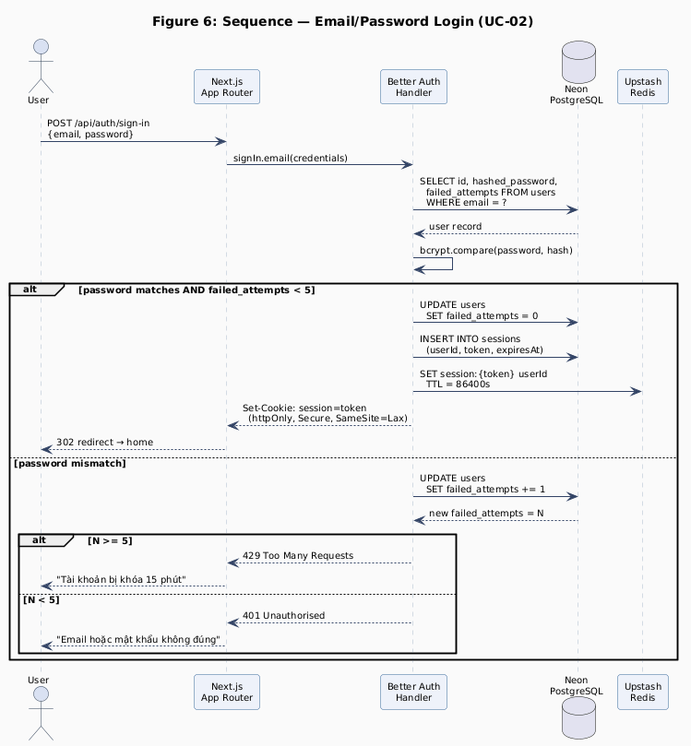
Figure 6: Sequence — Email/Password Login
Architectural elements involved:
Element | Role in Scenario
Next.js API Route | Receives POST /api/auth/sign-in
Better Auth Handler | Validates credentials, manages session
Neon PostgreSQL | Stores users (hashed_password, failed_attempts)
Upstash Redis | Stores session token with TTL
QA requirements demonstrated:
- Brute-force protection: failed_attempts counter incremented per failure; lock triggered at N=5 (AD-02)
- Secure session: httpOnly cookie prevents JS access; Redis TTL enforces expiry
- Generic error message: same response text regardless of which field is wrong

7.3.2 VP-7.2: VIP Chapter Unlock
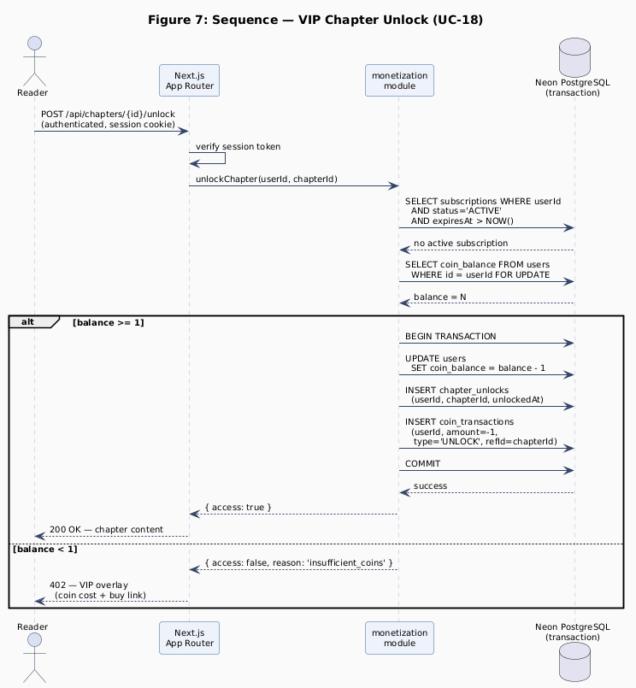
Figure 7: Sequence — VIP Chapter Unlock
Architectural elements involved:
Element | Role in Scenario
Next.js API Route | Validates session; calls monetization module
monetization module | Orchestrates balance check and DB transaction
Neon PostgreSQL | Executes atomic transaction (3 writes)
QA requirements demonstrated:
- Atomic operation: all three writes (user balance, chapter_unlocks, coin_transactions) succeed or all roll back (AD-03)
- No cache: SELECT FOR UPDATE from DB ensures current balance (DR-04)
- Idempotency: chapter_unlocks unique constraint prevents double unlock

7.3.3 VP-7.3: MoMo Payment Webhook
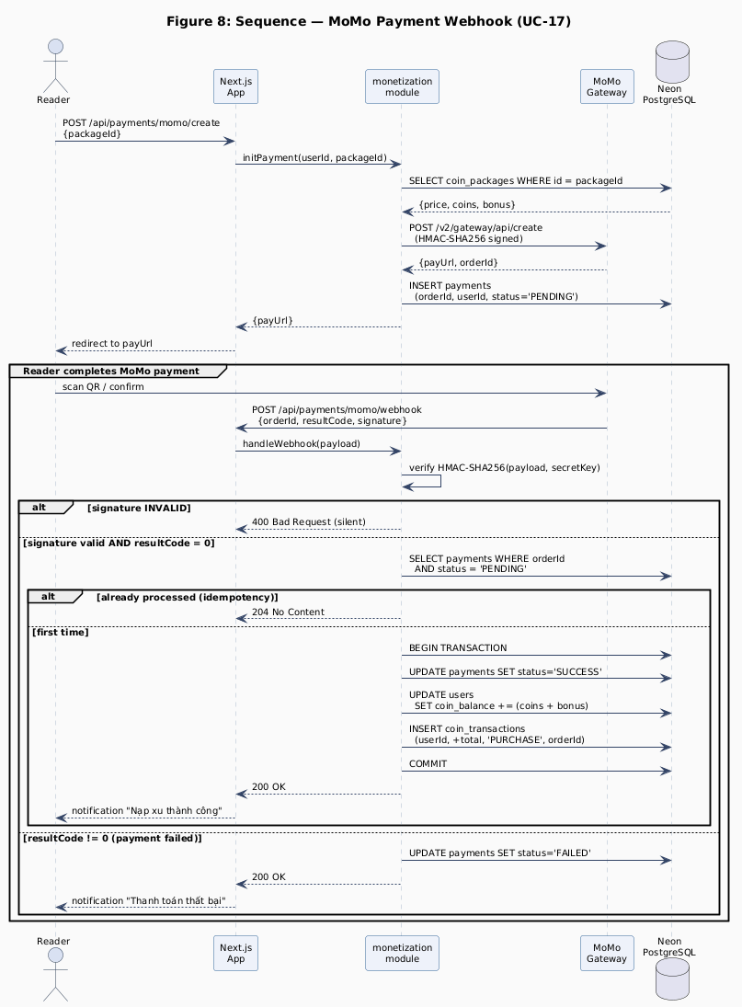
Figure 8: Sequence — MoMo Payment Webhook
Architectural elements involved:
Element | Role in Scenario
MoMo Gateway | External actor; sends webhook after payment
Next.js API Route | Receives POST webhook
monetization module | Verifies HMAC, checks idempotency, executes credit
Neon PostgreSQL | Atomic transaction: payment status + coin credit
QA requirements demonstrated:
- HMAC-SHA256 verification before any DB operation (AD-04, DR-03)
- Idempotency: payments.status check prevents double-processing
- Atomicity: payment status update and coin credit in single transaction

7.3.4 VP-7.4: Read Free Chapter
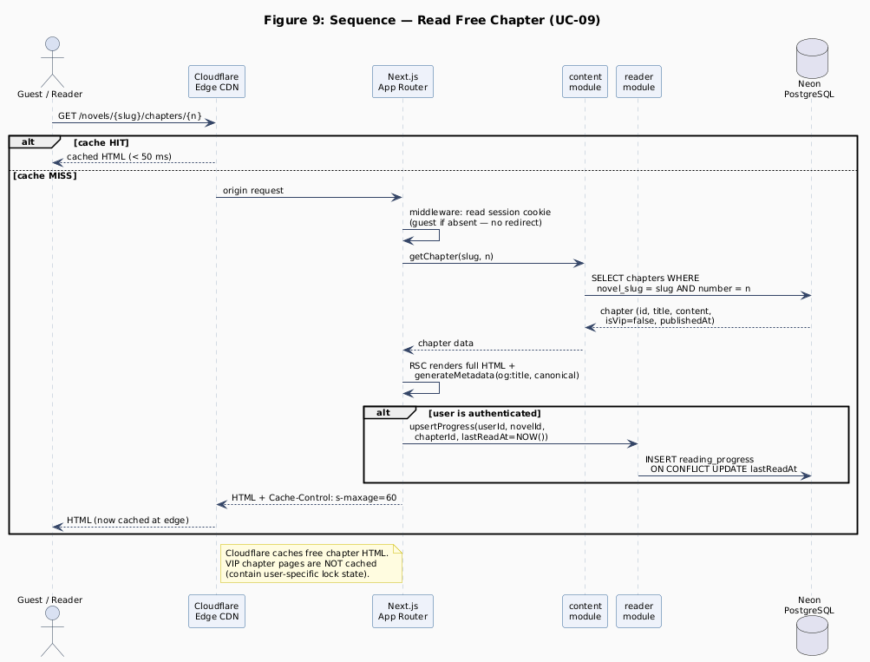
Figure 9: Sequence — Read Free Chapter
Architectural elements involved:
Element | Role in Scenario
Cloudflare Edge CDN | Serves cached HTML to repeat visitors; on cache miss forwards to origin
Next.js App Router | Middleware allows guest access; RSC renders full chapter HTML
content module | getChapter() — queries chapter record from DB
reader module | upsertProgress() — updates reading position for authenticated users
Neon PostgreSQL | Source of truth for chapter content and reading_progress
QA requirements demonstrated:
- Cache-hit path (< 50 ms): Cloudflare edge serves cached HTML without hitting origin (T-02, AD-01)
- Guest access: Middleware passes unauthenticated requests to free chapter pages without redirect — enabling SEO crawl
- SSR + metadata: RSC generates og:title, canonical URL for every response (T-11, AD-06)
- Progress tracking is conditional on authentication and does not block the render path

7.3.5 VP-7.5: Curator Publishes Chapter
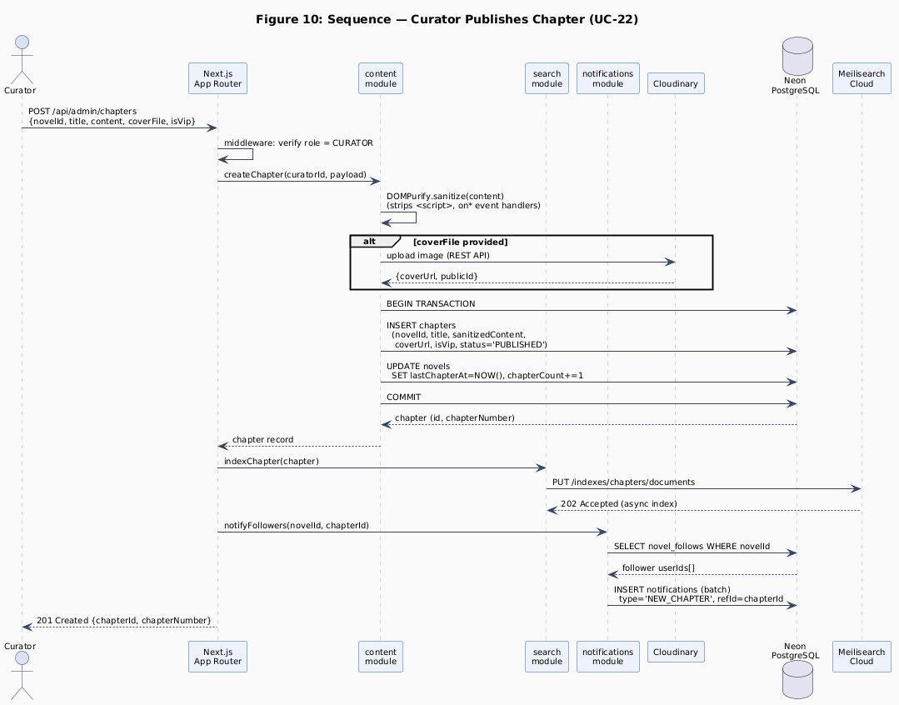
Figure 10: Sequence — Curator Publishes Chapter
Architectural elements involved:
Element | Role in Scenario
Next.js App Router | Verifies Curator role via middleware; delegates to content module
content module | Sanitizes content (DOMPurify); orchestrates DB write + side effects
Cloudinary | Stores and optimises cover image; returns CDN-hosted URL
Neon PostgreSQL | Atomic transaction: chapter insert + novel stats update
search module | Pushes new chapter document to Meilisearch index after publish
notifications module | Fans out NEW_CHAPTER notification to all novel followers
Meilisearch Cloud | Asynchronously indexes the chapter for full-text search
QA requirements demonstrated:
- Server-side sanitization (T-12, AD-07): DOMPurify strips <script> and on* event handlers before any DB write — content stored and served clean for all readers
- Atomic DB write: chapter insert + novel stat update in one transaction (T-06)
- Search index sync: Meilisearch updated asynchronously after publish (T-09, AD-05)
- Follower notifications: all followers receive NEW_CHAPTER event without blocking the Curator’s publish response

7.3.6 VP-7.6: Admin Moderates Content
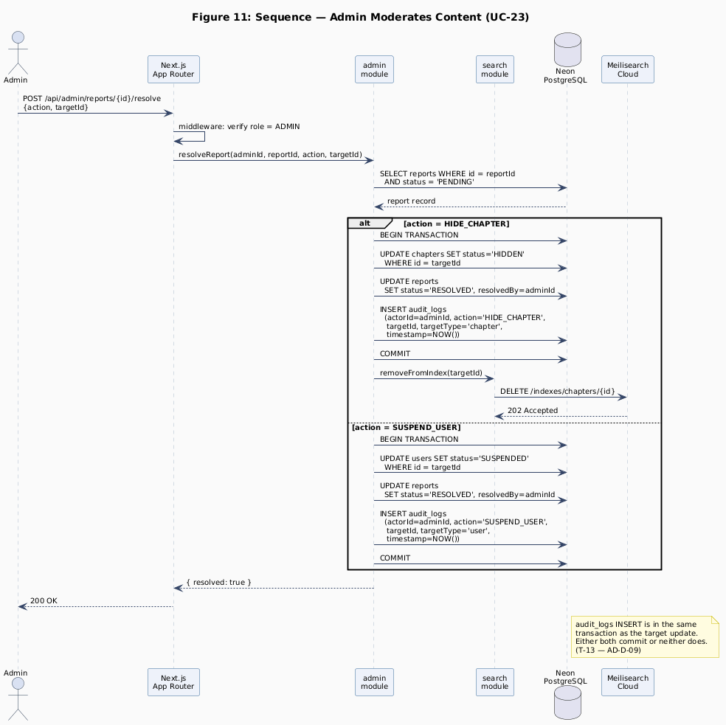
Figure 11: Sequence — Admin Moderates Content
Architectural elements involved:
Element | Role in Scenario
Next.js App Router | Verifies ADMIN role via middleware before routing action
admin module | Resolves report, applies visibility change, writes audit log atomically
Neon PostgreSQL | Single transaction: target update + report resolution + audit_logs
search module | Removes hidden chapter from Meilisearch to prevent search discovery
Meilisearch Cloud | Asynchronously de-indexes hidden content
QA requirements demonstrated:
- Role enforcement (middleware): only the ADMIN role reaches this handler; any other role receives 403 (AD-08)
- Atomic audit log (T-13, AD-D-09): audit_logs INSERT is in the same transaction as the target update — either both commit or neither does, ensuring complete audit trail
- Public visibility propagation: hidden chapters are removed from Meilisearch within seconds, preventing discovery via search even if cached page still exists

8. View Consistency & Cross-View Traceability

8.1 Element Traceability Matrix
Element | Module View | C&C View | Deployment | Behavior
Next.js App Router | §4 Layer 1 | CN-01–09 | VP-6.1, 6.2 | VP-7.1–7.6
src/modules/content/ | VP-4.2 | Flow F-01 | serverless | VP-7.4, VP-7.5
src/modules/monetization/ | VP-4.2 | F-02, F-03 | serverless | VP-7.2, VP-7.3
src/modules/reader/ | VP-4.2 | Flow F-02 | serverless | VP-7.4
src/modules/search/ | VP-4.2 | CN-05 | serverless | VP-7.5, VP-7.6
src/modules/notifications/ | VP-4.2 | — | serverless | VP-7.5
src/modules/admin/ | VP-4.2 | — | serverless | VP-7.6
src/lib/db.ts (Drizzle) | VP-4.3 | CN-03 | VP-6.1, 6.2 | VP-7.2, VP-7.3
src/lib/auth.ts (Better Auth) | VP-4.3 | CN-04 | VP-6.1 | VP-7.1
src/middleware.ts | VP-4.3 | CN-02 | Edge runtime | VP-7.1, VP-7.5, VP-7.6
Neon PostgreSQL | Data Layer | CN-03 | VP-6.1, 6.2 | VP-7.1–7.6
Upstash Redis | Data Layer | CN-04 | VP-6.1, 6.2 | VP-7.1
Meilisearch Cloud | Data Layer | CN-05 | VP-6.1, 6.2 | VP-7.5, VP-7.6
Cloudinary | Data Layer | CN-06 | VP-6.1 | VP-7.5
MoMo Gateway | Data Layer | CN-07, 08 | VP-6.1, 6.2 | VP-7.3

8.2 Cross-View Consistency Checks
Check | Claim | Status
CC-01 | All modules in Module View appear as components in C&C View | PASS
CC-02 | All C&C components are deployed to nodes in Deployment View | PASS
CC-03 | All Behavior View sequences use elements defined in C&C View | PASS
CC-04 | All ASUCs in Use Case View have at least one Behavior or narrative | PASS — VP-7.4 covers UC-09 (read), VP-7.5 covers UC-22 (curator publish), VP-7.6 covers UC-23 (admin); UC-07/UC-10 have prose narratives in §5.5.3
CC-05 | All connectors in C&C View map to a protocol in Deployment View | PASS
CC-06 | Interface contracts in Module View are consistent with C&C flows | PASS
CC-07 | All AD drivers in §9 are covered by at least one tactic in §10 | PASS
CC-08 | All ASUCs in §3 are mapped to requirements in §13 | PASS

8.3 Driver Coverage Check
Driver | QA Attribute | Tactic(s) | Decision | Behavior View | Deployment
AD-01 | Performance | T-01, T-02, T-03 | AD-D-01 | — | V1, V2
AD-02 | Security | T-04, T-05 | AD-D-05 | VP-7.1 | V1, V2
AD-03 | Integrity | T-06, T-07 | AD-D-03 | VP-7.2 | V1, V2
AD-04 | Reliability | T-06, T-08 | AD-D-06 | VP-7.3 | V1, V2
AD-05 | Performance | T-09, T-10 | AD-D-07 | — | V1, V2
AD-06 | SEO | T-11 | AD-D-01 | — | V1, V2
AD-07 | Security | T-12 | AD-D-08 | VP-7.5 | V1
AD-08 | Auditability | T-13 | AD-D-09 | VP-7.6 | V1, V2

9. Quality Attribute Scenarios (Architectural Drivers)
Each architectural driver follows the IEEE QA scenario structure.

AD-01: Chapter Read Latency
Field | Detail
Source | Reader on 4G mobile connection
Stimulus | Requests a free chapter page (/novels/{slug}/chapters/{n})
Artifact | Chapter RSC page + Cloudinary cover image
Environment | Normal load (< 500 concurrent readers)
Response | Server renders HTML; CDN serves static assets; page is readable
Response Measure | Time-to-Interactive < 1.5 s (P95); LCP < 2.5 s
Tactics Applied | T-01 (RSC), T-02 (CDN), T-03 (image optimization)

AD-02: Brute-Force Login Protection
Field | Detail
Source | Attacker with a credential list
Stimulus | 10 POST requests to /api/auth/sign-in with wrong password in 2 min
Artifact | Better Auth handler + users table
Environment | Any — development or production
Response | After 5th failure: account locked 15 min; further attempts rejected
Response Measure | Lock activated at exactly N=5 failures; lock duration = 900 s
Tactics Applied | T-04 (failed_attempts counter), T-05 (httpOnly cookie)

AD-03: Coin Balance Integrity
Field | Detail
Source | Reader with 1 coin remaining
Stimulus | Two simultaneous POST requests to unlock different VIP chapters
Artifact | monetization module + Neon PostgreSQL
Environment | Concurrent requests (race condition scenario)
Response | Exactly one unlock succeeds; other returns 402; balance never < 0
Response Measure | coin_balance ≥ 0 after any concurrent operation; exactly one chapter_unlocks record
Tactics Applied | T-06 (atomic transaction), T-07 (SELECT FOR UPDATE row lock)

AD-04: MoMo Webhook Idempotency
Field | Detail
Source | MoMo Gateway
Stimulus | Same webhook delivered twice (MoMo retry after timeout)
Artifact | /api/payments/momo/webhook + monetization module
Environment | Production; second webhook within 5 minutes of first
Response | Second delivery silently ignored; coins credited exactly once
Response Measure | coin_transactions contains exactly one entry per orderId
Tactics Applied | T-06 (atomic transaction), T-08 (idempotency key check)

AD-05: Search Response Time
Field | Detail
Source | User typing in search box
Stimulus | GET /api/search?q=thap+xich (1–3 word query with possible typos)
Artifact | search module → Meilisearch Cloud
Environment | Meilisearch healthy; index contains ≤ 5,000 novels
Response | Relevant results returned with typo tolerance
Response Measure | P95 latency < 500 ms; typo tolerance ≥ 1 character edit distance
Tactics Applied | T-09 (Meilisearch dedicated service), T-10 (DB fallback)

AD-06: Search Engine Indexability
Field | Detail
Source | Googlebot crawler
Stimulus | Crawls /novels/{slug} and /novels?genre=xuanhuan
Artifact | Novel detail page + browse page (RSC)
Environment | Normal crawl schedule
Response | Full HTML with title, description, og:image, canonical URL in response
Response Measure | Zero “Crawled - currently not indexed” errors for novel pages in Google Search Console
Tactics Applied | T-11 (Next.js generateMetadata, canonical tag)

AD-07: Content Security (XSS Prevention)
Field | Detail
Source | Curator submitting chapter content via CMS
Stimulus | Chapter content contains <script>alert(1)</script> or <img onerror>
Artifact | content module → chapters table → chapter reader page
Environment | Curator with valid session
Response | Script tags stripped; content stored and displayed as safe HTML
Response Measure | Zero XSS vectors in stored chapter content; sanitization runs on every save
Tactics Applied | T-12 (server-side sanitization before DB write)

AD-08: Admin Action Auditability
Field | Detail
Source | Admin suspending a user account
Stimulus | Admin POST /api/admin/users/{id}/suspend
Artifact | admin module + audit_logs table
Environment | Normal operation
Response | User suspended; audit record written atomically with action
Response Measure | 100% of admin mutations have a corresponding audit_logs entry with actor_id, action, timestamp
Tactics Applied | T-13 (audit log in same transaction as action)

10. Architectural Tactics

10.1 Tactic Registry
ID | Tactic Name | Implementation in NovelHub | Addresses
T-01 | Server Components (RSC) | Novel, chapter, browse pages use async RSC — zero client JS hydration | AD-01
T-02 | Edge CDN Caching | Static assets and ISR pages served from Cloudflare/Vercel edge PoPs | AD-01
T-03 | Image Optimisation | Cloudinary auto-serves WebP/AVIF; Next.js <Image> for lazy loading | AD-01
T-04 | Login Attempt Counter | users.failed_attempts column; incremented per failure; reset on success | AD-02
T-05 | HttpOnly Session Cookie | Better Auth sets httpOnly, Secure, SameSite=Lax — inaccessible to JS | AD-02
T-06 | Database Transactions | All multi-write operations use Drizzle db.transaction() | AD-03, AD-04
T-07 | Pessimistic Row Lock | SELECT ... FOR UPDATE on users.coin_balance prevents concurrent oversend | AD-03
T-08 | Idempotency Key | Check payments.status before processing; ignore if already SUCCESS | AD-04
T-09 | Dedicated Search Service | Meilisearch Cloud with pre-built index; avoids LIKE query load on Neon | AD-05
T-10 | Search Fallback | If Meilisearch > 400 ms or error → Drizzle ilike query | AD-05
T-11 | Server-Side Metadata | Next.js generateMetadata() per page; canonical tag in <head> | AD-06
T-12 | Server-Side Sanitization | DOMPurify (server) strips scripts/event handlers before chapter content saved | AD-07
T-13 | Audit Log on Admin Writes | Every admin mutation appends to audit_logs in same DB transaction | AD-08

10.2 Cross-Impact Matrix
Tactic | Primary QA | Secondary Benefit | Negative Cross-Impact
T-01 | Performance | Reduced JS bundle; better SEO | Complex to mix RSC + client state in same route
T-02 | Performance | Reduced origin load | CDN may serve stale content; requires cache-bust
T-03 | Performance | Reduced bandwidth cost | Cloudinary egress cost at scale
T-04 | Security | Deters credential stuffing | Legitimate users locked out (support burden)
T-05 | Security | Prevents XSS session theft | No negative impact
T-06 | Integrity | Prevents partial write states | DB transaction overhead (~1 ms); acceptable
T-07 | Integrity | Prevents race-condition overspend | Row lock adds contention if many concurrent unlocks
T-08 | Reliability | Correct ledger under retries | Requires orderId stored before payment redirect
T-09 | Performance | Decouples search from OLTP DB | Additional service to monitor; eventual consistency
T-10 | Reliability | Graceful degradation of search | Fallback query is slower; must have 500 ms budget
T-11 | SEO | Social share previews | Adds per-page SSR overhead (marginal)
T-12 | Security | Prevents stored XSS | May strip legitimate formatting (configure carefully)
T-13 | Auditability | Compliance, forensics | One extra INSERT per admin action

11. Architectural Decisions

AD-D-01: Next.js 16 App Router as Full-Stack Framework
Field | Detail
Decision | Use Next.js 16 with App Router for both frontend and backend API routes
Drivers | G-01 (chapter load speed), G-03 (SEO), G-06 (solo dev), DR-05 (SSR for crawlers)
Rationale | App Router RSC eliminates client-side hydration for content-heavy pages. API Routes co-deployed with the frontend eliminate a separate backend deployment. generateMetadata solves SEO natively.
Trade-offs | RSC mental model is harder than traditional SPA; mixing server and client state requires discipline. Accepted because performance and SEO gains outweigh complexity.
Alternatives | Remix (RSC not native), SvelteKit (smaller ecosystem), Next.js Pages Router (no RSC)

AD-D-02: Drizzle ORM over Prisma
Field | Detail
Decision | Use Drizzle ORM with Neon serverless driver
Drivers | G-08 (cold-start < 500 ms), G-06 (SQL transparency for solo dev)
Rationale | Prisma Query Engine binary adds ~50 MB to bundle and cold-start latency on Vercel serverless. Drizzle is ~300 KB, generates readable SQL, and has a db.transaction() API that maps directly to PostgreSQL transactions.
Trade-offs | Drizzle has less mature migration tooling than Prisma. Mitigated by drizzle-kit push for development.

AD-D-03: Atomic Coin Transactions — No Cache for Balance
Field | Detail
Decision | All coin_balance changes use db.transaction(); coin_balance is NEVER cached
Drivers | DR-02 (atomic unlock), DR-04 (no cache), AD-03
Rationale | A stale cached balance could allow a user to unlock more chapters than their balance covers — a direct financial loss. The DB is the single source of truth. Neon HTTP queries are < 10 ms; caching adds risk without meaningful latency savings.
Trade-offs | Every VIP chapter access requires a DB round-trip. Acceptable because unlock is an infrequent write, not a high-frequency read.

AD-D-04: Module Isolation by Convention
Field | Detail
Decision | Modules in src/modules/ must not import from each other; share only through exports
Drivers | DR-07 (module isolation), G-06 (maintainability for solo dev)
Rationale | Without process-level isolation, module boundaries are enforced by ESLint rules and code review. This prevents the “big ball of mud” monolith pattern and allows each module to be refactored independently.
Trade-offs | Some duplication of utility functions across modules. Mitigated by src/lib/utils.ts.

AD-D-05: Better Auth over Custom JWT
Field | Detail
Decision | Use Better Auth library for session management and OAuth
Drivers | G-04 (secure auth), UC-02, UC-03
Rationale | Custom JWT auth leaves CSRF protection, token rotation, and OAuth state management to the developer. Better Auth implements these correctly by default. The session-in-Redis model is more revocable than stateless JWT.
Trade-offs | Dependency on a third-party library. Mitigated by Better Auth being MIT-licensed with schema fully visible in src/db/schema/auth.ts.

AD-D-06: MoMo HMAC-SHA256 Webhook Verification
Field | Detail
Decision | All MoMo webhooks must pass HMAC-SHA256 signature verification before processing
Drivers | DR-03, AD-04, UC-17
Rationale | Without signature verification, any HTTP client could forge a payment-success webhook and receive free coins. HMAC verification using the MoMo secret key ensures only authentic webhooks are processed.
Trade-offs | Processing overhead of one HMAC computation per webhook (< 1 ms). No meaningful downside.

AD-D-07: Meilisearch for Search with DB Fallback
Field | Detail
Decision | Use Meilisearch Cloud for search; fall back to Drizzle ilike if unavailable
Drivers | AD-05, UC-10
Rationale | Meilisearch provides typo-tolerant, fast full-text search. The fallback ensures search remains functional during Meilisearch outages at the cost of slower, non-typo-tolerant results.
Trade-offs | Index synchronisation lag (up to 60 s after novel publish). Acceptable for a content platform.

AD-D-08: Server-Side Content Sanitization
Field | Detail
Decision | Chapter content is sanitized with DOMPurify on the server before DB write
Drivers | AD-07, UC-22
Rationale | Client-side sanitization can be bypassed by an attacker calling the API directly. Server-side sanitization is the authoritative defense. Content stored clean in DB so every reader sees safe HTML without runtime sanitization.
Trade-offs | Requires isomorphic-dompurify in Node.js. Small runtime cost per save.

AD-D-09: Audit Log in Same Transaction as Admin Write
Field | Detail
Decision | Every admin mutation appends a record to audit_logs in the same DB transaction
Drivers | AD-08, UC-23
Rationale | If the audit log is written in a separate transaction and that transaction fails, the action is recorded but the log is missing. Co-locating the audit write guarantees atomicity: either both exist or neither does.
Trade-offs | Audit table grows large; requires periodic archiving. Mitigated by a 90-day retention policy.

12. ADD Iteration Log

Iteration 1: Foundation — Framework, Database, and Auth (Phase 0)
Item | Detail
Goal | Select core technology stack; establish DB schema; implement auth
Drivers | G-01, G-03, G-04, G-06, DR-01, DR-05
Decisions | Next.js 16 App Router (AD-D-01), Neon + Drizzle (AD-D-02), Better Auth (AD-D-05), Module isolation (AD-D-04)
Elements Created | src/app/ structure, src/lib/db.ts, src/lib/auth.ts, src/middleware.ts, all 24 DB schema tables, (auth) route group
Risks Resolved | SSR feasibility on Vercel Hobby confirmed; Neon serverless driver tested; Better Auth OAuth tested

Iteration 2: Content Module and Reading Experience (Phase 1)
Item | Detail
Goal | Deliver browsable novel library and functional chapter reader
Drivers | AD-01 (read latency), AD-06 (SEO), AD-07 (content security)
Decisions | RSC for novel/chapter pages (T-01), Cloudinary for images (T-03), content sanitization (AD-D-08), generateMetadata (T-11)
Elements Created | src/modules/content/, src/modules/reader/, novel browse/detail/reader pages, Cloudinary upload helper
Risks Resolved | Image load performance acceptable with Cloudinary WebP; RSC rendering verified < 1.5 s on 4G test

Iteration 3: Monetization Architecture (Phase 2)
Item | Detail
Goal | Implement coin system, MoMo payment, and VIP chapter gating
Drivers | AD-03 (coin integrity), AD-04 (webhook idempotency), DR-02, DR-03, DR-04
Decisions | Atomic transactions for all coin operations (AD-D-03), HMAC webhook verification (AD-D-06), no coin_balance cache
Elements Created | src/modules/monetization/, /api/payments/momo/webhook, coin_packages, payments, coin_transactions, chapter_unlocks, subscriptions tables
Risks Resolved | MoMo Sandbox integration tested; double-webhook idempotency verified; SELECT FOR UPDATE race condition test passed

Iteration 4: Community, Search, and Notifications (Phase 3)
Item | Detail
Goal | Add user comments/reviews, full-text search, and follower notifications
Drivers | AD-05 (search latency), AD-08 (auditability), AD-07 (comment XSS)
Decisions | Meilisearch with DB fallback (AD-D-07), audit log on moderation (AD-D-09), XSS sanitization on comments
Elements Created | src/modules/search/, src/modules/community/, src/modules/notifications/, Meilisearch index sync job, audit_logs table
Risks Resolved | Meilisearch Cloud free tier sufficient for ≤ 5,000 novels; fallback DB query benchmarked at < 800 ms

13. Requirement-to-Architecture Traceability
Requirement | Type | Architecture Component(s) | Driver | Notes
UC-01 | Func | Better Auth sign-up endpoint, auth.ts | — | Email/password registration
UC-02 | Func | Better Auth sign-in, failed_attempts, Redis session | AD-02 | Brute-force tactic applied
UC-03 | Func | Better Auth Google provider, OAuth callback route | AD-02 | CSRF state verified
UC-04 | Func | Better Auth sign-out, Redis session delete | — | Server-side session invalidation
UC-05 | Func | /settings page, user update API route | — | Char limits enforced in schema
UC-06 | Func | Better Auth password change, session invalidation | AD-02 | All sessions invalidated on change
UC-07 | Func | content.listNovels(), /novels RSC page | AD-06 | URL filter params, SSR
UC-08 | Func | content.getNovel(), /novels/[slug] RSC page | AD-01, AD-06 | LCP < 2.5 s, canonical URL
UC-09 | Func | content.getChapter(), reader page RSC | AD-01 | 1.5 s target; VIP gate
UC-10 | Func | search.searchNovels(), Meilisearch, DB fallback | AD-05 | < 500 ms; typo tolerance
UC-11 | Func | content.listNovels() with filter params | AD-06 | URL-driven filters
UC-12 | Func | reader.toggleLibrary(), library_entries table | — | Optimistic UI update
UC-13 | Func | /library page, reader.getLibrary() | — | Progress bar from reading_progress
UC-14 | Func | reader.upsertProgress(), reading_progress table | — | Upsert on every chapter open
UC-15 | Func | reader.toggleFollow(), notifications module | — | Notification on new chapter
UC-16 | Func | Header coin balance, monetization.getCoinBalance() | AD-03 | DB read, no cache
UC-17 | Func | monetization.initPayment(), MoMo API, webhook handler | AD-04 | HMAC verification, idempotency
UC-18 | Func | monetization.unlockChapter(), atomic DB transaction | AD-03 | SELECT FOR UPDATE, T-06, T-07
UC-19 | Func | monetization.checkSubscription(), subscriptions table | AD-03 | Per-request DB check, no cache
UC-20 | Func | community.createReview(), reviews table | — | One review per user per novel
UC-21 | Func | community.createComment(), XSS sanitization | AD-07 | T-12 applied on save
UC-22 | Func | community.reportContent(), reports table | AD-08 | Audit trail for moderation
UC-23 | Func | admin module, audit_logs table, middleware role check | AD-08 | T-13; role = ADMIN in MW
NFR-01 | NFR | RSC pages, Cloudflare CDN (T-01, T-02) | AD-01 | < 1.5 s chapter load
NFR-02 | NFR | db.transaction(), SELECT FOR UPDATE (T-06, T-07) | AD-03 | Coin atomicity
NFR-03 | NFR | HMAC verification, idempotency key (T-08) | AD-04 | Payment integrity
NFR-04 | NFR | generateMetadata, canonical URL (T-11) | AD-06 | SEO
NFR-05 | NFR | DOMPurify server-side (T-12) | AD-07 | XSS prevention
NFR-06 | NFR | audit_logs in same transaction (T-13) | AD-08 | Auditability

14. References
ID | Reference
R-01 | Bass, L., Clements, P., Kazman, R. — Software Architecture in Practice, 3rd ed., 2012
R-02 | Clements et al. — Documenting Software Architectures: Views and Beyond, 2nd ed., 2010
R-03 | IEEE 1471-2000 — Recommended Practice for Architectural Description of Software-Intensive Systems
R-04 | Kruchten, P. — The 4+1 View Model of Architecture, IEEE Software, 1995
R-05 | Rozanski, N., Woods, E. — Software Systems Architecture, 2nd ed., 2011
R-06 | NovelHub SRS v1.0 — docs/SRS.md
R-07 | NovelHub User Story v1.0 — docs/USER-STORY.docx
R-08 | NovelHub Utility Tree v1.0 — docs/UTILITY-TREE.docx
R-09 | NovelHub ERD v1.0 — docs/ERD.md
R-10 | Next.js 16 App Router documentation — https://nextjs.org/docs
R-11 | Drizzle ORM documentation — https://orm.drizzle.team
R-12 | Better Auth documentation — https://better-auth.com
R-13 | Meilisearch documentation — https://www.meilisearch.com/docs
R-14 | MoMo Payment API v2 — https://developers.momo.vn

Appendix A: Glossary
Term | Definition
App Router | Next.js routing system (v13+) based on filesystem conventions under app/
Architectural Driver | A QA scenario that significantly influences architectural decisions
ASUC | Architecturally Significant Use Case
Better Auth | Open-source authentication library for Next.js with session-in-DB/Redis model
C&C View | Component-and-Connector View — describes runtime topology
Coin | NovelHub virtual currency; 1 coin = 1 VIP chapter unlock; 100 coins = 10,000 VND
Drizzle ORM | TypeScript-first ORM that generates typed SQL queries; used with Neon
Idempotency key | An identifier that prevents the same operation from being applied more than once
Neon | Serverless PostgreSQL provider used as the primary database for NovelHub
RSC | React Server Component — renders on server; sends HTML, no JS hydration
SELECT FOR UPDATE | PostgreSQL row-level lock; prevents concurrent reads from racing on the same row
Upstash Redis | Serverless Redis service used for session token storage
VIP chapter | A chapter requiring 1 coin or an active Premium subscription to read
Webhook | HTTP callback sent by MoMo after a payment event to notify NovelHub

Appendix B: Acronyms
Acronym | Full Form
ADD | Attribute-Driven Design
ASUC | Architecturally Significant Use Case
C&C | Component-and-Connector
CDN | Content Delivery Network
CSRF | Cross-Site Request Forgery
DAU | Daily Active Users
DR | Driving Requirement
ERD | Entity-Relationship Diagram
HMAC | Hash-based Message Authentication Code
ISR | Incremental Static Regeneration (Next.js)
LCP | Largest Contentful Paint (Core Web Vital)
NFR | Non-Functional Requirement
ORM | Object-Relational Mapper
PoP | Point of Presence (CDN node)
QA | Quality Attribute
RSC | React Server Component
SAD | Software Architecture Document
SSR | Server-Side Rendering
TTL | Time to Live (cache/session expiry)
UC | Use Case
VIP | Very Important Person (premium content tier)
XSS | Cross-Site Scripting

