# Lab 2

**Programming, Due 21:00, Thursday, October 14th , 2021**

**工科所 碩一 廖沁旋 N96104080**

**Late submission before post of solution: score*0.8 (the solution will usually be posted within a week); no late submission after the post of solution**

1. (50%) Bank of LAiMM wants to predict who are possible defaulters for the consumer loans product. They have data about historic customer behavior based on what they have observed. Hence when they acquire new customers, they want to predict who is riskier and who is not. You are required to use the training dataset to identify patterns that predict “potential” defaulters. Use Support Vector Machine to identify possible defaulters. There are some hyperparameters that can be adjusted in Support Vector Machine. These hyperparameters affect the results of training.
   1. Use GridSearchCV to search for best hyperparameters and select the parameters and set range of values to be searched. Please report training history, parameters and range of values, confusion matrix and accuracy. Please note that the number of possible combinations of parameters affects the search time, the more combinations will consume more time, especially when using GridSearchCV.

Example:

|  |  |
| --- | --- |
| Parameters | Range |
| C  [1, 27, 57] | [0.07, 0.527, 1] |
| Best: gamma': 0.07, 'C': 1 | |
| **⁞** | **⁞** |

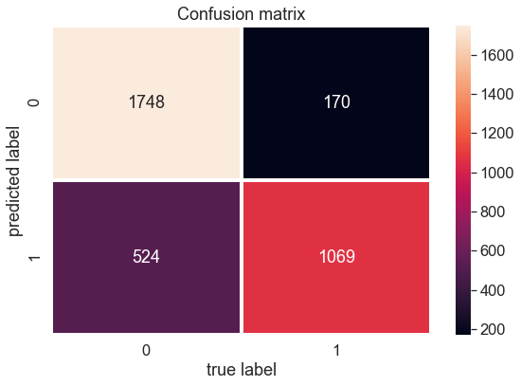

accuracy score: 0.8023355169467388

In [8]:

* 1. RandomizedSearchCV to search for best hyperparameters and select the parameters and set range of values to be searched. Please report training history, parameters and range of values, confusion matrix and accuracy.

Example:

|  |  |
| --- | --- |
| Parameters | Range |
| C [1, 5,10] | [0.52, 0.7, 1] |
| Best: gamma': 0.52, 'C': 1 | |
| **⁞** | **⁞** |

accuracy score: 0.8023355169467388

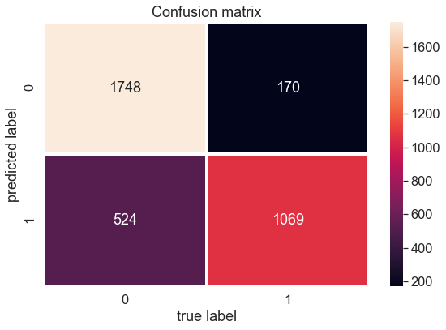

不知道為什麼參數都調不一樣，結果還是一樣欸… 下星期要進入深度學習，瑟瑟發抖。