**Infrared Lab**第11組:廖沁旋、利彥儒

1.IR運行結果(影片)

實作影片: <https://youtube.com/shorts/cpqqUTMmGGE?feature=share>

2.作業程式碼

Irrecord.py  
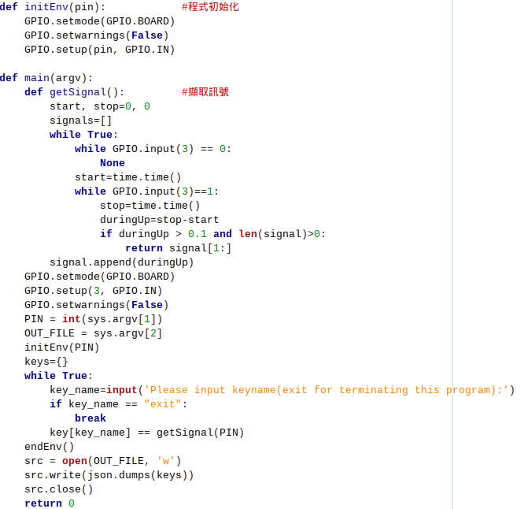  
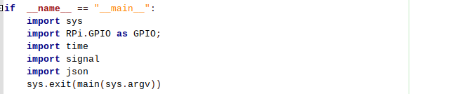

**Irrecogn.py**

