# **The Device**

The device I have chosen to talk about is a table/bedside cabinet. As you can see from the below picture, this cabinet has three legs which differs from the conventional four legged tables and cabinets we are accustomed to seeing. Throughout this essay I will be briefly discussing the bedside cabinet, talk about some of the universal principals that are violent and finally, propose an alternative way to better this cabinet.

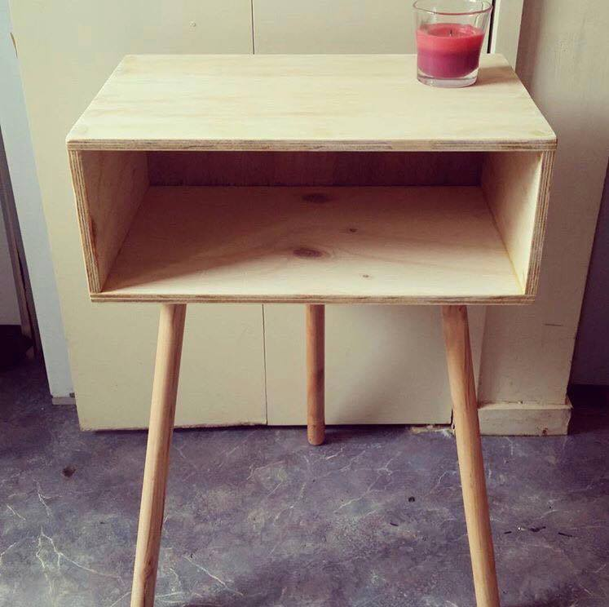

# Brief Description

This is a three legged bedside cabinet which is an interesting design as most cabinets usually have four legs. It has some flaws in design which makes it an annoyance for uses. For example, due to the three leg design, if you put weight on the back of the cabinet on either the left or the right side, the cabinet will topple over. This is due to there not being a fourth leg to balance out gravity. There is also another odd flaw in this cabinet design. As you can see in the picture below, the third leg which is located at the back of the cabinet sticks out further then the draw itself. This means that you cannot put the cabinet flush against the wall, which is a massive design flaw as items constantly fall off the back of the cabinet.



# Universal Principal Violations

**Visibility**:

This cabinet violates the visibility principal in the term that you can see what you would use it for, but if you were not aware of the balancing issues of the design, you would make the table fall over. This means that the function and operation are not entirely clear on inspection.

**Affordances**:

This device tells us, by appearance, what it is used for. When you look at the cabinet it is evident that it is used to store items on and inside. This means that the design is obvious. However, although the design is obvious, this does not mean that it is appropriate and matches its function. For example, you cannot put weight in the back corners without making the cabinet fall over.

**Constraints:**

Constraints are used to constrain user behavior to prevent errors. There are no constraint violations when it comes to the bedside cabinet.

**Mappings:**

Mappings are the relationship between user actions and the results. For example, when you turn a light on in a room, there is a consequent result and you would expect the room to light up. If mappings are difficult to learn, it will make using the device much harder than it needs to be. There is no mapping when it comes to the use of this bedside cabinet.

# **Alternative Design**

There are many ways to redesign this bedside cabinet so it is much more effective to use and does not violate any universal design principals. Firstly, you could just add another leg to the cabinet and make it four legged, however, that defeats the purpose of the trendy design of a three legged cabinet. An alternative way to fix the balancing issue is the change the shape of the cabinet itself. It could be much easier balance if it were more shaped like a guitar pick. You could then put one leg on the narrow side of the cabinet and the back two legs on the wider part of the cabinet. Another alternative you could use is if you did not want to change the shape of the table is to make the legs in a pedestal style. This is shown in the picture below:

