Creating Integration between Gitlab & Mattermost using Webhooks

1. Click on the repo that you want to see the notifications for (I Created a new test repo in Gtalab for testing)

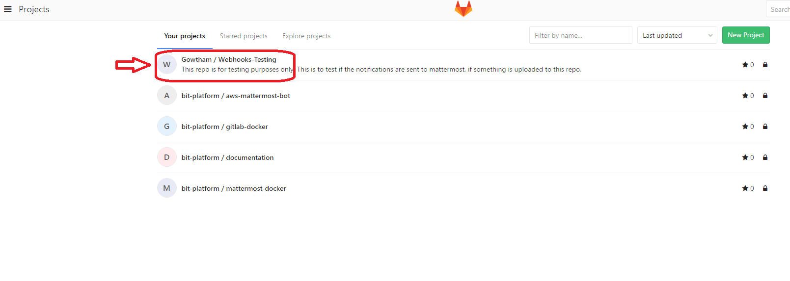

1. Click on the settings icon on top right; a pop down open up, then click on “Integrations” .

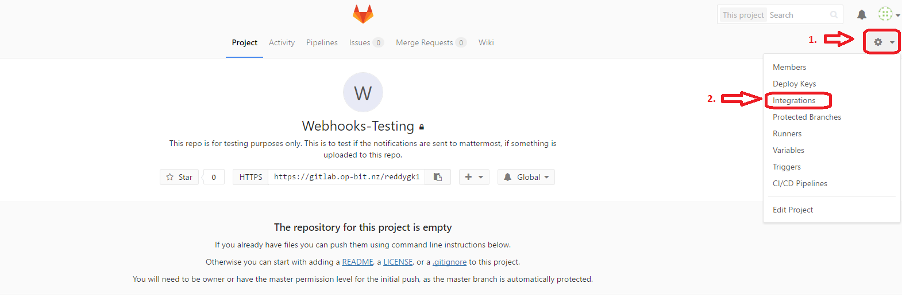

1. Scroll down the Integrations page and click on “Mattermost notifications” under *Project services.*

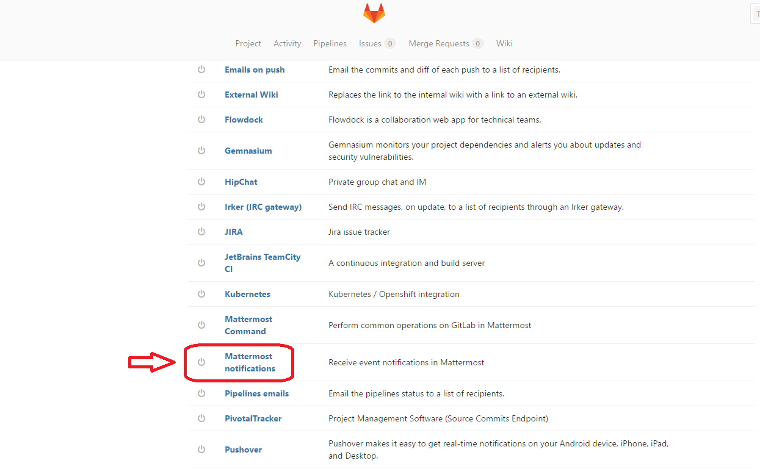

1. Before you proceed, you need to create Incoming webhook in mattermost, so go to mattermost and click on the ellipses on the left of the screen, next to your username.

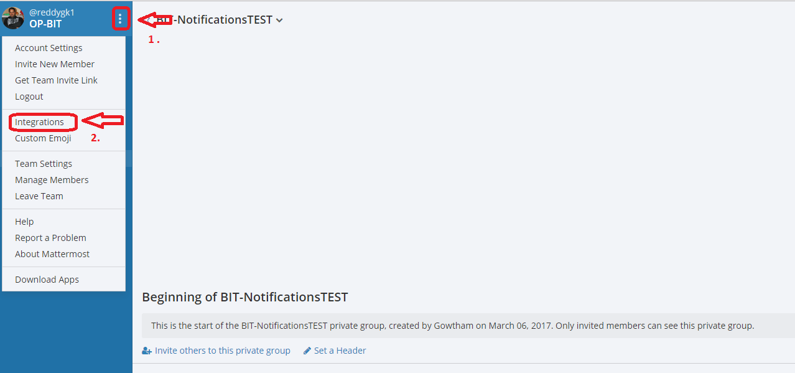

1. A new Incoming webhook needs to be created, to do that click on “Incoming Webhook”.

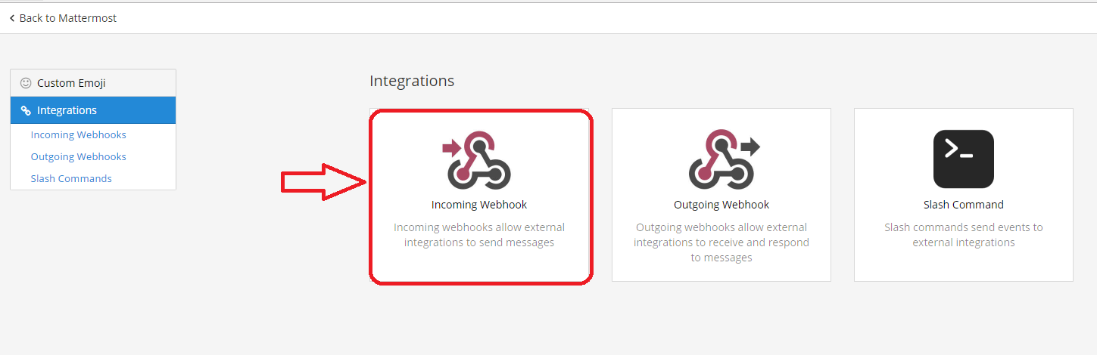

1. Incoming webhooks page opens, click on “Add Incoming Webhook”.

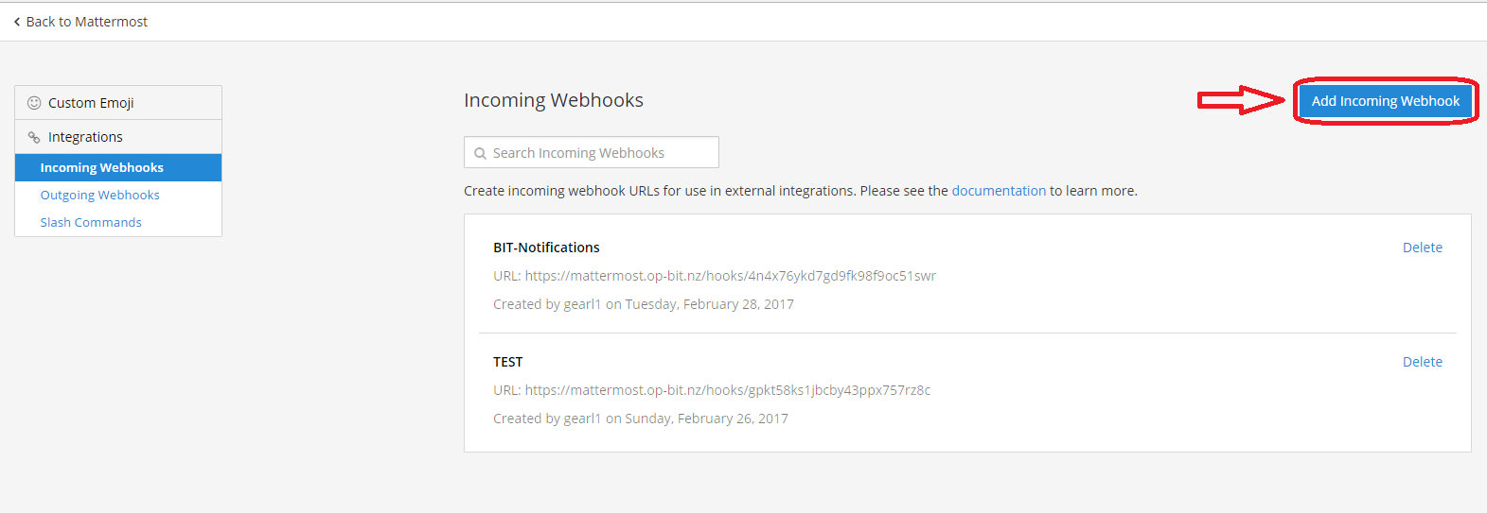

1. Give a display name to the webhook and give the description of what this webhook is for. Then click on the arrow next to Channel and choose the channel you want the notifications to go to. I have created a new test group for the notifications and click “Save”.

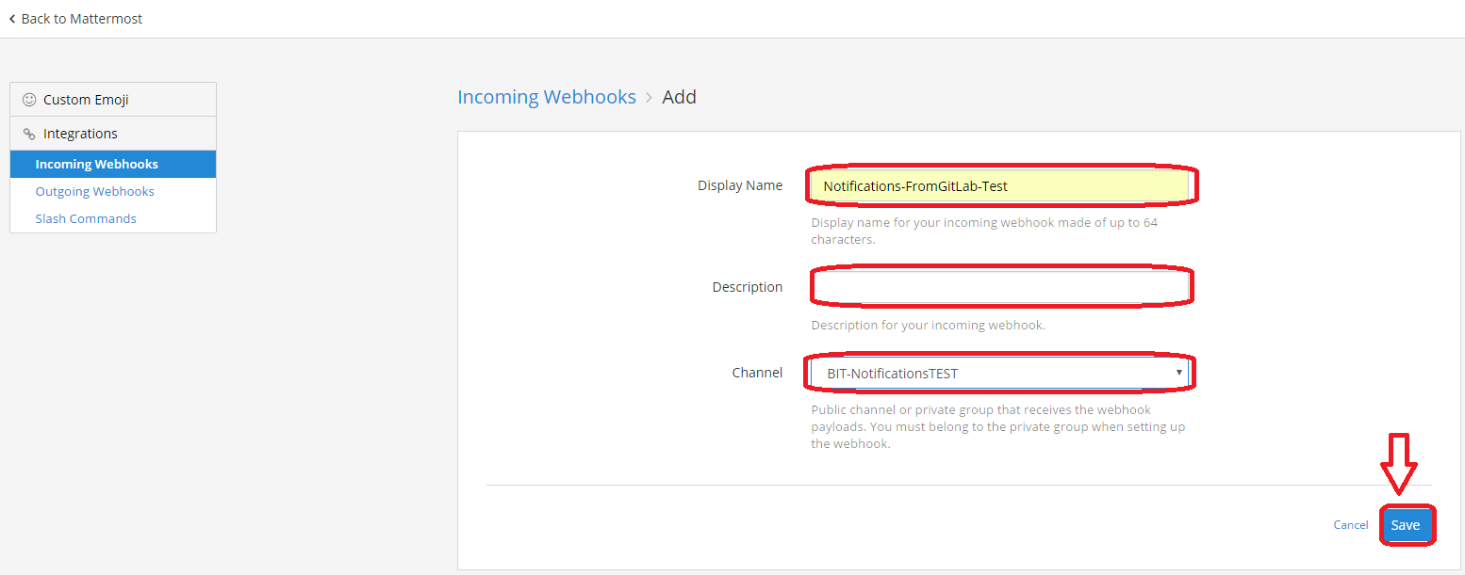

1. A webhook is now created and a URL will be given in the success page, copy the url and click “Done”.

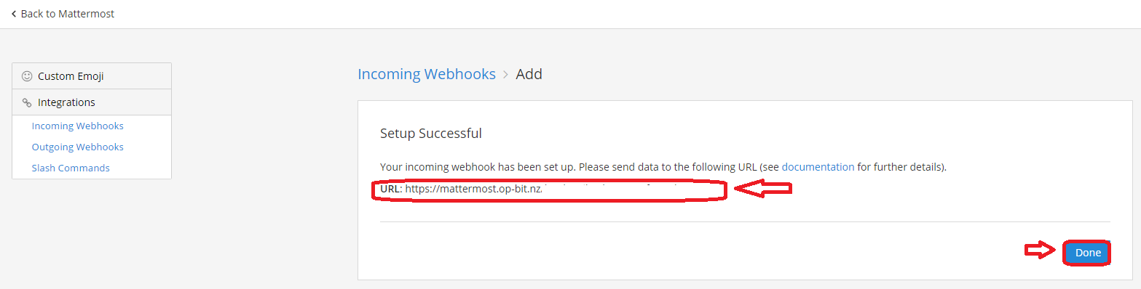

1. Now go back to git lab integrations page and untick all the things that you don’t want notified. And paste the webhook URL that is copied from the mattermost, and give a username. (this will be displayed in mattermost as a sender).

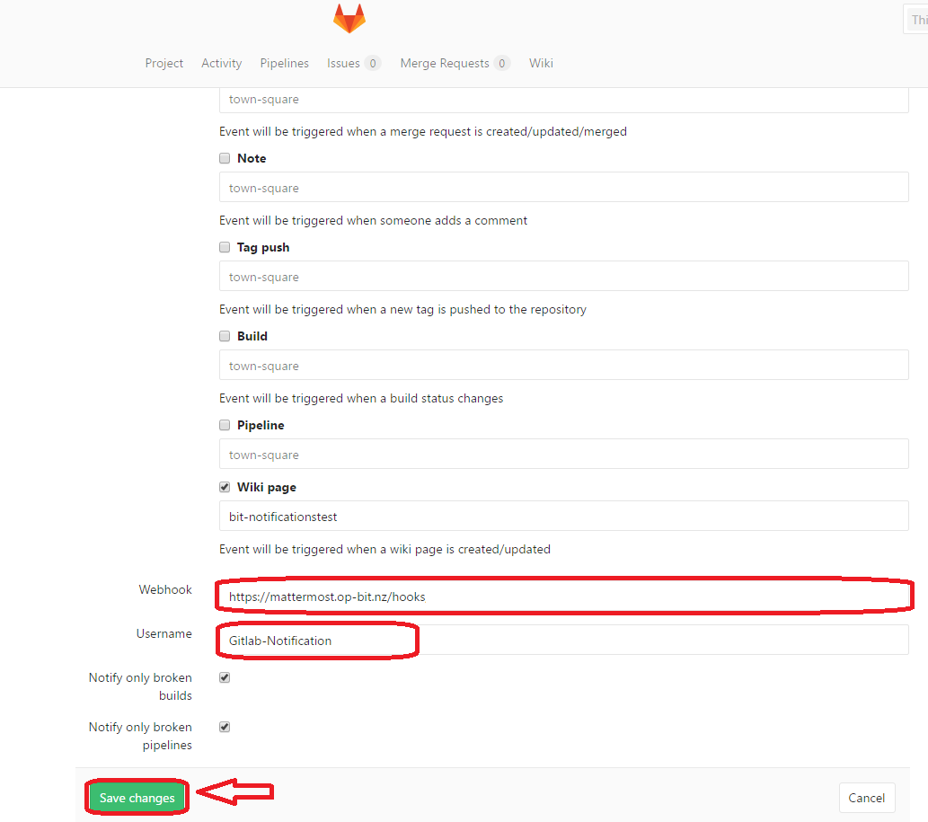

1. The details are updated, but if the “Active” field is not ticked it will not be activated. So on top of the *Mattermost notifications section,* click the active field and then click Save at the bottom again.

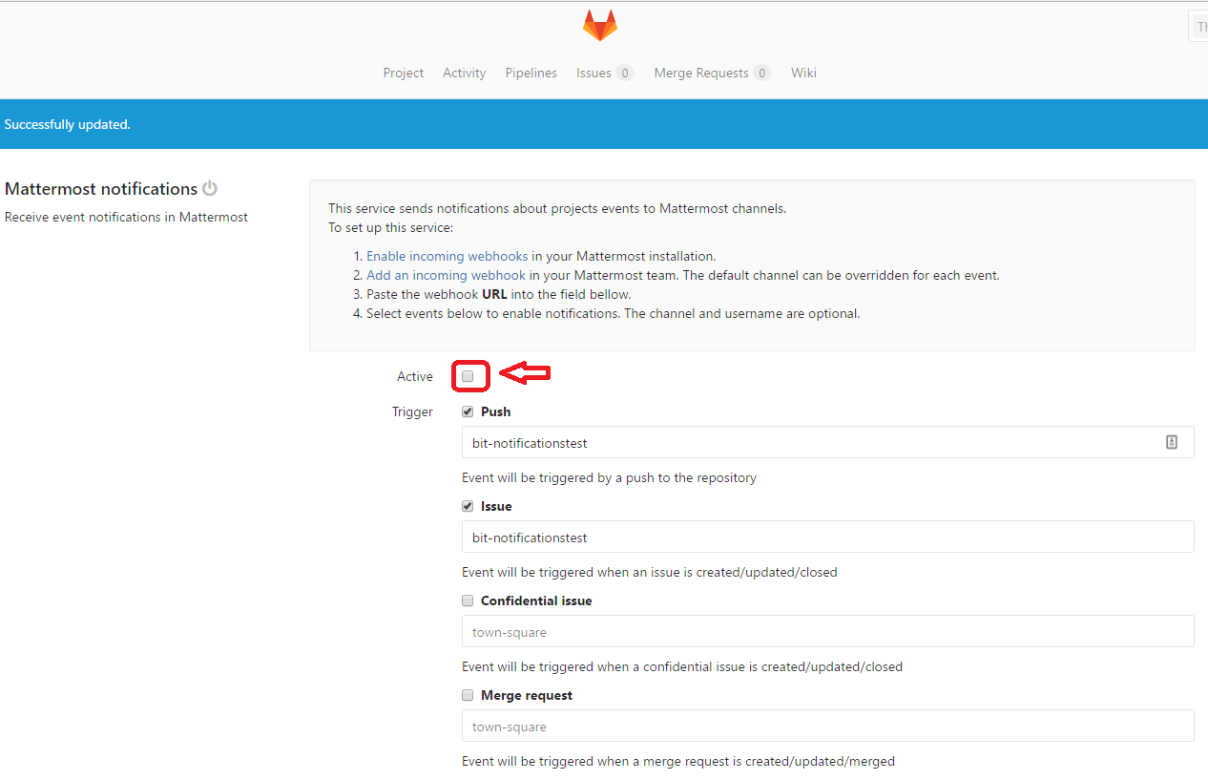

1. Now create a new wiki page on your repo and the notification should turn up in the mattermost channel.

