**Project-01**

**Problem-03**

* Do loop is using value of x from -5 to 5 by 0.25.

X =( -5, -4.75, -4.50,-4.0,………………4.0,4.25,4.50,4.75,5)

Y is taking value from -5 to 5 by 0.25.

Y =( -5, -4.75, -4.50,-4.0,………………4.0,4.25,4.50,4.75,5)

Z= $\sin{\sqrt{x^{2}+y^{2}}}$

Do loop is calculating Z by using X and Y variables from -5 to 5.

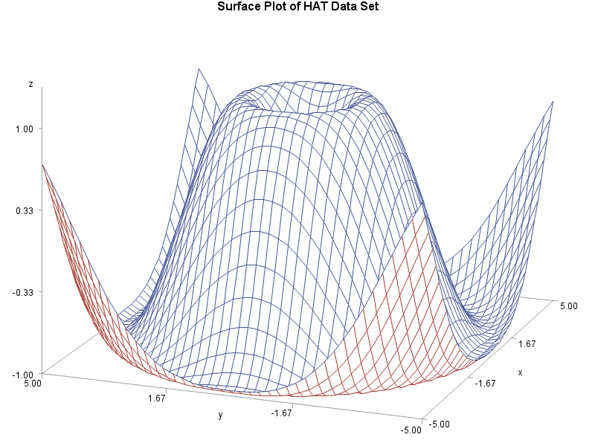

* X and Y are two independent random variables.

Bivariate distribution of (X,Y)

Probability mass function of bivariate distribution

|  |  |  |  |  |  |  |  |
| --- | --- | --- | --- | --- | --- | --- | --- |
| X/Y | -5.00 | -4.75 | -4.50 | ………. | 4.50 | 4.75 | 5.00 |
| -5.00 | (1/41*1/41) | (1/41*1/41) | (1/41*1/41) |  | (1/41*1/41) | (1/41*1/41) | (1/41*1/41) |
| -4.75 | (1/41*1/41) | (1/41*1/41) | (1/41*1/41) |  | (1/41*1/41) | (1/41*1/41) | (1/41*1/41) |
| -4.50 | (1/41*1/41) | (1/41*1/41) | (1/41*1/41) |  | (1/41*1/41) | (1/41*1/41) | (1/41*1/41) |
| ……. |  |  |  |  |  |  |  |
| 4.50 | (1/41*1/41) | (1/41*1/41) | (1/41*1/41) |  | (1/41*1/41) | (1/41*1/41) | (1/41*1/41) |
| 4.75 | (1/41*1/41) | (1/41*1/41) | (1/41*1/41) |  | (1/41*1/41) | (1/41*1/41) | (1/41*1/41) |
| 5.00 | (1/41*1/41) | (1/41*1/41) | (1/41*1/41) |  | (1/41*1/41) | (1/41*1/41) | (1/41*1/41) |

P(x=x,y=y)=1/1681

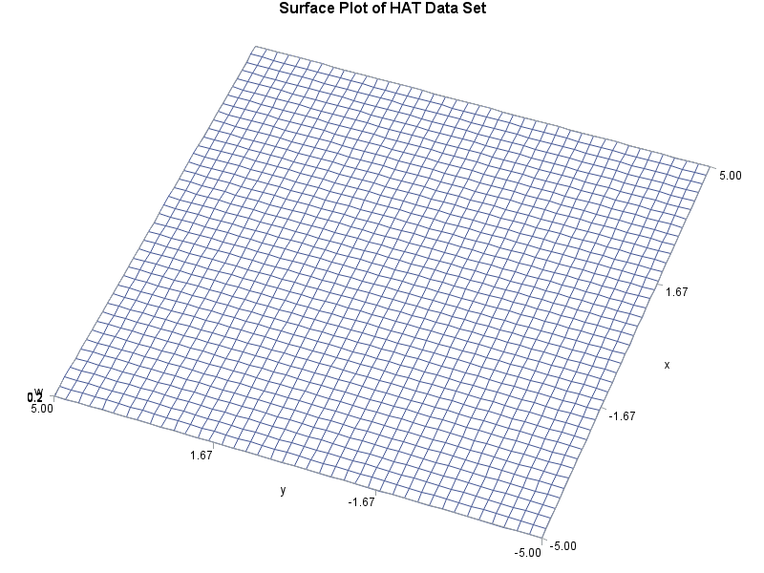

* Rotated picture

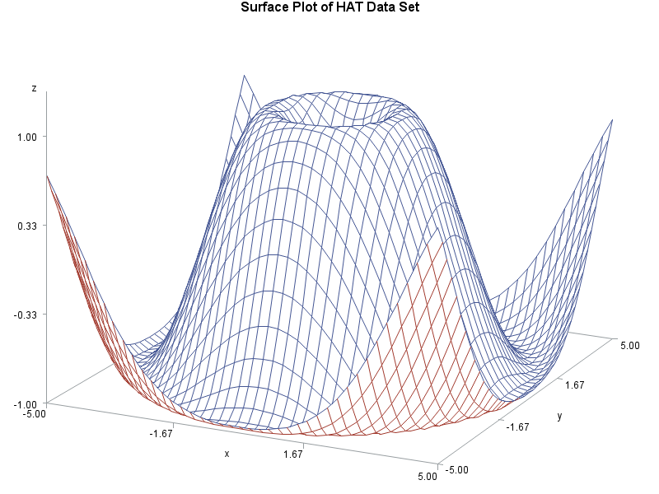

**SAS Codes:**

/* Set the graphics environment */

goptions reset=all border cback=white htitle=**12**pt;

/* Create the data set HAT */

**data** hat;

do x=-**5** to **5** by **0.25**;

do y=-**5** to **5** by **0.25**;

z=sin(sqrt(x*x+y*y));

w=**1**/**5**;

output;

end;

end;

**run**;

/* Define a title for the plot */

title1 'Surface Plot of HAT Data Set';

/* Create the plot */

**proc** **g3d** data=hat;

plot y*x=z;

**run**;

**quit**;

**proc** **g3d** data=hat;

plot y*x=w;

**run**;

**quit**;

/* rotate the picture to 25 degrees */

**proc** **g3d** data=hat;

plot y*x=z

/ rotate= -**25**;

**run**;

**quit**;