**Homework-04**

**STAT-6250 SAS Programming**

**Chinki Rai**

**15th October 2017**

**/*Chapter-11*/**

**Problem-01**

**SAS Code**

*Program name: Homework 05 is stored in C:\Computational Statistics\4th Quater\SAS\Homework.

Programmer: Chinki Rai

Date Written: 19th Oct 2017;

*Creating Dataset;

*Data set HEALTH;

**data** health;

input Subj : $3.

Height

Weight;

Weightkg=(weight/**2.2**);

Heightmt=(Height\***0.0254**);

BMI=Weightkg/(Heightmt*Heightmt);

BMIR=round(BMI);

BMIR_tenth=round(BMI,**0.1**);

BMIR_Group=round(BMI,**5**);

BMI_Trunc=round(BMI);

datalines;

001 68 155

003 74 250

004 63 110

005 60 95

;

**run**;

title "Health Data";

**proc** **print** data=health;

**run**;

Output:

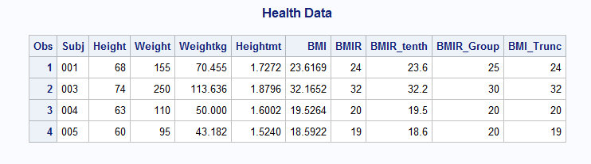

**Problem-05**

**SAS Code**

*Program name: Homework 05 is stored in C:\Computational Statistics\4th Quater\SAS\Homework.

Programmer: Chinki Rai

Date Written: 19th Oct 2017;

*Data set PSYCH;

**data** psych;

input ID : $3. Ques1-Ques10 Score1-Score5;

datalines;

001 1 3 2 4 5 4 3 4 5 4 90 92 93 90 88

002 3 3 . . 3 4 5 5 1 . 95 . . 86 85

003 . . . . 5 5 4 4 3 3 88 87 86 85 84

004 5 3 4 5 . 5 4 3 3 . 78 78 82 84 .

005 5 4 3 2 1 1 2 3 4 5 92 93 94 95 99

;

**data** Evaluate;

set PSYCH;

scoreAve=mean(Largest(**1**,of Score1-Score5),Largest(**2**,of Score1-Score5),Largest(**3**,of Score1-Score5));

if n(of Ques1-Ques10) ge **7** then

QuesAve = mean(of Ques1-Ques10);

Composit = ScoreAve + **10**\*QuesAve;

keep ID ScoreAve QuesAve Composit;

**run**;

title "Evaluate";

**proc** **print** data=Evaluate;

**run**;

**Output:**

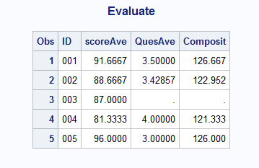

**Problem-08**

**SAS Code**

*Program name: Homework 05 is stored in C:\Computational Statistics\4th Quater\SAS\Homework.

Programmer: Chinki Rai

Date Written: 19th Oct 2017;

/*simple random sample with replacement*/

**data** random;

do i=**1** to **1000**;

x=int(ranuni(**0**)\***5**)+**1**;

output ;

end;

**run**;

title "Frequency table";

**proc** **freq** data=random;

tables x;

**run**;

Output:

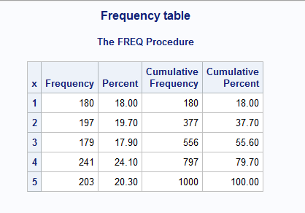

**/*Chapter-12*/**

**Problem-02**

**SAS Code**

*Program name: Homework 05 is stored in C:\Computational Statistics\4th Quater\SAS\Homework.

Programmer: Chinki Rai

Date Written: 23th Oct 2017;

*Data set MIXED;

**data** mixed;

input Name & $20. ID;

datalines;

Daniel Fields 123

Patrice Helms 233

Thomas chien 998

;

**Data** letter;

set mixed;

namelow=LOWCASE(Name);

nameprop=PROPCASE(Name);

First = lowcase(scan(Name,**1**,' '));

Last = lowcase(scan(Name,**2**,' '));

*converting entire word into lower case;

substr(First,**1**,**1**) = upcase(substr(First,**1**,**1**));

*converting entire word into upper case;

substr(Last,**1**,**1**) = upcase(substr(Last,**1**,**1**));

*converting entire word into upper case;

NameHard = catx(' ',First,Last);

**run**;

title "Printing dataset";

**Proc** **print** data=letter;

**run**;

**Output**

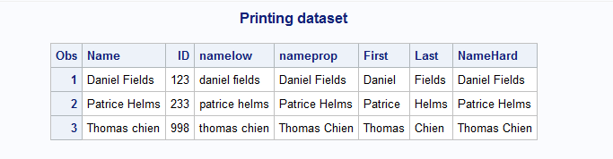

**Problem-06**

**SAS Code**

*Program name: Homework 05 is stored in C:\Computational Statistics\4th Quater\SAS\Homework.

Programmer: Chinki Rai

Date Written: 23th Oct 2017;

**data** study_new;

set learn.study;

length GroupDose $**6** ;

GroupDose =cats(Group,'-', Dose);

Join=Group || '-'|| Dose ;

**run**;

title "Printing Dataset";

**proc** **print** data=study_new;

**run**;

**proc** **contents** data=study_new;

**run**;

**Output:**

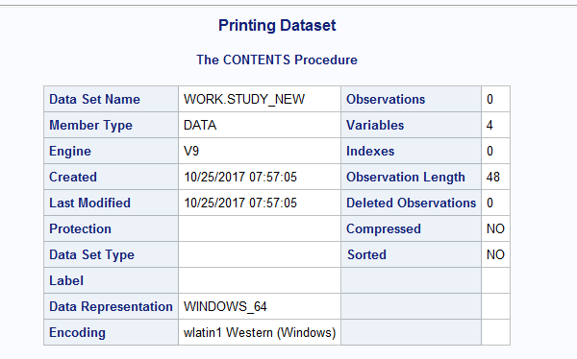

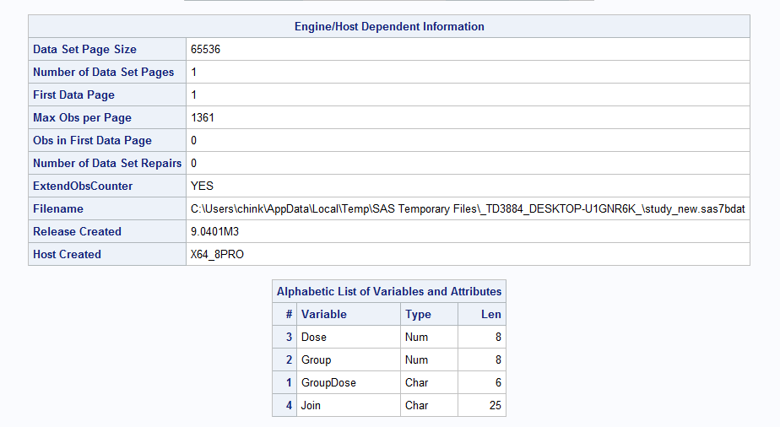

**Problem-13**

**SAS Code-**

*Program name: Homework 05 is stored in C:\Computational Statistics\4th Quater\SAS\Homework.

Programmer: Chinki Rai

Date Written: 23th Oct 2017;

*Data set SOCIAL;

**data** social1;

input SS1 $11.;

datalines;

123-45-6789

001-34-9876

007-77-6767

102-43-9182

;

*Data set SOCIAL2;

**data** social2;

input SS2 $11.;

datalines;

123-45-6789

001-43-9876

007-77-6767

485-46-1182

102-43-9188

;

**proc** **sql**;

create table social as

select *

from social1, social2;

**quit**;

**data** exact within25;

set social;

if ss1 eq ss2 then output exact;

else if spedis(ss1,ss2) le **25** and not missing(ss1) and not missing(ss2) then output within25; /*Spelling distance */

**run**;

title "Exact dataset";

**proc** **print** data=exact;

**run**;

title "Within25 dataset";

**proc** **print** data=within25;

**run**;

**Output:**

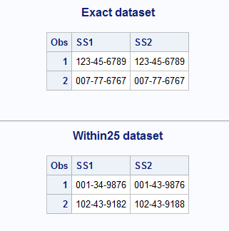

**Problem-17**

**SAS Code:**

*Program name: Homework 05 is stored in C:\Computational Statistics\4th Quater\SAS\Homework.

Programmer: Chinki Rai

Date Written: 25th Oct 2017;

*Data set PERSONAL;

**data** personal;

infile datalines missover;

input #**1** SS $11.

Gender : $1.

AcctNum : $5.

DOB : mmddyy10.

#**2** (Food1-Food8)(: $10.);

format DOB mmddyy10.;

label SS = "Social Security Number"

AcctNum = "Account Number"

DOB = "Date of Birth";

datalines;

123-45-6789 M 0192M 11/15/1949

Eggs Pancakes Sausage Toast Milk Coffee Beef Chicken

013-54-9388 F 9981S 1/2/1981

Pancakes Milk Chicken

112-11-1309 M 1322M 03/29/1988

Beef Toast Eggs Coffee

778-44-4655 F 9899M 7/4/1981

Pancakes Sausauge Coffee Beef

445-45-4455 M 2938S 8/9/1977

Tea Toast

;

**data** personal;

set personal(drop =Food1-Food8);

substr(SS,**1**,**7**)='*******';

substr(AcctNum,**5**,**1**)='-';

**run**;

title "personal dataset";

**proc** **print** data=personal;

**run**;

**Output:**

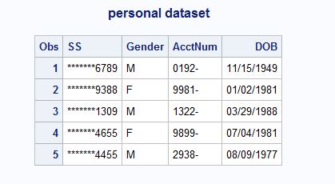

**/*Chapter-13*/**

**Problem-03**

**SAS Code:**

*Program name: Homework 05 is stored in C:\Computational Statistics\4th Quater\SAS\Homework.

Programmer: Chinki Rai

Date Written: 25th Oct 2017;

libname dataset 'C:\Computational Statistics\4th Quater\SAS\SAS_DataSets';

**data** survey1;

set dataset.survey1;

array Ques{**5**} $ Q1-Q5;

do i=**1** to **5**;

Ques{i}=translate(Ques{i},'54321','12345');

end;

drop i;

**run**;

title " Survey1";

**proc** **print** data=survey1;

**run**;

**Output:**

