**Homework-06**

**STAT-6250 SAS Programming**

**Chinki Rai**

**25th October 2017**

**/*Chapter-14*/**

**Problem-02**

**SAS Code**

*Program name: Homework 06 is stored in C:\Computational Statistics\4th Quater\SAS\Homework.

Programmer: Chinki Rai

Date Written: 29th Oct 2017;

libname dataset 'C:\Computational Statistics\4th Quater\SAS\SAS_DataSets';

**proc** **sort** data=dataset.Sales out=Salessort;

by Region Totalsales;

**run**;

title "Sales Figures from the SALES Data Set";

**Proc** **print** data=Salessort label;

by Region;

id Region;

Var Quantity TotalSales;

sum Quantity TotalSales;

label TotalSales= "Total Sales";

**run**;

**Output**

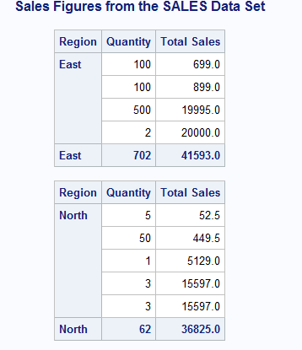

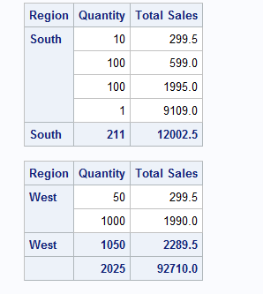

**Problem-04**

**SAS Code**

*Program name: Homework 06 is stored in C:\Computational Statistics\4th Quater\SAS\Homework.

Programmer: Chinki Rai

Date Written: 29th Oct 2017;

/*Used Export option to export dataset into SAS work library*/

title "Five observations of blood dataset";

**proc** **print** data=work.dataset1 (obs=**5**) noobs;

var Subject Gender BloodType;

**run**;

**Output**

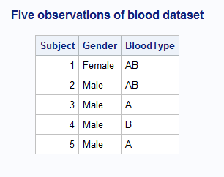

**/*Chapter-15*/**

**Problem-01**

**SAS Code**

*Program name: Homework 06 is stored in C:\Computational Statistics\4th Quater\SAS\Homework.

Programmer: Chinki Rai

Date Written: 29th Oct 2017;

/*Used Import option to export dataset into SAS work library*/

title "Five observations of blood dataset";

**proc** **report** data=work.dataset1(obs=**5**) nowd ;

column Subject WBC RBC ;

define subject / display "Subject Number" width=**7**;

define WBC / "White Blood Cells" width=**6** format=comma6.0;

define RBC / "Red Blood Cells" width=**5** format=**5.2**;

**run**;

**Output**

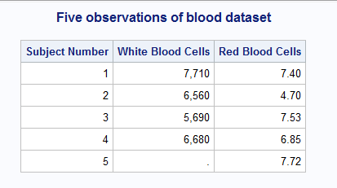

**Problem-04**

**SAS Code**

*Program name: Homework 06 is stored in C:\Computational Statistics\4th Quater\SAS\Homework.

Programmer: Chinki Rai

Date Written: 29th Oct 2017;

libname learn "C:\Computational Statistics\4th Quater\SAS\SAS_DataSets";

**proc** **Report** data=learn.bloodpressure nowd;

column Gender SBP DBP Hypertensive;

Define Gender /group width=**5**;

Define SBP /display width=**5**;

Define DBP/ display width=**5**;

Define Hypertensive/ computed "Hypertensive" width=**15**;

Compute Hypertensive / character length=**6**;

if Gender='F' and (SBP gt **138** or DBP gt **88** ) then Hypertensive='Yes';

else Hypertensive='No';

if Gender='M' and (SBP gt **140** or DBP gt **90** ) then Hypertensive='Yes';

else Hypertensive='No';

endcomp;

**run**;

**Output**

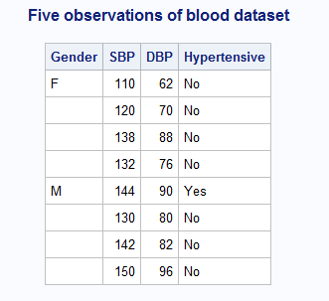

**Problem-05**

**SAS Code**

*Program name: Homework 06 is stored in C:\Computational Statistics\4th Quater\SAS\Homework.

Programmer: Chinki Rai

Date Written: 29th Oct 2017;

libname learn "C:\Computational Statistics\4th Quater\SAS\SAS_DataSets";

title "Patient Age group";

**proc** **report** data=learn.bloodpresure;

**quit**;

title "Patient Age Groups";

**proc** **report** data=learn.bloodpressure nowd;

column Gender Age AgeGroup;

define Gender / width=**6**;

define Age / display width=**5**;

define AgeGroup / computed "Age Group";

compute AgeGroup / character length=**5**;

if Age gt **50** then AgeGroup = '> 50';

else if not missing(Age) then AgeGroup = '<= 50';

endcomp;

**run**;

**Output**

