**Homework-07**

**STAT-6250 SAS Programming**

**Chinki Rai**

**09th November 2017**

**/*Chapter-16*/**

**Problem-01**

**SAS Code**

/* Problem01*/

*Program name: Homework 06 is stored in C:\Computational Statistics\4th Quater\SAS\Homework.

Programmer: Chinki Rai

Date Written: 09 Nov 2017;

libname learn 'C:\Users\chink\Google Drive\Computational Statistics\4th Quater\SAS\SAS_DataSets';

title 'Printing out variables ';

**proc** **means** data=learn.college mean median min max n nmiss maxdec=**2**;

var GPA ClassRank;

**run**;

**Output**

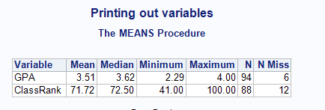

**Problem-02**

**SAS Code**

/* Problem02*/

*Program name: Homework 06 is stored in C:\Computational Statistics\4th Quater\SAS\Homework.

Programmer: Chinki Rai

Date Written: 09 Nov 2017;

libname learn 'C:\Users\chink\Google Drive\Computational Statistics\4th Quater\SAS\SAS_DataSets';

title 'Printing out variables ';

**proc** **format**;

value $yesno 'Y','1' = 'Yes'

'N','0' = 'No'

' ' = 'Not Given';

value $size 'S' = 'Small'

'M' = 'Medium'

'L' = 'Large'

' ' = 'Missing';

value $gender 'F' = 'Female'

'M' = 'Male'

' ' = 'Not Given';

**run**;

/*summary statistics of the dataset by by statement*/

**proc** **sort** data=learn.college;

by Gender SchoolSize;

**run**;

**proc** **means** data=learn.college mean median min max n nmiss maxdec=**2**;

by gender SchoolSize;

format Gender SchoolSize;

var GPA ClassRank;

**run**;

/*summary statistics of the dataset by class statement*/

**proc** **means** data=learn.college mean median min max n nmiss maxdec=**2**;

class gender SchoolSize;

format Gender SchoolSize;

var GPA ClassRank;

**run**;

**Output**

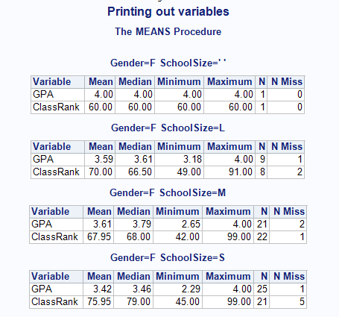

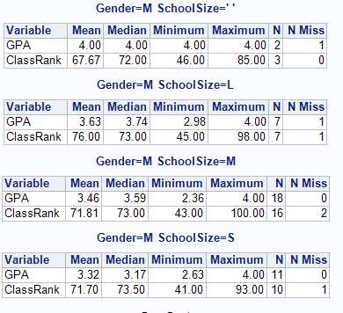

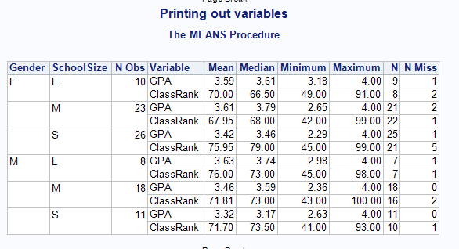

**Problem-03**

**SAS Code**

/***Problem-03***/

**proc** **sort** data=learn.college;

by SchoolSize;

**run**;

title 'Statistics of data using by statement';

**proc** **means** data=learn.college n mean median min max maxdec=**2**;

by schoolsize ;

var GPA ClassRank;

**run**;

title 'Statistics of data using class statement';

**proc** **means** data=learn.college n mean median min max maxdec=**2**;

class schoolsize ;

var GPA ClassRank;

**run**;

**Output**

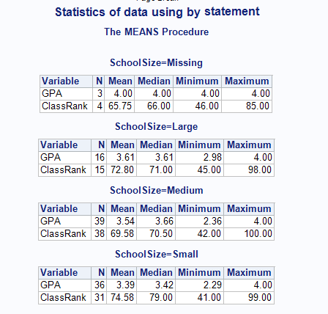

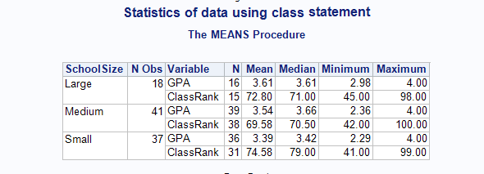

**/*Chapter-17*/**

**Problem-05**

**SAS Code**

*Program name: Homework 06 is stored in C:\Computational Statistics\4th Quater\SAS\Homework.

Programmer: Chinki Rai

Date Written: 09 Nov 2017;

libname learn 'C:\Users\chink\Google Drive\Computational Statistics\4th Quater\SAS\SAS_DataSets';

title 'Printing variables ';

**proc** **format**;

value rank low-**70**='Low to 70'

**71** - High='71 and higher';

**run**;

**proc** **freq** data=learn.college;

tables Scholarship*ClassRank;

format ClassRank rank.;

**run**;

**Output**

