**Homework-08**

**STAT-6250 SAS Programming**

**Chinki Rai**

**21th November 2017**

**/*Chapter-18*/**

**Problem-01**

**SAS Code**

*Program name: Homework 08 is stored in C:\Computational Statistics\4th Quater\SAS\Homework.

Programmer: Chinki Rai

Date Written: 21 Nov 2017;

libname learn 'C:\Users\chink\Google Drive\Computational Statistics\4th Quater\SAS\SAS_DataSets';

title "Table";

**proc** **format**;

value $schoolsize 'L' ='Large'

'M'='Medium'

'S'='small';

value $scholarship 'N'='No'

'Y'='yes' ;

**run**;

**proc** **tabulate** data=learn.college format=**6.**;

class Gender scholarship Schoolsize;

table Gender Scholarship all, schoolsize*n='';

format Schoolsize $schoolsize. Scholarship $scholarship.;

**run**;

**Output:**

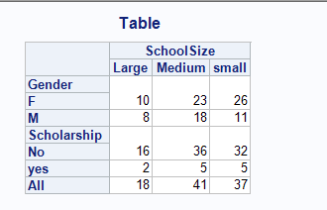

**Problem-02**

**SAS Code**

*Program name: Homework 08 is stored in C:\Computational Statistics\4th Quater\SAS\Homework.

Programmer: Chinki Rai

Date Written: 21 Nov 2017;

libname learn 'C:\Users\chink\Google Drive\Computational Statistics\4th Quater\SAS\SAS_DataSets';

title "Table";

**proc** **format**;

value $schoolsize 'L' ='Large'

'M'='Medium'

'S'='small';

value $scholarship 'N'='No'

'Y'='yes' ;

**run**;

**proc** **tabulate** data=learn.college format=**6.**;

class Gender scholarship Schoolsize;

tables schoolsize all , Gender*n='' Scholarship*n='' all /rts=**15** ;

format Schoolsize $schoolsize. Scholarship $scholarship.;

keylabel n='' All= 'Total';

**run**;

**Output:**

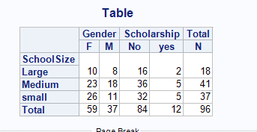

**Problem-03**

**SAS Code**

*Program name: Homework 08 is stored in C:\Computational Statistics\4th Quater\SAS\Homework.

Programmer: Chinki Rai

Date Written: 21 Nov 2017;

libname learn 'C:\Users\chink\Google Drive\Computational Statistics\4th Quater\SAS\SAS_DataSets';

title "Table";

**proc** **format**;

value $schoolsize 'L' ='Large'

'M'='Medium'

'S'='small';

value $scholarship 'N'='No'

'Y'='yes' ;

**run**;

**proc** **tabulate** data=learn.college format=**6.**;

class Gender scholarship Schoolsize;

tables (Gender all)* (Scholarship all) , schoolsize all /rts=**15** ;

format Schoolsize $schoolsize. Scholarship $scholarship.;

keylabel n='' All= 'Total';

**run**;

**Output:**

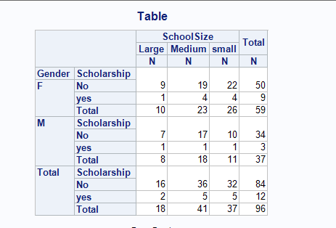

**Problem-06**

**SAS Code**

*Program name: Homework 08 is stored in C:\Computational Statistics\4th Quater\SAS\Homework.

Programmer: Chinki Rai

Date Written: 21 Nov 2017;

libname learn 'C:\Users\chink\Google Drive\Computational Statistics\4th Quater\SAS\SAS_DataSets';

title "Table";

**proc** **format**;

value $schoolsize 'L' ='Large'

'M'='Medium'

'S'='small';

value $scholarship 'N'='No'

'Y'='yes' ;

**run**;

**proc** **tabulate** data=learn.college format=**6.1**;

class Gender ;

var GPA ClassRank;

tables GPA*(n*f=**4.** mean) ClassRank*(n*f=**4.** mean) , Gender all;

keylabel n='Number'

all='Total'

mean='Average';

**run**;

**Output:**

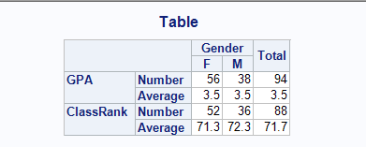

**/*Chapter-19*/**

**Problem-04**

**SAS Code**

*Program name: Homework 08 is stored in C:\Computational Statistics\4th Quater\SAS\Homework.

Programmer: Chinki Rai

Date Written: 21 Nov 2017;

ods rtf file='C:\Users\chink\Google Drive\Computational Statistics\4th Quater\SAS\SAS_DataSets\surveyresult.rtf';

libname learn 'C:\Users\chink\Google Drive\Computational Statistics\4th Quater\SAS\SAS_DataSets';

title "Survey data";

**proc** **print** data=learn.survey1;

**run**;

ods rtf close;

**Output:**

**Please look attached file** 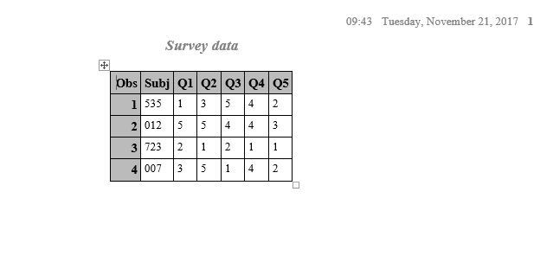

**/*Chapter-20*/**

**Problem-08**

**SAS Code**

*Program name: Homework 08 is stored in C:\Computational Statistics\4th Quater\SAS\Homework.

Programmer: Chinki Rai

Date Written: 21 Nov 2017;

libname learn 'C:\Users\chink\Google Drive\Computational Statistics\4th Quater\SAS\SAS_DataSets';

title "Scatter plot ";

**proc** **sort** data=learn.fitness out=fitness;

by RestPulse;

**run**;

symbol value=dot ;

**proc** **gplot** data=fitness;

plot TimeMile * RestPulse;

**run**;

Output:

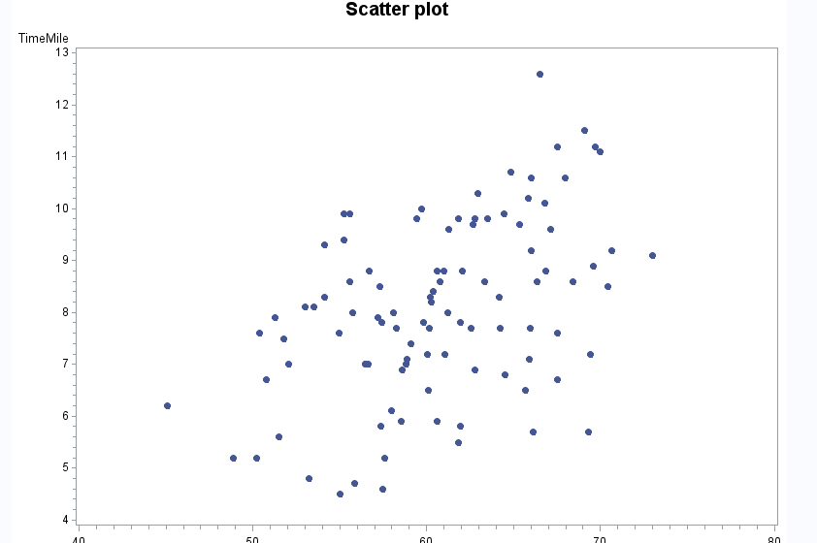

**Problem-09**

**SAS Code**

*Program name: Homework 08 is stored in C:\Computational Statistics\4th Quater\SAS\Homework.

Programmer: Chinki Rai

Date Written: 21 Nov 2017;

libname learn 'C:\Users\chink\Google Drive\Computational Statistics\4th Quater\SAS\SAS_DataSets';

title "Stock Prices by Time";

symbol value=dot i=sm;

**proc** **gplot** data=learn.stocks;

plot Price * Date;

**run**;

**quit**;

**Output:**

