no1 = int(input(**"1st Integer No :"**))  
no2 = int(input(**"2nd Integer No :"**))  
print(**"Sum = "**,no1+no2)  
print(**"Div = "**,no1/no2)  
print(**"Sub = "**,no1-no2)  
print(**"Mul = "**,no1*no2)  
print(**"Thanks"**)

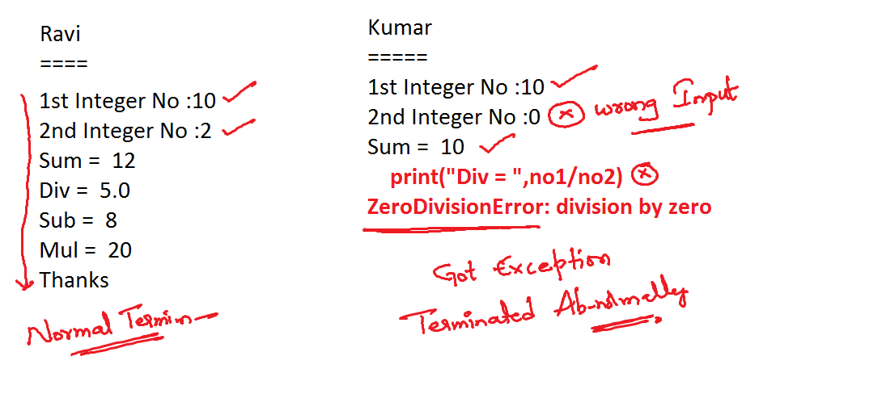

no1 = int(input(**"1st Integer No :"**))  
no2 = int(input(**"2nd Integer No :"**))  
print(**"Sum = "**,no1+no2)  
**try**:  
 print(**"Div = "**,no1/no2)  
**except** ZeroDivisionError **as** zde:  
 print(zde)  
 print(**"Don't Divide By Zero"**)  
print(**"Sub = "**,no1-no2)  
print(**"Mul = "**,no1*no2)  
print(**"Thanks"**)

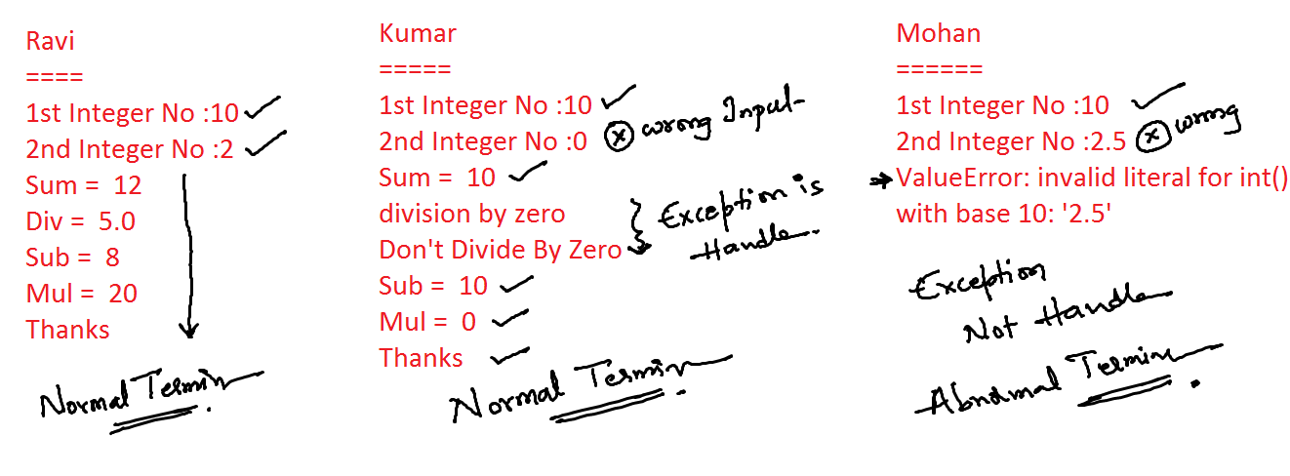

**try**:  
 no1 = int(input(**"1st Integer No :"**))  
 no2 = int(input(**"2nd Integer No :"**))  
 print(**"Sum = "**,no1+no2)  
 print(**"Div = "**,no1/no2)  
**except** ZeroDivisionError **as** zde:  
 print(**"Can't Divide By Zero"**)  
**except** ValueError **as** ve:  
 print(**"Only Integer Values are allowed"**)  
print(**"Sub = "**,no1-no2)  
print(**"Mul = "**,no1*no2)  
print(**"Thanks"**)

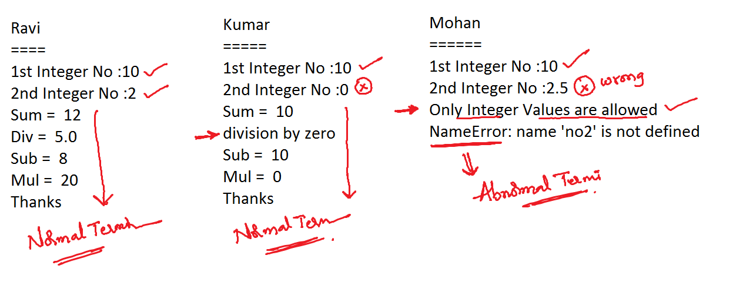

**try**:  
 no1 = int(input(**"1st Integer No :"**))  
 no2 = int(input(**"2nd Integer No :"**))  
 print(**"Sum = "**,no1+no2)  
 print(**"Div = "**,no1/no2)  
 print(**"Sub = "**, no1 - no2)  
 print(**"Mul = "**, no1 * no2)  
**except** ZeroDivisionError **as** zde:  
 print(**"Can't Divide By Zero"**)  
**except** ValueError **as** ve:  
 print(**"Only Integer Values are allowed"**)  
print(**"Thanks"**)

