November 1, 2025
Paula Nwaneri
Data-driven Marketing

Rideshare predictive regression
Pricing models
Agenda
Step 1. Feature Engineering: Removing outliers and recording them into dummy variables
Step 2. Feature Selection: Correlation Analysis of independent variables with dependent variable & independent variables with each other
Step 3. Model building: Use of all Variable Selection methods
Step 4. Model validation: Comparing based on Adjusted R-square and Average Square Error
Step 5: Key Insights & Benefits

Step 1. Feature Engineering
Removing Outliers
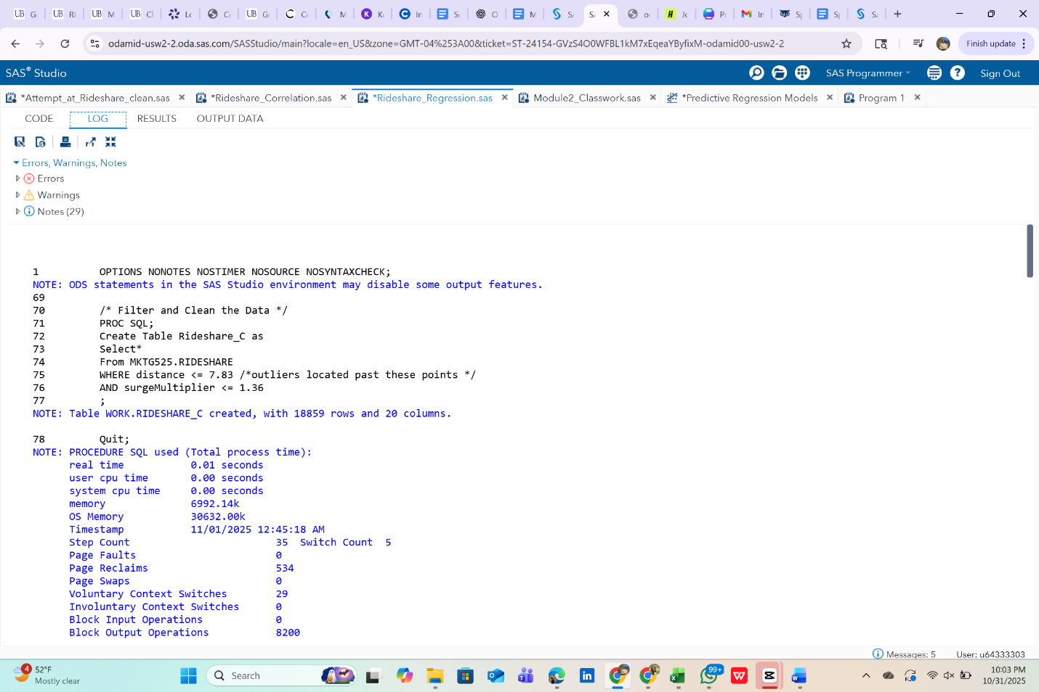
To ensure the model was not influenced by erroneous data points, the variables were checked within logic such as standard spelling or hour being between 0-23. Also, measuring ±4 standard deviation from the mean to remove extreme data points.
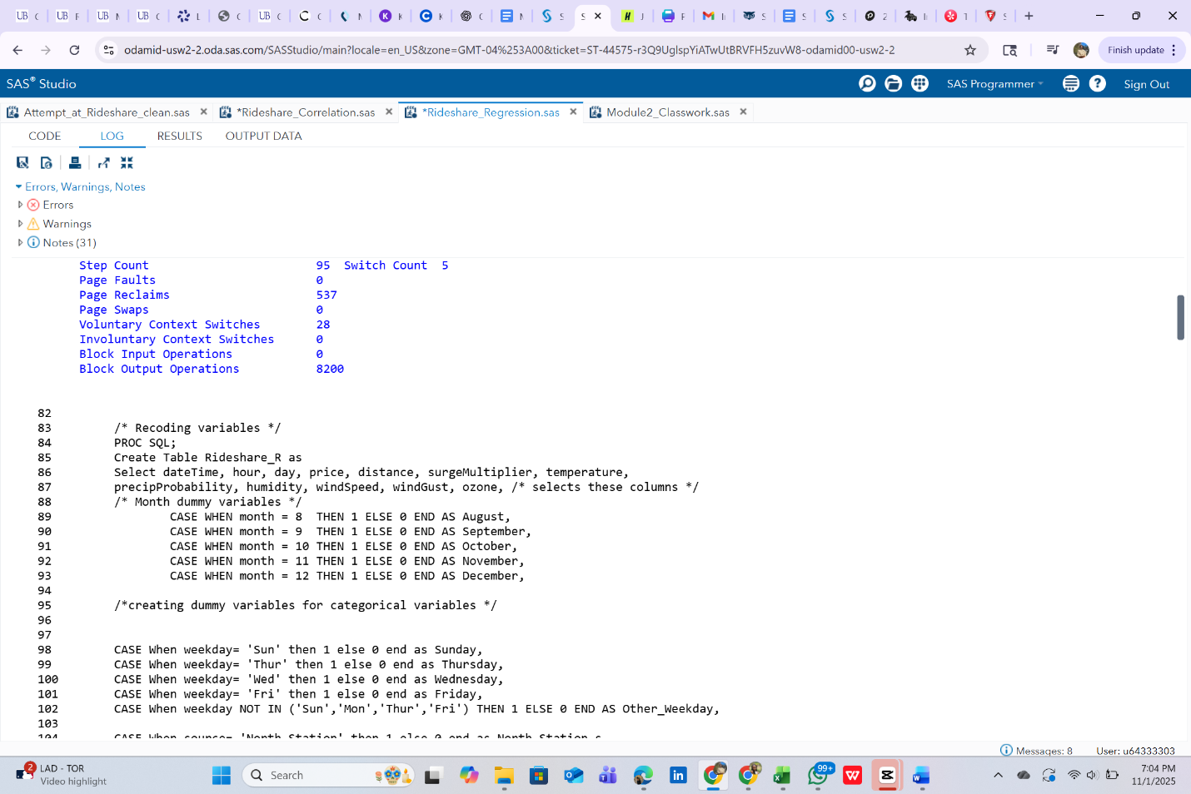
Recode into dummy variables
Since month only contains variables from August to December, recoding them into dummy variables allow us to determine the correlation among the recorded months.

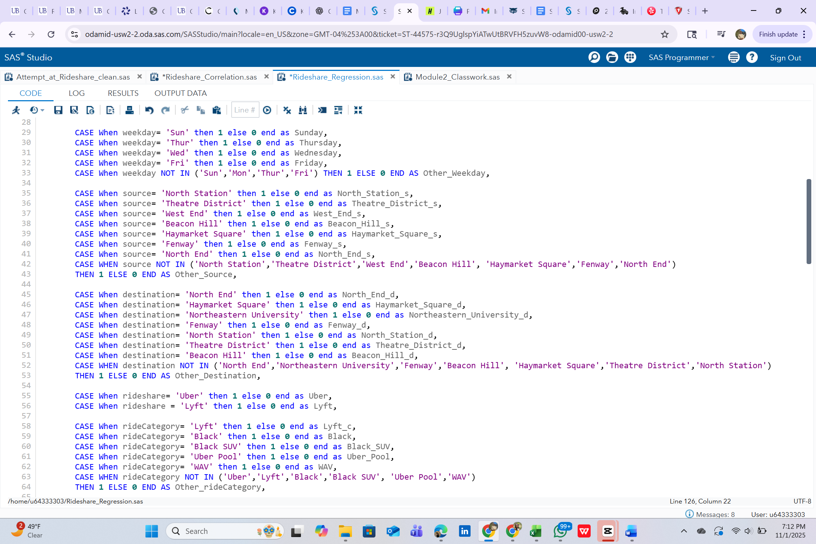
Recoding the categorical data into dummy variables ensures that the data type can be used in correlation analysis and used for a predicitve model.

Step 2: Feature Selection
Correlation of independent variables with dependent variable

To identify relevant predictors, correlation was analyzed between independent variables and the dependent variable (price)
All the correlations are low (|r|<0.5) but October, November and distance are within the judgement zone and will be used. Specifically, October has a slight negative correlation while both November and distance have positive correlations.

Correlation between independent variables

There is high negative correlation between October and November, but because the correlation between price and November is higher, then October will be excluded to prevent multicollinearity.

Step 3:
Model building
Several regression models were evaluated using SAS studio.
- Using November and distance as continuous variables
- A partition of 0.3 (70% training, 30% validation)

Step 4:
Model Validation

Based on the lowest ASE to attain the highest accuracy, the forward selection model is the best predictive model.

Final Model equation: Price = $3.83 + 2.35(distance) + 14.48(November)
- Intercept (3.83): The baseline cost of a ride when both x-values are 0.
- Distance (2.35): Ride price increases buy approximately $2.35 for every unit of distance.
- November (14.48):

Key Results:
- Ride price is primarily affected by distance
- Indicates that November has an increase in pricing possibly due to holiday demand.
Benefits to Lyft & Uber:
- Improves pricing transparency and profitability.
- Enables data-driven seasonal adjustments.
- Enhance customer satisfaction by providing consistent and fair pricing logic.

Limitations:
- The data does not contain all the months
- There is not much correlation between any of the variables

