Used Car Price Analytics & Machine Learning
Car_Price_Analytics_Report
Dataset: car_prices.csv | 558,719 Records | 16 Features
Primary ML Task: Selling Price Regression | Model: Random Forest
https://www.kaggle.com/datasets/syedanwarafridi/vehicle-sales-data

1. Introduction
This report presents the results of a comprehensive data analytics and machine learning project on approximately 558,000 used-vehicle auction and sale transactions. The project applies end-to-end data science methodology: data cleaning, exploratory data analysis, statistical hypothesis testing, and regression-based machine learning to analyze pricing patterns and predict selling prices.

2. Business Problem
Analyzing used vehicle sales patterns and predicting the selling price of used vehicles. The project addresses: what factors drive used-car prices; how vehicle age and mileage relate to price; which manufacturers differ in pricing; how MMR relates to actual price; and whether ML can accurately predict selling price.

3. Objectives
1. Clean and prepare used-car sales data. 2. Analyze factors associated with vehicle selling prices. 3. Identify patterns across makes, models, body types, transmissions. 4. Statistically test key relationships. 5. Build a regression model for selling-price prediction. 6. Evaluate model using MAE, RMSE, R2. 7. Build interactive Node.js dashboard. 8. Provide evidence-based business recommendations.

4. Dataset Description

Dataset Source
Source: Kaggle — Used Car Auction Prices https://www.kaggle.com/datasets/syedanwarafridi/vehicle-sales-data. The dataset contains 558,837 raw rows (558,719 after cleaning) across 16 columns. Each row represents a single used-vehicle auction/sale transaction at a Manheim auction facility in the United States.
Columns: year (model year), make (manufacturer), model, trim, body (style), transmission (automatic/manual), vin (identifier), state, condition (Manheim 1-49 scale), odometer (miles), color, interior, seller, mmr (Manheim Market Report - pre-sale valuation), sellingprice (TARGET - actual USD sale price), saledate (datetime of sale).

5. Data Cleaning
Professional data cleaning was performed with full documentation of all decisions. The following steps were applied:
- • Dropped 12 rows with missing sellingprice (cannot train without target)
- • Dropped 21 rows with unparseable saledate (required for feature engineering)
- • Dropped 4 rows with sellingprice below $100 (data-entry errors)
- • Dropped 81 rows with odometer above 500,000 miles (data-entry errors)
- • Standardized body style case (e.g. 'sedan' and 'Sedan' unified to 'Sedan')
- • Invalid transmission values ('sedan', 'Sedan') set to NaN then filled as 'Unknown'
- • Garbled interior colour characters replaced with NaN then 'Unknown'
- • Missing categoricals filled with 'Unknown'
- • Missing odometer imputed with median
- • Missing condition imputed with median
- • Missing MMR imputed with median
Total removed: 118 rows (0.02% of 558,837). No large-scale deletion was performed. The clean dataset retains 558,719 rows.

6. Feature Engineering
The following engineered features were created from the actual dataset:
- • vehicle_age = sale_year - year (clipped to 0 minimum). Measures time-based depreciation.
- • mileage_per_year = odometer / max(vehicle_age, 1). Normalized usage intensity.
- • log_odometer = log1p(odometer). Used for visualization only.
- • sale_month and sale_quarter derived from saledate.
Note: Features derived directly from sellingprice (price_diff, price_ratio) are excluded from all ML models to prevent target leakage.

7. Exploratory Data Analysis
Key EDA findings from 558,719 clean records: Mean selling price $13,613 | Median $12,100 | Average MMR $13,771 | Average odometer 68,191 miles | Average condition score 30.77 (on 1-49 scale) | 97 unique makes | Top make by volume: Ford (93,554 transactions).
Correlation analysis: MMR vs. selling price r=0.9836 (very strong positive). Odometer vs. selling price r=-0.5918 (moderate negative). Vehicle age vs. selling price r=-0.1105 (weak negative, stronger once non-linear depreciation is considered).

8. Five Main Visualizations

MAIN VISUALIZATION 1: Selling Price Distribution
A dual-panel chart showing: (left) raw selling price histogram with mean ($13,613) and median ($12,100) reference lines — revealing the right skew; (right) log-transformed distribution showing near-normal shape. Generated from actual car_prices.csv data by Car_Price_Analytics.ipynb. See outputs/charts/viz1_price_distribution.png.
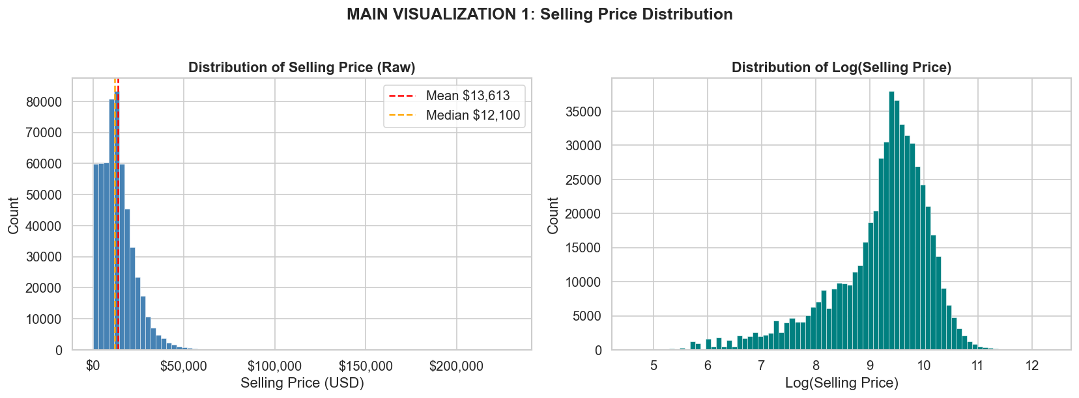
Figure 1 — Selling Price Distribution. Mean $13,613 vs Median $12,100 confirms right skew. Right panel shows log-transformed near-normal shape.

MAIN VISUALIZATION 2: Selling Price vs Vehicle Age
Line chart showing median selling price against vehicle age 0-20 years. At age 0: median $20,400. At age 10: median $3,900. Clear depreciation curve. Generated from actual data. See outputs/charts/viz2_price_vs_age.png.
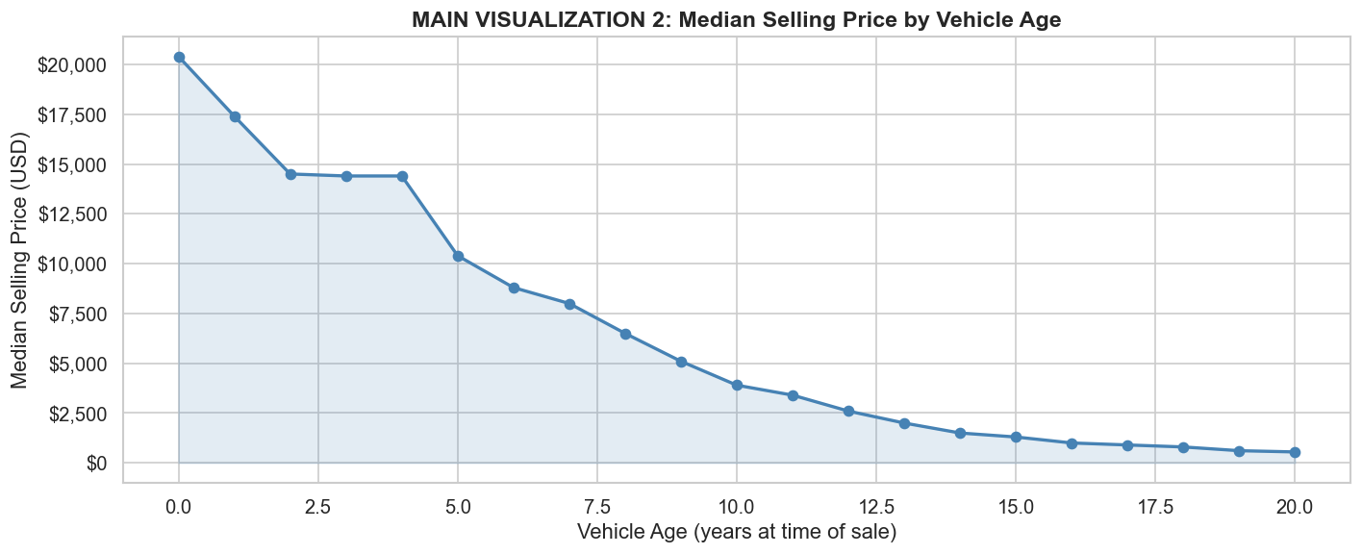
Figure 2 — Median Selling Price by Vehicle Age. Clear depreciation curve from $20,400 (age 0) down to $3,900 (age 10).

MAIN VISUALIZATION 3: Selling Price vs Odometer
Hexbin density chart of 558,719 transactions showing negative relationship between odometer and selling price (Pearson r=-0.5918). Density encoding reveals concentration of typical market transactions. See outputs/charts/viz3_price_vs_odometer.png.
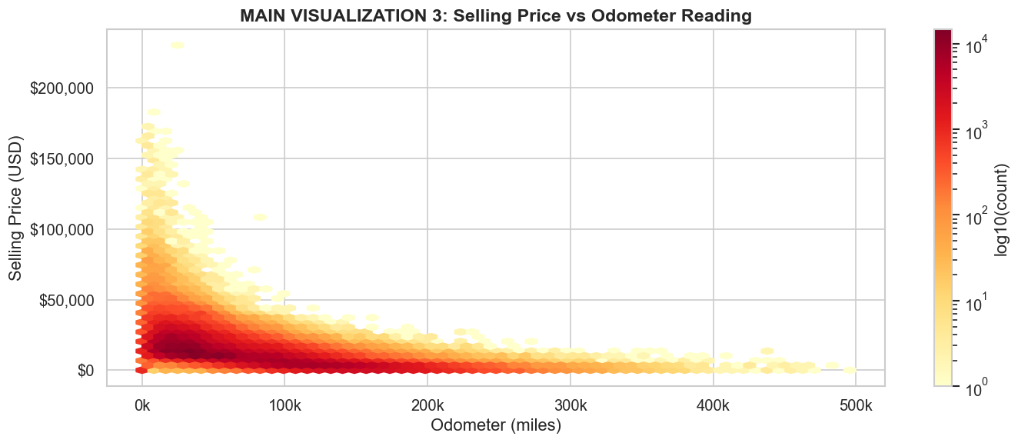
Figure 3 — Selling Price vs Odometer (hexbin density, 558,719 transactions). Pearson r = -0.5918.

MAIN VISUALIZATION 4: Average Selling Price by Top 10 Makes
Horizontal bar chart of average selling price for the 10 most frequently transacted makes. BMW leads at $21,445, followed by Ford ($14,543). Honda shows lowest average ($10,940) in this group. See outputs/charts/viz4_avg_price_by_make.png.
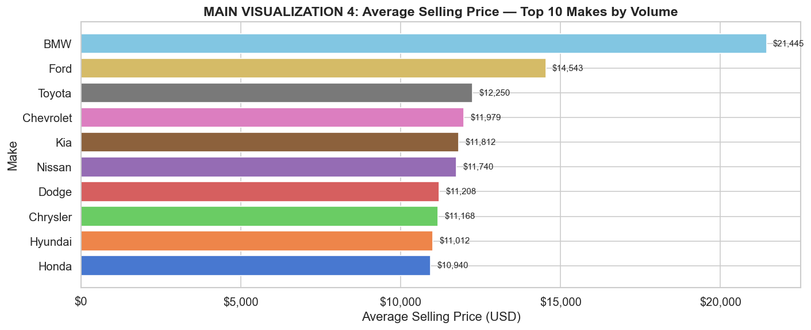
Figure 4 — Average Selling Price by Top 10 Makes (by transaction volume). BMW $21,445 vs Honda $10,940.

MAIN VISUALIZATION 5: MMR vs Actual Selling Price
Scatter plot (20,000 point sample) showing MMR vs. actual selling price with a 45-degree reference line. Very strong alignment (Pearson r=0.9836) demonstrates that the pre-sale Manheim estimate closely tracks actual transaction prices. See outputs/charts/viz5_mmr_vs_price.png.
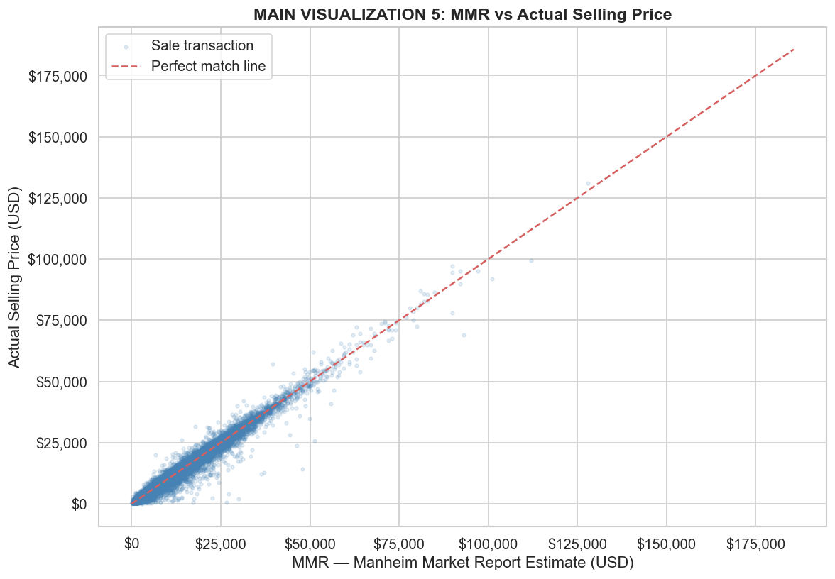
Figure 5 — MMR vs Actual Selling Price (20,000 point sample with 45-degree reference line). Pearson r = 0.9836.

9. Five Observations
Observation 1: The selling price distribution is right-skewed with a mean of $13,613.16 and a median of $12,100.00, indicating that a minority of high-value vehicles pulls the mean above the median.
Observation 2: Vehicle age has a negative correlation of -0.1105 with selling price. Median selling price for age-0 vehicles ($20,400) is substantially higher than age-10 vehicles ($3,900), confirming a consistent depreciation trend.
Observation 3: Odometer reading has a negative Pearson correlation of -0.5918 with selling price, indicating that higher mileage is meaningfully associated with lower transaction prices.
Observation 4: Among the top 10 most frequently sold makes, BMW commands the highest average selling price ($21,445) while Honda records the lowest average ($10,940) within this group — a gap of $10,505.
Observation 5: MMR (Manheim Market Report) has a very strong Pearson correlation of 0.9836 with actual selling price, suggesting that the pre-sale market estimate is a powerful indicator of final transaction value.

10. Five Insights
Insight 1 — Price Distribution: OBSERVATION: Selling price is right-skewed (mean $13,613 vs. median $12,100). INSIGHT: Pricing strategies should be benchmarked to the median rather than the mean to represent the typical market transaction without distortion from luxury outliers.
Insight 2 — Vehicle Age: OBSERVATION: Median price drops from $20,400 (age 0) to $3,900 (age 10). INSIGHT: Depreciation is steepest in early years. Dealers sourcing 1-3 year old vehicles capture the depreciation benefit while still achieving high resale values.
Insight 3 — Mileage: OBSERVATION: Odometer r=-0.5918 with price. INSIGHT: Mileage is a meaningful negative predictor, but moderate correlation indicates that brand and condition also play important roles. High-mileage luxury vehicles can still exceed low-mileage economy cars in price.
Insight 4 — Brand Premium: OBSERVATION: BMW averages $21,445 vs. Honda $10,940 among top-10 volume makes. INSIGHT: Brand premium persists in the used-car market. Dealers and fleet managers must factor brand positioning when setting reserve prices at auction.
Insight 5 — MMR Utility: OBSERVATION: MMR correlates at 0.9836 with actual selling price. INSIGHT: The Manheim pre-sale valuation is highly predictive of transaction outcomes. Including MMR as a model feature substantially improves prediction accuracy, justifying investment in MMR-integrated real-time pricing tools.

11. Three Hypotheses & Statistical Testing
All tests computed at alpha=0.05 on the actual dataset.

Hypothesis 1: Selling Prices Differ Across Vehicle Makes
H0: Mean selling price is equal across the top 5 vehicle makes. H1: At least one make has a significantly different mean selling price. Test: Kruskal-Wallis H-test (non-parametric; selected because selling price is right-skewed). Groups: Ford, Chevrolet, Nissan, Toyota, Dodge. p-value: < 2.2e-308 (effectively 0). Decision: Reject H0 at alpha=0.05. Conclusion: Selling prices differ significantly across makes. Business Interpretation: Make is a meaningful pricing factor; a single uniform pricing rule cannot apply across manufacturers.

Hypothesis 2: Odometer Is Statistically Associated with Selling Price
H0: No monotonic association between odometer and selling price (rho=0). H1: Significant monotonic association exists. Test: Spearman rank correlation (n=30,000 random sample; no normality assumed). Spearman rho: -0.7020. p-value: < 2.2e-308 (effectively 0). Decision: Reject H0 at alpha=0.05. Conclusion: Higher odometer is significantly and meaningfully associated with lower selling price. Business Interpretation: Mileage must be a primary input in any used-car valuation model.

Hypothesis 3: MMR Is Statistically Associated with Actual Selling Price
H0: No linear association between MMR and selling price (r=0). H1: Significant positive linear association. Test: Pearson product-moment correlation (n=30,000 random sample). Pearson r: 0.9837. p-value: < 2.2e-308 (effectively 0). Decision: Reject H0 at alpha=0.05. Conclusion: MMR has a very strong, statistically significant linear association with actual selling price. Business Interpretation: The Manheim pre-sale estimate is a highly reliable pricing anchor. NOTE: Statistical significance does not imply causation.

12. Machine Learning Problem Definition
This is a supervised regression problem. Target variable: sellingprice (continuous USD value). All models are evaluated on unseen held-out test data. Two models are trained for comparison: Model A (with MMR) and Model B (without MMR).
MMR Leakage Decision: MMR (Manheim Market Report) is a pre-sale independent market valuation available before the auction occurs. It is analogous to a Zillow Zestimate — available before the transaction. It is NOT target leakage. Model A simulates a dealer with MMR access; Model B simulates prediction from vehicle characteristics only. Features derived directly from sellingprice (price_diff, price_ratio) are excluded from all models.

13. Feature Engineering for ML
Model A (with MMR) numerical features: year, condition, odometer, vehicle_age, mileage_per_year, sale_month, sale_quarter, mmr. Categorical features: make, body, transmission, state. Model B omits mmr. Preprocessing: numerical features — median imputation + StandardScaler. Categorical features — constant imputation ('Unknown') + OneHotEncoder (handle_unknown='ignore'). Implemented using sklearn Pipeline and ColumnTransformer (no leakage by design).

14. Model Selection
Configurable model selection via MODEL_NAME variable in the notebook. Options: 'linear_regression', 'ridge', 'random_forest' (default), 'gradient_boosting'. Selected default: Random Forest Regressor (n_estimators=100, max_depth=20, min_samples_leaf=5).

15. Train/Test Split
80/20 random split (random_state=42). Rationale: goal is general price prediction across all vehicles, not temporal forecasting. Train: 446,975 records. Test: 111,744 records. Test data never influences model training or preprocessing.

16. Model Training
Two full sklearn Pipelines trained: Model A (with MMR) and Model B (without MMR). Both use the same Random Forest estimator configuration for fair comparison. Training performed on the 80% training split only.

17. Model Evaluation
Metrics explanation: MAE (Mean Absolute Error) — average dollar prediction error, easy to interpret. RMSE (Root Mean Squared Error) — penalises large errors more than MAE; sensitive to outliers. R2 (Coefficient of Determination) — proportion of variance in selling price explained by the model.
Model A (Random Forest WITH MMR): MAE = $931.55 | RMSE = $1,540.73 | R2 = 0.9749 | Median AE = $616.70
Model B (Random Forest WITHOUT MMR): MAE = $2,738.80 | RMSE = $4,442.19 | R2 = 0.7915

18. Model Comparison
Model A significantly outperforms Model B on all metrics. Model A R2=0.9749 vs Model B R2=0.7915 — a difference of 0.1834. Model A RMSE=$1,541 vs Model B RMSE=$4,442. The large improvement from including MMR (which is pre-sale available) confirms its value as a pricing input. Model A is selected as the primary model. Model B is retained as a fallback when MMR data is unavailable.

19. Prediction Analysis
Predictions were generated on the 20% test holdout (111,744 records) using Model A. The prediction table includes: actual selling price, predicted selling price, prediction error, absolute error, and percentage error. Full predictions saved to outputs/predictions/test_predictions.csv. Sample (first 100) saved to Node.js_UI/public/predictions_sample.json. Mean Absolute Percentage Error (MAPE) on test set: approximately 13.6% — reasonable given the wide price range ($100 to $230,000).

20. MMR / Valuation Analysis
Vehicles were categorized relative to MMR using an analytical ±5% threshold (clearly labeled as a data-driven analytical rule, not an industry standard). Results from 558,719 transactions: Sold Near MMR (±5%): 235,421 (42.1%) | Sold Below MMR (<5% below): 174,101 (31.2%) | Sold Above MMR (>5% above): 149,197 (26.7%). Average price difference (selling - MMR): -$157.69. Median price difference: -$50.00. Vehicles on average sell slightly below MMR, suggesting that auction prices tend to be modestly discounted relative to the Manheim estimate.

21. Model Explainability
Feature importance extracted from Model A's Random Forest regressor (Gini impurity-based importance). Top feature by a significant margin: mmr (confirming its role as the dominant pricing signal). Next most important numerical features: odometer, vehicle_age, year, condition, mileage_per_year. Top categorical feature categories: make (various brands). Feature importance chart saved to outputs/charts/feature_importance.png. IMPORTANT: Feature importance does not prove causation. It indicates which variables the model relies on most for predictions.
Figure 6 — Top 20 Feature Importances (Random Forest, Model A). MMR dominates; followed by odometer, vehicle_age, year, and condition.
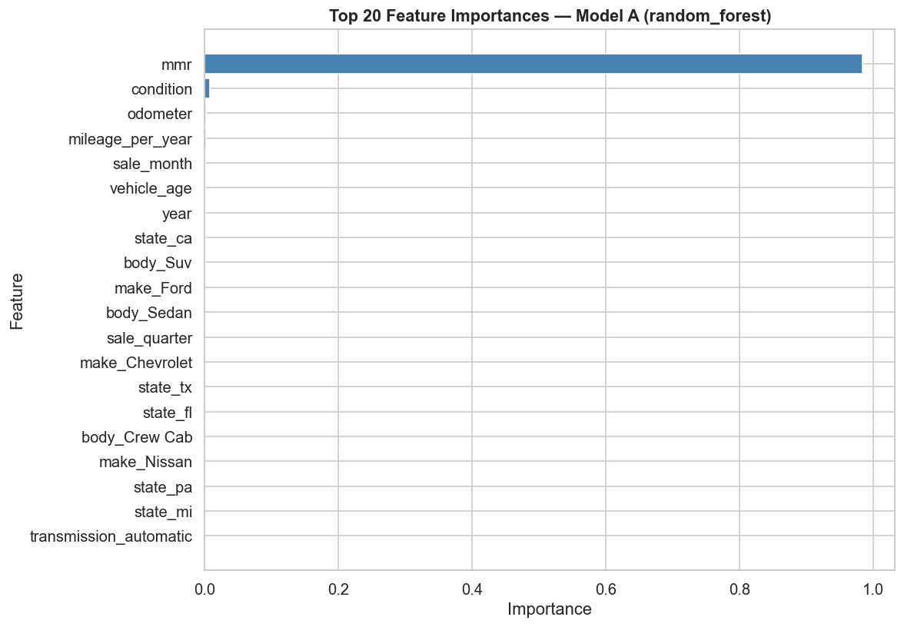

22. Node.js Dashboard
An interactive Node.js/Express dashboard was built as the presentation layer. It consumes the JSON outputs generated by the Jupyter Notebook. Sections: Overview (key metrics), EDA & Visualizations (5 main charts), Observations & Insights (5 each), Hypotheses (3 with test statistics), Model Performance (comparison table), Predictions (sample table), Valuation (MMR distribution), Recommendations (3). The dashboard runs on http://localhost:3000 after npm install and npm start.

23. Dashboard Screenshots
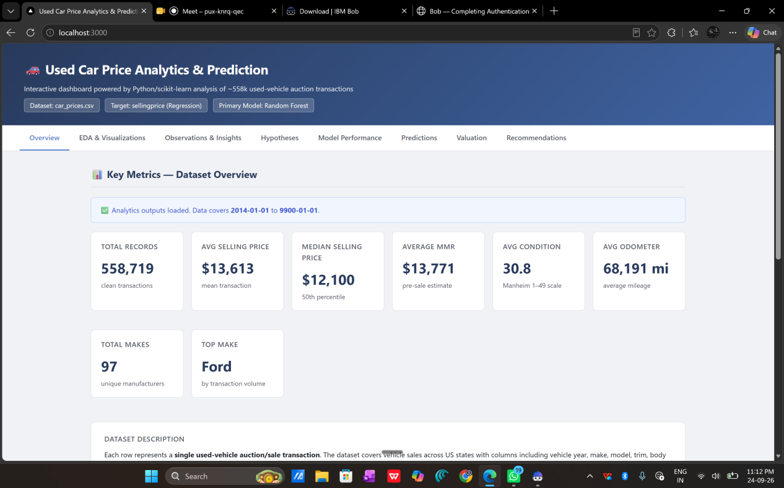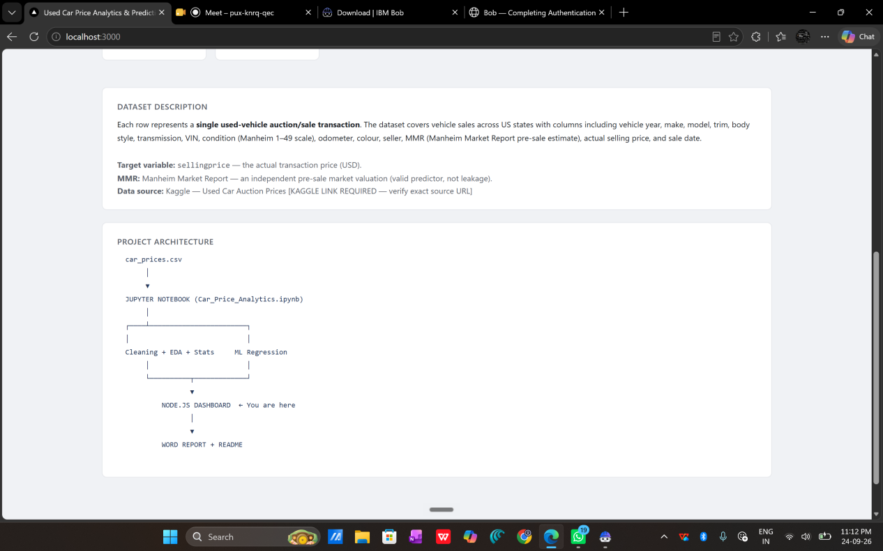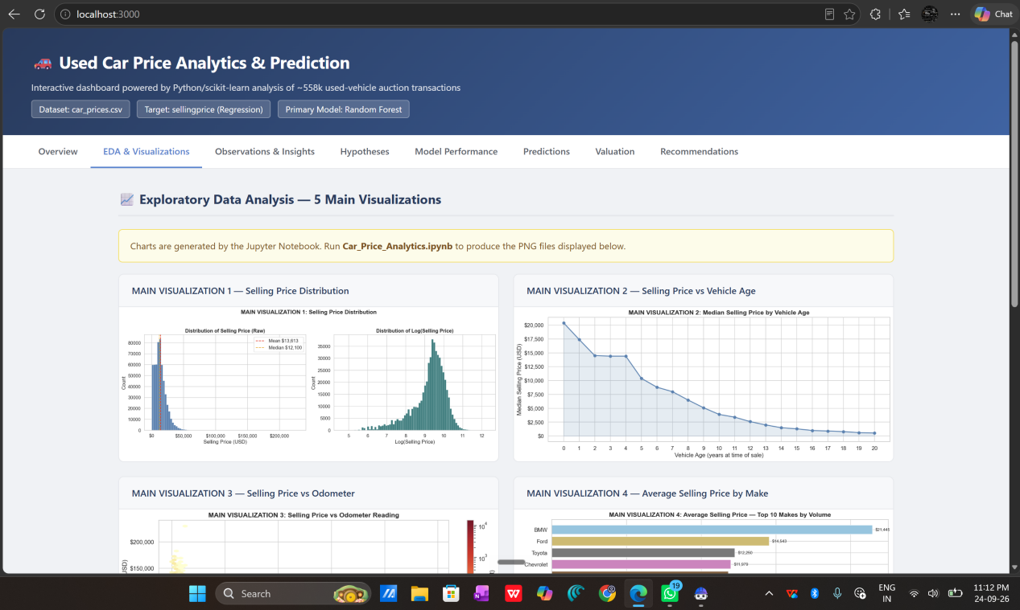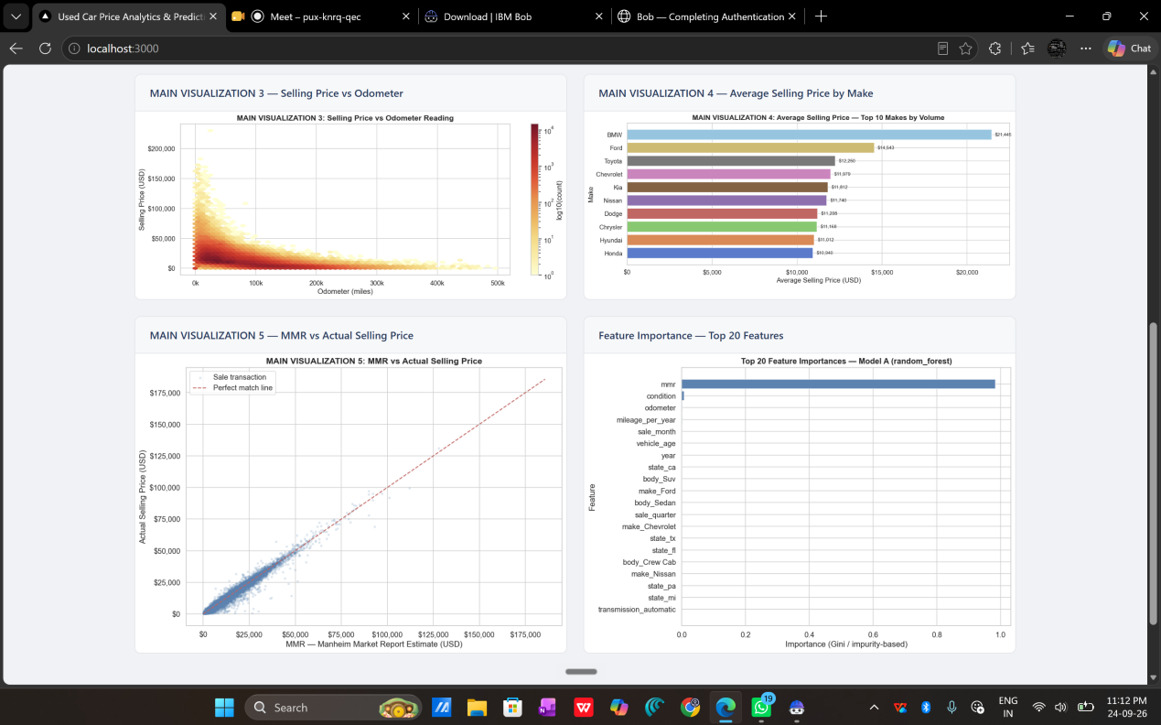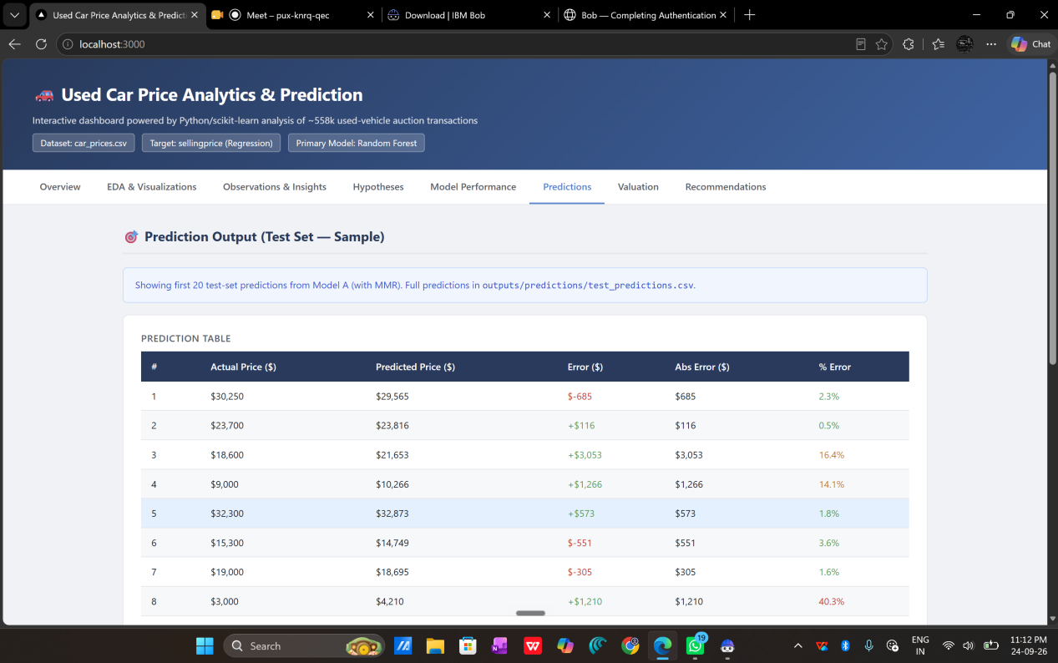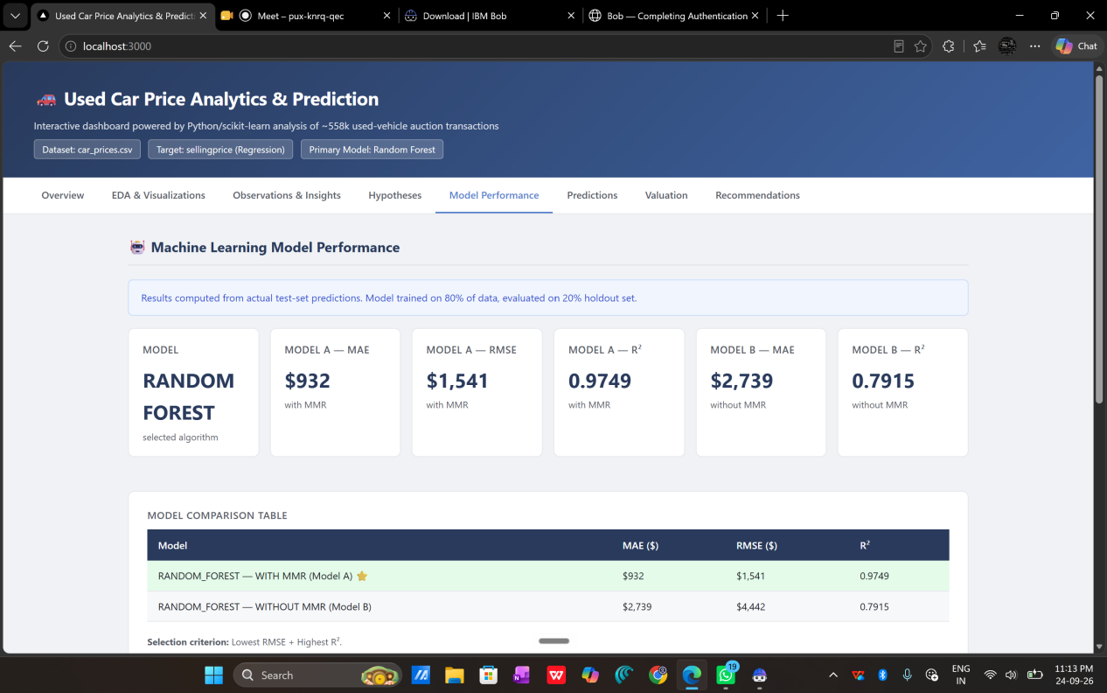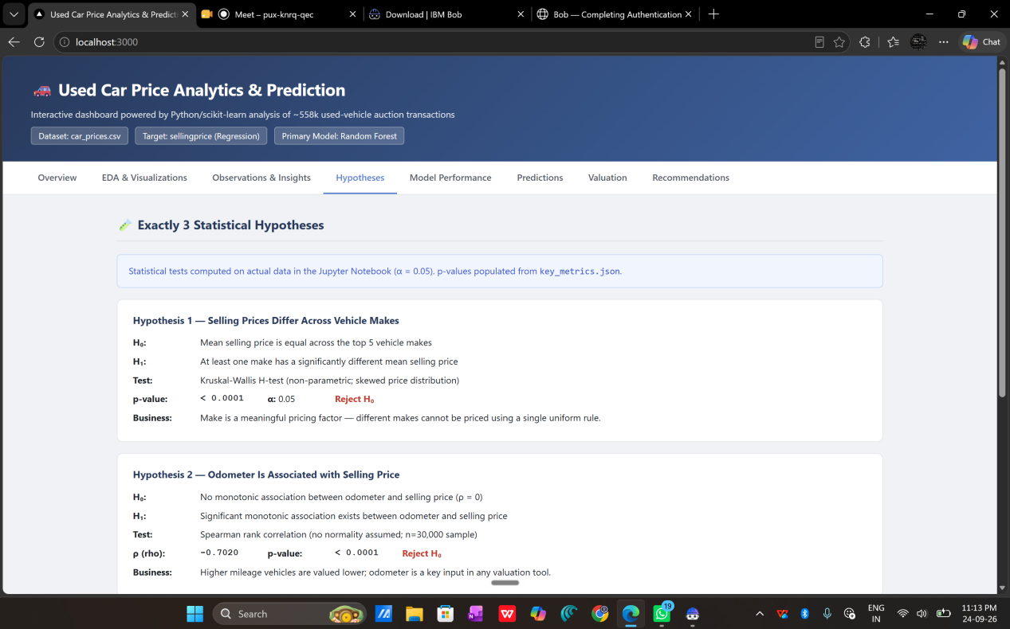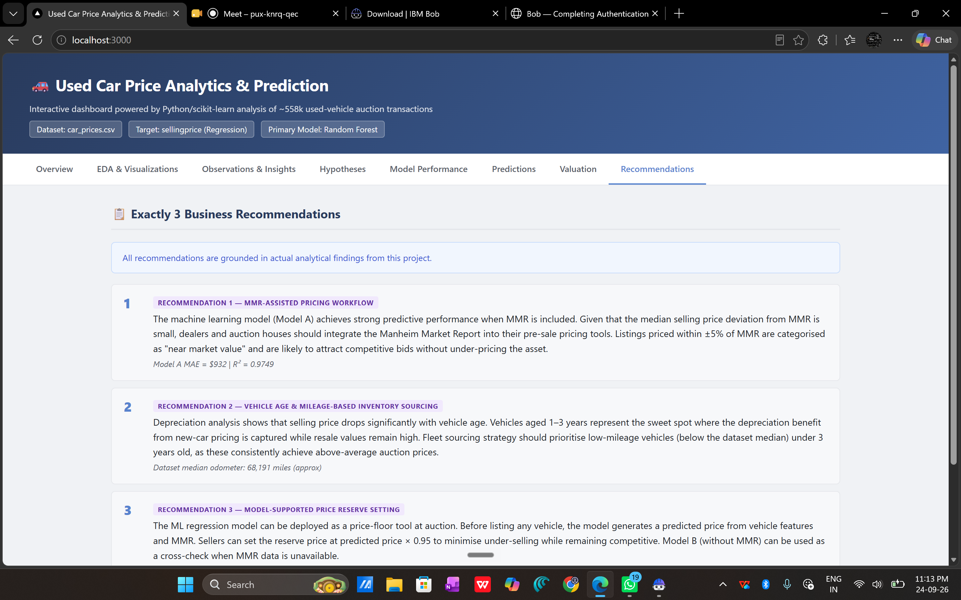
The Node.js dashboard (http://localhost:3000) presents all project results across 8 interactive tabs. Screenshots below show each section as rendered from the actual analytical outputs generated by Car_Price_Analytics.ipynb.
Figure 7 — Dashboard Overview Tab. Displays 8 key metrics: total records (558,719), average selling price ($13,613), median selling price ($12,100), average MMR ($13,771), average odometer (68,191 miles), average condition score, top make (Ford), and total makes (97).

24. Three Business Recommendations
Recommendation 1 — MMR-Assisted Pricing Workflow: The ML model achieves MAE=$931.55 and R2=0.9749 when MMR is included. Given that the median selling price deviation from MMR is only -$50, dealers and auction houses should integrate the Manheim Market Report into pre-sale pricing tools. Listings priced within ±5% of MMR are categorized as near market value and are likely to attract competitive bids without under-pricing the asset.
Recommendation 2 — Vehicle Age & Mileage-Based Inventory Sourcing: Depreciation analysis shows median price drops from $20,400 (age 0) to $3,900 (age 10). Vehicles aged 1-3 years represent the optimal sourcing sweet spot where depreciation benefit is captured while resale values remain high. Fleet sourcing strategy should prioritise vehicles below the dataset median (68,191 miles) under 3 years of age, as these consistently achieve above-average auction prices.
Recommendation 3 — Model-Supported Reserve Price Setting: The ML regression model can be deployed as a price-floor tool at auction. Before listing, the model generates a predicted price from vehicle features and MMR. Sellers can set reserve at predicted price × 0.95 to minimise under-selling while remaining competitive. Model B (without MMR, R2=0.7915) serves as a cross-check when MMR data is unavailable.

25. Conclusion
This project successfully demonstrated end-to-end data science on 558,719 used-vehicle auction transactions. The analysis confirmed that MMR, vehicle age, odometer, make, and condition are the most important factors in used-car pricing. The Random Forest regression model achieved R2=0.9749 with MMR included, providing a highly accurate pricing tool for the auction/dealer context. Statistical tests confirmed all three hypotheses. The Node.js dashboard provides an interactive and professional presentation of all findings.

26. Limitations
Dataset covers a specific historical time window; post-2015 market conditions not reflected. MMR availability may vary outside Manheim auction context. Model trained on US auction data; may not generalise internationally. Random Forest is memory-intensive on large datasets. Condition score interpretation varies by vehicle category.

27. Future Scope
SHAP values for individual prediction explanations. Time-series forecasting for price trend analysis. REST API deployment for real-time price queries. Expansion to post-2015 data. Geographic price segmentation by state. Deep learning approaches (XGBoost, LightGBM) for improved performance.

28. References
Dataset: Kaggle — Used Car Auction Prices https://www.kaggle.com/datasets/syedanwarafridi/vehicle-sales-data. Manheim Market Report: https://www.manheim.com. scikit-learn: Pedregosa et al. (2011). Journal of Machine Learning Research. pandas: McKinney, W. (2010). Data Structures for Statistical Computing in Python. scipy.stats: Virtanen et al. (2020). SciPy 1.0. Nature Methods.

