NAME: Chinmay

USN: 22BTRCL089

BRANCH/SECTION: AIML/’C’

For following practice sets, use Online SQL editor provided by W3Schools.

It already has a database with 8 tables. Also, There are sufficient records in each table.

Develop queries for following tasks while executing them on this database itself. Please keep all the queries saved in a txt file for uploading your assignment purposes.

To complete following tasks, use only your understanding of SQL and JOINS. You can take little help in syntax from internet, but try to avoid using Gen-AI products like ChatGPT to complete the tasks.

**Task 1: List out all the orders with customers. CODE:**

SELECT Orders.OrderID, Orders.OrderDate, Customers.CustomerName FROM Orders

INNER JOIN Customers ON Orders.CustomerID = Customers.CustomerID;

# OUTPUT:

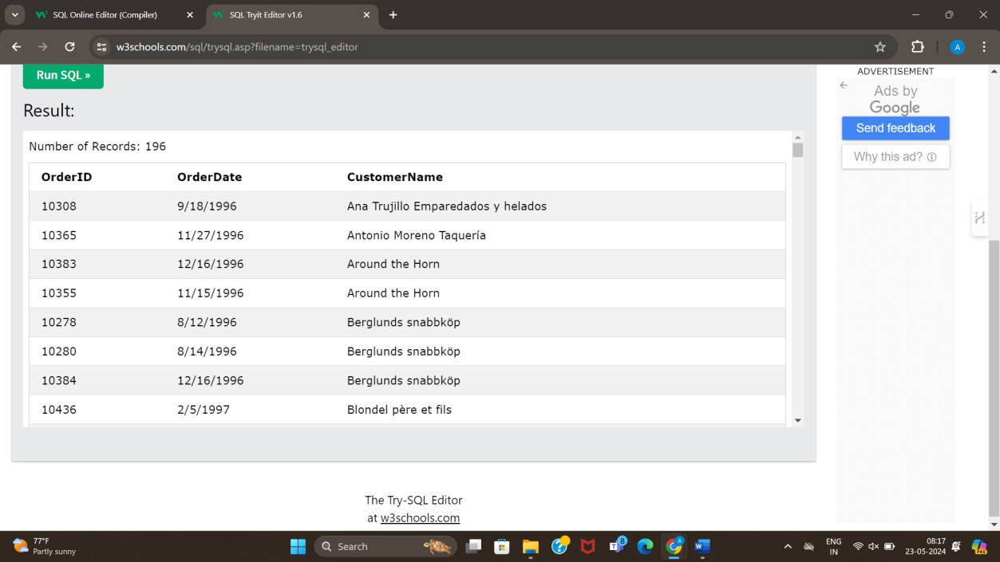

## Task 2: List out all the orders with customers and employees. CODE:

SELECT Orders.OrderID, Orders.OrderDate, Customers.CustomerName FROM Orders

INNER JOIN Customers ON Orders.CustomerID = Customers.CustomerID; (Joining orders and customers table)

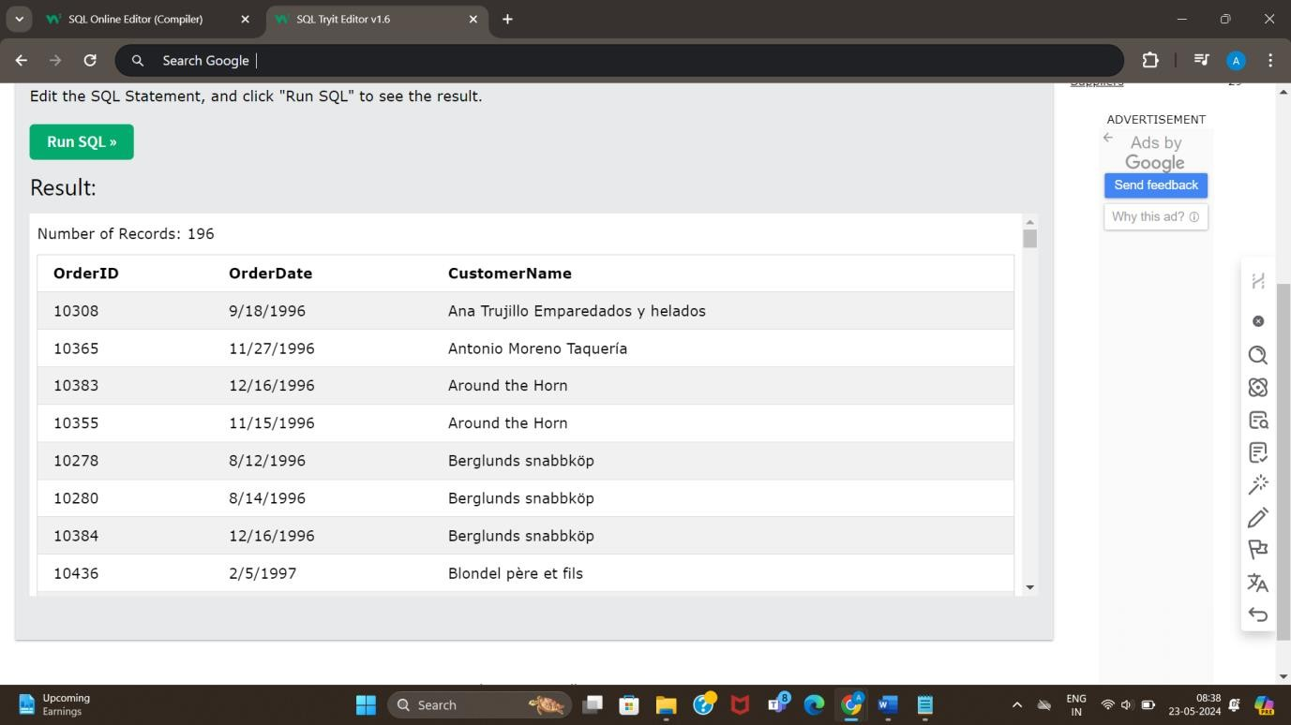

SELECT Orders.OrderID, Orders.OrderDate, Employees.FirstName, Employees.LastName FROM Orders

INNER JOIN Employees ON Orders.EmployeeID = Employees.EmployeeID; (joining orders and employees table)

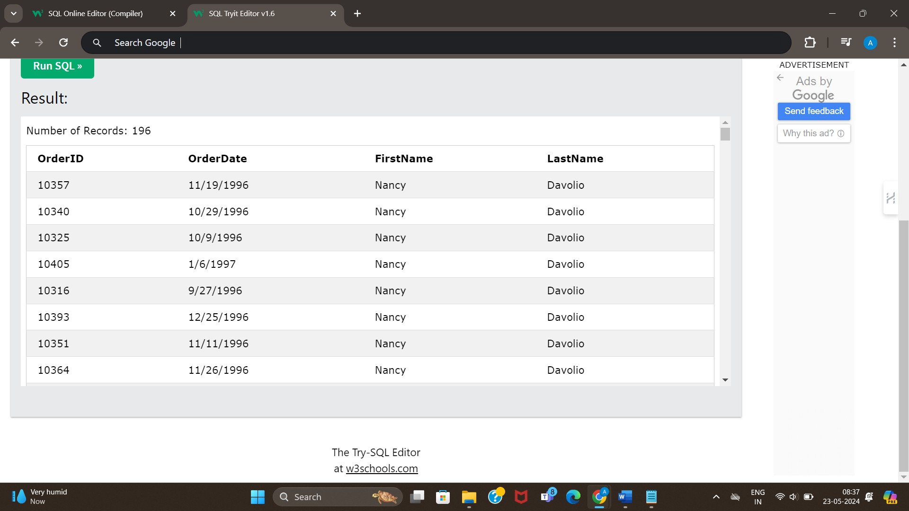

## Task 3: List out all the products with their categories. CODE:

SELECT Products.ProductName, Categories.CategoryName FROM Products

INNER JOIN Categories ON Products.CategoryID = Categories.CategoryID;

# OUTPUT:

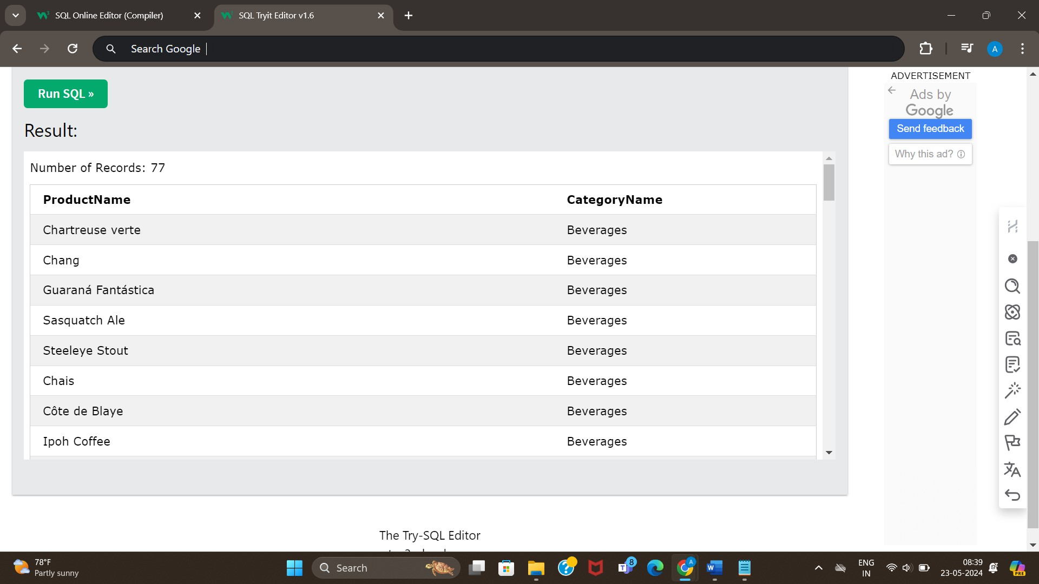

## Task 4: List out all the orders with shipping details. CODE:

SELECT Orders.OrderID, Orders.OrderDate, Shippers.ShipperName FROM Orders

INNER JOIN Shippers ON Orders.ShipperID = Shippers.ShipperID

# OUTPUT:

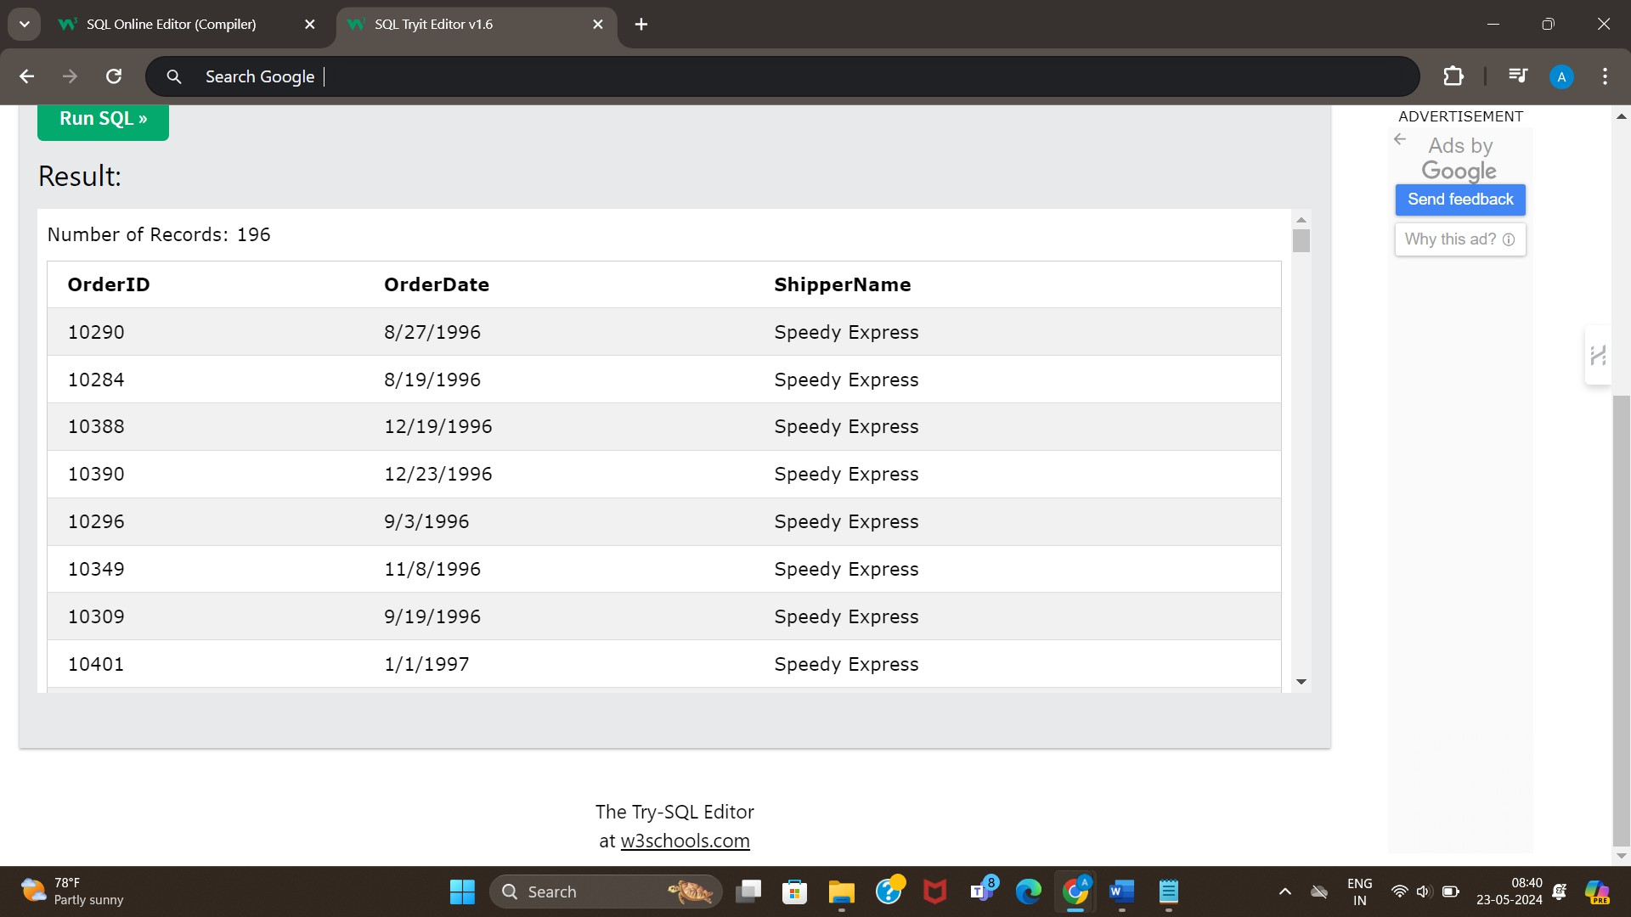

SELECT Orders.OrderID, Orders.OrderDate, Customers.CustomerName FROM Orders

INNER JOIN Customers ON Orders.CustomerID = Customers.CustomerID;

# OUTPUT:

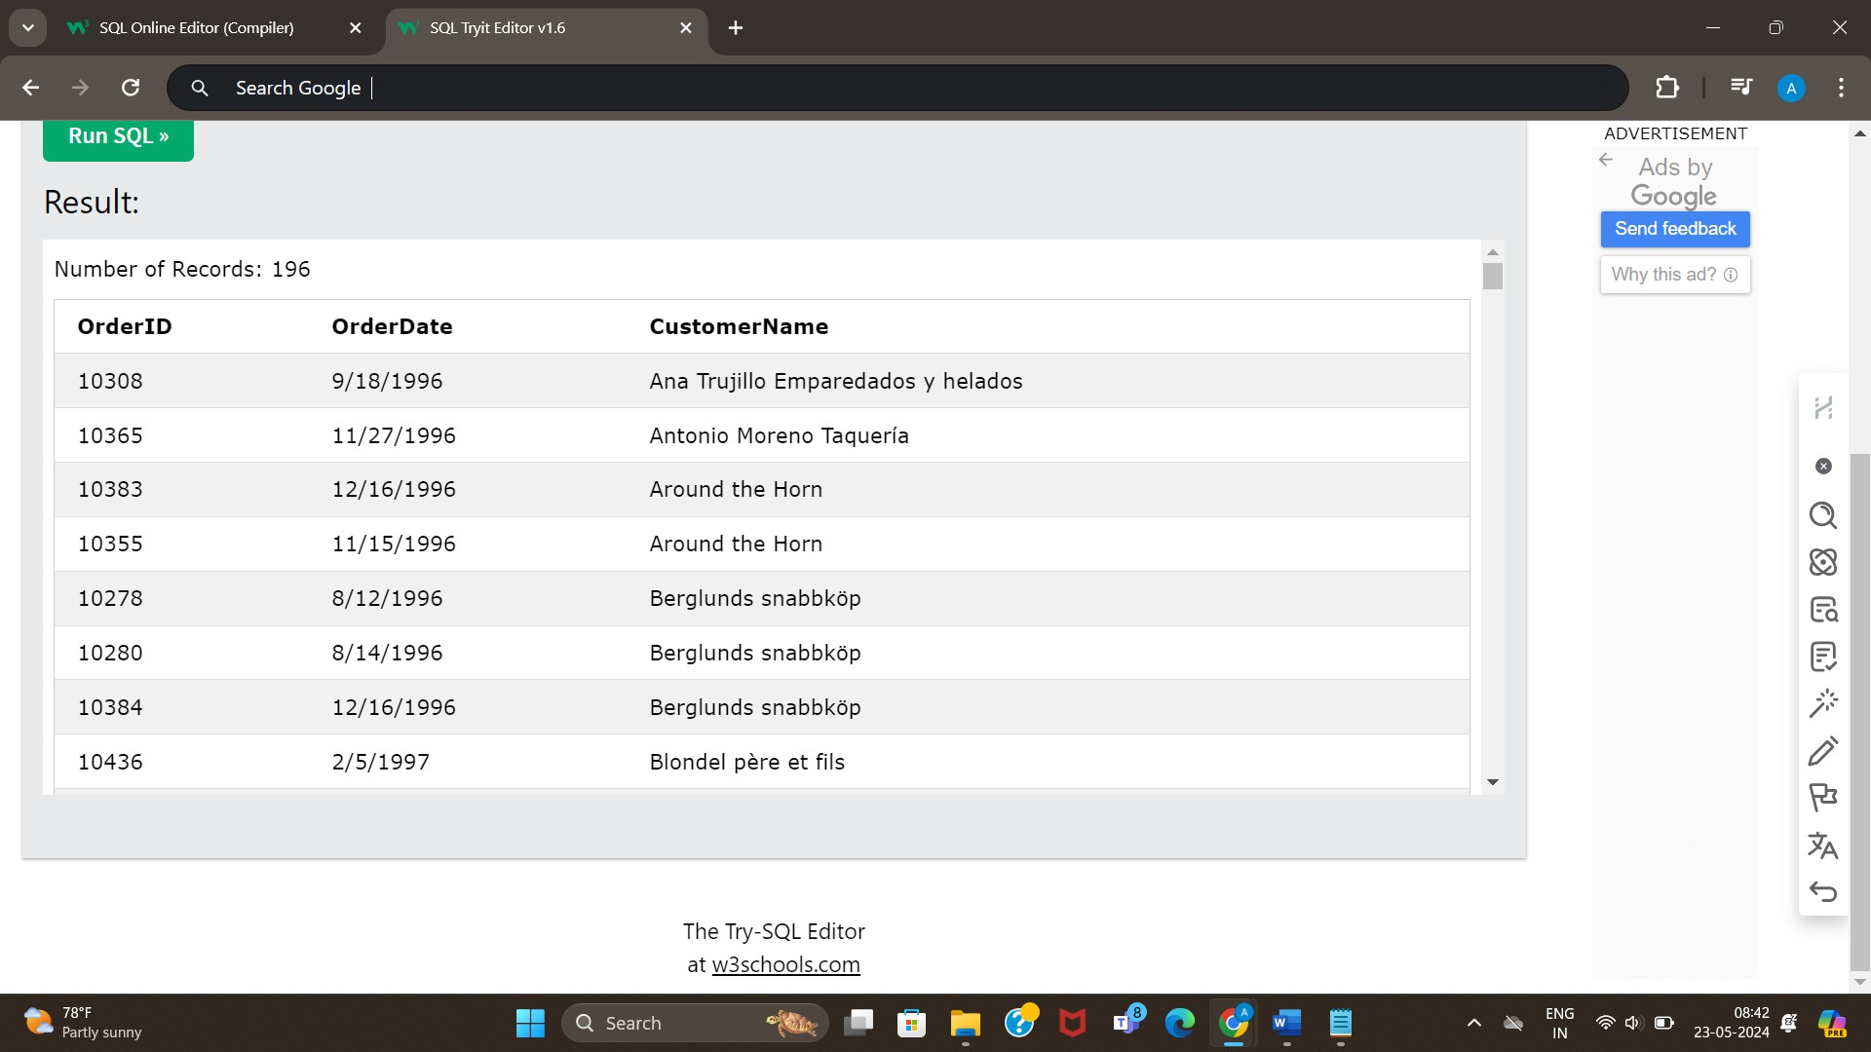

## Task 5: List out all the employees who have not placed any orders. CODE:

SELECT Employees.EmployeeID, Employees.FirstName, Employees.LastName FROM Employees

LEFT JOIN Orders ON Employees.EmployeeID = Orders.EmployeeID WHERE Orders.OrderID IS NULL;

# OUTPUT:

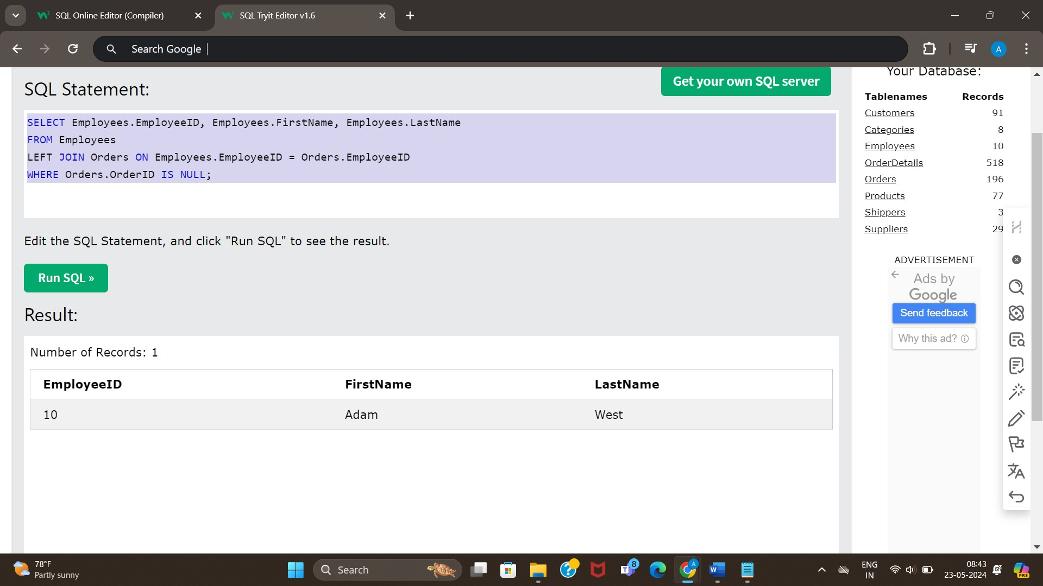

## Task 6: List out top 5 products by order quantity. CODE:

SELECT Products.ProductId, ProductName, sum(OrderDetails.Quantity) as Total_quantity FROM Products

INNER Join OrderDetails on Products.ProductID = OrderDetails.ProductID group by Products.ProductId, Products.ProductName

order by sum(OrderDetails.Quantity) desc

# OUTPUT:

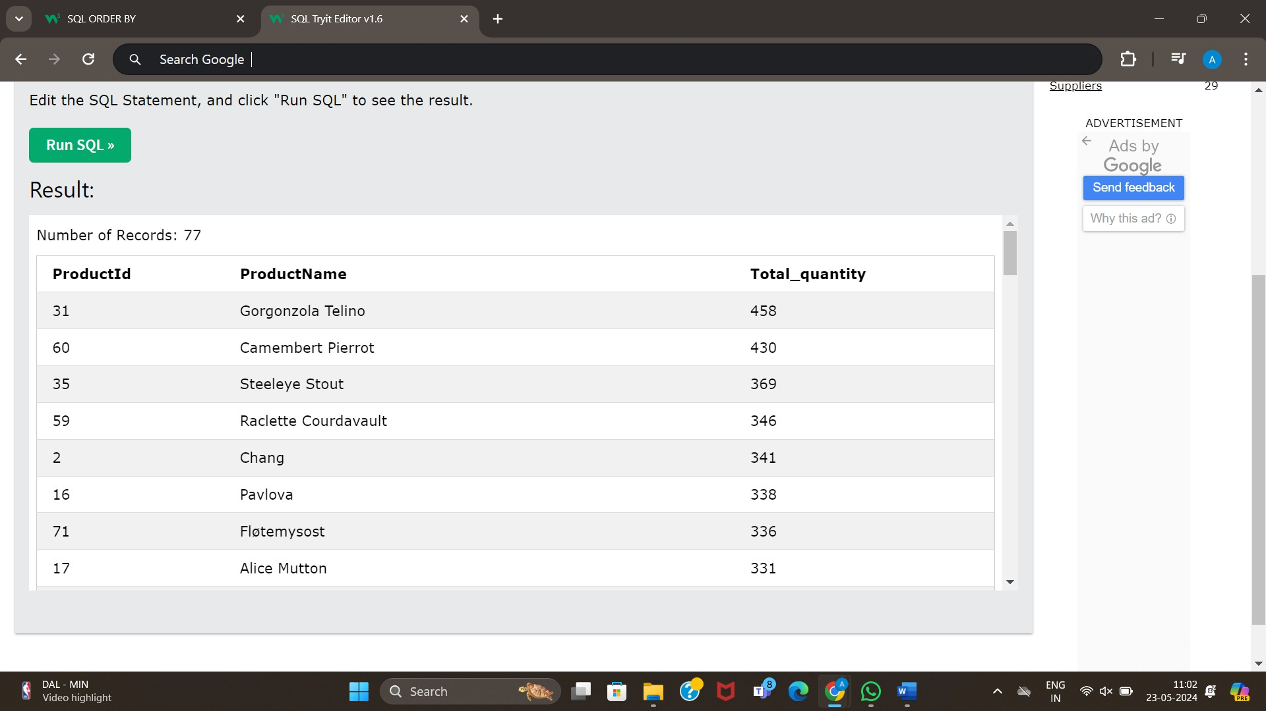

## Task 7: List out customers and their orders in 2023 only. CODE:

SELECT Customers.CustomerName, Orders.OrderID, Orders.OrderDate FROM Orders

INNER JOIN Customers ON Orders.CustomerID = Customers.CustomerID WHERE YEAR(Orders.OrderDate) = 2023;

# OUTPUT:

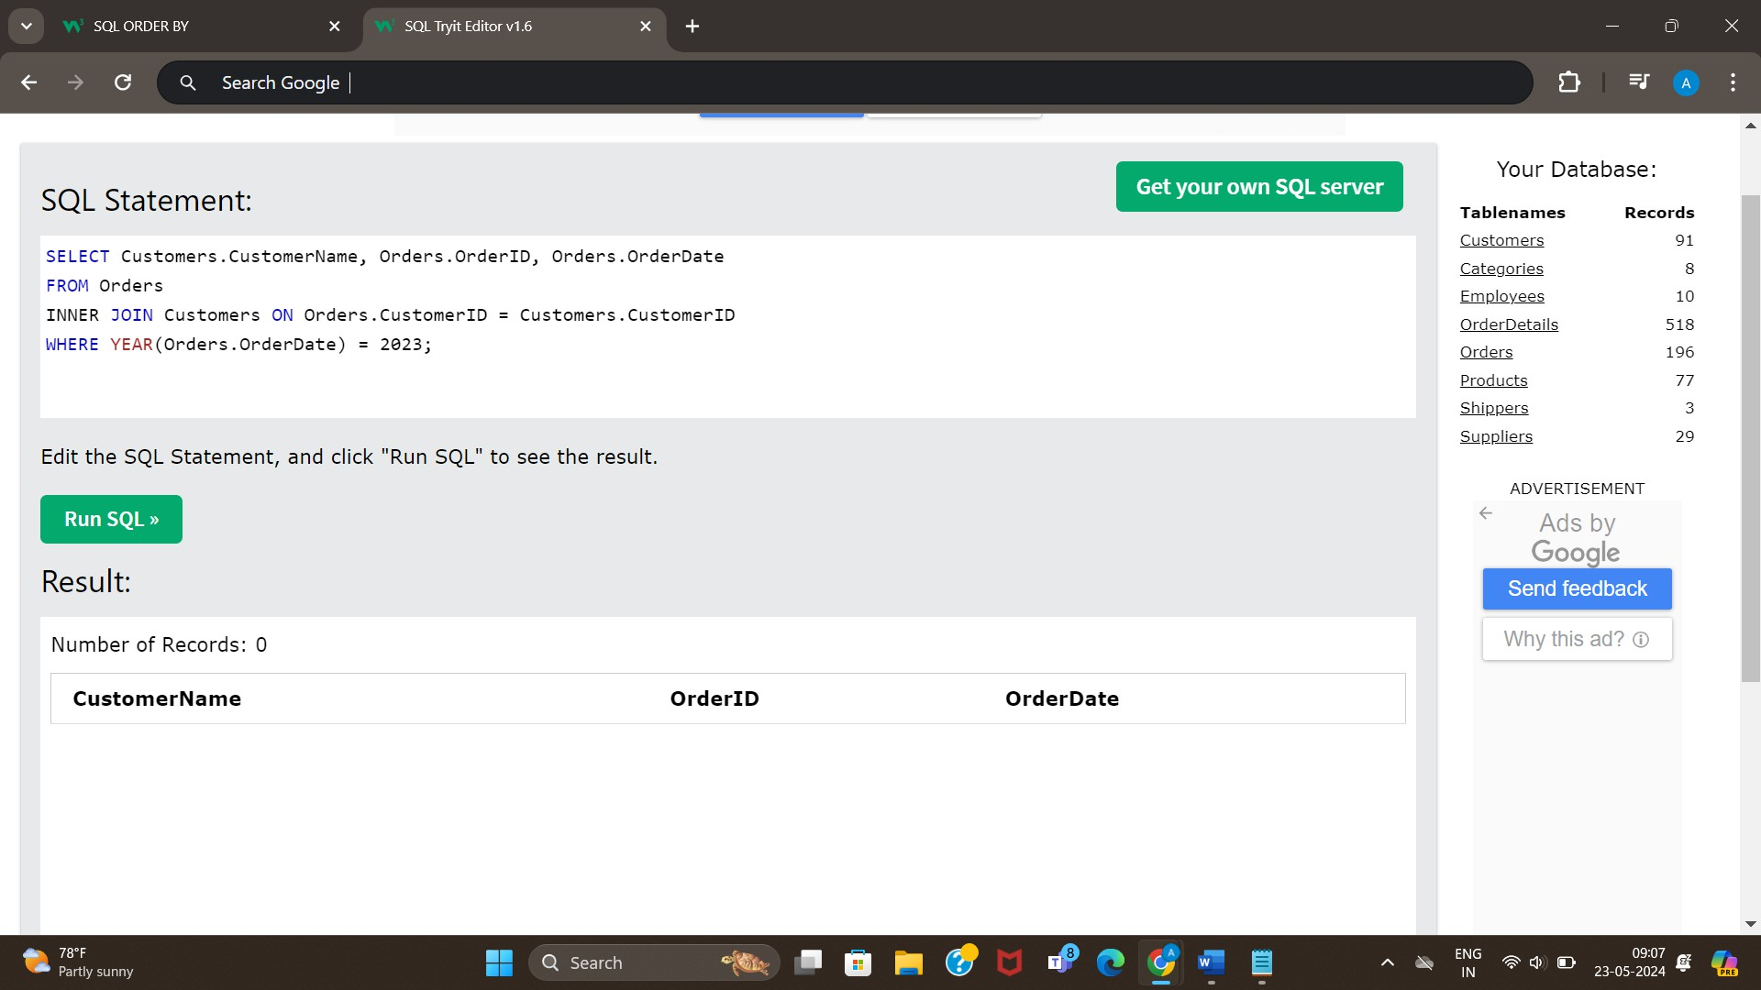

## Task 8: List out all the suppliers with their products. CODE:

SELECT Suppliers.SupplierName, Products.ProductName FROM Suppliers

INNER JOIN Products ON Suppliers.SupplierID = Products.SupplierID;

# OUTPUT:

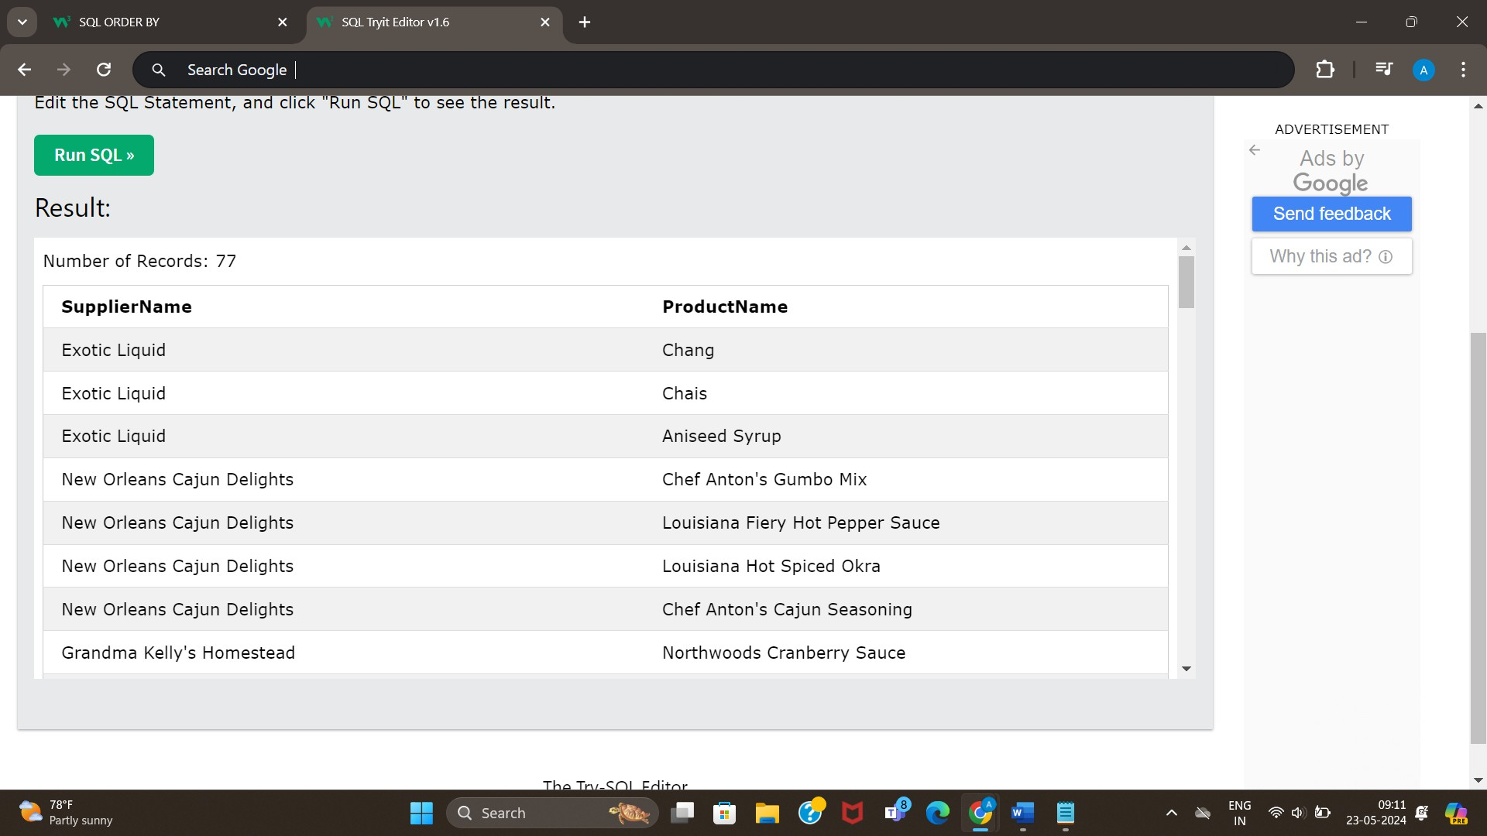

## Task 9: List out all the orders with their detailed product information. CODE:

SELECT * FROM OrderDetails

INNER JOIN Products ON OrderDetails.ProductsID = Products.ProductID;

# OUTPUT:

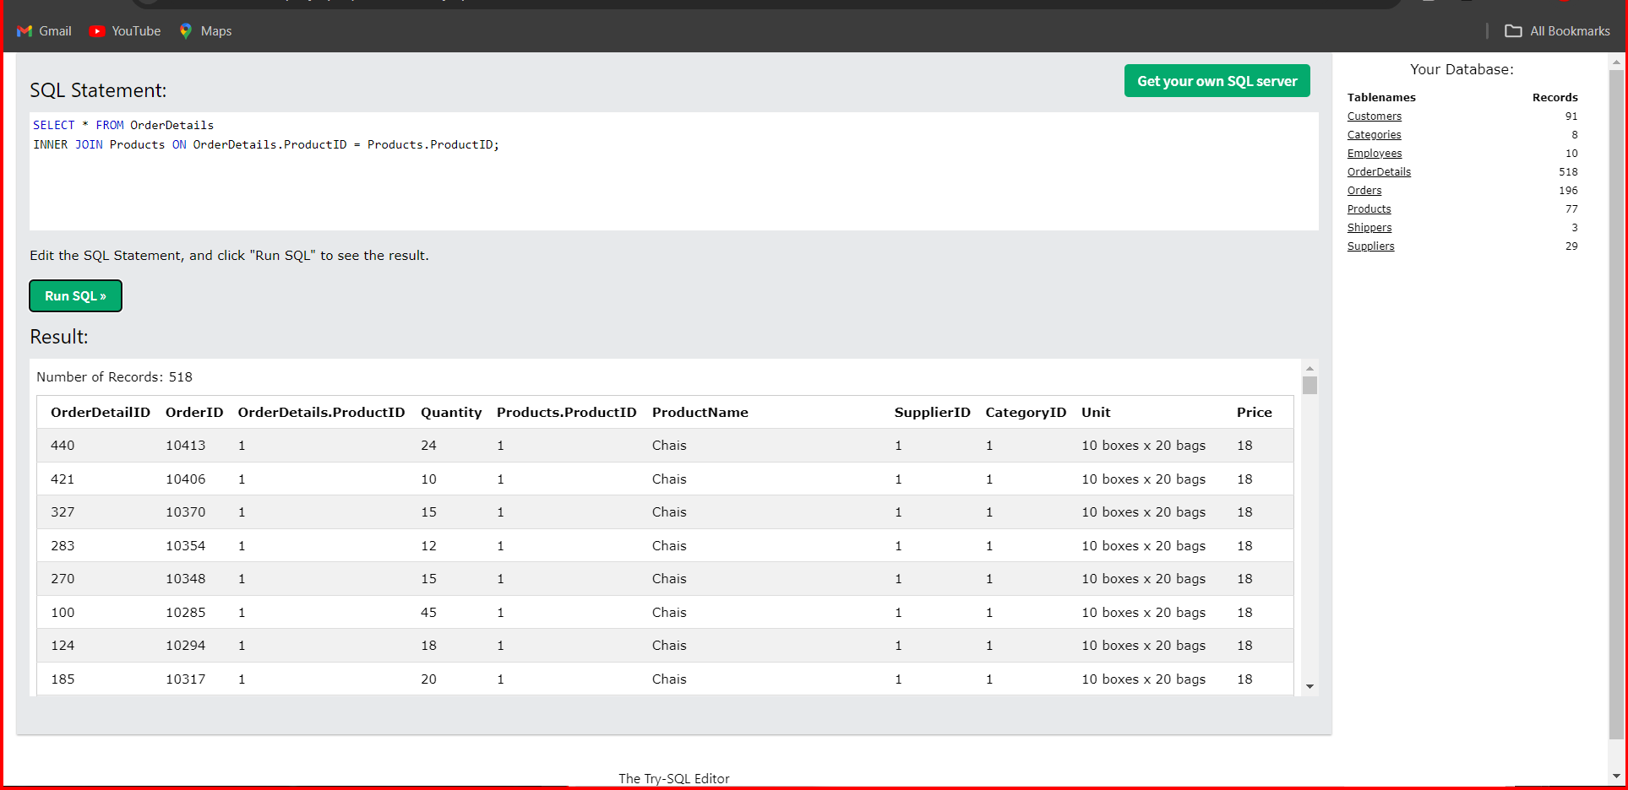

## Challenge: Find birthdays in same month. CODE:

SELECT E1.FirstName AS name_1, E2.FirstName AS name_2, MONTH(E1.BirthDate) AS birth_month FROM Employees E1, Employees E2

WHERE E1.EmployeeID < E2.EmployeeID

AND MONTH(E1.BirthDate)=MONTH(E2.BirthDate) ORDER BY MONTH(E1.BirthDate), E1.EmployeeID

**OUTPUT:**

