GALGOTIAS UNIVERSITY
(School of Computer Science Engineering)

Project Report
On
Pizza Ordering System
Subject-: Web Technologies

Admission No | Enroll. No | Name
17SCSE101592 | 1713101565 | NIKHIL BATHAM
Presented By
Under the guidance of
Prof. Lalit Sharma

Signature of Internal Examiner Signature of External Examiner

Contents of Report:
- ABSTRACT
- INDEX
- Chapter 1-Introduction
- Chapter 2-Analysis
- Chapter-3 Design
- Chapter-4 Implementation
- Chapter-5 Screenshots
- Chapter-6 Conclusion

ABSTRACT:

This is a small scale project for online pizza ordering system. The basic idea is that customers can order pizza online. The administrator can enter the name and password and can create an account and then generate the receipt of the pizza sold.
The Pizza ordering system enables customer to order pizza online, customers can browse through the menu page and select any type of pizza. Customer has to select size of the pizza after selecting pizza type.
The objective and scope of my Project Pizza Ordering System is to record the details various activities of user. It will simplifies the task and reduse the paper work. During implementation every user will be given appropriate training to suit their specific needs. Specific support will also be provided at key points within the academic calendar. Training will be provided on a timely basis, and you will be trained as the new is Pizza Ordering System rolled out to your area of responsibility. At the moment we are in the very early stages, so it is difficult to put a specific time on the training, but we will keep people informed as plans are developed.The system is very user friendly and it is anticipated that functions of the system will be easily accessed by customers,students,etc.

INDEX:

CHAPTER NO. | TOPIC | PAGE NO.
1 | INTRODUCTION | 5
2 | ANALYSIS
2.1 | STUDY OF THE PROBLEM | 6
2.2 | PROJECT SCOPE | 7
2.3 | OBJECTIVES | 8
3 | DESIGN | 9
4 | IMPLEMENTATION | 10

CHAPTER-1

INTRODUCTION:
The aim of this project is on the online pizza ordering system it is developed using HTML5, CSS. The whole world is in love with pizzas. The billions of dollars earned by different pizzerias across the globe just prove this. The love of pizzas has enabled the rise of large pizza companies like Pizza Hut, Domino’s, Papa John’s and much more.
As the internet users are increasing exponentially, these companies have introduced Online Pizza ordering system for taking orders from customers. This system not only improves customer’s experience but also eases the workload on the staff of pizzerias. Thats why it is very important to develop a standalone website to take order from customers.

CHAPTER-2

ANALYSIS:
2.1.Study of the Problem
You must have ordered your pizzas by phone for home delivery. The process seems easy to use but at times there is miscommunication.

As there is no visual menu shown during a phone call, the employees have to repeat a lot of things again and again to the customers.
It’s a time-consuming process which at times irritates customers. Also, it takes a lot of time of the pizzeria staff.
It would be much more comfortable for the customers to have an online pizza ordering system. It would be hassle-free for users as they can select the pizzas they want and make payment for it. Also, it will reduce the purchasing time for customers.
Let us look at another benefit of using this system. Suppose I go to a pizzeria and make the order. Even after ordering pizzas from their outlet, I have to wait at least 15 minutes for my order to be ready.
Wouldn’t it be much more convenient if I ordered my pizzas before using a mobile app or an online system and then it will tell me the time by which I have to pick my order from their counter?

It would be great for me as I don’t need to wait for my pizza. I need to reach there only when my pizza is ready.
In a nutshell, we can say that improved and efficient services are provided to the customers by the inclusion of internet in your business. As a business point of view, it gives you an edge over your competitors.

customer role:
The customer’s can login to the System. She/he can view his/her pizza details and buy their kind of pizza.

ADMINISTRATOR ROLE:
The administrator plays a vital role in the Online pizza ordering system. The administrator controls the entire database. The report of the pizza is generated by the administrator itself. The main role of the administrator is to safeguard the database and can add/delete the pizza from the database.
2.2.Project Scope
The supplementary specification applies to online shopping system. This specification defines the non-functional requirement of the system such as:
Functionality:
Since it stand alone application, one or more user may use it at a time.
Usability:
Desktop interface
Windows 98/2000/XP/7/8
Technology:
Front End : HTML, CSS
Reliability:
The system is available during online time only .
Performance:
The performance depends on hardware specification

2.3. Objectives
The main objectives of this ordering system are:
Build your own pizza – This system will help customers in ordering custom pizzas. So the customer will pick exactly the things which he/she wants in their pizza. This will surely enhance the image of the pizzeria and customer satisfaction will be more.
Online Payment- This system will give the option to the customer for online payment.
This will make pizza buying experience cash free.
Better Knowledge- This system will provide customer all the details of his order before making the order. This confirmation will help customers to check the items ordered with their prices.
Know Delivery Time- This system will show the time by which the order will be delivered to the customer. For pick-ups, customers can fix the time by which they will pick their order.
Reduce Paper Work- As most of the things will be performed online, it will reduce the usage of paper for the pizzeria.
Improves Efficiency- This system will make things easier for staff as whole ordering process is done by the customer only.
These were the objectives of the online pizza ordering System. Let us now get into the details of the working of this ordering system.

CHAPTER-3

DESIGN:

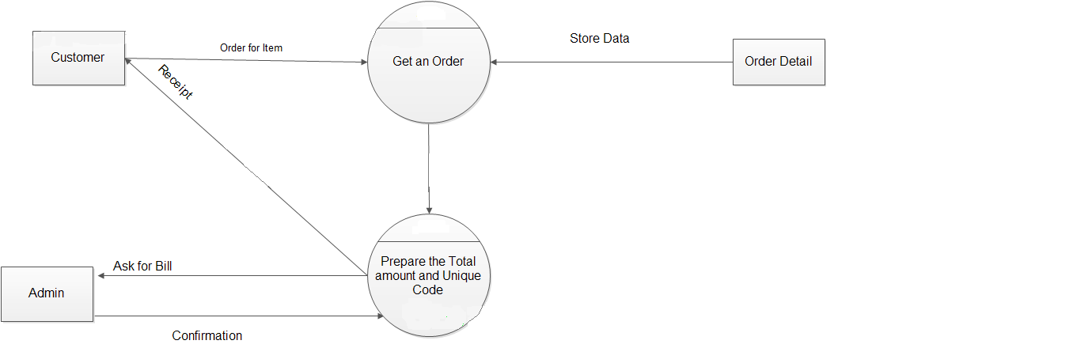

CHAPTER-4

IMPLEMENTATION:
CODE FOR HOMEPAGE
<html><head>
<link rel="stylesheet" href="https://cdnjs.cloudflare.com/ajax/libs/font-awesome/4.7.0/css/font-awesome.min.css">
<title><Pizza Ordering System></title>
<style>
.links{
border-radius:10px;
}
.links:hover{
background-color:green;
}
.zoom
{
transition:transform 0.5s;
}
.zoom:hover
{
transform:scale(1.2);
}
.checked{
color: orange;
}
.header {
padding: 1px;
text-align: center;
background: gray;
color: white;
font-size: 15px;
}

</style>
</head>
<body>
<div class="header" class="links">
<h1><b>Yummy Pizza</b></h1>
</div>
<table border="0" width="100%" height="10%" >
<tr>
<td width="12.5%" align="center" bgcolor="purple" class="links"><font color ="white"><a href="pizza.html" style="color:white">HOME</td>
<td width="12.5%" align="center"bgcolor="Purple" class="links"><font color ="white"><a href="about.html" style="color:white">ABOUT US</a></td>
<td width="12.5%" align="center"bgcolor="purple" class="links"><font color ="white"><a href="contact.html" style="color:white">CONTACT US</td>
<td width="12.5%" align="center"bgcolor="purple" class="links"><font color ="white"><a href="signup.html" style="color:white">SIGN UP</td>
<td width="12.5%" align="center"bgcolor="purple" class="links"><font color ="white"><a href="login.html" style="color:white">LOGIN</td>
</tr>
</table>

<img src="banner_image.jpg" width=100%>
<br>
<H1 align="center"><font color="purple" align="center">Menu</H1>

<table border="0" width="100%">

<tr>
<td class="zoom" align="center"><a href="order.html"><img src="a.png"></a></td>
<td class="zoom" align="center"><a href="order.html"><img src="b.png"></a></td>
<td class="zoom" align="center"><a href="order.html"><img src="farm.png"></a></td>
<td class="zoom"align="center"><a href="order.html"><img src="peppy.png"></a></td>
</tr>

<tr>
<td align="center"><font size="4"><b>Margherit</b></td>
<td align="center"><font size="4"><b>Double Cheese Margherita</b></td>
<td align="center"><font size="4"><b>FarmHouse</b></td>
<td align="center" ><font size="4"><b>Peepy Panner</b></td>

<tr>
<td align="center">
<span class="fa fa-star checked"></span>
<span class="fa fa-star checked"></span>
<span class="fa fa-star checked"></span>
<span class="fa fa-star"></span>
<span class="fa fa-star"></span>
</td>

<td align="center">
<span class="fa fa-star checked"></span>
<span class="fa fa-star checked"></span>
<span class="fa fa-star checked"></span>
<span class="fa fa-star checked"></span>
<span class="fa fa-star"></span>
</td>

<td align="center">
<span class="fa fa-star checked"></span>
<span class="fa fa-star checked"></span>
<span class="fa fa-star checked"></span>
<span class="fa fa-star checked"></span>
<span class="fa fa-star"></span>
</td>

<td align="center">
<span class="fa fa-star checked"></span>
<span class="fa fa-star checked"></span>
<span class="fa fa-star checked"></span>
<span class="fa fa-star"></span>
<span class="fa fa-star"></span>
</td>
</tr>

<tr>
<td align="center"><font size="4" color="green">Price: INR 90/-</td>
<td align="center"><font size="4" color="green">Price: INR 120/-</td>
<td align="center"><font size="4" color="green">Price: INR 150/-</td>
<td align="center" ><font size="4" color="green">Price: INR 150/-</td>
<tr>

<td class="zoom" align="center"><a href="order.html"><img src="mexican.png"></a></td>
<td class="zoom" align="center"><a href="order.html"><img src="deluxv.png"></a></td>
<td class="zoom" align="center"><a href="order.html"><img src="vegextra.png"></a></td>
<td class="zoom" align="center"><a href="order.html"><img src="corn.png"></a></td>
</tr>

<tr>
<td align="center"><font size="4"><b>Mexican Green Wave</b></td>
<td align="center"><font size="4"><b>Deluxe Veggie</b></td>
<td align="center"><font size="4"><b>Veg_Extravaganz</b></td>
<td align="center" ><font size="4"><b>Corn & Cheese</b></td>
<tr>

<tr>
<td align="center">
<span class="fa fa-star checked"></span>
<span class="fa fa-star checked"></span>
<span class="fa fa-star checked"></span>
<span class="fa fa-star checked"></span>
<span class="fa fa-star checked"></span>
</td>

<td align="center">
<span class="fa fa-star checked"></span>
<span class="fa fa-star checked"></span>
<span class="fa fa-star checked"></span>
<span class="fa fa-star checked"></span>
<span class="fa fa-star"></span>
</td>

<td align="center">
<span class="fa fa-star checked"></span>
<span class="fa fa-star checked"></span>
<span class="fa fa-star checked"></span>
<span class="fa fa-star"></span>
<span class="fa fa-star"></span>
</td>

<td align="center">
<span class="fa fa-star checked"></span>
<span class="fa fa-star checked"></span>
<span class="fa fa-star checked"></span>
<span class="fa fa-star checked"></span>
<span class="fa fa-star"></span>
</td>
</tr>

<tr>
<td align="center"><font size="4" color="green">Price: INR 160/-</td>
<td align="center"><font size="4" color="green">Price: INR 160/-</td>
<td align="center"><font size="4" color="green">Price: INR 170/-</td>
<td align="center" ><font size="4" color="green">Price: INR 175/-</td>
<tr>

<tr>
<td class="zoom" align="center"><a href="order.html"><img src="panner.png" ></a></td>
<td class="zoom" align="center"><a href="order.html"><img src="digital.png"></a></td>
<td class="zoom" align="center"><a href="order.html"><img src="fresh.png"></a></td>
<td class="zoom" align="center"><a href="order.html"><img src="indian.png" height=55%></a></td>
</tr>

<tr>
<td align="center"><font size="4"><b>Paneer Makhni</b></td>
<td align="center"><font size="4"><b>Digital Veggie</b></td>
<td align="center"><font size="4"><b>Fresh Veggie</b></td>
<td align="center" ><font size="4"><b>Indian Tandoori Paneer</b></td>
<tr>

<tr>
<td align="center">
<span class="fa fa-star checked"></span>
<span class="fa fa-star checked"></span>
<span class="fa fa-star checked"></span>
<span class="fa fa-star checked"></span>
<span class="fa fa-star checked"></span>
</td>

<td align="center">
<span class="fa fa-star checked"></span>
<span class="fa fa-star checked"></span>
<span class="fa fa-star checked"></span>
<span class="fa fa-star checked"></span>
<span class="fa fa-star"></span>
</td>

<td align="center">
<span class="fa fa-star checked"></span>
<span class="fa fa-star checked"></span>
<span class="fa fa-star checked"></span>
<span class="fa fa-star"></span>
<span class="fa fa-star"></span>
</td>

<td align="center">
<span class="fa fa-star checked"></span>
<span class="fa fa-star checked"></span>
<span class="fa fa-star checked"></span>
<span class="fa fa-star checked"></span>
<span class="fa fa-star checked"></span>
</td>
</tr>
<tr>
<td align="center"><font size="4" color="green">Price: INR 160/-</td>
<td align="center"><font size="4" color="green">Price: INR 185-</td>
<td align="center"><font size="4" color="green">Price: INR 170/-</td>
<td align="center" ><font size="4" color="green">Price: INR 200/-</td>
<tr>

</table>

<table border="0" width="100%" bgcolor="purple" height="10%">
<tr>
<td align="center" ><font color="white"> Designed By Nikhil Batham
</td>
</tr>
</table>

</body>
</html>
CODE FOR SIGNUP

<html>
<head>
<title>Sign up</title>
<style>
input[type=text], select, textarea {
width: 100%;
padding: 12px;
border: 1px solid #ccc;
border-radius: 4px;
box-sizing: border-box;
margin-top: 6px;
margin-bottom: 16px;
resize: vertical
}

input[type=submit] {
background-color: #4CAF50;
color: white;
padding: 12px 20px;
border: none;
border-radius: 4px;
cursor: pointer;
}

input[type=submit]:hover {
background-color: #45a049;
}

.container {
border-radius: 5px;
background-color: #f2f2f2;
padding: 20px;
}
.header {
padding: 1px;
text-align: center;
background: gray;
color: white;
font-size: 15px;
}
.links{
border-radius:10px;
}
</style>
</head>
<body>
<div class="header" class="links">
<h1>Sign Up</h1>

</div>
<div class="container">
<form action="action_page.php">

<label for="fname">First Name</label>
<input type="text" id="fname" name="firstname" placeholder="Your name..">

<label for="lname">Last Name</label>
<input type="text" id="lname" name="lastname" placeholder="Your last name..">

<label for="lname">E-Mail </label>
<input type="text" placeholder="Your email">

<label for="lname">Mobile Number </label>
<input type="text" placeholder="Your Mobile Number">
<label for="lname">Password </label>
<input type="password" id="lname" name="lastname" placeholder="Password">
<label for="lname">Confirm password </label>
<input type="password" placeholder="Confirm password">
<input type="submit" value="Signup">

</form>
</div>
</body>
</html>

CODE FOR LOGIN

<html><head>
<title>Login</title>
<style>
input[type=text], select, textarea {
width: 100%;
padding: 12px;
border: 1px solid #ccc;
border-radius: 4px;
box-sizing: border-box;
margin-top: 6px;
margin-bottom: 16px;
resize: vertical
}

input[type=submit] {
background-color: #4CAF50;
color: white;
padding: 12px 20px;
border: none;
border-radius: 4px;
cursor: pointer;
}

input[type=submit]:hover {
background-color: #45a049;
}

.container {
border-radius: 5px;
background-color: #f2f2f2;
padding: 20px;
}
.header {
padding: 1px;
text-align: center;
background: gray;
color: white;
font-size: 15px;
}
.links{
border-radius:10px;
}
</style>
</head>
<body>
<div class="header" class="links">
<h1>Login</h1>

</div>
<div class="container">
<form action="action_page.php">

<label for="lname">E-Mail </label>
<input type="text" placeholder="Your email">

<label for="lname">Password </label>
<input type="password" id="lname" name="lastname" placeholder="Password">

<input type="submit" value="Login">

</form>
</div>
</body>
</html>
CODE FOR CONTACT US

<html><head>
<title>Contact us</title>
<style>
input[type=text], select, textarea {
width: 100%;
padding: 12px;
border: 1px solid #ccc;
border-radius: 4px;
box-sizing: border-box;
margin-top: 6px;
margin-bottom: 16px;
resize: vertical
}

input[type=submit] {
background-color: #4CAF50;
color: white;
padding: 12px 20px;
border: none;
border-radius: 4px;
cursor: pointer;
}

input[type=submit]:hover {
background-color: #45a049;
}

.container {
border-radius: 5px;
background-color: #f2f2f2;
padding: 20px;
}
.header {
padding: 1px;
text-align: center;
background: gray;
color: white;
font-size: 15px;
}
.links{
border-radius:10px;
}
</style>
</head>
<body>
<div class="header" class="links">
<h1>Contact Us</h1>

</div>
<div class="container">
<form action="action_page.php">

<label for="fname">First Name</label>
<input type="text" id="fname" name="firstname" placeholder="Your name..">

<label for="lname">Last Name</label>
<input type="text" id="lname" name="lastname" placeholder="Your last name..">

<label for="subject">Subject</label>
<textarea id="subject" name="subject" placeholder="Write something.." style="height:200px"></textarea>

<input type="submit" value="Submit">

</form>
</div>
</body>
</html>
CODE FOR ABOUT

<html>
<head>
<title>About-us Page</title>
<style>
.header {
padding: 1px;
text-align: center;
background: gray;
color: white;
font-size: 15px;
}
.links{
border-radius:10px;
}
</style>
</head>
<body>
<div class="header" class="links">
<h1>About Us</h1>

</div>

<p><b>Y</b>UMMY PIZZA HAS REACHED MIDDLE AGE BECAUSE WE ARE GOOD AT WHAT WE DO.

WE'RE PROUD TO RESPONSIBLY MANAGE OUR RESOURCES TO HELP OUR PEOPLE, OUR GUESTS AND OUR PLANET.

THAT'S WHY WE LIKE TO THINK WE'RE THE BEST LOVED PLACE TO EAT AND WORK.

WE PRIDE OURSELVES IN OFFERING YOU THE VERY BEST PIZZA AND WE VALUE YOUR PATRONAGE.</p>
<BR>
<BR>

<footer>Devloped by Nikhil Batham</footer>
</body>
</html>

CODE FOR ORDER:

<html><head>
<title>Place your order</title>
<style>
input[type=text], select, textarea {
width: 100%;
padding: 12px;
border: 1px solid #ccc;
border-radius: 4px;
box-sizing: border-box;
margin-top: 6px;
margin-bottom: 16px;
resize: vertical
}

input[type=submit] {
background-color: #4CAF50;
color: white;
padding: 12px 20px;
border: none;
border-radius: 4px;
cursor: pointer;
}
input[type=submi] {
background-color: red;
color: white;
padding: 12px 20px;
border: none;
border-radius: 4px;
cursor: pointer;
}

input[type=submit]:hover {
background-color: #45a049;
}

.container {
border-radius: 5px;
background-color: #f2f2f2;
padding: 20px;
}
.header {
padding: 1px;
text-align: center;
background: gray;
color: white;
font-size: 15px;
}
.links{
border-radius:10px;
}
</style>
</head>
<body>
<div class="header" class="links">
<h1>Place your Order</h1>

</div>
<div class="container">
<form action="action_page.php">

<label for="lname">Name</label>
<input type="text" placeholder="Your Name">
<label for="lname">Mobile Number</label>
<input type="text" placeholder="Your Mobile Number" maxlength='10'>
<label for="lname">Size</label><br>

<select id="size" name="size">
<option value="Small">Small</option>
<option value="Medium">Medium</option>
<option value="Large">Large</option>

</select>
<br>
<label for="lname">Quanitity </label>
<input type="number" placeholder="Quantity">
<br><br>
<label for="Address">Address </label>
<input type="text" placeholder="Your Address">
<br>
<td>Payment mode</td>
<select id="Payment" name="Payment">
<option value="Cash">Cash On Delivery</option>
<option value="Online">Online Mode</option>

<input type="submit" value="Login">
<input type="submi" value="Pay As Guest">

</form>
</div>
</body>
</html>

SCREENSHOTS

HOMEPAGE:

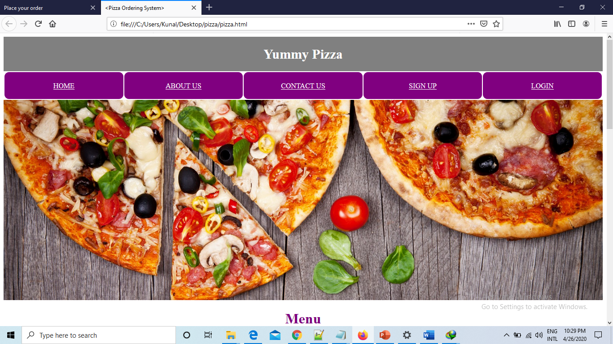

MENU: 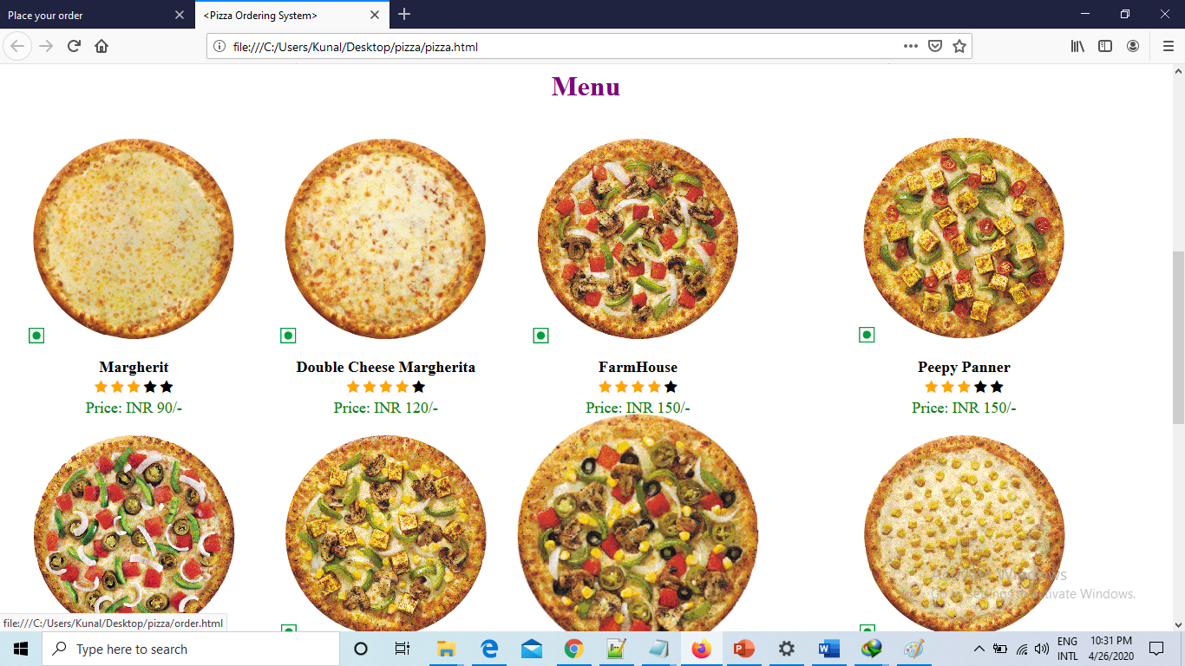

ABOUT US:
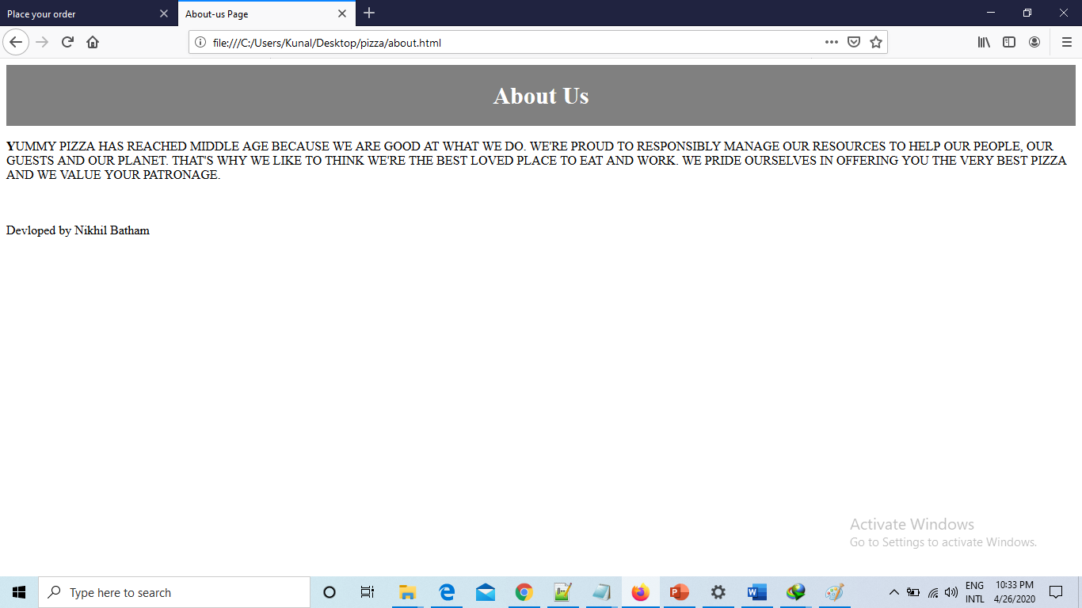

CONTACT US:

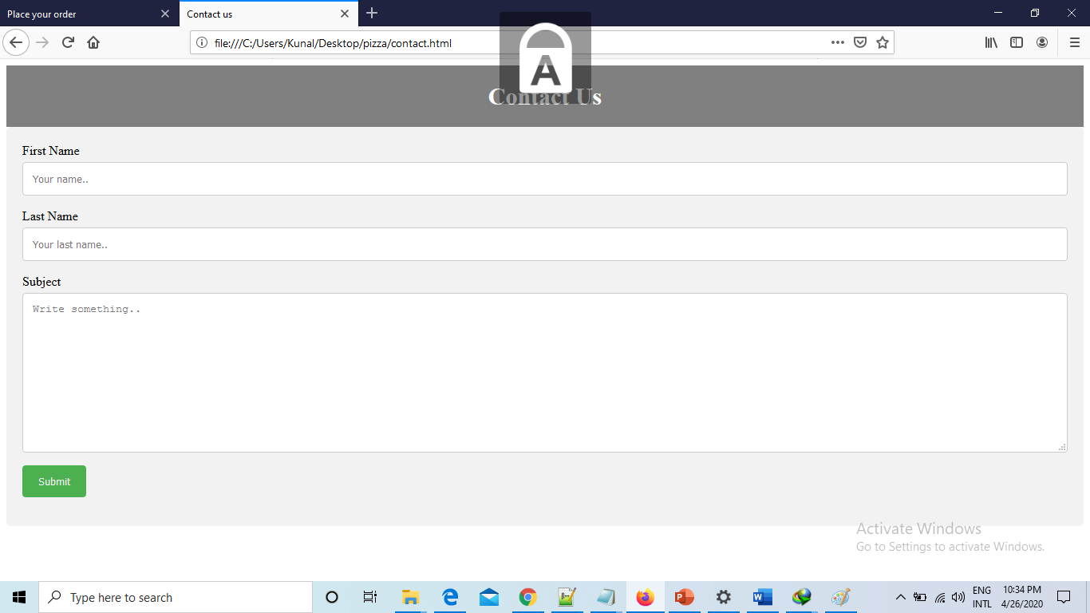

SIGNUP:
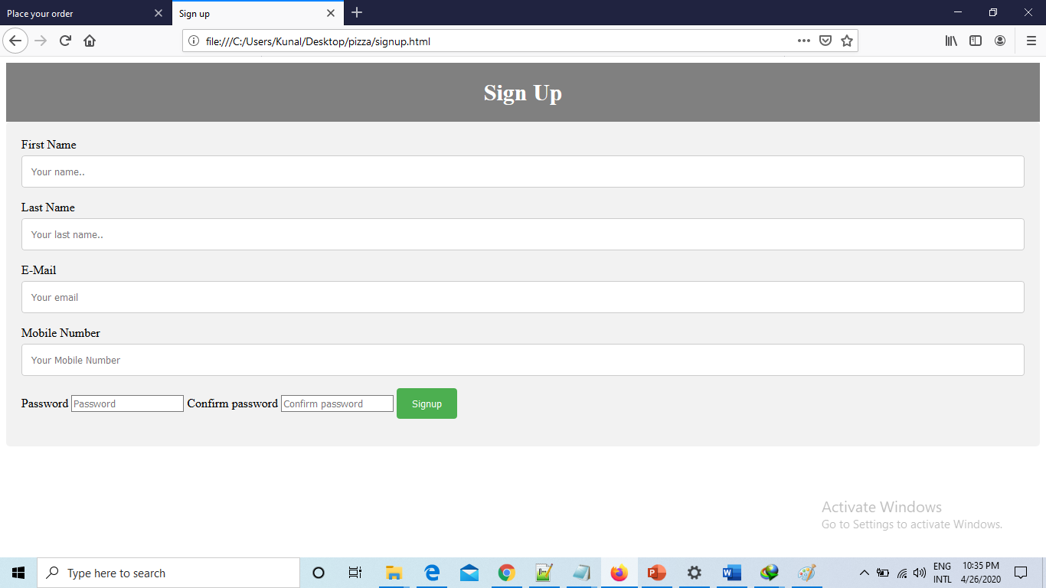

LOGIN:
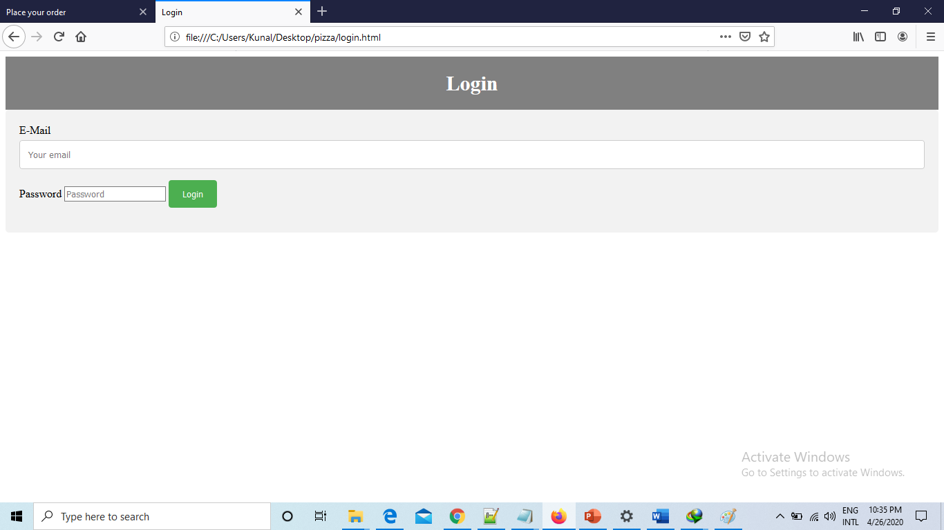

ORDER:
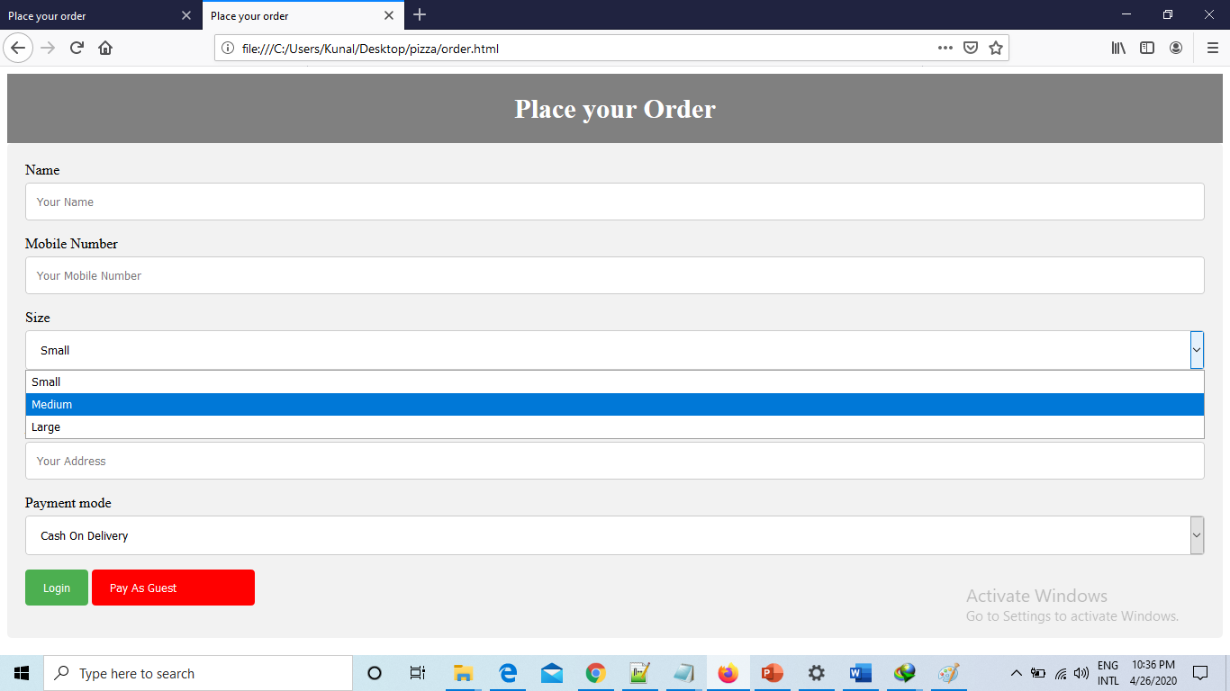

CONCLUSION

So, friends, this was all about online pizza ordering system. You know the importance of this system in our day-to-day lives as we all prefer online ordering over ordering on phone. This website can be accessed through any operating system. This Online system will help customer and retailer both.

