**Aim:** To study the basics of prolog

**Theory:**

A Prolog program is a set of facts or rules called definite clauses. We’ll usually refer to them as clauses. The example program that follows describes some family relationships. We’ll use the predicates “par” and “grand” with the following meanings.

par(X, Y) means that X is a parent of Y.

grand(X, Y) means that X is a grandparent of Y.

Now we’ll list the program, which consists of some parent facts together with a rule that defines the grandparent relationship in terms of parents. Note that a comment is signified by the character % followed by any sequence of characters up to the end of the line. Another way to comment is to place any sequence of characters, including new lines, between the symbols /* and */.

% Here is a set of facts describing parental relationships.

par(lloyd, james).

par(lloyd, janet).

par(ruth, james).

par(ruth, janet).

par(emma, lloyd).

par(katherine, ruth).

par(adolph, lloyd).

par(edgar, ruth).

% The grandparent relationship. Any rule of the form

% A :- B, C is read, “A is true if B is true and C is true.”

grand(X, Z) :- par(Y, Z), par(X, Y).

Now, suppose that you have entered this program into a file named familyTree. To read in the program type the following command.

|?- [familyTree].

Once the program has been read in it won’t do anything until it is presented with a goal. We’ll give some example goals that ask questions about children and grandparents.

**Block Diagram:**

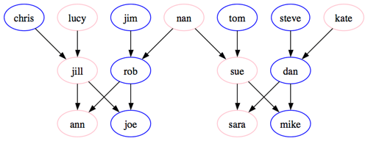

**Code:**

Experiment 1.pl

parent(pam, bob).

parent(tom, bob).

parent(tom, liz).

parent(bob, ann).

parent(bob, pat).

parent(pat, jim).

parent(liz, ann).

female(pam).

male(tom).

male(bob).

female(liz).

female(ann).

female(pat).

male(jim).

offspring(Y, X):- parent(X, Y).

mother(X, Y):- parent(X, Y),female(X).

grandparent(X, Z):- parent(X, Y),parent(Y, Z).

sister(X,Y):- parent(Z, X), parent(Z, Y), female(X), X \= Y.

predecessor(X, Z):- parent(X, Z).

predecessor(X, Z):- parent(X, Y), predecessor(Y, Z).

sisters(X, Y):- sister(X, Y), sister(Y, X).

father(X, Y):- parent(X, Y), male(X).

Experiment1(b).pl

category(base,electronics).

category(electronics,handhelds).

category(electronics,laptops).

category(base,clothings).

category(clothings,formals).

category(clothings,casuals).

category(base,others).

category(others,xtoys).

**Output:**

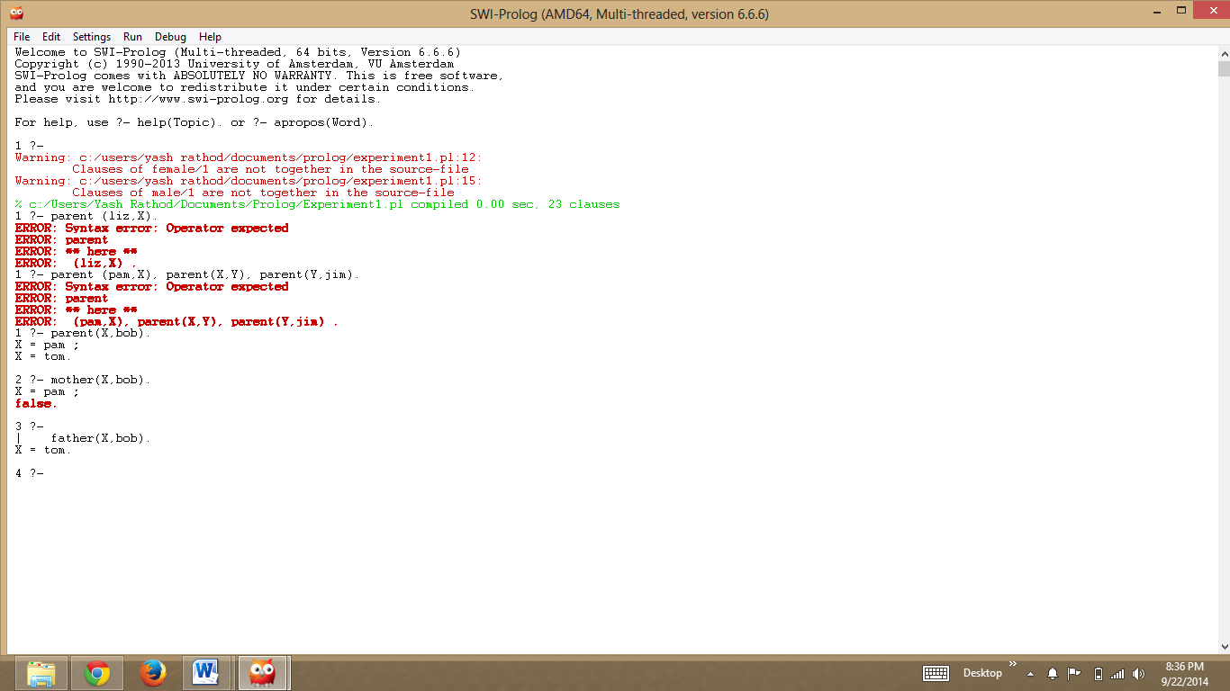

**Conclusion:** We have learned about Prolog and the basics of the same and implemented a simple family tree program and executed few queries in it.