**Aim:** To implement-

1. Guess the word
2. Prefix, suffix and infix

**Theory:**

Guess the word is a game where the computer already has a few words stored in his mind and the user needs to guess the word. If the word is correct the user may continue playing or else he is out.

The next program is used to find the prefix, suffix and infix from a given word.

**Code:**

Guess.pl:

in_mind([l,o,v,e]).

start:- write('Guess first letter'),read(X),

in_mind([X|T]),write('OK. '),guess(T).

guess([]):- write('Congratulations! The word is '),in_mind(W),write(W),!.

guess(L):- repeat,write('Next letter'),read(X),

((L=[X|T1],write('OK. '),guess(T1));

(write('Fail. Try again!'),guess(L))).

**Output:**

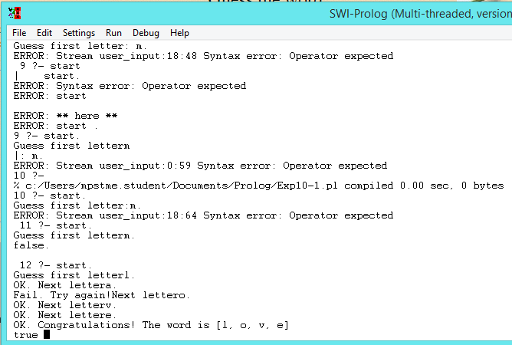

**Code:**

Prefix.pl:

prefix(P,C):- name(P,Pcod),name(C,Ccod),

append(Pcod,_,Ccod).

suffix(S,C):- name(S,Scod),name(C,Ccod),

append(X,Scod,Ccod),not X=[].

infix(I,C):- name(I,Icod),name(C,Ccod),

append(C1,C2,Ccod),append(Icod,_,C2).

**Output:**

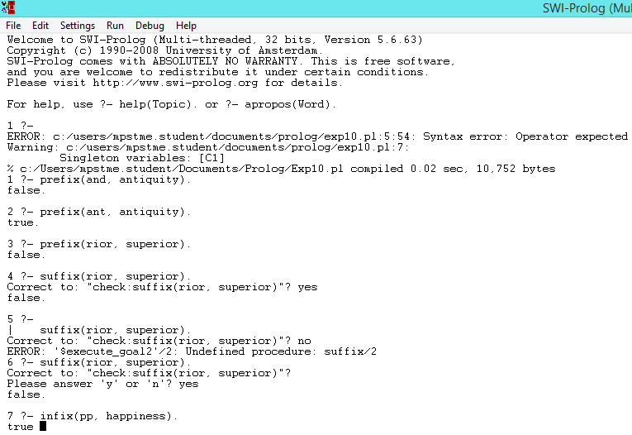

**Conclusion:** Hence we have implemented guess the word and finding the prefix, suffix and infix from a given word in prolog.