**Aim:** To implement Water Jug Problem in Prolog.

**Theory:**

You are given two jugs, a 4‐litre one and a 3‐litre one. Neither has any measuring markers on it. There is a pump that can be used to fill the jugs with water. How can you get exactly 2 litres of water into 4‐litre jug.

**Code:**

move(s(X,Y),s(Z,5)) :- Z is X - (5 - Y), Z >= 0.

move(s(X,Y),s(Z,0)) :- Z is X + Y, Z =< 3.

move(s(X,Y),s(3,Z)) :- Z is Y - (3 - X), Z >=0.

move(s(X,Y),s(0,Z)) :- Z is X + Y, Z =< 5.

move(s(0,Y),s(3,Y)).

move(s(X,0),s(X,5)).

move(s(X,Y),s(X,0)) :- Y > 0.

move(s(X,Y),s(0,Y)) :- X > 0.

moves(Xs) :- moves([s(0,0)],Xs).

moves([s(X0,Y0)|T], [s(X1,4),s(X0,Y0)|T])

:- move(s(X0,Y0),s(X1,4)), !.

moves([s(X0,Y0)|T],Xs) :-

move(s(X0,Y0),s(X1,Y1)),

not(member(s(X1,Y1),[s(X0,Y0)|T])),

moves([s(X1,Y1),s(X0,Y0)|T],Xs).

**Output:**

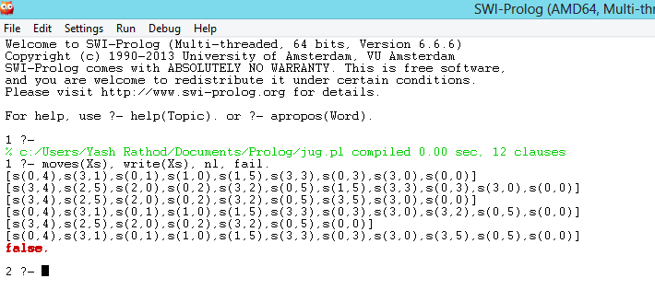

**Conclusion:**

Hence we have implemented Water Jug problem in prolog.