**Aim:** To implement Fibonacci Problem in Prolog.

**Theory:**

Fibonacci numbers or Fibonacci sequence are the numbers in the following integer sequence:[1][2]

1,1,2,3,5,8,13,21,34,55,89,144, \ldots

or (often, in modern usage):

0,1,1,2,3,5,8,13,21,34,55,89,144, \ldots (sequence A000045 in OEIS).

The Fibonacci spiral: an approximation of the golden spiral created by drawing circular arcs connecting the opposite corners of squares in the Fibonacci tiling;[3] this one uses squares of sizes 1, 1, 2, 3, 5, 8, 13, 21, and 34.

By definition, the first two numbers in the Fibonacci sequence are 1 and 1, or 0 and 1, depending on the chosen starting point of the sequence, and each subsequent number is the sum of the previous two.

In mathematical terms, the sequence Fn of Fibonacci numbers is defined by the recurrence relation

F_n = F_{n-1} + F_{n-2},\!\,

with seed values[1][2]

F_1 = 1, F_2 = 1

or[4]

F_0 = 0, F_1 = 1.

The Fibonacci sequence is named after Fibonacci.

**Code:**

fib(0, 0).

fib(X, Y):- X > 0, fib(X, Y, _).

fib(1, 1, 0).

fib(X, Y1, Y2) :- X > 1,

X1 is X - 1,

fib(X1, Y2, Y3),

Y1 is Y2 + Y3.

**Output:**

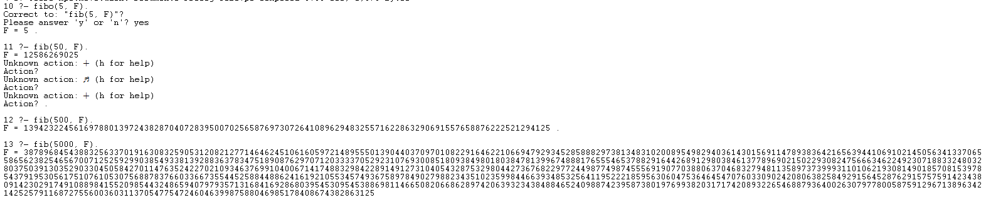

**Conclusion:**

Hence we have implemented Fibonacci Series problem in prolog.