|  |  |
| --- | --- |
| **Roll No.:** A059 | **Name:** Chinmay Parikh |
| **Prg/Yr/Sem:** B.Tech(I.T.)/4th /7 | **Batch:** A3 |
| **Date of Experiment:** 30/8/2014 | **Date of Submission: 29**/10/2014 |

**Aim**: Implementing a J2EE EJB Game.

**Design Scenario –**

J2EE web services provides for two types of endpoints. If you think of a web service as a platform-independent invocation layer, then the end point is the object you are exposing the operations of and invoking operations on. Naturally, J2EE web services support exposing EJBs as web services, but only stateless session beans can be used. That makes sense given the stateless nature of web services requests. Additionally, J2EE web services provide for JAX-RPC service endpoints, (JSEs) which are nothing more than simple Java classes.

**Detailed Steps for creating a web service & web service client in Net Beans 7.0**

*Steps –*

1. Start NetBeans 7.0 by clicking on it and start a new project File->New Project. Select the New Project as Java EE ->Enterprise Application. Name it MyEnterpriseApp.
2. This creates the JEE Application MyEnterpriseApp and MyEnterprise-ejb, MyEnterpriseApp-war.
3. Select MyEnterprise-ejb and right click on it and select New->Web Service. This creates a Web Service called RPSService. This creates the RPSService with default operation hello.
4. Select the Web Service RPSService and right click on it and select Add Operation to add a new operation called playTheGame returning a string and with one string parameter called clientChoice.
5. Add the code given in red box in the method playTheGame for creating a game which creates result as loss if input given as scissors, win if input given as paper and draw if input given as rock.
6. Select the MyEnterpriseApp-ejb, right click on it and deploy the application. Select the RPSService web service right click on it and select Test Web Service to display the RPSService Web Service Tester.

**Printouts –**

**EXP4.txt**

package ebjpkg;

import javax.jws.WebService;

import javax.jws.WebMethod;

import javax.jws.WebParam;

import javax.ejb.Stateless;

import java.util.*;

@WebService(serviceName = "RPSService")

@Stateless()

public class RPSService {

@WebMethod(operationName = "playtheGame")

public String playtheGame(@WebParam(name = "ClientChoice")

String ClientChoice) {

Random rm = new Random();

int n = rm.nextInt(3);

String result = "failure";

String var;

String serverChoice;

if (n==0){

var = "rock";

}

else if (n==1){

var = "paper";

}

else{

var = "scissors";

}

try{

if("rock".equals(var)){

if (ClientChoice.equalsIgnoreCase("paper")){

result = "win";

}

if (ClientChoice.equalsIgnoreCase("scissors")){

result = "loss";

}

if (ClientChoice.equalsIgnoreCase("rock")){

result = "draw";

}

}

if("scissors".equals(var)){

if (ClientChoice.equalsIgnoreCase("scissors")){

result = "draw";

}

if (ClientChoice.equalsIgnoreCase("paper")){

result = "loss";

}

if (ClientChoice.equalsIgnoreCase("rock")){

result = "win";

}

}

if("paper".equals(var)){

if (ClientChoice.equalsIgnoreCase("rock")){

result = "loss";

}

if (ClientChoice.equalsIgnoreCase("scissors")){

result = "win";

}

if (ClientChoice.equalsIgnoreCase("paper")){

result = "draw";

}

}

}catch(RuntimeException e){

System.out.println("Exception");

}

//TODO write your implementation code here:

return n+" "+result;

}

}

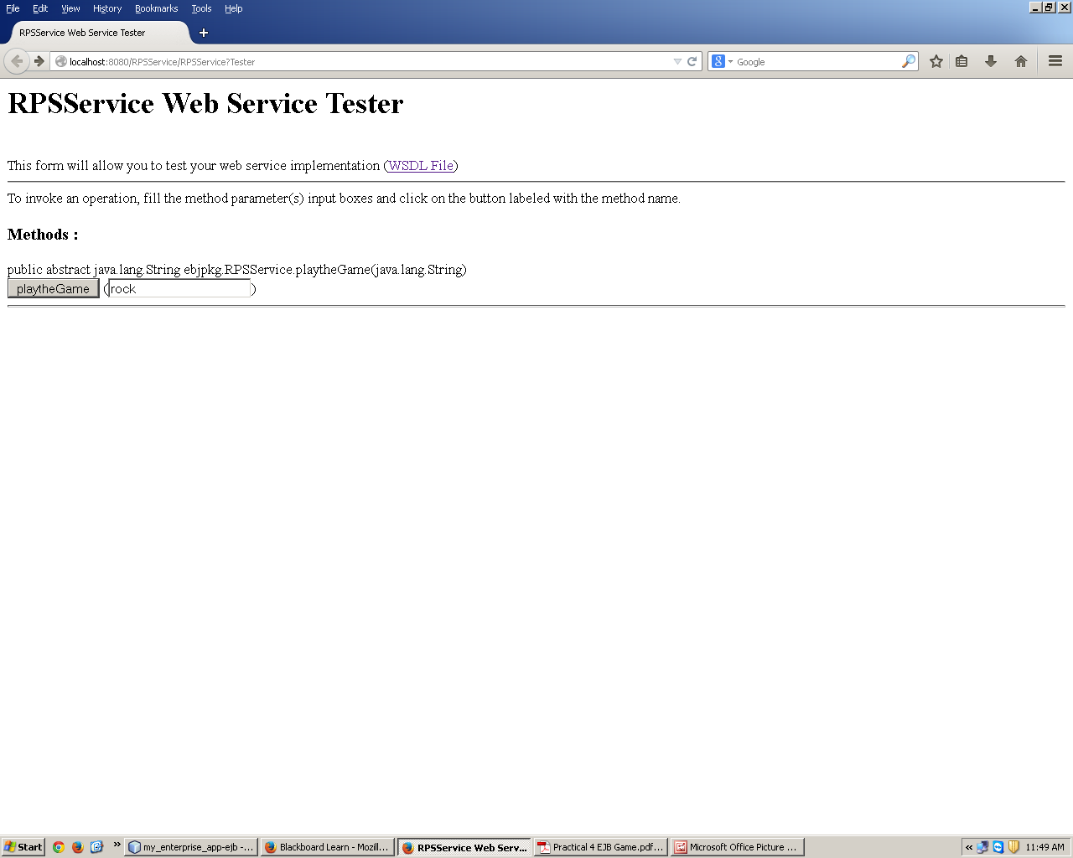

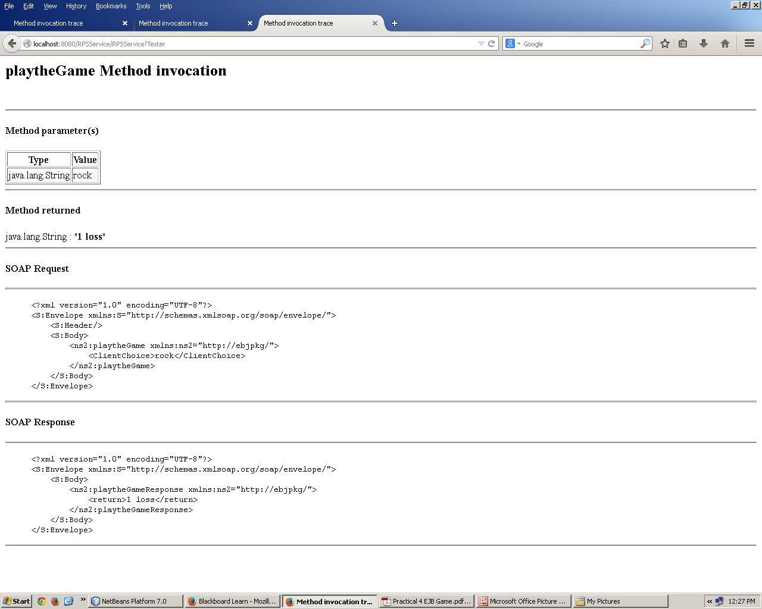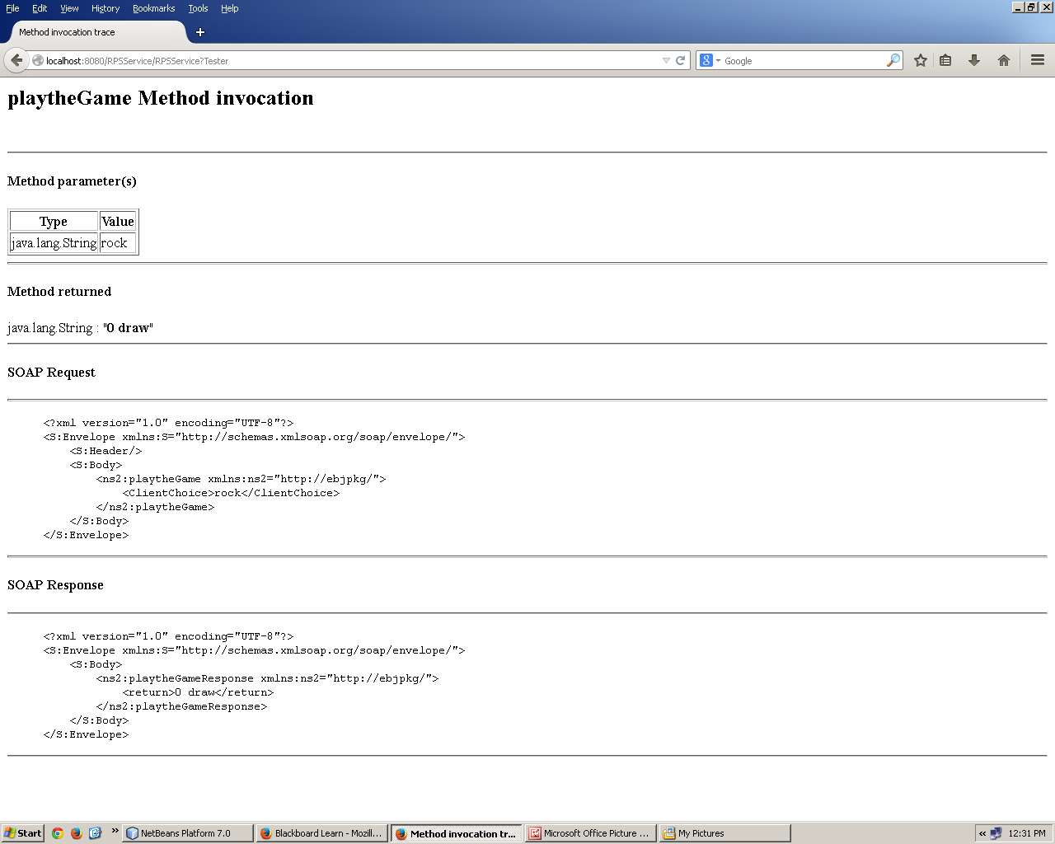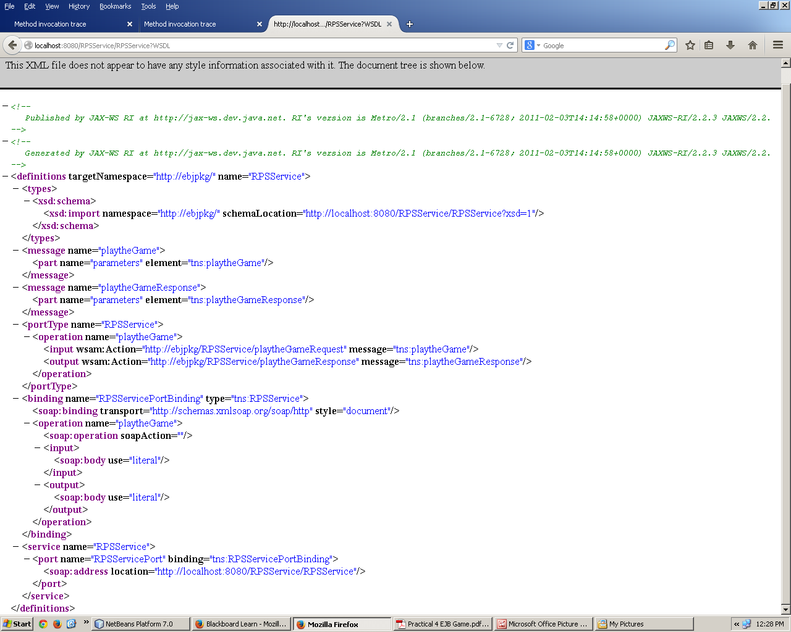

1. **Conclusion –** Thus we have learnt about JAVA J2EE EJB Game and implemented a rock, paper and scissor game in our program using random function and tried various result.