|  |  |
| --- | --- |
| **Roll No.:** A059 | **Name:** Chinmay Parikh |
| **Prg/Yr/Sem:** B.Tech(I.T.)/4th /7 | **Batch:** A3 |
| **Date of Experiment:** 11/10/2014 | **Date of Submission:** 2/11/2014 |

1. **Design Scenario**

**Ans:** Creating a web service using PHP server technology in Netbeans for checking the list of books name stored in database.

1. **Detailed Steps for completing the Practical**

**Ans: Steps:**

Let’s start with the creation of the WebService.

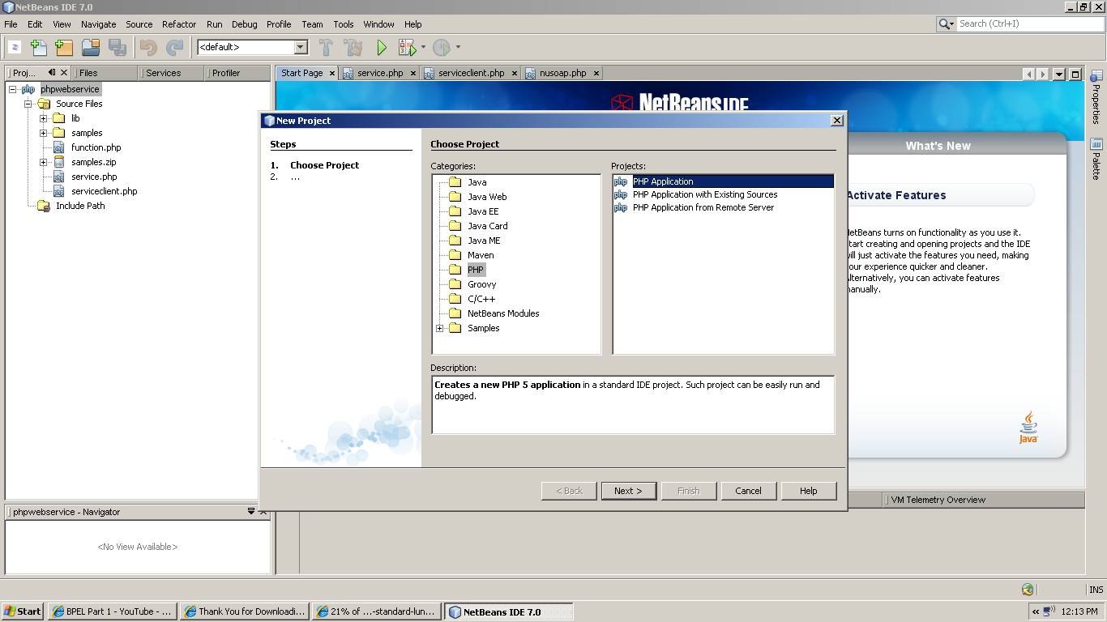

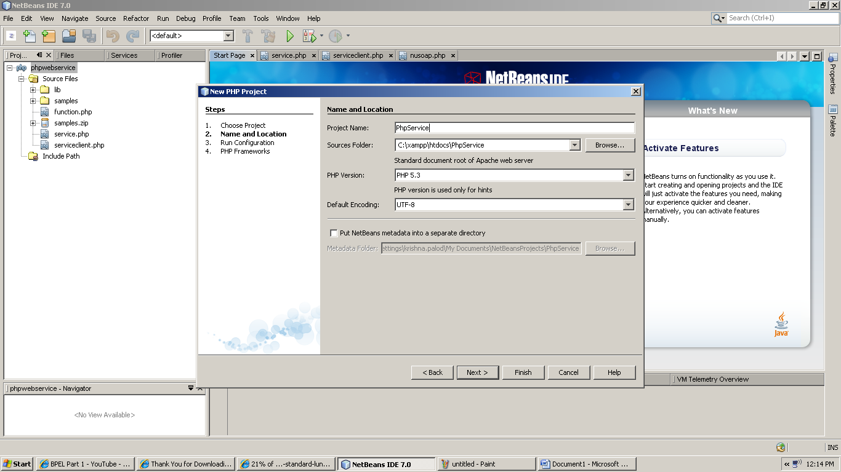

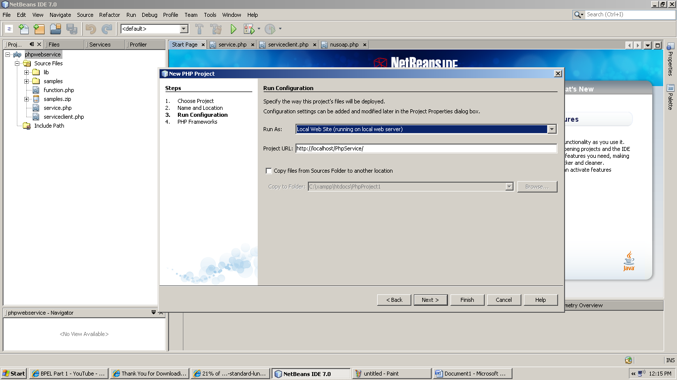

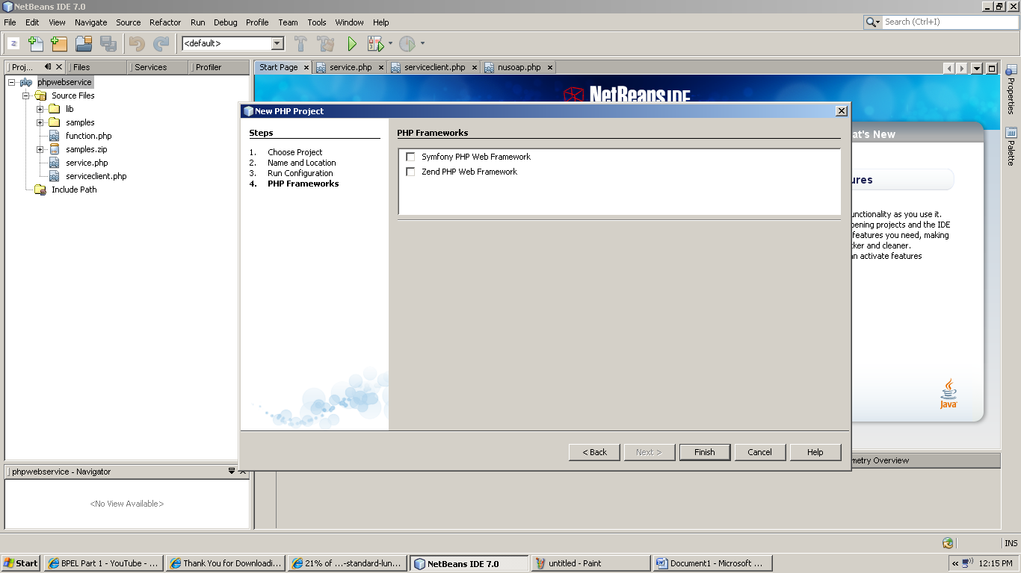

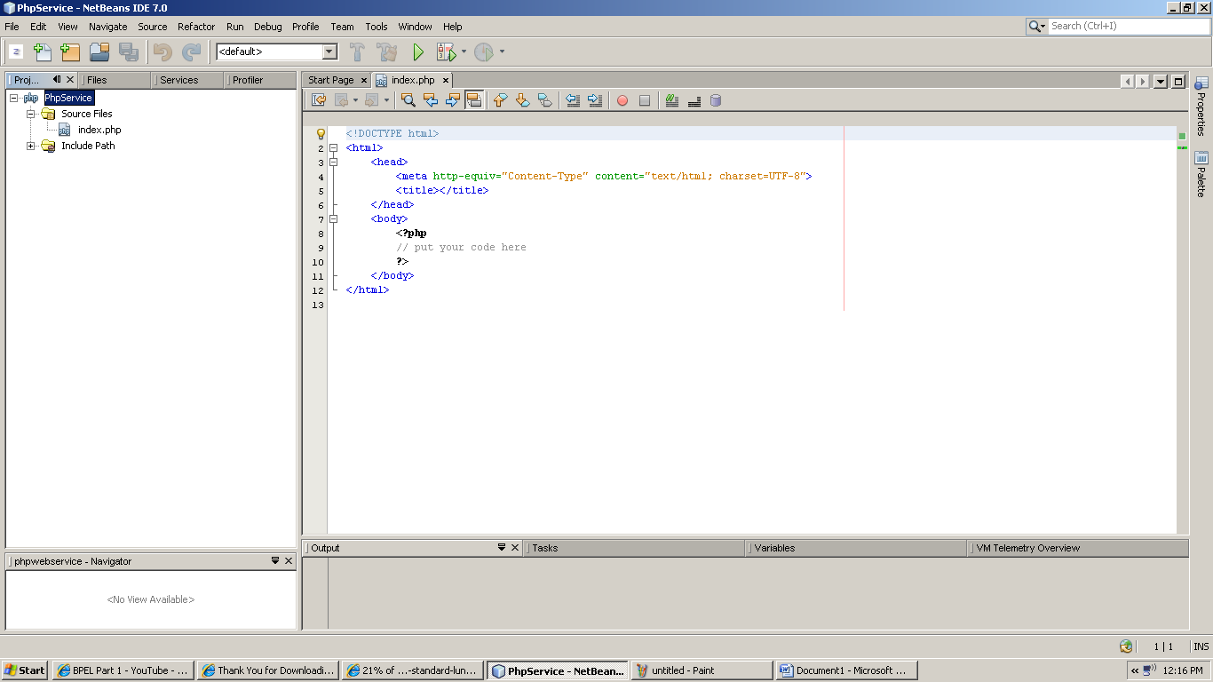

Copy lib folder into project “PhpService” folder within xampp\htdocs folder. This will make the folder “lib” available to the project “PhpService”.

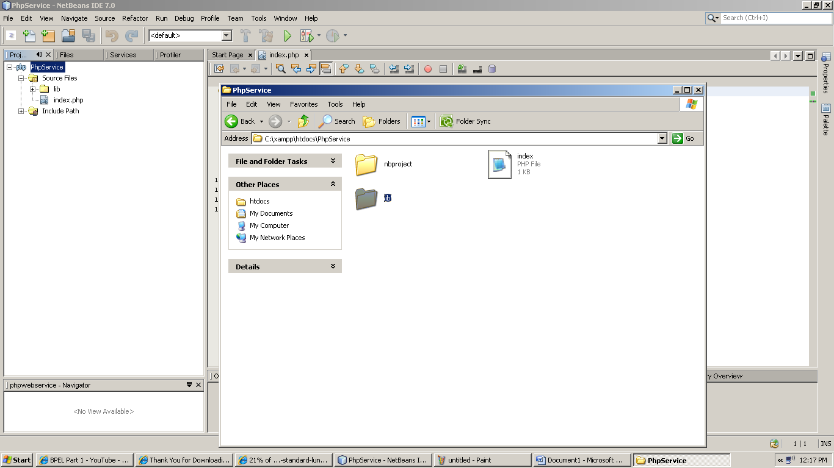

Create a PHP file

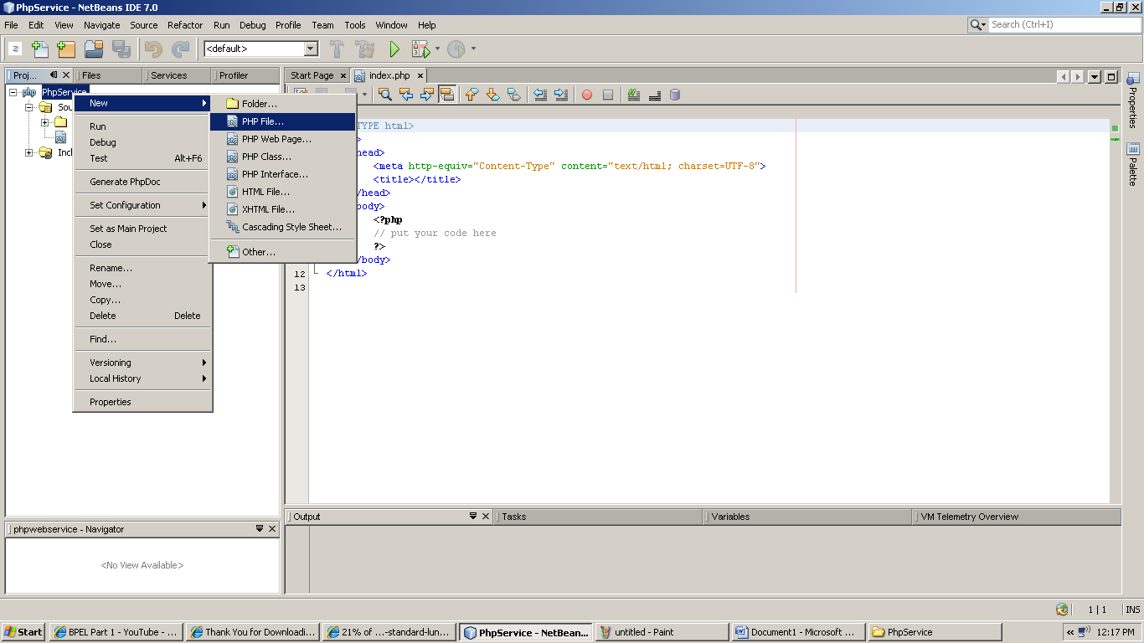

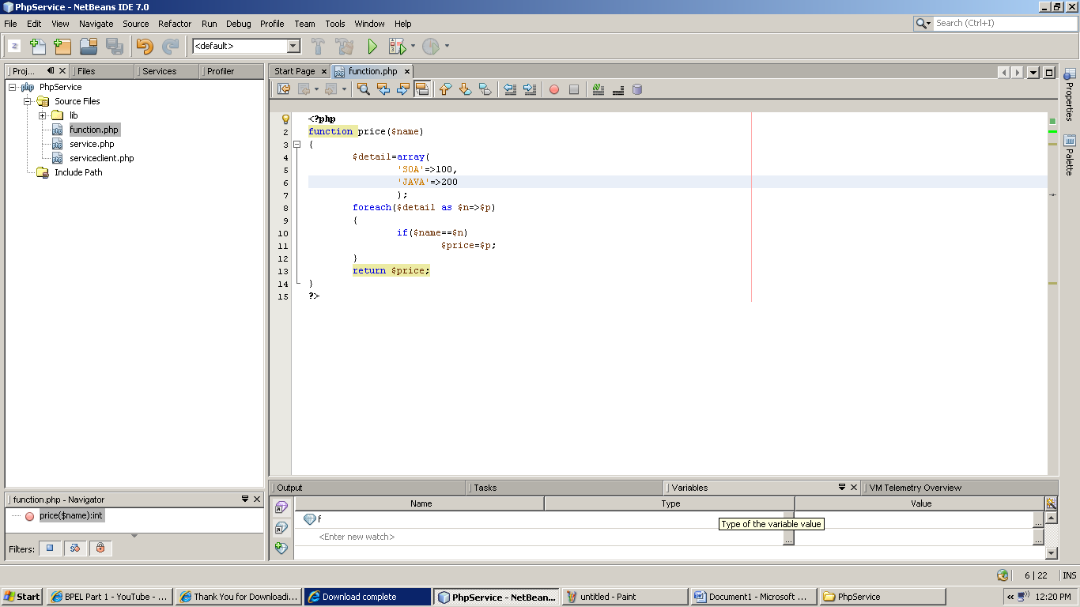

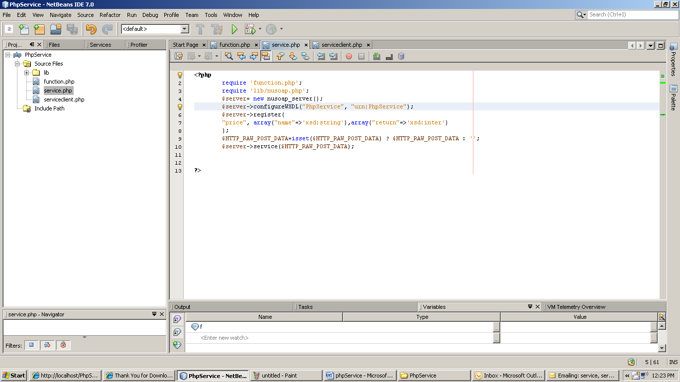

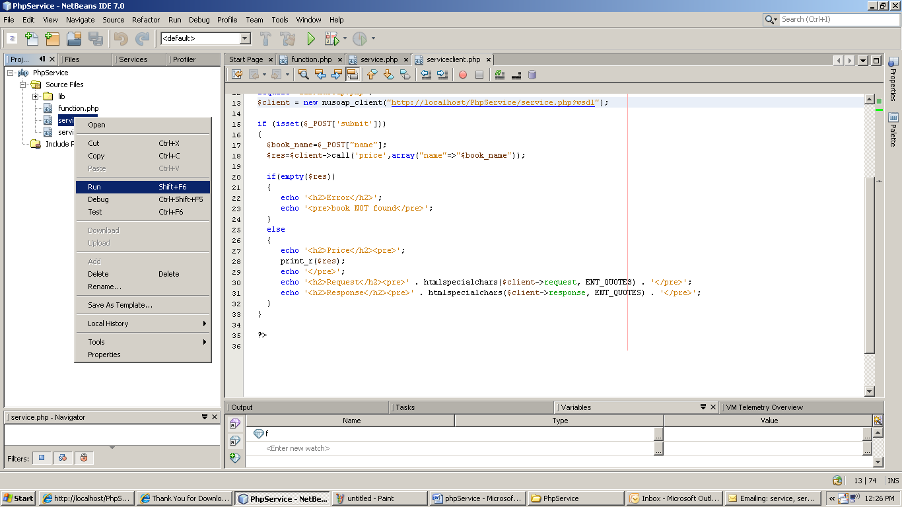

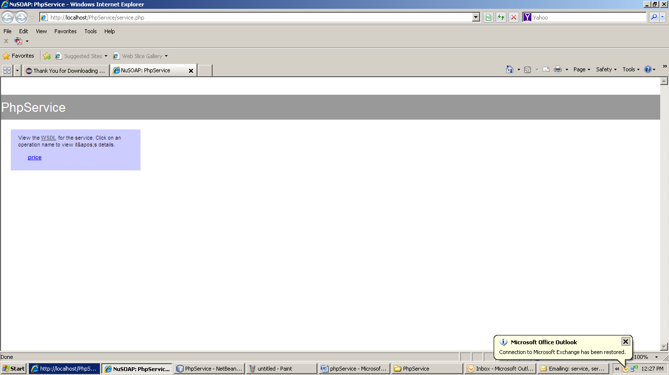

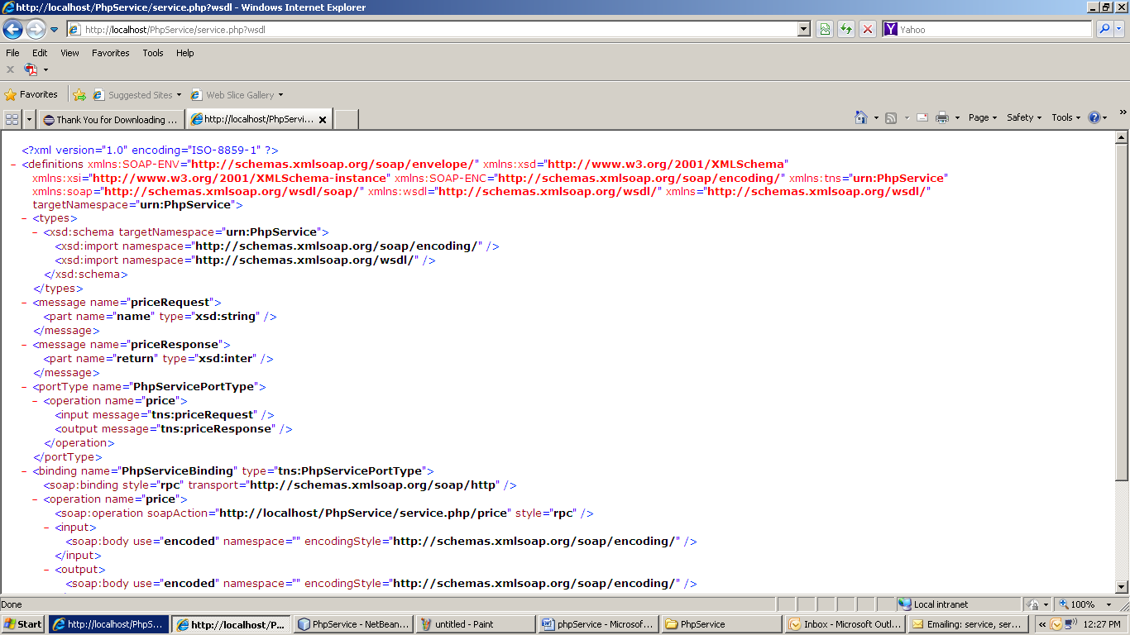

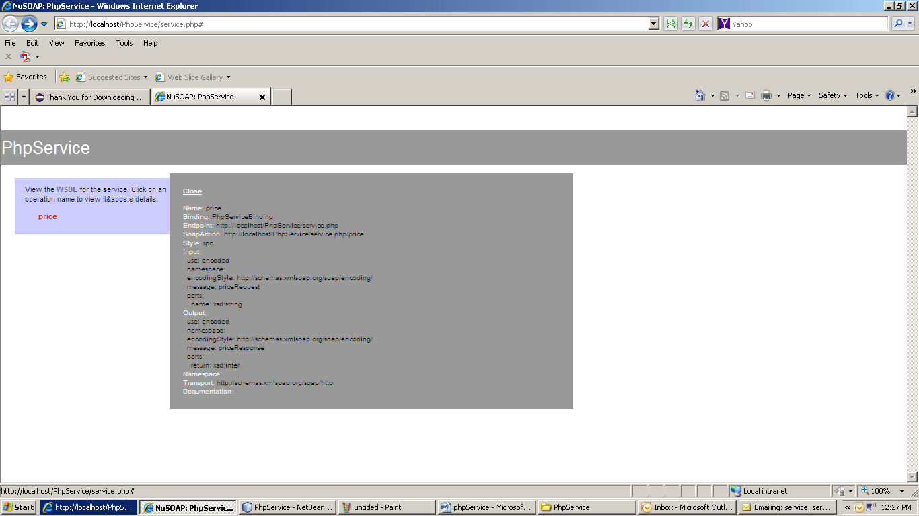

Now we will start creating the Client Service :

Create a php file “serviceclient.php” in the project “PhpService”.

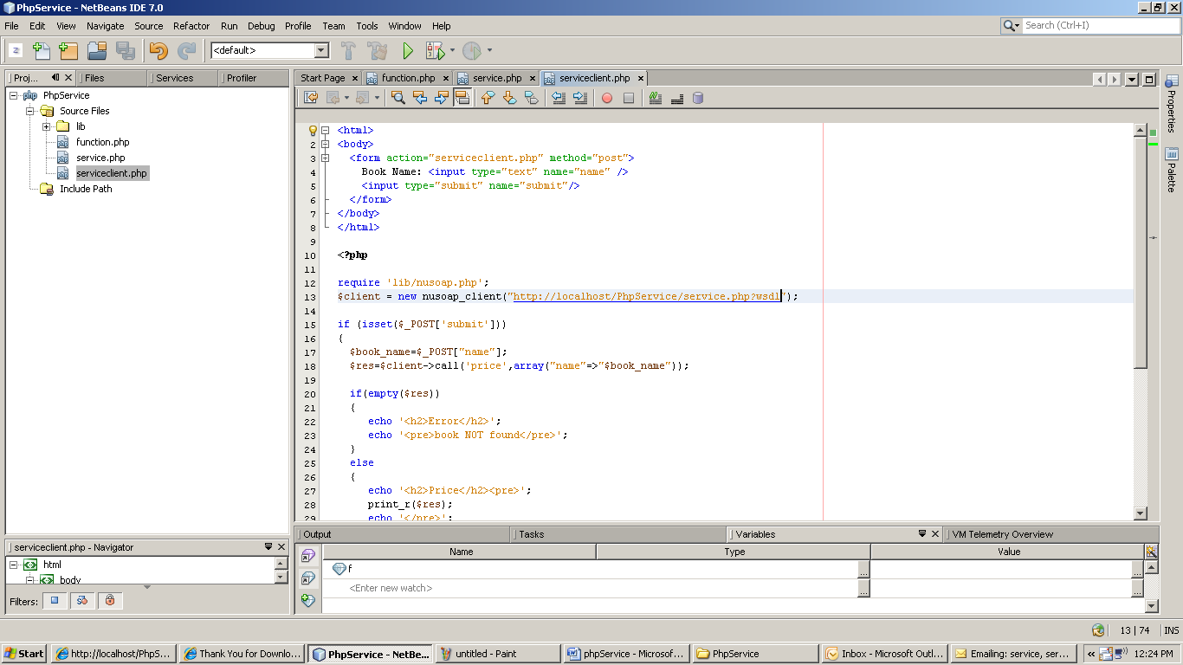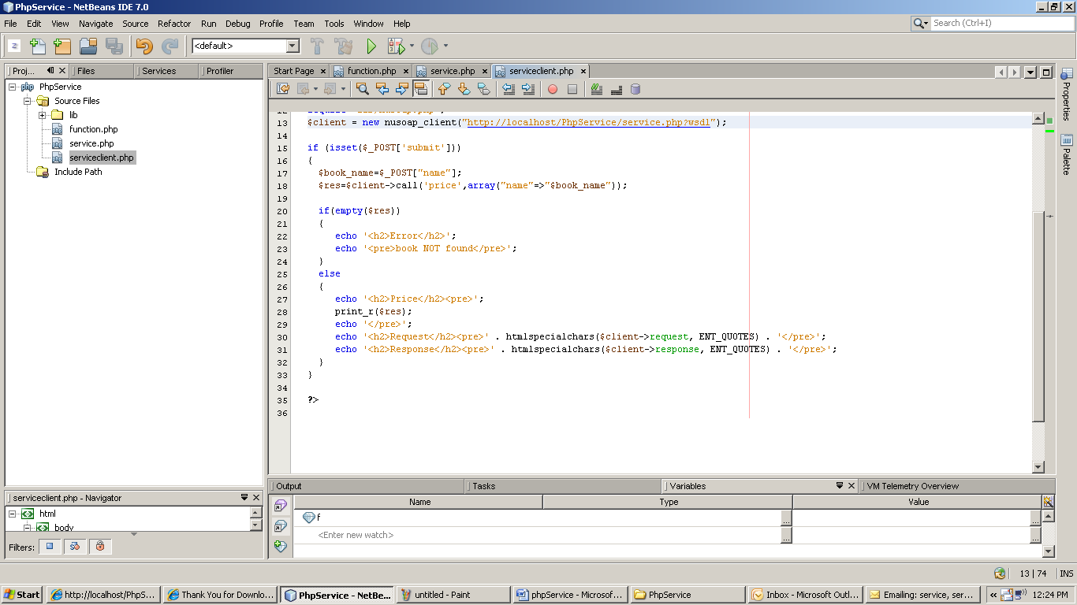

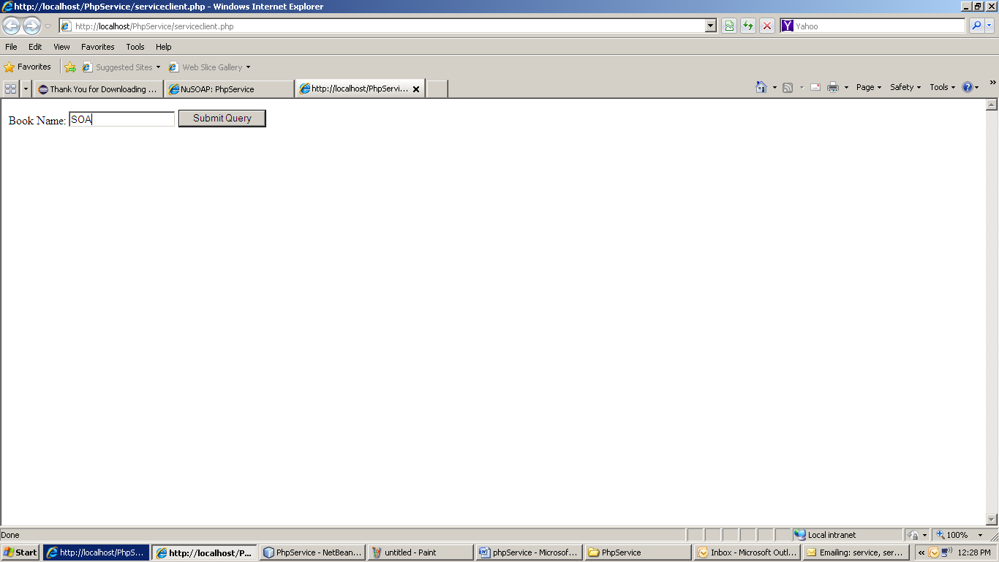

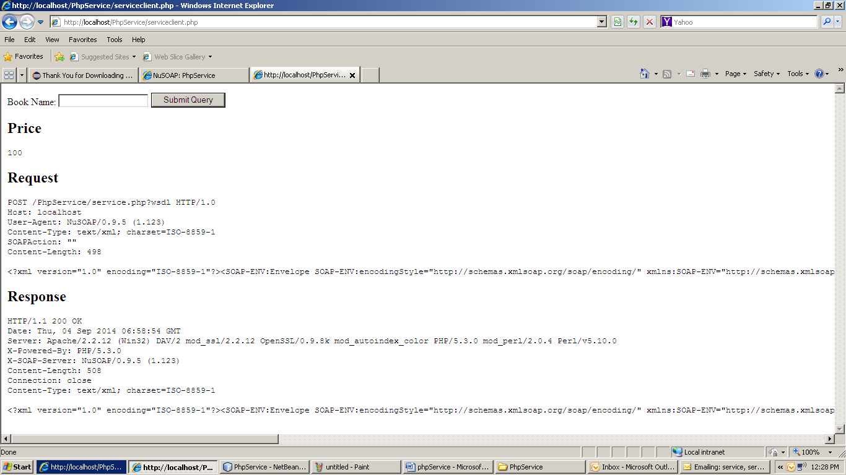

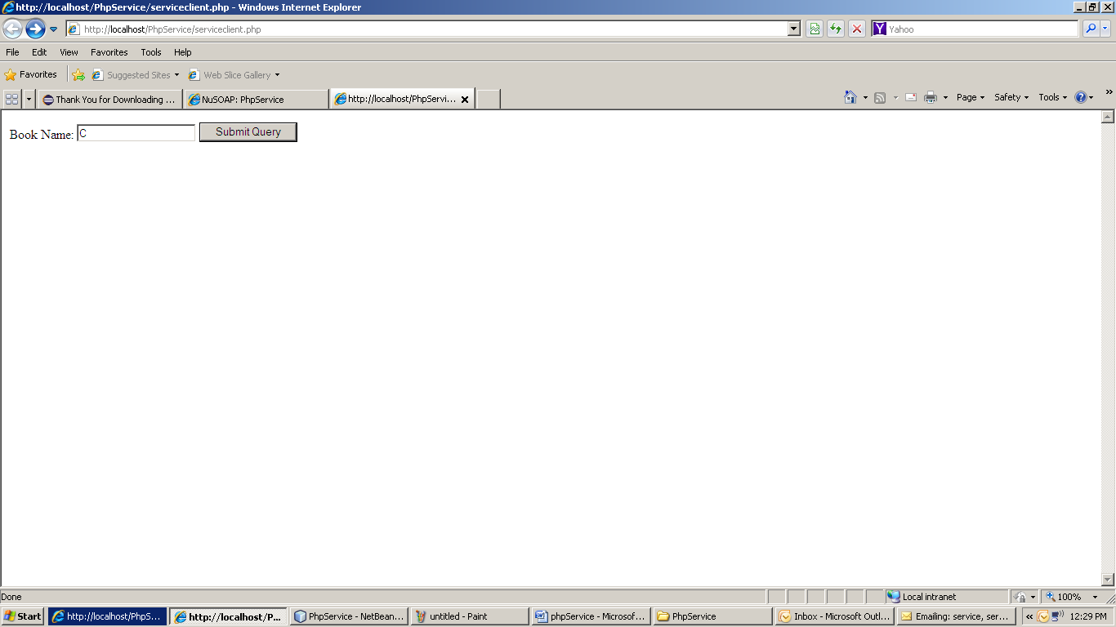

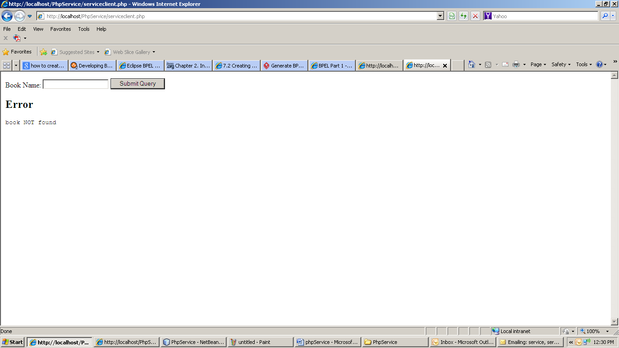

1. **Printout:**

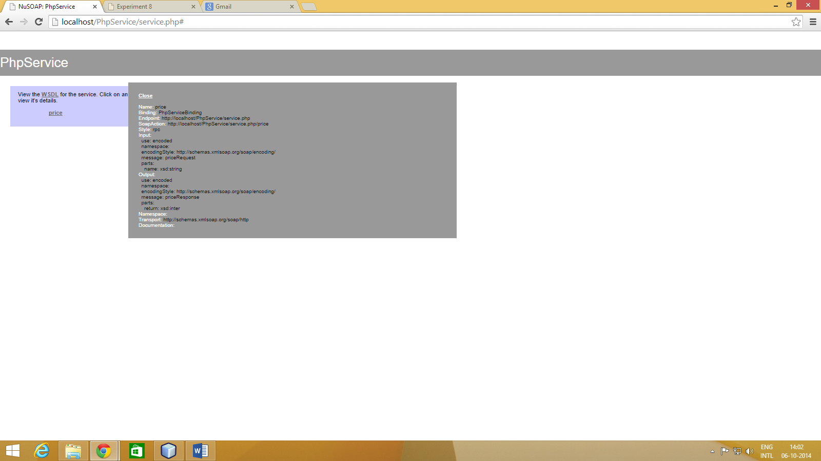

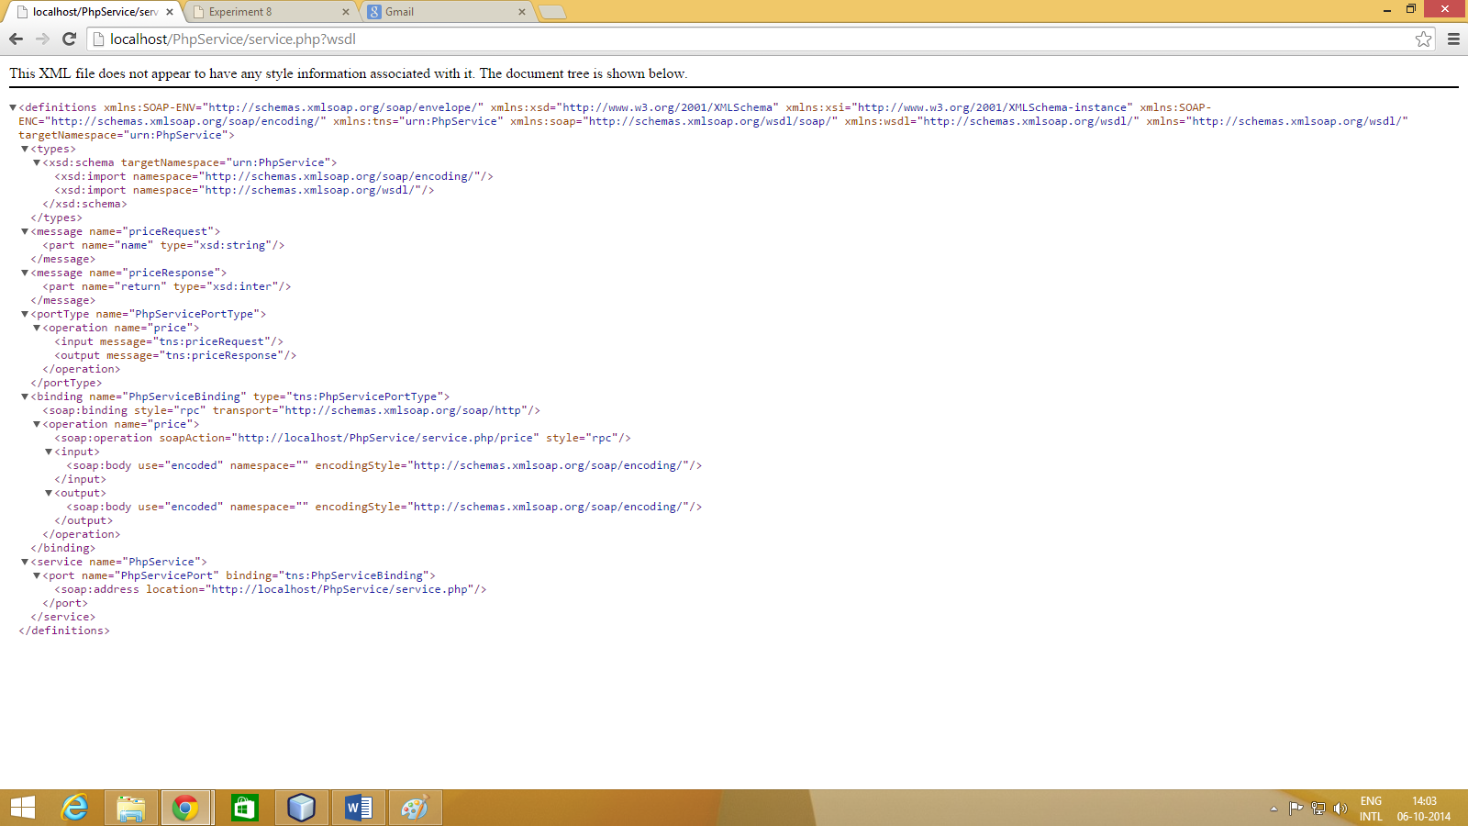 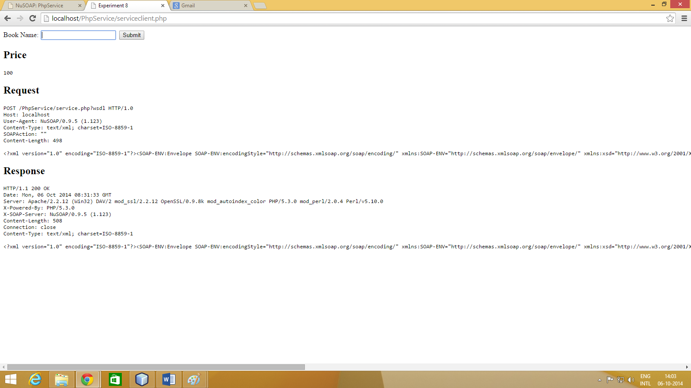 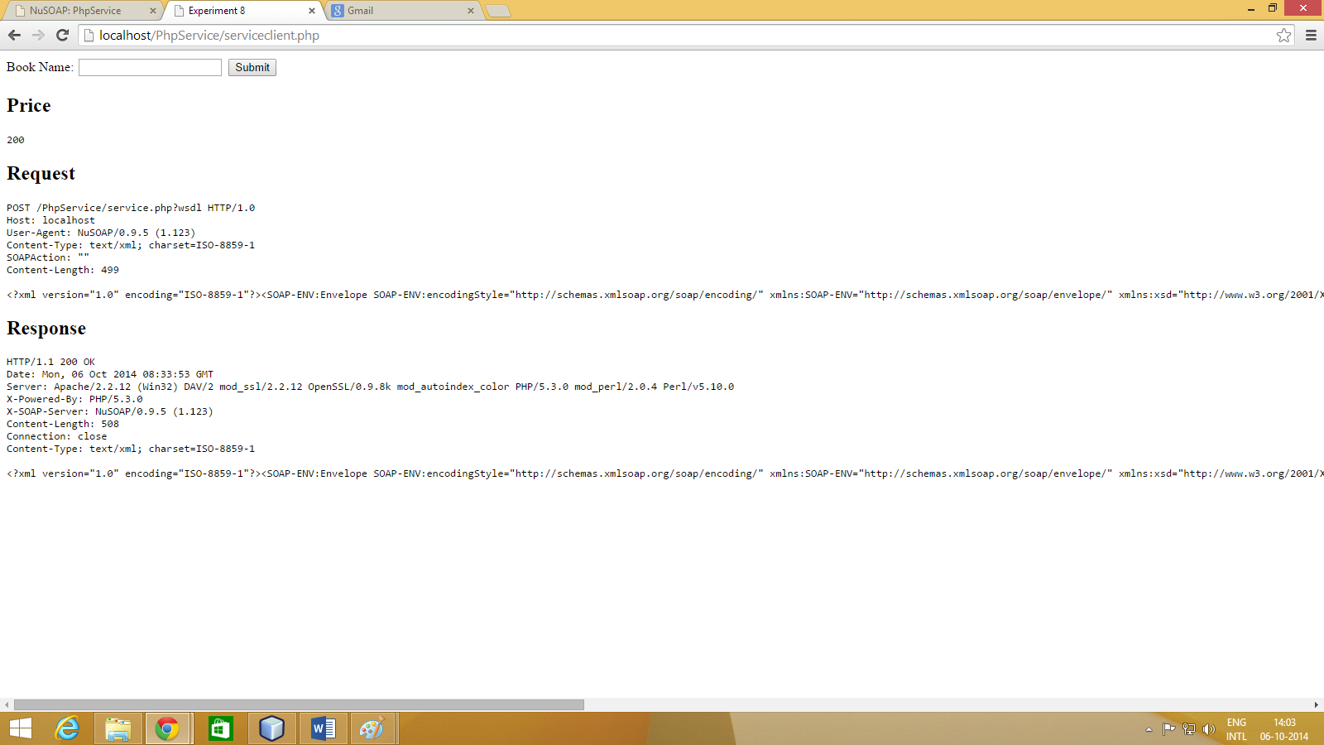 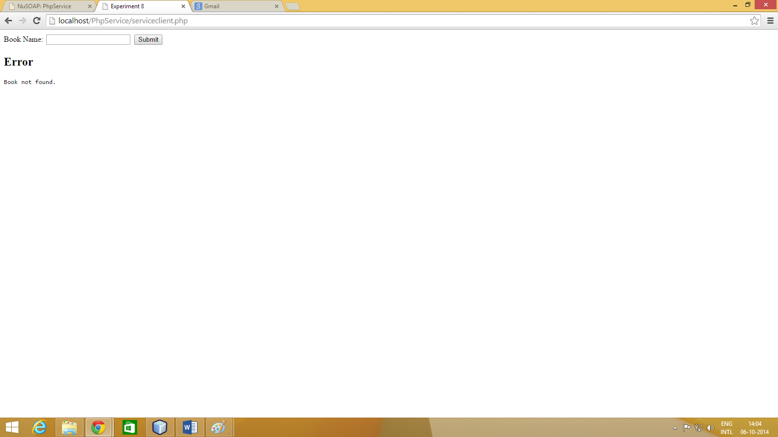

1. **Conclusion:** Thus we have learnt about how to store a list of books in a datebase and use it to check the price of the book. If the book is not found it returns an error.