**Aim**: Develop a Task network and estimate the Man power effort required for the project.

**Theory**:

An Activity Network Diagram (AND) is also called an Arrow Diagram (because the pictorial display has arrows in it) or a PERT (Program Evaluation Review Technique) Diagram, and it is used for identifying time sequences of events which are pivotal to objectives. In Critical Path Analysis this helps the teams to comprehend specific event sequences driving time requirements for objective achievement. Activity Network Diagrams are also very useful when a project has multiple activities which need simultaneous management.

Activity Network Diagrams started out as an engineering and construction project management tool. Critical Path Analysis draws on this methodology to identify and standardize medical management activities.

An Activity Network Diagram helps to find out the most efficient sequence of events needed to complete any project. It enables you to create a realistic project schedule by graphically showing

* the total amount of time needed to complete the project
* the sequence in which tasks must be carried out
* which tasks can be carried out at the same time
* which are the critical tasks that you need to keep an eye on.

A project is composed of a set of actions or tasks which usually have some kind of interdependency. For example, before an axle can be turned, it must first be designed, the metal must be purchased, etc. This type of complex system is much easier to understand through the use of diagrams than through textual description, as actual interconnections between tasks can be shown.

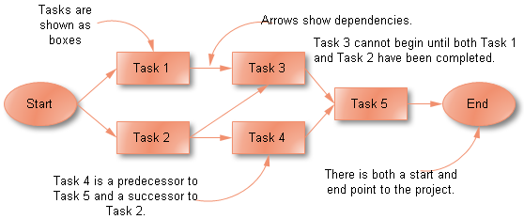

The Activity [Network diagram](http://www.edrawsoft.com/Network-Diagrams.php) displays interdependencies between tasks through the use of boxes and arrows. Arrows pointing into a task box come from its predecessor tasks, which must be completed before the task can start. Arrows pointing out of a task box go to its successor tasks, which cannot start until at least this task is complete.

**Procedure**:

Tasks or Activities

Effective planning of projects requires careful thought and the application of logic. To illustrate this planning tool, let's consider the manufacture of a small item. Some typical processes might be:

Cutting, finishing, assembling, purchasing ,machining, testing ,designing

All these processes are called ‘ACTIVITIES’ or ‘TASKS’

Step 1:

List WHAT has to be done.

Hint: try thinking of verbs ending in “...ing”, like machining or testing.

Do not consider at this stage who is going to do what, concentrate on WHAT.

An activity or task is represented by a rectangle, thus:



Step 2:

Decide the ORDER in which it is to be done.

Some steps are obvious: we, perhaps, cannot test until assembly has been completed, which cannot be done until the various parts have been made. So we have a logical relationship between the start of one task and the beginning of the next. We could order our list of tasks thus:

designing purchasing cutting machining assembling testing finishing

Logic Network or PERT Chart

Writing this out as a network: 

We put the tasks into rectangles and join them with arrows to show the sequence or precedence: the logical relationships between them.

Suppose that once we have bought the materials, some need cutting to size and others need turning on a lathe. The tasks of machining and cutting could run in parallel rather than consecutively, assuming we have the appropriate resources. But let's add a bit more. Say the cut parts need to be welded together before assembling — like this:



Let's add another task: the writing of a set of test instructions. Where would writing fit in? Well, the writing cannot really start until the design is finished, though it could be carried out at the same time as the fabrication, but it must be ready before the testing can begin. Applying such logic to the relationships, we can add the task writing like this:



Now let's say we need to have our draughtsman produce some illustrations for our test instructions. When the writing and the drawing are finished, we will then need to edit the whole:



And so the network is built up, often cuing the mind to missing tasks. In this step always assume you have infinite resources so that who does what does not cloud the issue – concentrate only on the LOGIC.

**Output**: 