Initialising

* Creating Virtual Env:- pip install virtualenv ,<>\Scripts\activate, deactivate

* Start project using command :- django-admin startproject nameofproject
* To see the website :-python manage.py runserver
* To make app:- python manage.py startapp nameofapp
* Add the app name in setting :-

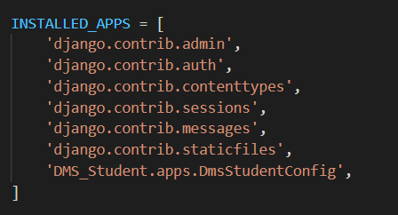

Appname.apps.app.ClassNameInApps

* In urls of project include the urls of app:-

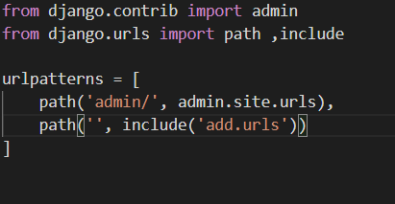

* In urls import the views:-

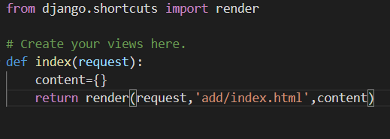

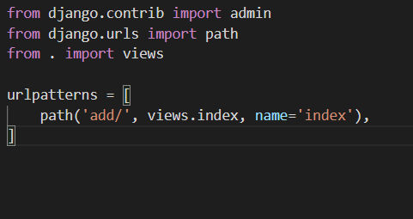

* Templates write this in setting of project:-

 os.path.join(BASE_DIR, 'add/templates'),

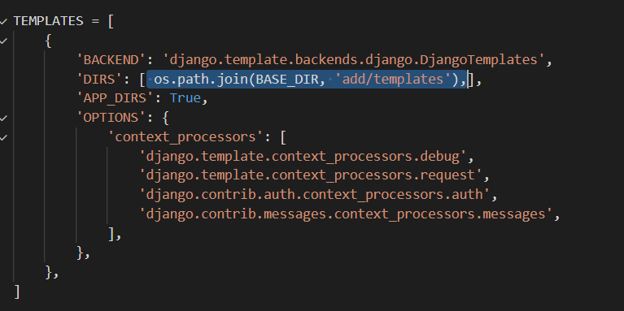

* For Making form:-

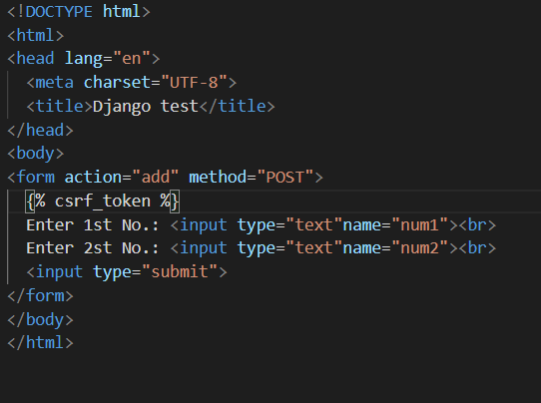

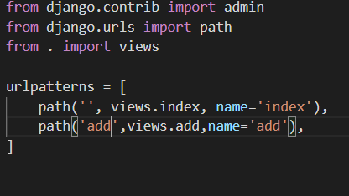

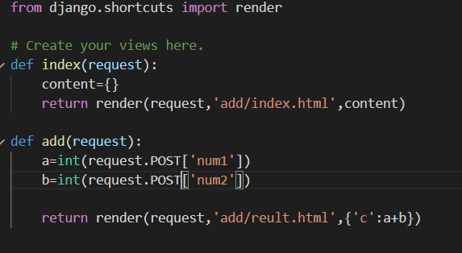

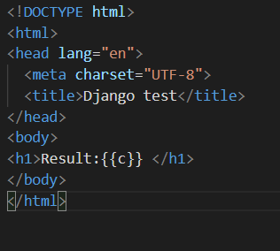

* To load static files

{% load static %}  
<**a href="{% static 'poster/file.txt'%}"**>Click</**a**>

* First make a model :-Model class should have same name as table name
* To make migration form specific app python migrate.py makemigrations appname
* To generate table write pyhton manage.py sqlmigrate nameofapp idintheaboveproccess
* To make migration python manage.py migrate
* Python manage.py shell
* from appname.models import modelname
* modelname.objects.all() to see the table in model
* a=Poster(artistname="Chinmay",uploaded_at="17 may")
* >>> a.save()
* Make superuser by python manage.py createsuperuser
* Make the views .py file .
* URL file manage the url of all the pages.We should import the views file in the url file by from . import views
* To make work easy we use template.We should import the from Django.shortcuts import render.
* To use template the make change in setting file in DIRS=[].
* And then return render(request,”nameofhtmlpage”)
* To insert the variable on webpage by {{nameofvariableonwebpage}}