**Locating Nearby Hospital**

Chinmay Garge

* Introduction where you discuss the business problem and who would be interested in this project.
* Data where you describe the data that will be used to solve the problem and the source of the data.
* Methodology section which represents the main component of the report where you discuss and describe any exploratory data analysis that you did, any inferential statistical testing that you performed, if any, and what machine learnings were used and why.
* Results section where you discuss the results.
* Discussion section where you discuss any observations you noted and any recommendations you can make based on the results.
* Conclusion section where you conclude the report.

Introduction:

Now a days, at the time of medical emergency, it’s too hard for locating the nearby Hospital, especially when you are in unknown city, town, place etc. The main idea is to pick the location of the user and compare it with the location of the Hospitals from our datasets. User will get this information on the single click..

Data:

<https://github.com/chinmay546/Coursera_Capstone/blob/master/hospital-locations.csv>

I have converted this csv file into Data Frame using Python Library “Pandas”. It contains data such as: Name, Address, Zip code, Neighbor, X Co-ordinate, Y Co-ordinate of the Hospitals. Previously, X Co-ordinate and Y Co-ordinate from the Dataset where in the following format:

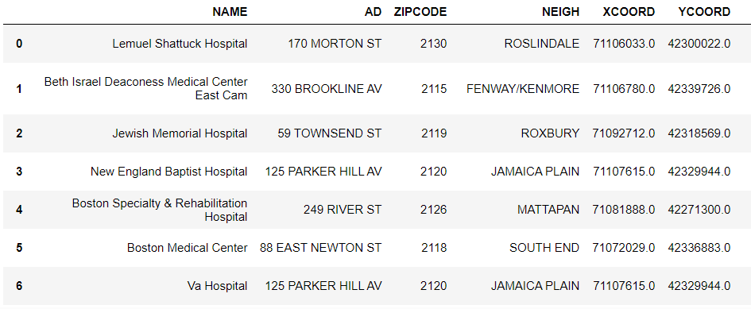

It was required to change the col into:

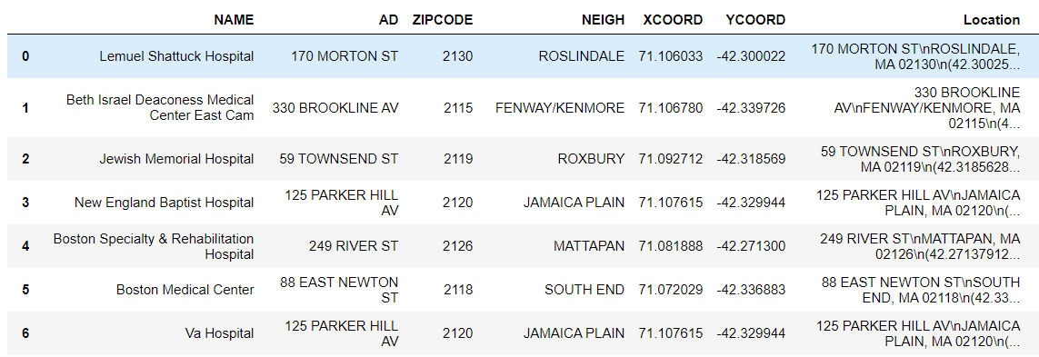

I have dropped row with missing value.

Methodology:

After cleaning data, we take input from the user. Here, I have inputted the co-ordinates.

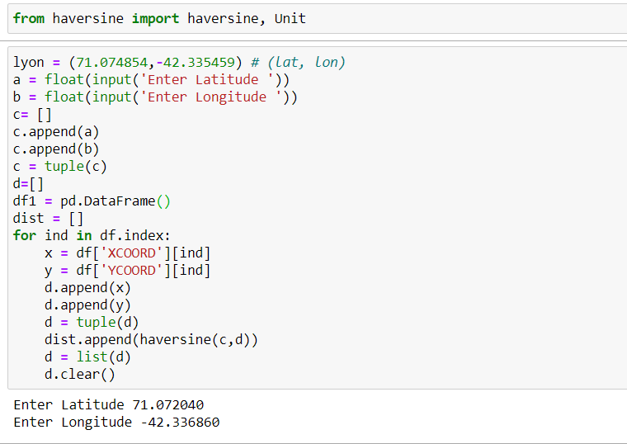

Basically, this compares the distance between the inputted co-ordinates and the co-ordinates from the dataset. List named ‘dist’ is created and further added as a column to the dataset.

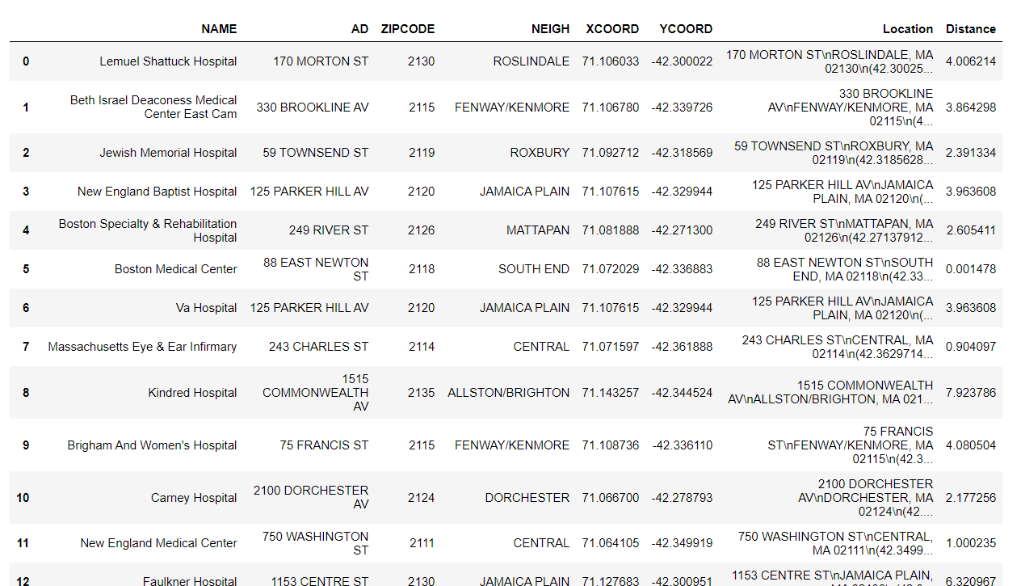

When Compared, we get the result with Hospital which is nearest to the inputted co-ordinates.

Result:

Here is the Computed Result:



Discussion:

Further we can apply this methodology in fully automated way , where user can give a input of his/her location (co-ordinates ) on a single click using mobile hardware

Conclude:

Here I conclude this report