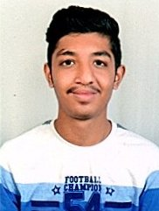



**Chinmay Milind Garge**

Secure a responsible career opportunity to fully utilize my training and skills, while making a significant contribution to grow the company to achieve its goal.

Satara, Maharashtra, India

8551007638

gargechinmay1025@gmail.com

m

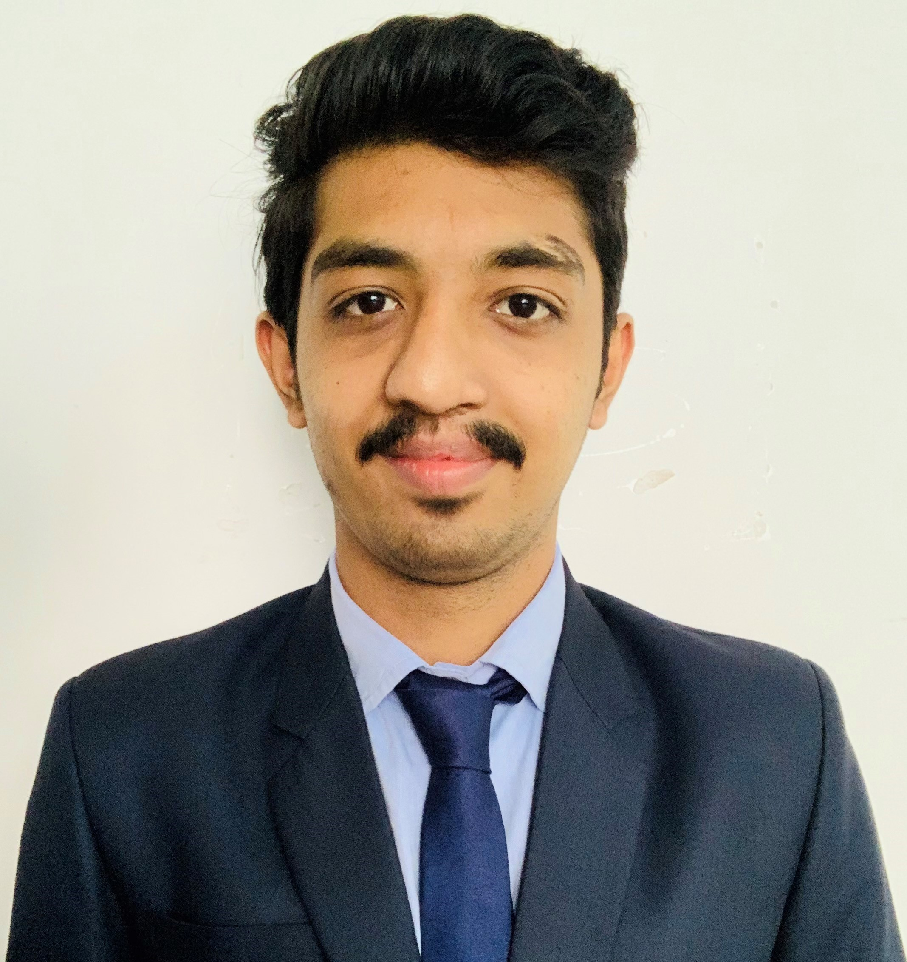

**EDUCATION**

**BTECH COMPUTER ENGINEERING | DBATU**

**KARMAVEER BHAURAO PATIL COLLEGE OF ENGINEERING, SATARA**

2017 – 2021

CGPA: 8.15

(Pursuing)

**INTERMEDIATE | HSC**

**DISHA PUBLIC SCHOOL & JR. COLLEGE, WAI, SATARA**

2017

Percentile: 65%

**HIGH SCHOOL| SSC**

**DNYANDEEP ENGLISH MEDIUM SCHOOL, WAI, SATARA**

2015

Percentile: 82%

**INTERNSHIP**

**1. PRISMS | COMPANY**

DEC 2019-JAN 2020

Internship at Prisms Communications:

* 1. Topics - Linux Commands (SA1, SA2, SA3)
  2. Cloud Computing Using AWS

**2. LOKRAJA RAJASHRI SHAHU SHIKSHAN SANSTHA, SATARA| SCHOOL**

JULY 2020

Designing website for a school. WordPress is used for designing and AWS is used for hosting purpose. Please find the link below for website: <http://13.126.168.196/>

**3. TRAINING**

|  |  |  |
| --- | --- | --- |
| **Domain** | **Institute Name** | **Link** |
| **Data Science** | **IBM** | [**Link**](https://drive.google.com/file/d/1M1c_84KlSGMfO-ZEY1ymNenmo0rZkNYC/view?usp=sharing) |
| **Python** | **Microsoft** | [**Link**](https://drive.google.com/file/d/1Tq8zDxJnPIogHOjjmzerVEoIli08NVWh/view?usp=sharing) |
| **Web Development** | **Internshala** | [**Link**](https://drive.google.com/file/d/1QIrlU7-41a8LGALbv_gAjS0mWa9IGPx4/view?usp=sharing) |
| **Python** | **NPTEL** | [**Link**](https://drive.google.com/file/d/1bSG1Bq3g3HDDgRJEmH6ssVp72HbMZdF_/view?usp=sharing) |
| **Soft Skill** | **TCS** | [**Link**](https://drive.google.com/file/d/1XWw_L9tuvSpC1oex3LX2ypt1rx93HJlH/view?usp=sharing) |

**TECHNICAL** **SKILLS**

|  |  |
| --- | --- |
| **Programing Language:**  C, C++, PYTHON | **Operating System:**  UBUNTU, WINDOWS |
| **Web Technologies:**  HTML, CSS, BOOTSTRAP, WORDPRESS, JAVASCRIPT, NODEJS, PHP | **Database:**  MYSQL |
| **IDE’S:**  ANACONDA NAVIGATOR, PYCHARM, VISUAL CODE, NETBEANS, MYSQL WORKBENCH | **Cloud Services:**  AWS |

**PROJECT UNDERTAKEN**

**Project: Chat Bot**

**Objective:**  To learn python libraries

**Description:** Designed a chatbot which would answer some common questions asked about my college using python libraries

**Project: Vending Machine**

**Objective:** Integrated solution vending machine

**Description:** To develop an integrated system which would dispense sanitary napkins using an automated vending machine through QR code, with disposing unit and sanitizer unit

Ecommerce Website: <https://crimson-fin.herokuapp.com/> (Still in developing phase)

**CO – CURRICULAR ACTIVITIES**

* **Treasurer of the student association of CSE Department in College.**
* **Working as TPO Student Co - Ordinator.**
* **Represented my dept by playing in Volleyball team.**
* **Co - Ordinated for department level events in college**
* **Selected for final round of “Ideathon Competition” from my zone.**
* **Secured 2nd Rank in Jetking Netcamp 2020**

**INTERESTS**

### 1. Enjoying Music 2. Sports

**LANGUAGES**

* **English:** Professional Working Proficiency
* **Marathi:** Native or Bilingual Proficiency
* **Hindi:** Full Professional Proficiency