Learning Financial-Ratio Weights for Company Valuation with Gradient-Based Optimization
Deshnaa Suresh  School of Computer Science and Engineering  RV University  Bengaluru, India  USN: 1RUA25CSE0150 | Dindukurti Varshini  School of Computer Science and Engineering  RV University  Bengaluru, India  USN: 1RUA25CSE0161 | Asmita Guptha  School of Computer Science and Engineering  RV University  Bengaluru, India  USN: 1RUA25CSE0093 | Chinmay S  School of Computer Science and Engineering  RV University  Bengaluru, India  USN: 1RUA25CSE0141

Abstract, Estimating what one listed company should be worth from its published accounts generally rests on a second analyst deciding, by judgement, how strongly each individual ratio should count; this paper replaces that judgement with any unambiguous optimization problem, in many respects; applying annual statements of large US companies, twelve point-in-time financial ratios plus the sector indicator are built and model the logarithm of market capitalization as a linear function of them, broadly speaking. The weights are acquired by the minimization of a ridge-regularized squared-error objective, which we also articulate as a norm-constrained issue and connect through the Karush, Kuhn, Tucker conditions; plain gradient descent, heavy-ball momentum, mini-batch stochastic gradient descent and projected gradient descent are realized without an optimization library and agree with a closed-form solver. Against this backdrop, we formulate this gradient and Hessian, reveal the goal is convex, and apply the largest Hessian eigenvalue to bound the learning rate; indeed, on a later, held-out period the learned model is reaching a coefficient of assessment of 0.810 with a median absolute deviation of 22.2 % of market value.
Index Terms, gradient descent, convex tuning, ridge regression, momentum, projected gradient, company valuation, financial ratios, in real-world scenarios.
I. Introduction
A recurring question in corporate finance is how much the market tends to pay for a firm with a given set of cores, in actual application, and practitioners answer it with multiples and rules of thumb [1], [2], which quietly suppose a fixed importance for each ratio, to a significant degree. Viewed through this lens, two analysts looking at the same balance sheet can therefore reach rather diverse numbers, and also, neither can easily explain the weights they applied.
The view is taken that all the weights are unknowns to be estimated. Also that estimating them is one optimization task. Along these dimensions, once one more measure of prediction error is written down, calculus supplies the direction in which the discrepancy falls fastest, on the whole. Also, gradient descent follows that direction step by step; this strategy is attractive for any teaching project, because every individual stage, from this spin-off of the loss to the safe step size, can be worked out by hand and then verified numerically, to a significant degree.
The insights of the current inquiry are: (i) a leakage-controlled dataset of company-years built from annual statements; (ii) a convex expression of the valuation problem in punished and restricted form; (iii) from-scratch implementations of four first-order methods with step sizes taken from the Hessian spectrum; broadly speaking. In this broader context, also, (iv) an empirical study of convergence and out-of-time precision, together with an interactive tool that lets the behaviour of each approach be examined live.
II. Related Work
Multiple-based valuation has been analyzed thoroughly; Liu et al. [2] are comparing several multiples and show that forward earnings measures tend to price firms best, to a significant degree. Building on this observation, polyak's heavy-ball method [6] is accelerating descent on badly regulated obstacles, and stochastic approximation, which is underlying mini-batch training, goes back to Robbins and Monro [7]; Bottou et al. [8] are reviewing those approaches for large-scale learning, in real-world scenarios. Ridge regression was introduced by Hoerl and Kennard [3] to stabilize least squares when predictors are connected, one situation that is standard of accounting ratios. On the optimization side, the convergence theory of gradient techniques for smooth convex issues is covered by Boyd and Vandenberghe [4] and Nocedal and Wright [5]. Damodaran [1] surveys the practice in detail.
III. Problem Formulation
A. Data and Features
Annual income statements, balance sheets and cash-flow statements were collected for large US companies from several sectors, in many respects. 117 company-years from 40 companies with prediction dates from December 2023 to October 2026 are included by the final dataset, broadly speaking; the target is the natural logarithm of market capitalization. The sector is one-hot encoded, giving 19 inputs in total, and each finding is one company in one fiscal year. Under these conditions, size (log revenue, is outlined by twelve base predictors log total assets), profitability (gross, operating, net and free-cash-flow margins, return on assets), liquidity and use, with a further center on revenue growth, where growth is the first difference of log revenue between consecutive years.
To avoid look-ahead bias, statements are treated as public only 90 days after the fiscal year ends, in actual application; also prices never enter the predictors. In parallel with this, rows are, by definition, ordered by date: the earliest 60 % are applied for fitting, the next 20 % for choosing hyper-parameters and the latest 20 % for the final check, giving 72, 37 and 8 rows respectively, broadly speaking, and missing values take the training median, extremes are clipped, and every predictor is standardized.
B. Model and Objective
With standardized predictors x_{i} the prediction for row i is
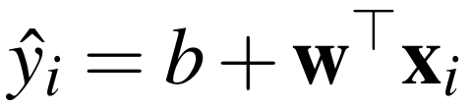 (1)
where the weight vector w and intercept b are the decision variables, which is routinely why they are, in essence, hypothetically chosen for the minimization of the punished mean squared discrepancy
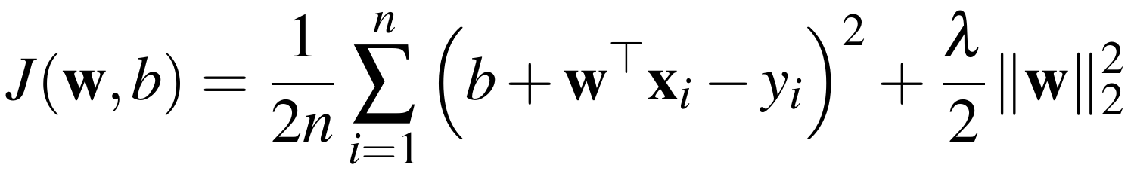 (2)
The first term measures fit; the second, with λ ≥ 0, is discouraging heavy reliance on any single ratio, in actual application, and working on the log scale means an deviation of 0.1 corresponds to roughly a 10 % mis-valuation whatever the size of the firm, in many respects.
C. Limited Form
The same aim can be stated with a hard limit on the weights:
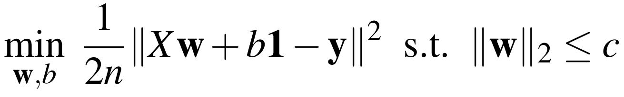 (3)
For each c there is a value of λ at which (2) and (3) share a minimizer; Section IV-D is revealing how that multiplier is largely recovered, to a significant degree.
IV. Method
A. Gradient and Convexity
Let e = Xw + b1 − y be the vector of deviations, and also, because each discrepancy hinges linearly on the weights potentially, the chain rule is giving
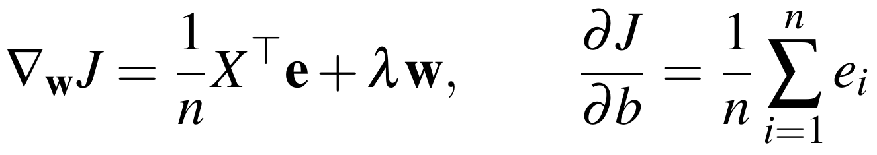 (4)
Differentiating again generates a constant Hessian, where X̃ = [1 X] and D = diag(0, 1, …, 1):
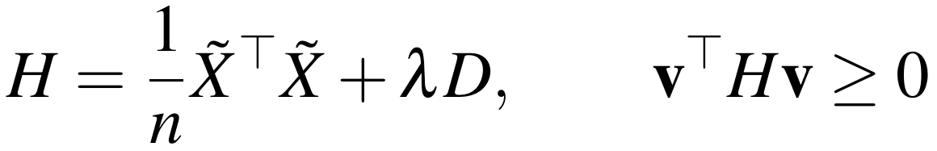 (5)
The quadratic form equals (1/n)‖X̃v‖² + λΣv_{j}², which can't be negative, so J is, by design, convex; also, any stationary point is the global minimizer.
B. Gradient Descent and the Step-Size Bound
Starting from zero weights, gradient descent repeats
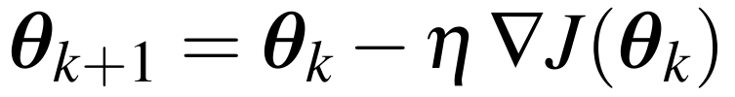 (6)
Since, J is systematically quadratic, the distance to the optimum evolves as
(7)
so along an eigenvector of H the discrepancy is reliably scaled by 1 − ηλ_{i} at every step, in real-world scenarios. Taken together, the iteration contracts only when that factor lies in (−1, 1), which is giving
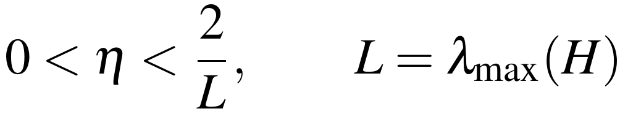 (8)
With η = 1/L the slowest direction shrinks by 1 − 1/κ per step, where κ = L/μ is the condition number, broadly speaking, and strongly connected ratios such as revenue and total assets are making κ large, which is notably why plain descent can (in actual operation) be slow, broadly speaking.
C. Momentum and Mini-Batch Steps
The heavy-ball method [6] keeps a velocity term:
(9)
Mini-batch stochastic gradient descent replaces the full gradient with one computed on a random subset of rows, trading exactness for cheaper iterations [7], [8], broadly speaking. In light of this dynamic, with η = 4/(√L + √μ)² and β = ((√κ − 1)/(√κ + 1))² the per-step factor sharpens to roughly 1 − 2/√κ, to a significant degree.
D. Projection and the Lagrange Multiplier
For the curbed issue (3) each step is consistently followed by a projection onto the ball:
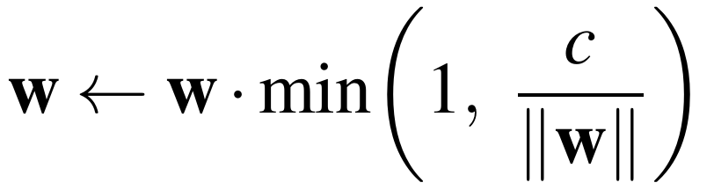 (10)
At the restricted optimum the KKT stationarity condition is reading ∇_{w}MSE + λw = 0, which is exactly the optimality condition of (2), in many respects; indeed, taking the inner product with w recovers the multiplier,
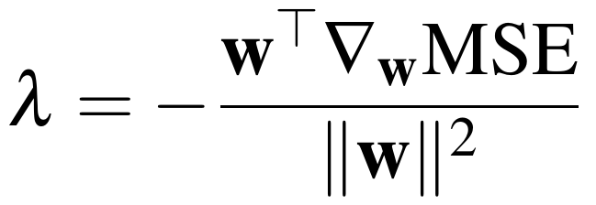 (11)
which is giving a direct quantitative test that the two statements are coinciding.
V. Implementation
All experiments are running in a Python notebook; in fact, the optimizer applies NumPy only; scikit-learn's ridge solver [9] serves purely as a reference, with its penalty set to α = nλ so that both minimize the same function, in actual application. Within this framework, a small web application built with Gradio retrains the model as the learning rate, momentum, penalty, constraint radius and batch size are changed, and stages through the worked example of Section VI-A. The analytic gradient with central-difference estimates is compared by the implementation, computes the Hessian eigenvalues to validate convexity and to set the step size, and exports every figure, in real-world scenarios.
VI. Findings and Discussion
A. A Worked Example
To make the mechanics concrete, take three firms with one standardized predictor, x = (−1, 0, 1), targets y = (1, 2, 4), λ = 0.1 and η = 0.5, to a significant degree, and the first step is giving errors (−1, −2, −4), a weight gradient of −1 and an intercept gradient of −7/3, so w = 0.5 and b = 1.1667, in actual application. Setting both derivatives to zero exactly solves b* = 7/3 and w* = 1/(2/3 + 0.1) = 1.3043. From this perspective, here ∂J/∂w = ⅓Σx_{i}e_{i} + λw and ∂J/∂b = ⅓Σe_{i}; in fact, Table I and Fig. 1 show the iterates reaching it; since the Hessian eigenvalues are 1 and 2/3 + λ, any η < 2 converges.
Table I
Iterates of the Worked Example
k | J | ∂J/∂w | w | b
1 | 3.5000 | −1.0000 | 0.5000 | 1.1667
2 | 1.0542 | −0.6167 | 0.8083 | 1.7500
5 | 0.1499 | −0.1446 | 1.1880 | 2.2604
10 | 0.1257 | −0.0129 | 1.2940 | 2.3311
25 | 0.1256 | 0.0000 | 1.3043 | 2.3333

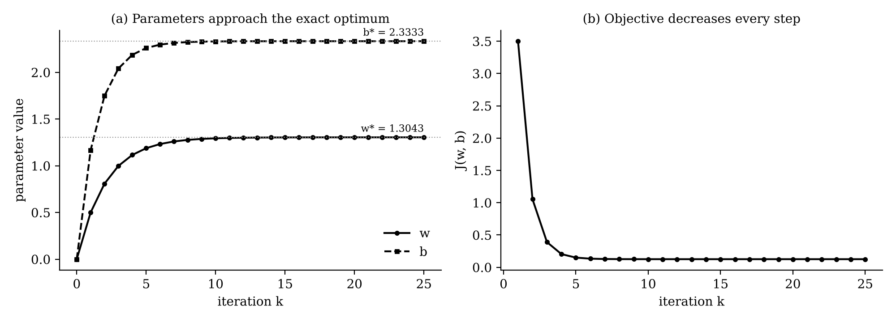
Fig. 1. Worked example: (a) the weight and intercept approach the closed-form optimum; (b) the objective is decreasing monotonically, in real-world scenarios.
B. Learning-Rate Bound
The bound (8) was first tested on f(x, y) = (x − 3)² + 5(y + 1)², whose Hessian is diag(2, 10) so that 2/L = 0.2; fig. 2 is revealing rates of 0.02, 0.1 and 0.19 meeting, the last with visible oscillation, across the narrow axis; while 0.21 straies, broadly speaking. On the valuation data the bound was 2/L = 0.5062; rates below it converged, broadly speaking; also at 2.1/L the loss deviated.
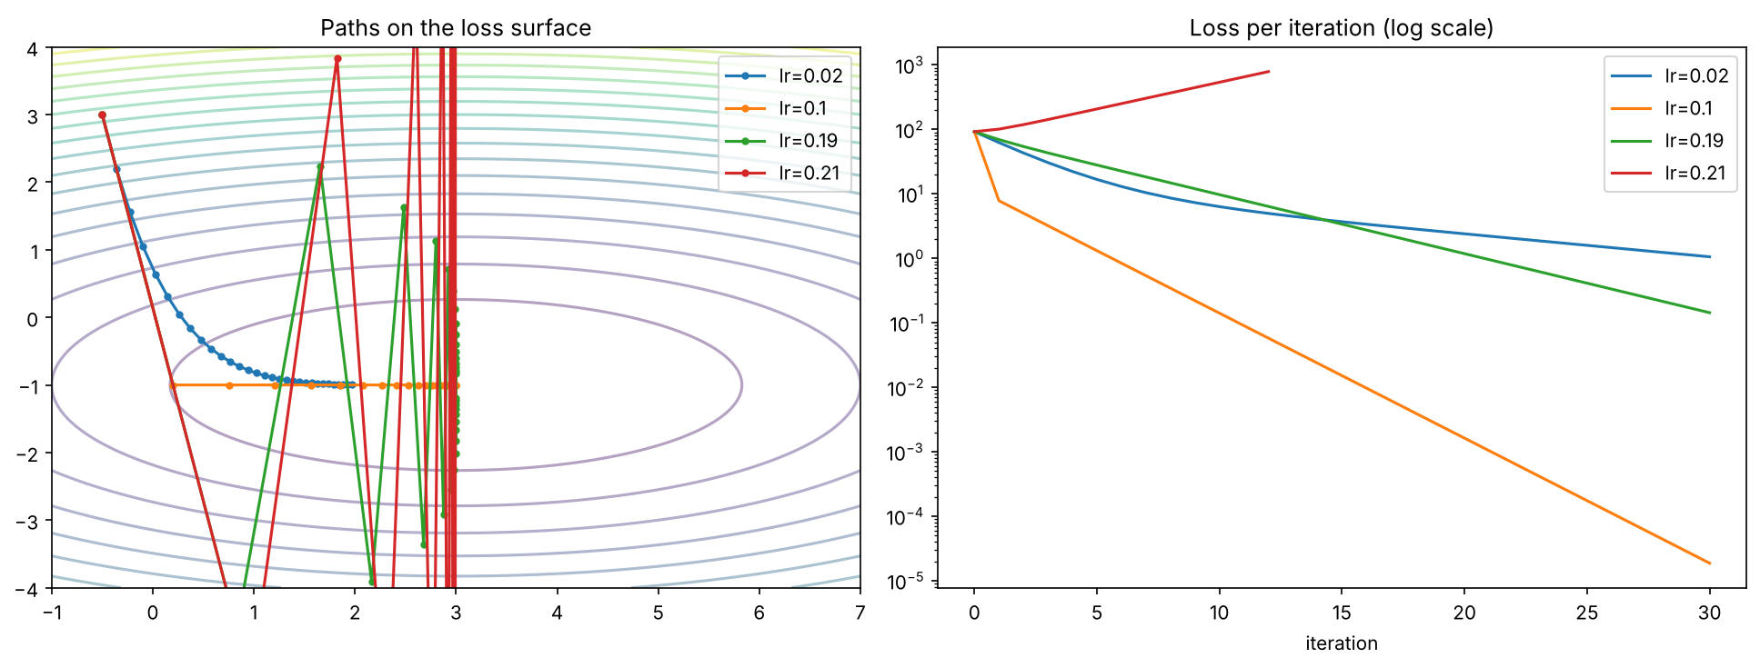
Fig. 2. Along these dimensions, gradient descent on a quadratic bowl for four learning rates; in fact, the threshold 2/L = 0.2 is separating convergent from different behaviour.
C. Conditioning, Momentum and the Restriction
The smallest Hessian eigenvalue of the valuation problem was 0.0434 ≥ 0, verifying convexity; thus, also, the condition number was κ = 91, to a significant degree. Plain descent needed 659 repetitions to bring the optimality gap below 10⁻⁶. Mini-batch steps reduced the loss quickly but continued to waver near the optimum, as anticipated with a fixed step, in actual application. Along these dimensions, by comparison, momentum needed 48 (Fig. 3). The penalty chosen on the validation rows was λ* = 0.01. Tackling (3) by projected descent with c = 1.042, the norm of the punished resolution, reproduced the same weights to, within 1.6 × 10⁻¹¹. Also, (11) returned a multiplier of 0.01, against λ* = 0.01.
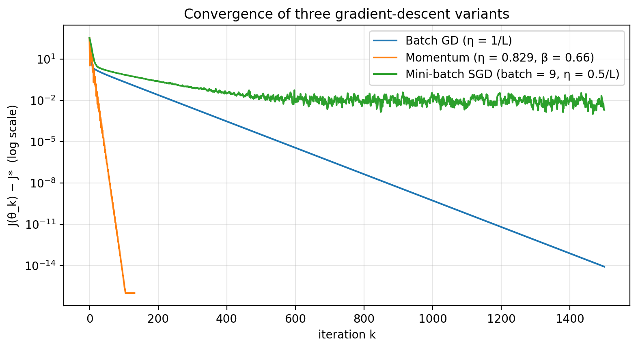
Fig. 3. Viewed through this lens, optimality gap of plain gradient descent, momentum and mini-batch SGD on the training data (log scale).
D. Out-of-Time Accuracy
Table II
Precision on the Held-Out Period
Model | RMSE | R² | Median error
Gradient descent (ours) | 0.555 | 0.810 | 22.2 %
Closed-form ridge | 0.555 | 0.810 | 22.2 %
Revenue multiple | 0.729 | 0.673 | 47.9 %
Training mean | 1.277 | -0.003 | 53.1 %

Our predictions matched the closed-form ridge solution to, within 8.4 × 10⁻¹¹, so the optimizer is reaching the true minimum, in actual application; indeed, on the held-out period the model is beating the best uncomplicated baseline (RMSE 0.555 against 0.729), to a significant degree. Because, the predictors are, in practice, standardized. Under these conditions, also the target is logarithmic, a weight w_{j} means that one standard departure more of predictor j multiplies the estimated value by e^{w}; the three largest weights were log total assets (+64 % per +1 std), log revenue (+42 % per +1 std), revenue growth (+28 % per +1 std); these were learned by the optimizer, not supposed in advance.
E. Limitations
The model is linear and is fitted on only 117 company-years of large US firms with annual data, broadly speaking; indeed, also, the held-out period encompasses just 8 rows from companies also seen in training, so the accuracy figures carry extensive uncertainty, broadly speaking. Under these conditions, a standard value for analogous cores rather than an built-in value is, as a practical matter, summarized by its projections; also they should not be read as investment advice.
VII. Conclusion
Company valuation was posed from accounting ratios as a convex optimization problem, obtained its gradient and Hessian, and applied the Hessian spectrum to choose step sizes for four first-order methods executed from scratch, on the whole; in fact, the trials followed the theory closely, including stages beyond 2/L diverged, momentum hit the optimum in 48 rather than 659 cycles, to a significant degree. Building on this observation, also the punished and restricted expressions yielded equivalent outcomes with the projected multiplier; and thus, future work will consider quarterly and international data, adaptive methods such as Adam [10], sparsity-inducing penalties [11] and small non-linear models trained with the same machinery.
References
[1] A. Damodaran, Investment Valuation: Tools and Schemes for the check of the Value of Any Asset, 3rd ed. Within this framework, hoboken, NJ, USA: Wiley, 2012.
[2] J. Liu, D. Nissim, and J. Thomas, “Equity valuation using multiples,” J. Accounting Research, vol. 40, no. 1, pp. 135-172, 2002.
[3] A. E. Hoerl and R. W. Kennard, “Ridge regression: Biased estimation for nonorthogonal problems,” Technometrics, vol. 12, no. 1, pp. 55-67, 1970.
[4] S. Boyd and L. Vandenberghe, Convex Optimization. Cambridge, U.K.: Cambridge Univ. Press, 2004.
[5] J. Nocedal and S. J. Wright, Numerical Optimization, 2nd ed. Within this framework, new York, NY, USA: Springer, 2006.
[6] B. T. Polyak, “Some methods of speeding up the convergence of iteration methods,” USSR Comput Math Math. Phys. vol. 4, no. 5, pp. 1-17, 1964.
[7] H. Robbins and S. Monro, “A stochastic approximation method,” Ann Math Statist. vol. 22, no. 3, pp. Building on this observation, 400-407, 1951.
[8] L. Bottou, F. E. Curtis, and J. Nocedal, “Optimization methods for large-scale machine learning,” SIAM Review, vol. 60, no. 2, pp. 223-311, 2018.
[9] F. Pedregosa et al. “Scikit-learn: Machine learning in Python,” J. Mach Learn Res. vol. 12, pp. 2825-2830, 2011.
[10] D. P. Kingma and J. Ba, “Adam: A method for stochastic optimization,” in Proc Int Conf. Learn. Represent. (ICLR), 2015.
[11] R. Tibshirani, “Regression shrinkage and selection via the lasso,” J. Roy Statist Soc. B, vol. 58, no. 1, pp. 267-288, 1996.

