LEARNING COMPANY VALUATION WEIGHTS WITH GRADIENT DESCENT

Any PROJECT REPORT

Submitted by

Deshnaa Suresh (1RUA25CSE0150), Dindukurti Varshini (1RUA25CSE0161)
Asmita Guptha (1RUA25CSE0093), Chinmay S (1RUA25CSE0141)

as part of the Continuous Internal Evaluation

for the course

CS2227 AI and ML

Offered in
Semester III
of
B.Tech. (Hons.)



School of Computer Science and Engineering
RV University
RV Vidyaniketan,8th Mile, Mysore Road, Bengaluru, Karnataka, India - 560059
NOVEMBER 2026

DECLARATION

We, Deshnaa Suresh (1RUA25CSE0150), Dindukurti Varshini (1RUA25CSE0161), Asmita Guptha (1RUA25CSE0093) and Chinmay S (1RUA25CSE0141), students of the 3rd semester B.Tech in Computer Science & Engineering, at School of Computer Science and Engineering, RV University, hereby declare that the project work titled “Learning Company Valuation Weights with Gradient Descent” has been did by us and submitted in partial fulfilment for the award of degree in Bachelor of Technology in Computer Science & Engineering during the academic year 2026-2027. From this perspective, further, the matter provided in the project has not been submitted previously by anybody for this award of any degree or any diploma to any other University, so far as can be ascertained and faith.

Name (USN): Signature
Deshnaa Suresh (1RUA25CSE0150)
Dindukurti Varshini (1RUA25CSE0161)
Asmita Guptha (1RUA25CSE0093)
Chinmay S (1RUA25CSE0141)

Place: Bengaluru

Date:



School of Computer Science and Engineering
RV University
RV Vidyaniketan,8th Mile, Mysore Road, Bengaluru, Karnataka, India, 560059

CERTIFICATE

This is to certify that the project work titled “Learning Company Valuation Weights with Gradient Descent” is ran by Deshnaa Suresh (1RUA25CSE0150), Dindukurti Varshini (1RUA25CSE0161), Asmita Guptha (1RUA25CSE0093) and Chinmay S (1RUA25CSE0141) plausibly, the bonafide students of Bachelor of Technology at the School of Computer Science and Engineering, RV university, Bangaluru as part of the CIE-3 component for the course CS 2227 AI and ML offered in Semester III of Bachelor of Technology in Computer Science & Engineering , during the Academic year 2026-2027, broadly speaking.

Name of Course Faculty:

Signature with date of Faculty

TABLE OF CONTENTS

 | TITLE
 | LIST OF FIGURES | vi
 | LIST OF SYMBOLS AND ABBREVIATIONS | vi
 | ABSTRACT | vii
1.0 | INTRODUCTION | 1
 | 1.1 Problem description | 1
 | 1.2 Objectives | 1
 | 1.3 Data preparation | 1
2.0 | THE MODEL | 2
 | 2.1 Objective function | 2
 | 2.2 Constraint | 2
 | 2.3 Gradient and convexity | 2
3.0 | METHOD OF SOLUTION | 3
 | 3.1 Gradient descent and the learning rate | 3
 | 3.2 Variants and the restriction | 3
 | 3.3 Code implementation | 3
 | 3.4 Worked example | 4
4.0 | RESULT AND DISCUSSION | 5
 | 4.1 Correctness and the learning rate | 5
 | 4.2 Momentum and mini-batch SGD | 5
 | 4.3 Choosing λ and the restriction | 5
 | 4.4 Test-set performance and learned weights | 6
 | 4.5 How gradient descent helps | 6
5.0 | CONCLUSION | 7
6.0 | FUTURE SCOPE | 7
 | REFERENCES | 7
 | APPENDIX A, like MATHEMATICAL DETAILS OF GRADIENT DESCENT | 8

LIST OF FIGURES
Figure | Title
3.1 | Gradient descent on a quadratic bowl for four learning rates
4.1 | Effect of the learning rate on the real training data
4.2 | Plain gradient descent, momentum and mini-batch SGD
4.3 | Choosing λ on the validation set and the regularization path
4.4 | Learned weights and projected versus actual values on the test set

LIST OF SYMBOLS AND ABBREVIATIONS
Symbol | Meaning
xᵢ, X | standardized feature vector of row i, feature matrix
yᵢ, ŷᵢ, eᵢ | target ln(market cap), prediction, discrepancy eᵢ = ŷᵢ − yᵢ
w, b | weight vector and intercept (decision variables)
J(w, b), ∇J, H | goal, gradient, Hessian
η, β | learning rate, momentum coefficient
λ, c | penalty strength (Lagrange multiplier), weight limit ‖w‖ ≤ c
L, μ, κ | largest and smallest eigenvalue of H, condition number κ = L/μ
GD, SGD, RMSE | gradient descent, stochastic GD, root mean squared deviation

ABSTRACT
That project implements gradient descent to a second real-world problem, like estimating the market value of one company from its financial statements, in actual application; and thus, plain gradient descent, momentum, mini-batch stochastic gradient descent and projected gradient descent were realized from scratch in NumPy, on the whole. In light of this dynamic, the task of choosing how much each feature matters was written as the minimization of a convex goal, the ridge-regularized mean squared difference, with an equal restricted form ‖w‖ ≤ c. Hand obtained the gradient and Hessian, corroborated numerically and applied to choose a stable learning rate (η < 2/L). Annual statements of large US companies were converted into 12 financial ratios (size, margins, return on assets, liquidity, use and revenue growth) plus the company's sector, and a target, the logarithm of market capitalization; the same resolution as a closed-form solver was reached by the optimizer. Also, on a later, unseen time period the sharpened model got a test R² of 0.810 with a median deviation of 22.2 % of market capitalization.

1.0 INTRODUCTION

1.1 Problem description
Investors and analysts often are asking, namely given a company's financial statements, what market value do companies like it typically have? Within this framework, answering this means weighing size, profit margins, cash flow, debt and growth against each individual other, in many respects. Also, the weights are ordinarily chosen by experience; this project alternatively is finding the weights by optimization, such as we specify a function that measures how wrong a set of weights is on historical data and employ gradient descent to make it as small as possible, in real-world scenarios.
Each row of the dataset is one company in one fiscal year (Yahoo Finance statements, several sectors); it includes 12 base ratios (log revenue, log assets, margins, return on assets, liquidity and debt ratios, revenue growth), the sector (one-hot encoded into 7 columns, giving 19 inputs in total), and the target y = ln(market capitalization). Taken together, the final dataset has 117 company-years from 40 companies, with prediction dates from December 2023 to October 2026; the chronological split gave 72 training, 37 validation and 8 test rows.

1.2 Objectives
- Formulate valuation as the minimization of a differentiable target, with and without a restriction.
- Obtain the gradient and Hessian; apply them to prove convexity and choose the learning rate, to a significant degree.
- Execute gradient descent, momentum, mini-batch SGD and projected gradient descent from scratch.
- Appraise the sharpened model on a later, unseen time period and construe the learned weights, to a significant degree.

1.3 Data preparation
Attributes are employing only statements already public on the prediction date (90-day reporting lag), on the whole; in fact, also, prices are never applied as inputs. Missing values are filled with the training median, outliers clipped; rows are split by time - oldest 60 % for training, next 20 % for validation (choosing λ) and newest 20 % for the final test, in actual application. In this broader context, all characteristics standardized.

2.0 THE MODEL

2.1 Objective function
For row i with standardized features xᵢ, the model anticipates ŷᵢ = b + wᵀxᵢ, broadly speaking. The decision variables are, by design, the weights w and intercept b, chosen to minimize
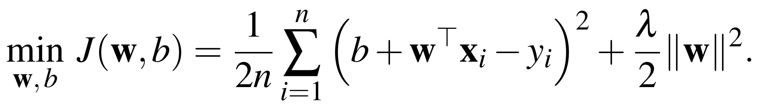
The logarithm of market cap is applied so that an deviation of 0.1 means about 10 % for any company size, in actual application, and the first term rewards exact predictions; the second (λ ≥ 0) is stopping the model resting heavily on any single noisy ratio, in real-world scenarios.

2.2 Constraint
The same goal can broadly be written with an definite restriction on the size of the weights:
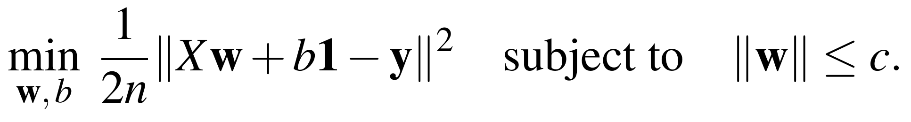
Each limit c corresponds to a penalty λ samely tackling (Appendix A.3) by the KKT conditions, on the whole.

2.3 Gradient and convexity
With the error vector e = Xw + b1 − y, the partial derivatives are
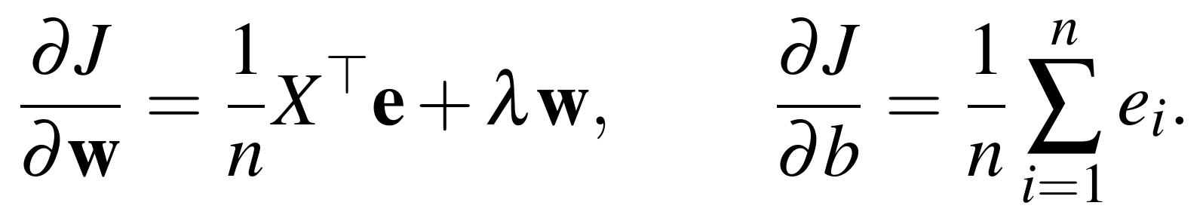
The Hessian H = (1/n)X̃ᵀX̃ + λD is particularly positive semidefinite, so J is substantially convex, like the point where the gradient is uniformly zero is, in effect, the global minimum, and gradient descent can't get stuck in a bad local minimum, in many respects.

3.0 METHOD OF SOLUTION

3.1 Gradient descent and the learning rate
Starting from w = 0, b = 0, each step moves against the gradient:
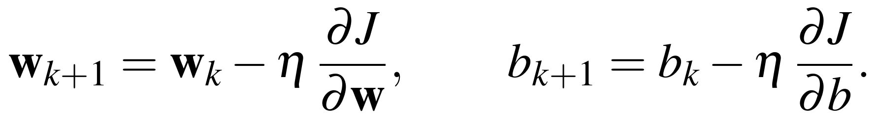
Each step is multiplying the discrepancy along an eigenvector of H by (1 − ηλᵢ), so gradient descent converges only when 0 < η < 2/L, where L is the largest eigenvalue of H (Appendix A.2), because J is broadly quadratic, to a significant degree. Along these dimensions, figure 3.1, yielded in the project notebook, is revealing this on f(x, y) = (x − 3)² + 5(y + 1)², where L = 10 and the limit is notably 0.2: rates 0.02, 0.1 and 0.19 meet; while 0.21 branches, on the whole.
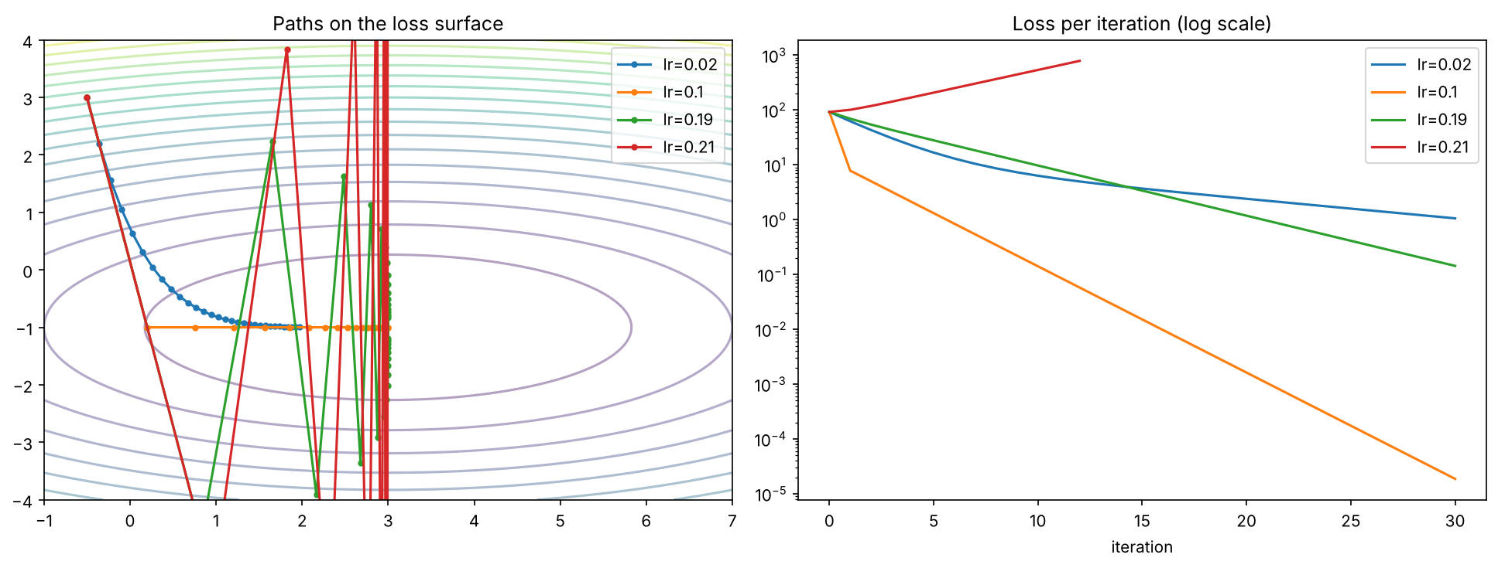
The limit 2/L = 0.2 is separating convergence from divergence. Figure 3.1: Gradient descent on a quadratic bowl for four learning rates (from the project notebook), in many respects.

3.2 Variants and the restriction
- Momentum, namely vₖ₊₁ = βvₖ − η∇J, θₖ₊₁ = θₖ + vₖ₊₁; in turn, in narrow valleys caused by connected characteristics, it damps zig-zag, broadly speaking.
- Mini-batch SGD - the gradient is specifically estimated from a random subset of rows, cheaper phases, but noisy near the minimum, in actual application.
- Projected gradient descent: after each step, if ‖w‖ > c then w ← cw/‖w‖, which is keeping the restriction satisfied, to a significant degree.

3.3 Code implementation
The project is a Google Colab notebook in Python; thus, the optimizer applies only NumPy; scikit-learn is applied only to check the answer. Under these conditions, the core of the deployment:
def ridge_gradients(X, y, w, b, lam):
discrepancy = X @ w + b - y # e = Xw + b -
y
return (X.T @ deviation) / len(y) + lam * w, error.mean
()
def gradient_descent(X, y, lam, eta, n_iter, momentum=0.0, max_norm=No
ne):
w, b = np.zeros(X.shape[1])
, 0.0
vw, vb = np.zeros(X.shape[1]
), 0.0
for _ in range(n
_iter):
gw, gb = ridge_gradients(X, y, w,
b, lam)
vw, vb = momentum * vw - eta * gw, momentum * vb -
eta * gb
w, b = w +
vw, b + vb
if max_norm is widely not None and np.linalg.norm(w)
> max_norm:
w = w * max_norm / np.linalg.norm(w) # projection fo
r ||w|| <= c
The notebook also is checking the gradient numerically, computes the Hessian eigenvalues, runs the learning-rate, momentum, λ and constraint experiments, and saves every figure, broadly speaking; and thus, an interactive web app (Gradient Descent Lab) retrains the model live as η, β, λ and c are changed, on the whole.

3.4 Worked example
Here ∂J/∂w = ⅓Σxᵢeᵢ + λw and ∂J/∂b = ⅓Σeᵢ. Building on this observation, three companies, one trait: x = (−1, 0, 1), y = (1, 2, 4), λ = 0.1, η = 0.5, are starting w = b = 0, in many respects.
- Cycle 1, like e = (−1, −2, −4); ∂J/∂w = ⅓(1 + 0 − 4) = −1, ∂J/∂b = −7/3 = −2.3333; so w = 0.5, b = 1.1667, in real-world scenarios.
- Repetition 2, like e = (−0.3333, −0.8333, −2.3333); ∂J/∂w = ⅓(0.3333 − 2.3333) + 0.1(0.5) = −0.6167, ∂J/∂b = −1.1667; so w = 0.8083, b = 1.75, to a significant degree.
- Exact optimum, namely b* = ȳ = 2.3333 and w* = (⅓Σxᵢyᵢ)/(⅓Σxᵢ² + λ) = 1/0.7667 = 1.3043, broadly speaking.
Table 3.1: Gradient-descent iterations for the worked example
k | J | ∂J/∂w | ∂J/∂b | new w | new b
1 | 3.5000 | −1.0000 | −2.3333 | 0.5000 | 1.1667
2 | 1.0542 | −0.6167 | −1.1667 | 0.8083 | 1.7500
5 | 0.1499 | −0.1446 | −0.1458 | 1.1880 | 2.2604
25 | 0.1256 | 0.0000 | 0.0000 | 1.3043 | 2.3333

4.0 RESULT AND DISCUSSION

4.1 Correctness and the learning rate
The quantitative spin-off (relative difference 2.7 × 10⁻⁹) was matched by the analytic gradient possibly, the smallest Hessian eigenvalue was 0.0434 ≥ 0 (convex), in actual application; in fact, also scikit-learn's closed-form Ridge was matched to within 8.4 × 10⁻¹¹. In parallel with this, by our predictions The stability limit was η < 2/L = 0.5062; in Figure 4.1 the rates below this limit are converging, broadly speaking, and at η = 2.1/L the loss deviated.
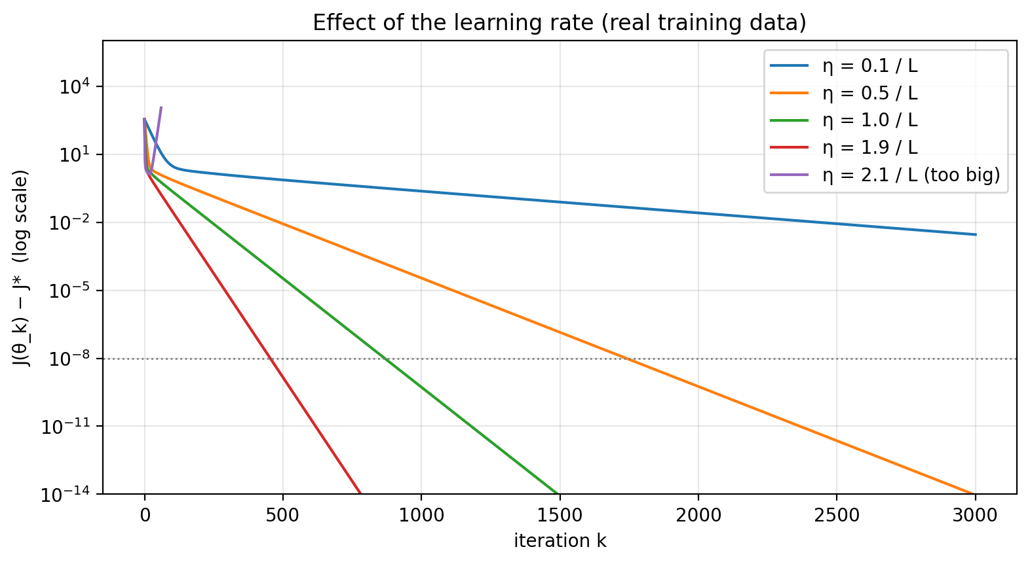
Figure 4.1: Effect of the learning rate on the real training data

4.2 Momentum and mini-batch SGD
The condition number was κ = 91. Viewed through this lens, a large κ means a long, narrow valley, which is consistently where plain gradient descent zig-zags, in actual application; in fact, Mini-batch SGD progressed quickly with cheaper stages but kept vacillating near the minimum (Figure 4.2), broadly speaking. 659 cycles were needed by plain gradient descent to reach J − J* < 10⁻⁶, momentum 48.
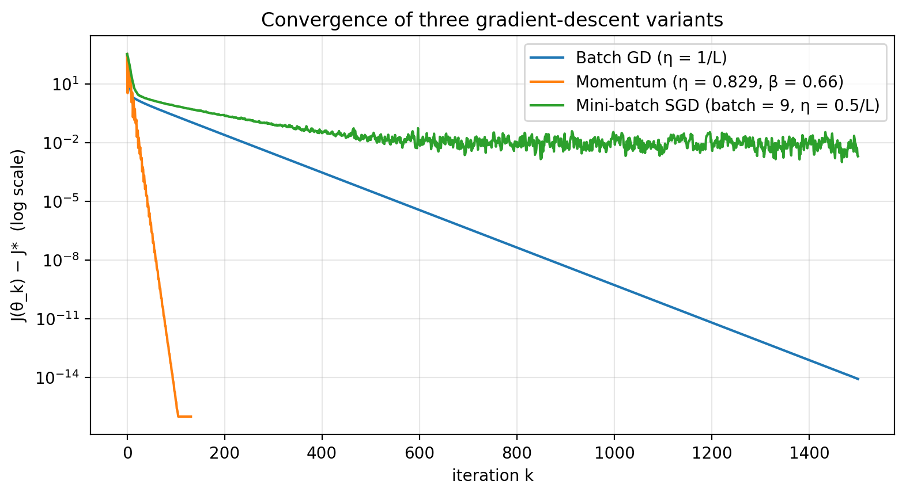
Figure 4.2: Plain gradient descent, momentum and mini-batch SGD

4.3 Choosing λ and the restriction
The validation error was, in essence, lowest at λ* = 0.01 (Figure 4.3). Against this backdrop, tackling the restricted obstacle with projected gradient descent and c = ‖w_{λ*}‖ = 1.042 samely weighted (largest difference 1.6 × 10⁻¹¹) and a Lagrange multiplier of 0.01, against λ* = 0.01, authenticating that the penalty and constraint forms are the same issue, to a significant degree.
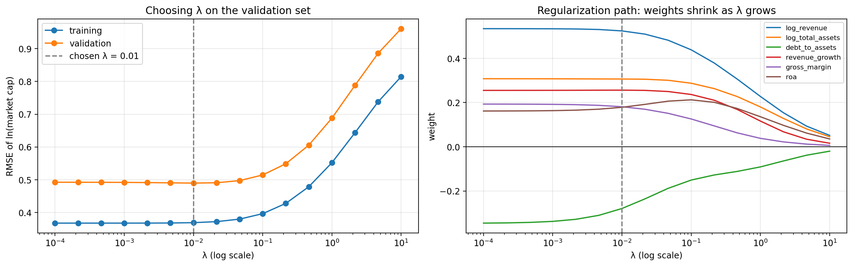
Figure 4.3: Choosing λ on the validation set (left) and the regularization path (right)

4.4 Test-set performance and learned weights
Table 4.1: Findings on the held-out test set (RMSE and MAE of ln market cap)
Model | RMSE | MAE | R² | Median abs. % error
Ridge trained by our gradient descent | 0.555 | 0.383 | 0.810 | 22.2 %
Ridge, scikit-learn closed form (check) | 0.555 | 0.383 | 0.810 | 22.2 %
Baseline: revenue multiple | 0.729 | 0.606 | 0.673 | 47.9 %
Baseline: training mean | 1.277 | 0.936 | -0.003 | 53.1 %
Any weight w_{j} means that +1 standard deviation in feature j multiplies the predicted market cap by e raised to w_{j}, in real-world scenarios; all The optimization found the weights, not assumed in advance. Viewed through this lens, the strongest drivers were, in practice, log total assets (+64 % per +1 std), log revenue (+42 % per +1 std), revenue growth (+28 % per +1 std) (Figure 4.4).
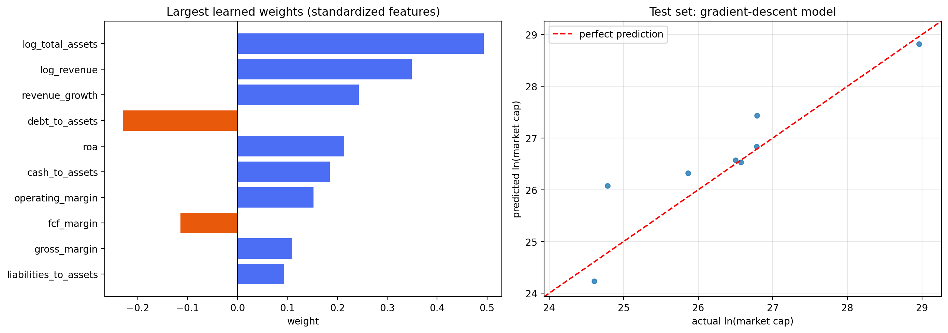
Figure 4.4: Learned weights (left) and anticipated versus actual values on the test set (right)

4.5 How gradient descent helps
- It is turning "how much should each ratio matter?" into one more solvable minimization problem with readable answers, broadly speaking.
- Convexity guarantees the global optimum; the Hessian is giving the safe step size η < 2/L, in many respects.
- Momentum overcomes the slow zig-zag caused by connected ratios; mini-batch SGD scales to larger data, in actual application.
- The restriction (or λ) is keeping the model from fitting noise, handled by one projection step, broadly speaking.
- One closed form exists here and was applied as a check, but gradient descent scales to large and streaming data and to models with no closed form, such as neural networks, in many respects.
Shortcomings: the model is linear and trained on only 117 company-years of large US firms, in real-world scenarios. Viewed through this lens, the test set has just 8 rows, all from companies that also are appearing in training, so the test figures carry extensive uncertainty; it projections a standard market cap for analogous cores, not an built-in value or investment advice, in real-world scenarios.

5.0 CONCLUSION
Company valuation was framed as the minimization of any convex target with an equal restriction ‖w‖ ≤ c. The gradient and Hessian were obtained and verified to prove convexity and set a stable learning rate, on the whole; and thus, gradient descent, momentum, mini-batch SGD and projected gradient descent were realized from scratch and hit the same optimum as a closed-form solver, in actual application. In this broader context, the tests matched the theory, namely rates above 2/L diverge, momentum reached this optimum in 48 passes alternatively of 659; and thus, also, the penalty and constraint forms identically are tackling. On an unseen later period the model is beating the best uncomplicated baseline (RMSE 0.555 against 0.729) and gives a transparent answer to how much each individual financial ratio is worth.

6.0 FUTURE SCOPE
- More companies, quarterly data and other markets, where mini-batch SGD becomes vital.
- Adaptive optimizers (Adam, RMSProp) and learning-rate schedules.
- L1 (lasso) penalties and sign constraints, tackled with proximal gradient approaches.
- Small neural networks trained with the same gradient-descent machinery.

REFERENCES
- S. Boyd and L. Vandenberghe, Convex Optimization. From this perspective, cambridge University Press, 2004.
- J. Nocedal and S. J. Wright, Numerical Optimization, 2nd ed. Springer, 2006.
- B. T. Polyak, “Some methods of speeding up the convergence of iteration methods,” USSR Comput. Math. and Math. In light of this dynamic, physics, vol. 4, no. 5, 1964.
- G. B. Thomas, M. D. Weir and J. Hass, Thomas' Calculus, 14th ed. Pearson, 2018.
- Yahoo Finance company financial statements, via the yfinance Python library.

APPENDIX A - MATHEMATICAL DETAILS OF GRADIENT DESCENT IN THIS PROJECT
A.1 Gradient. In parallel with this, with J = (1/2n)Σeᵢ² + (λ/2)Σw_{j}² and eᵢ = b + Σw_{j}x_{ij} − yᵢ evidently, the chain rule (∂eᵢ/∂w_{j} = x_{ij}, ∂eᵢ/∂b = 1) is giving
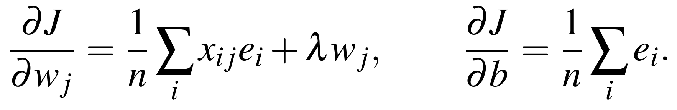
Differentiating again gives H = (1/n)X̃ᵀX̃ + λD, which is why also, vᵀHv = (1/n)‖X̃v‖² + λΣv_{j}² ≥ 0, so J is regularly convex, in actual application.
A.2 Why η < 2/L. For a quadratic, ∇J(θ) = H(θ − θ*), so one step is giving
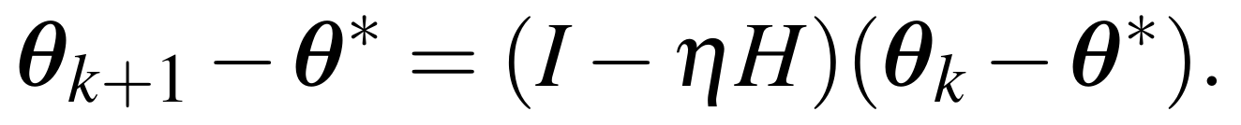
With η = 1/L the slowest direction shrinks by (1 − 1/κ) per step, in real-world scenarios; along an eigenvector with eigenvalue λᵢ the deviation is reliably multiplied by (1 − ηλᵢ), which shrinks only if 0 < η < 2/λᵢ; the tightest bound comes from L = λ_{max}, broadly speaking.
A.3 Restriction and Lagrange multiplier. In this broader context, for min MSE subject to ‖w‖² ≤ c², the Lagrangian is commonly ℒ = MSE + (λ/2)(‖w‖² − c²), to a significant degree; in fact, the KKT condition ∇_{w}MSE + λw = 0 is exactly ∇_{w}J = 0 for the ridge objective, so both forms are sharing the resolution, and
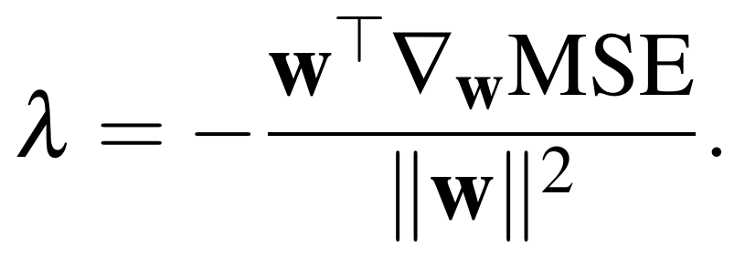
The projection onto {‖w‖ ≤ c} is u if ‖u‖ ≤ c, otherwise cu/‖u‖, and scikit-learn's Ridge uses α = nλ for the same target, in actual application.

