PROJECT REPORT
Smart Railway Level-Crossing Safety Controller with Emergency Override
A fail-safe, Arduino-based scale-model prototype simulated in Tinkercad
TEAM MEMBERS Team 1
No. | Name
1 | V Chinmaya Datta
2 | N Jathin
3 | Ch Sai Krishna
4 | S Konda Reddy
Amrita Vishwa Vidyapeetham, Coimbatore
October 2026

1. Project Scope
This project covers the design, simulation and testing of a controller for a single-track railway level crossing, built as a scale model. The controller decides when to stop road traffic, lowers a barrier, warns people with lights and a buzzer, and reopens the crossing only when it is certain that the train has left. The whole system is simulated in Tinkercad Circuits using only components that exist in real hardware, so the same circuit can be built on a breadboard.

In scope
- Detecting a train with two force-sensitive resistors (FSRs) placed at the entry and exit of a protected track section.
- Axle counting, train speed estimation and arrival-time (ETA) prediction.
- Control of road signals for two approaches, flashing railway warning lights, a buzzer and a servo-driven barrier.
- An emergency override and a safe-state response to sensor faults, wrong sensor order and stalled trains.
- Simulation and testing of every behaviour in Tinkercad Circuits.

Assumptions and exclusions
- The track is a scale model. A real railway would use axle counters (Hall-effect or inductive) instead of FSRs.
- Trains travel in one direction, from the entry sensor to the exit sensor.
- Train speed is assumed constant between the first two entry axles and the crossing.
- The prototype is not a certified railway safety system and has no hardware redundancy.

2. Objective
To build a low-cost, fail-safe scale-model level-crossing controller that detects a train reliably, warns early enough for the barrier to be down before the train arrives, and always falls back to a safe state when anything is in doubt.
The specific objectives are:
- Count axles entering and leaving the protected section so that the crossing reopens only when every axle has left.
- Estimate train speed and arrival time so that the warning starts at the right moment, and shorten the sequence for fast trains.
- Sequence the road signal, barrier, flashers and buzzer through a state machine, never switching abruptly from green to red.
- Provide an emergency override on a hardware interrupt that always wins.
- Make faults visible: broken sensor wire, stuck sensor, wrong sensor order and stalled train.
- Use only components that exist in real hardware, and validate the design in simulation.

3. Existing Related Work

3.1 Constant warning time systems
Grade crossing predictors, also called constant warning time devices, are connected to the rails and detect a train from the changes its wheels and axles cause in the electrical impedance of the track. From these changes they compute the train's distance and speed, and activate the lights, bells and gates a fixed time before it arrives (for example 30 seconds), whatever its speed [1][2][3]. This avoids very slow trains closing the road for a long time without reason.

3.2 Axle counters
In railway signalling, axle counters count the axles entering and leaving a track section. The section is declared clear only when the number counted out equals the number counted in, which makes the result independent of train length. This idea is the basis of our occupancy logic.

3.3 Interlocked crossing gates
On main lines, crossing gates and signals are commonly interlocked, so a signal for the train can clear only while the gate is closed. Our controller follows the same principle in a simpler form: the road stays red until the barrier is fully up.

3.4 Student and hobby designs
Many Arduino level-crossing projects use infrared or ultrasonic sensors with a servo gate and fixed delays. They demonstrate the basic idea, but they typically use fixed warning times, have no fault detection, and cannot tell a failed sensor from an idle one.

3.5 Comparison
Feature | Typical student projects | Industrial systems | This project
Train detection | IR, ultrasonic or push switch | Track circuits, axle counters | Two FSRs counting axles
Long or paused trains | Often fails with entry/exit flags | Handled | Handled by axle-count balance
Warning timing | Fixed delay | Constant warning time from speed and distance | Speed-based hold-off; shorter sequence for fast trains
Sensor fault detection | Usually none | Fail-safe design, redundancy | Open-circuit, stuck and wrong-order checks
Emergency override | Rare | Yes | Interrupt-driven button
Cost and complexity | Very low | High | Low: Arduino Uno and common parts

4. Proposed Idea
The central idea is to treat the crossing as a safety function, not just as a set of lights and a gate. The controller combines six ideas that real railways use, scaled down to a low-cost model:
- Axle counting instead of simple entry and exit flags.
- Speed-based warning time: the first two axles give speed and ETA, so a slow train is not warned too early and a fast train is warned at once.
- Fast-train mode: when the ETA is too short for the normal sequence, the yellow phase and barrier travel are shortened.
- Wiring-level fault detection: one 470 kΩ resistor per sensor keeps the idle reading above zero, so a broken wire (reading 0) is distinguishable from an idle sensor.
- Interrupt-driven emergency override and a fully non-blocking program, so the button can never be missed.
- Visibly safe sequencing: yellow before red, even in an emergency, and the road stays red until the barrier is fully up.
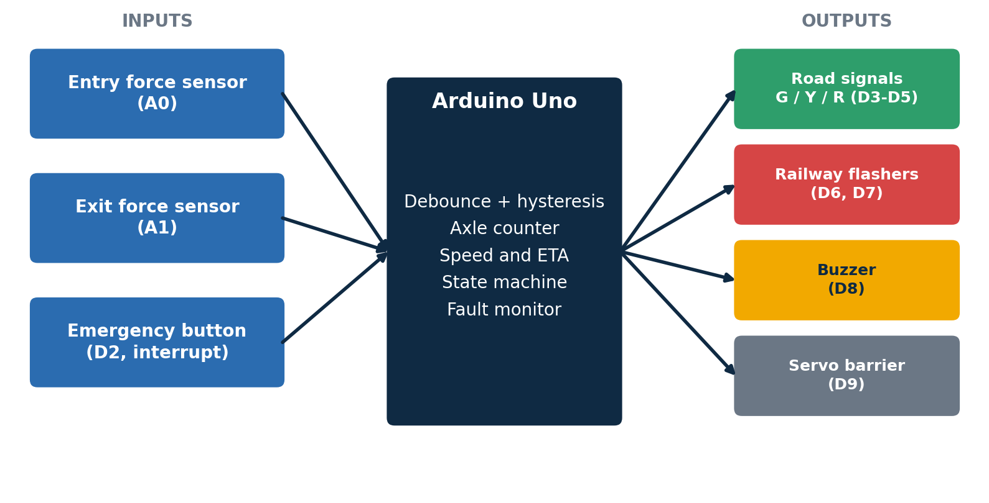
Figure 1: System block diagram: sensors and button feed the Arduino, which drives the outputs.

5. Implementation: Algorithm, Tools and Method

5.1 Tools and method
The circuit was built and simulated in Tinkercad Circuits and programmed in Arduino C++ using the Servo library, `millis()` timing and a hardware interrupt. The Serial Monitor prints every state change, every axle and a log for each train. The work followed a design, simulate, test and tune cycle. For example, timing analysis showed that a fixed 3.35 s closing sequence could not protect fast trains, which led to the fast-train mode.

5.2 Sensing circuit
Each FSR is wired in a voltage divider with a 10 kΩ pull-down, and a 470 kΩ resistor is placed in parallel with the FSR. When nothing presses the sensor, the 470 kΩ keeps the node at about 0.1 V (ADC reading about 21). A press raises the voltage; a cut wire pulls the node to 0 V, which is a reading no healthy sensor can give.
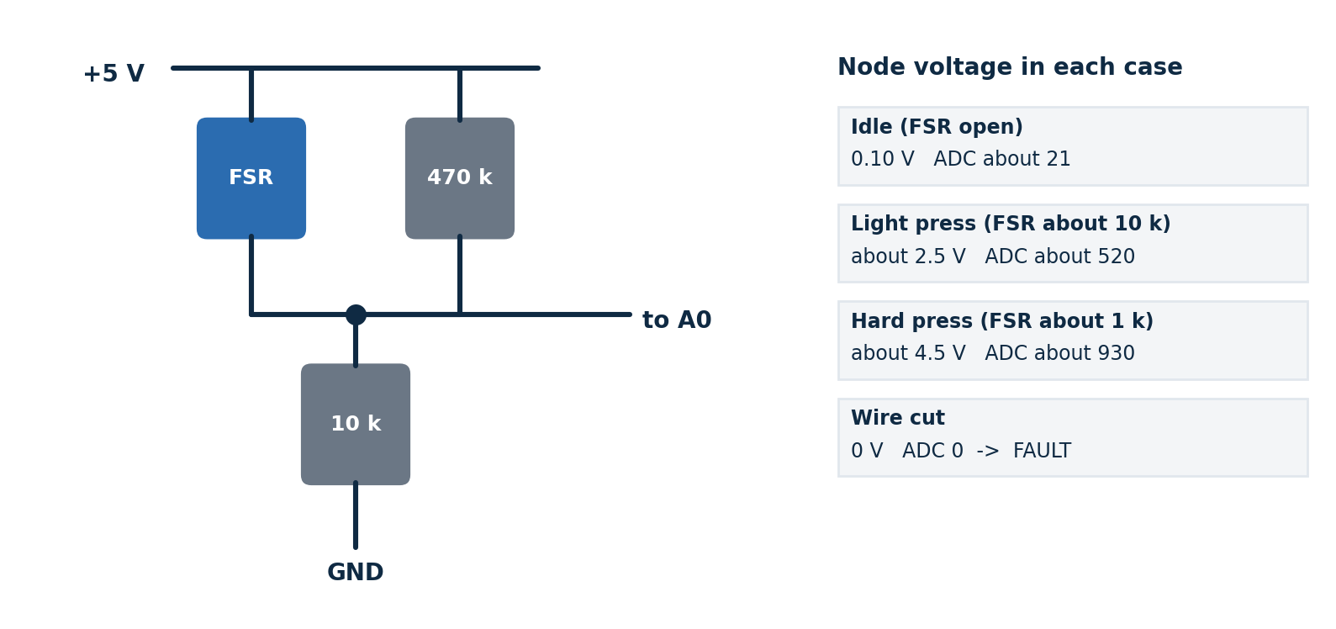
Figure 2: Sensor circuit and the node voltage in each case.
A press is recognised with three protections: a threshold of 300 to press and 150 to release (hysteresis), a 40 ms debounce, and counting only the rising edge, so one press is one axle. In Tinkercad a press is simulated by dragging the sensor slider up and back to zero.

5.3 Axle counting and arrival prediction
The entry sensor adds 1 to the in-count for each axle and the exit sensor adds 1 to the out-count. The section is occupied while in-count exceeds out-count. Speed and ETA come from the time gap between the first two entry axles, whose spacing is known:
speed = axle_spacing / gap
ETA = distance_to_crossing x gap / axle_spacing
warning_start = first_axle_time + max(0, ETA - 5 s)

fast-train mode: if ETA < 3.35 s + 1 s margin
yellow = 1 s, barrier step = 5 ms (sequence 1.45 s)

The hold-off is counted from the first axle because it is the first to reach the crossing. If no second axle arrives within 1.5 s, the warning starts anyway, which is the fail-safe choice. The normal sequence takes 2 s of yellow plus 1.35 s of barrier travel (90 steps of 15 ms), so 3.35 s in total.

5.4 State machine
The controller is a non-blocking finite-state machine with seven normal states and two safe states. No `delay()` is used in the running loop, so sensors and the emergency button are monitored continuously.
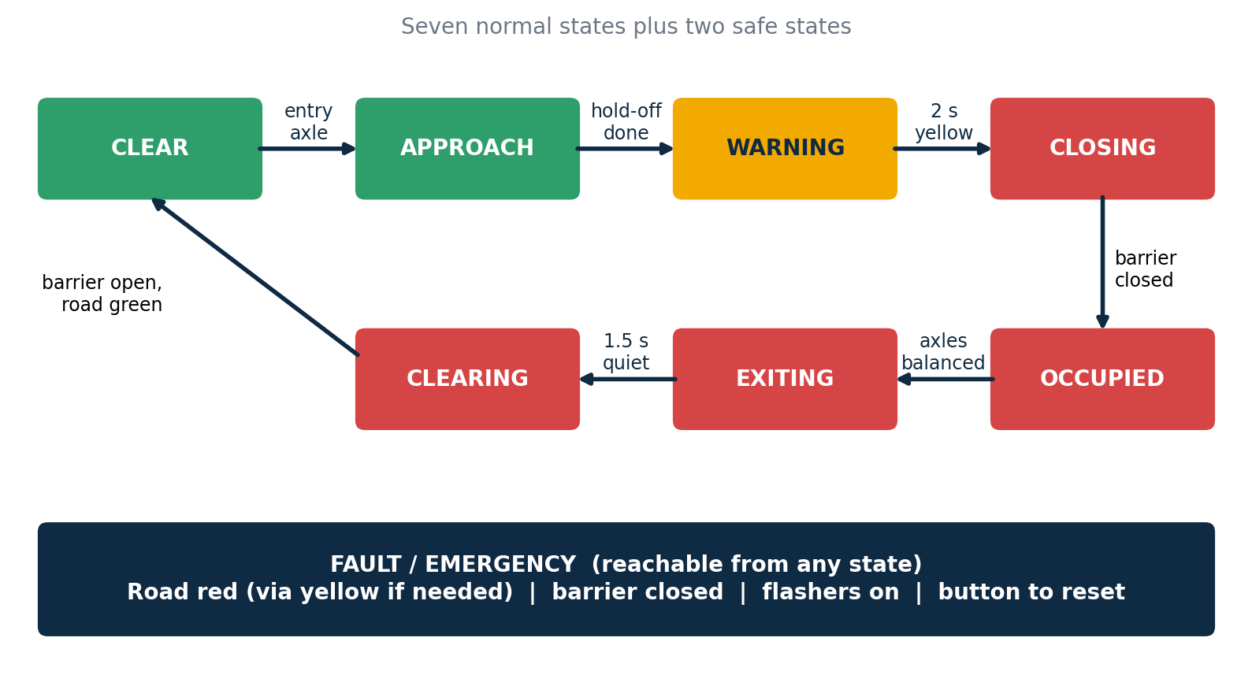
Figure 3: State machine: seven normal states and the FAULT / EMERGENCY safe states.
State | Road | Warnings | Barrier | Leaves when
CLEAR | Green | Off | Open | An entry axle is detected
APPROACH | Green | Off | Open | Hold-off time reached (or 1.5 s with no second axle)
WARNING | Yellow | Flashers, slow beep | Open | Yellow time finished (2 s, or 1 s in fast mode)
CLOSING | Red | Flashers, slow beep | Closing | Barrier fully closed
CROSSING OCCUPIED | Red | Flashers, slow beep (siren if stalled) | Closed | Axles out ≥ axles in
EXITING | Red | Flashers, slow beep | Closed | 1.5 s with no new activity
CLEARING | Red | Flashers | Opening | Barrier fully open, then road turns green

5.5 Emergency override and fault handling
The button is attached to a hardware interrupt (pin D2) with a 300 ms debounce. A first press enters EMERGENCY from any state: the road passes through yellow for 2 s (if it was not red already), then red, the barrier closes and a fast beep sounds. A second press means the operator confirms the crossing is clear, and the system reopens through CLEARING.

Condition | How it is detected | Response
Wire break | Reading below 3 for 300 ms | FAULT (latched): road red, barrier closed, long low tone
Stuck sensor | Pressed for more than 30 s | FAULT (latched)
Wrong order | Exit axle with nothing inside | FAULT (latched)
Stalled train | Occupied for more than 30 s | Siren alarm; barrier stays closed; reset with the button
Emergency button | Interrupt on D2 | Yellow, then red; barrier closed; fast beep

A FAULT clears only when the operator presses the button and both sensors read healthy.

5.6 Control algorithm
every loop:
read A0, A1; apply hysteresis and debounce -> entryAxle, exitAxle
if emergency flag set:
in EMERGENCY: release; in FAULT: acknowledge if sensors healthy;
otherwise: enter EMERGENCY
if a sensor is open-circuit or stuck: enter FAULT
if entryAxle: axlesIn++
first axle: record time, state = APPROACH
second axle: compute speed, ETA, hold-off; choose normal or fast mode
if exitAxle: if axlesOut >= axlesIn then FAULT else axlesOut++
run state machine: set road, flashers, buzzer, barrier target
step the servo, flash the LEDs, update the buzzer pattern

5.7 Circuit in Tinkercad
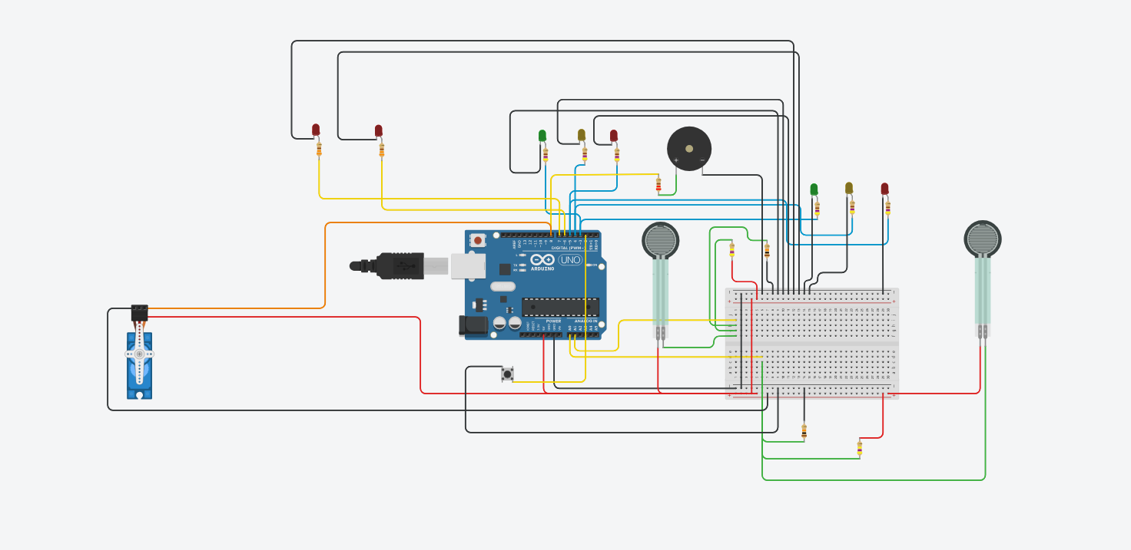
Figure 4: Tinkercad circuit: Arduino Uno, two force sensors, road and railway LEDs, buzzer, servo and button.
Six road LEDs share three pins, because both approaches always show the same colour. Every LED has its own series resistor, the buzzer has a 220 Ω series resistor, and a 470 µF capacitor sits across the servo supply.

6. Hardware and Software Specification
ML / DL / NLP / CV: none of these are used. This is an embedded hardware and control project, and every decision comes from deterministic logic (thresholds, counters and a state machine).

6.1 Hardware components
Component | Specification | Qty | Function
Arduino Uno R3 | ATmega328P, 5 V logic, 16 MHz, 10-bit ADC (0 to 1023), 32 KB flash, 2 KB SRAM | 1 | Controller
Force-sensitive resistor (FSR) | Resistance falls as applied force rises; used in a voltage divider | 2 | Entry and exit axle detection
Micro servo (SG90 type) | Operates from 5 V, positions to a commanded angle | 1 | Barrier arm
LED: green, yellow, red | Standard LEDs, 2 of each colour | 6 | Road signals, two approaches
LED: red | Standard LED | 2 | Railway warning flashers
Piezo buzzer | Passive, driven with tone() | 1 | Audible warning patterns
Push button | Momentary, 4-pin, internal pull-up | 1 | Emergency override
Resistors | 10 kΩ ×2, 470 kΩ ×2, 470 Ω ×6, 330 Ω ×2, 220 Ω ×1 | 13 | Divider, fault bypass, LED and buzzer current limiting
Electrolytic capacitor | 470 µF, 10 V or more | 1 | Smooths the servo supply
Breadboard | Full size | 1 | Power rails and connections

6.2 Pin assignment
Pin | Connected to | Function
A0 | Entry sensor node | Axle detection (analog input)
A1 | Exit sensor node | Axle detection (analog input)
D2 | Emergency button to GND | Hardware interrupt, internal pull-up
D3 / D4 / D5 | Road green / yellow / red (2 LEDs each) | Road signals
D6 / D7 | Railway warning LEDs | Alternating flashers
D8 | Buzzer through 220 Ω | Sound patterns
D9 | Servo signal | Barrier angle
5 V / GND | Power rails | Supply for sensors, servo and LEDs

6.3 Software and key parameters
Software: Tinkercad Circuits (simulation), Arduino C++ with the Servo library, Serial Monitor at 9600 baud.
Parameter | Value
Press / release thresholds | 300 / 150 (ADC), 40 ms debounce
Open-circuit limit | Reading below 3 for 300 ms
Yellow phase | 2 s normal, 1 s fast-train mode
Barrier travel | 90° in 1.35 s normal (15 ms per degree), 0.45 s fast (5 ms)
Target warning time | 5 s before arrival
Wait for second axle | 1.5 s
Exit quiet period | 1.5 s
Stall and stuck timeouts | 30 s each
Model geometry | 60 mm axle spacing, 600 mm sensor-to-crossing, 800 mm sensor-to-sensor

7. Results
How to read this section: the sensor and timing results are calculated directly from the circuit values and the controller's timing constants. The test table lists the expected behaviour for each scenario, with a column to record the outcome observed in the Tinkercad simulation.

7.1 Sensor characterisation
Condition | Node voltage | ADC reading | Interpretation
Idle (FSR open) | 0.10 V | about 21 | No axle
Light press (FSR about 10 kΩ) | about 2.5 V | about 520 | Axle
Hard press (FSR about 1 kΩ) | about 4.5 V | about 930 | Axle
Wire cut | 0 V | 0 | FAULT

The press threshold of 300 corresponds to an FSR resistance of roughly 25 kΩ or lower, and the idle value of about 21 leaves a clear margin above the open-circuit limit of 3.

7.2 Warning timing
The table shows the timing for trains with different gaps between the first two axles, measured from the first entry axle and assuming constant speed.
Axle gap | Speed | ETA | Mode | Warning starts | Barrier closed | Lead before arrival
1000 ms | 60 mm/s | 10 s | Normal | 5.0 s | 8.35 s | 1.65 s
500 ms | 120 mm/s | 5 s | Normal | 0.5 s | 3.85 s | 1.15 s
300 ms | 200 mm/s | 3 s | Fast | 0.3 s | 1.75 s | 1.25 s
100 ms | 600 mm/s | 1 s | Fast (too late) | 0.1 s | 1.55 s | −0.55 s (late)

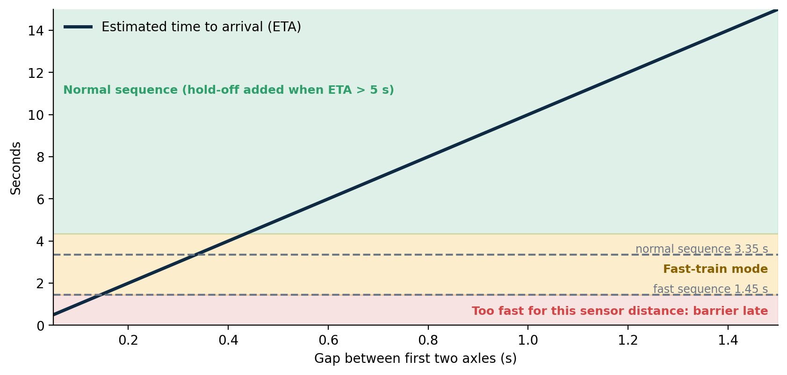
Figure 5: Arrival time against axle gap, with the normal (3.35 s) and fast (1.45 s) closing sequences.
The last row shows a physical limit, not a software fault: the entry sensor sets the fastest train that can be protected. When even the fast sequence cannot finish in time, the controller prints a warning in the Serial Monitor. A real installation places the entry sensor far enough out for its fastest train.
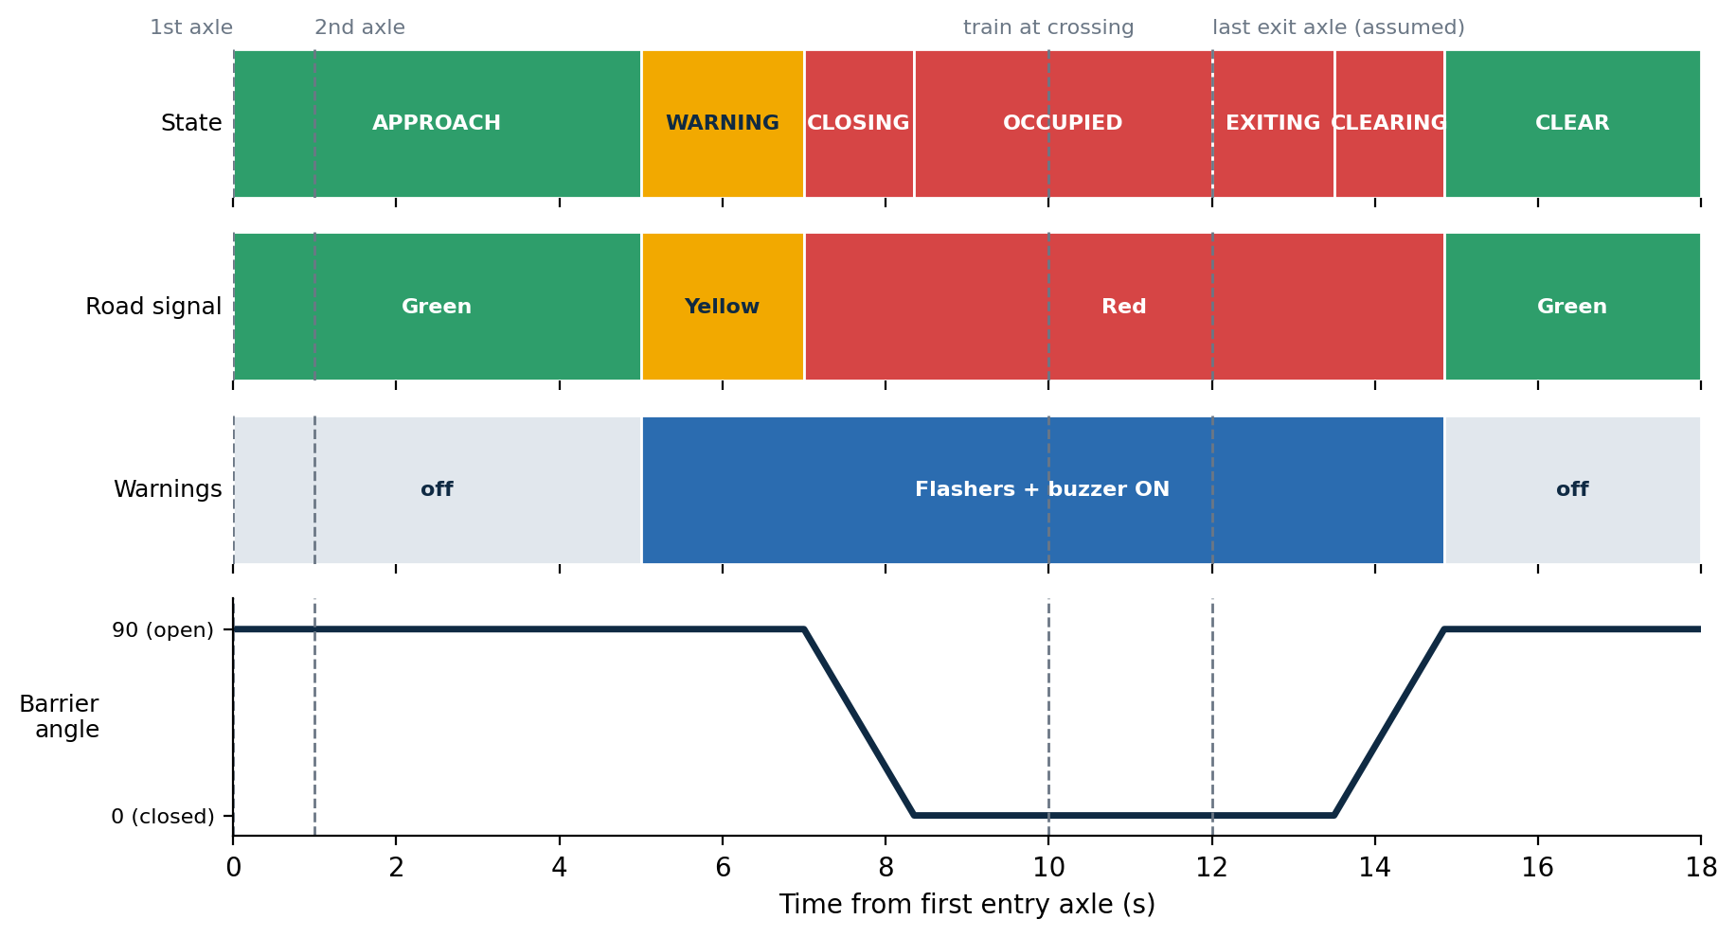
Figure 6: Timing diagram of one slow train (1 s axle gap). The exit axle time is assumed for illustration.

7.3 Test scenarios
Test | Action (slider = press) | Expected behaviour | Outcome (Pass / Fail)
Normal train | Entry twice, 1 s apart; exit twice | Hold-off of about 4 s, then yellow 2 s, red, barrier closes; after the exit axles and 1.5 s the barrier lifts, road turns green, train log prints
Fast train | Entry twice, about 0.3 s apart | Warning at once; yellow 1 s; barrier closes faster; Serial message “Fast train”
Single axle | Entry once | Warning starts after 1.5 s (fail-safe)
Long train | Entry 4 times, exit 3 times, then a 4th | Stays OCCUPIED until the 4th exit axle, then EXITING
Emergency | Press the button in any state | Yellow 2 s then red; barrier closed; fast beep; second press reopens via CLEARING
Wrong order | Exit sensor first | FAULT; long low tone; button acknowledges
Wire break | Disconnect the A0 wire | FAULT after about 0.3 s; button refuses to clear while disconnected
Stalled train | Leave the crossing occupied for 30 s | Siren alarm; barrier stays closed; reset with the button

7.4 Discussion
- The 470 kΩ bypass makes a cut wire detectable, but a failed FSR element alone looks like “no train”, because the bypass bridges it.
- Speed is estimated from only two axles and assumes constant speed, so an accelerating train arrives earlier than predicted.
- The emergency release is deliberately manual: after an override the controller cannot know that the crossing is clear.

8. Conclusion
We designed and implemented, in Tinkercad, a scale-model level-crossing controller that goes beyond a simple sensor-and-gate demonstration. It counts axles so that long or paused trains are handled correctly, uses speed to time the warning, shortens the sequence for fast trains, and makes sensor failures visible with one extra resistor per sensor. An interrupt-driven emergency override and a set of fault checks ensure the system always ends in a safe state: red road signal and closed barrier.
The calculated results show the normal sequence gives about 1.65 s of margin for slower trains, and that the sensor distance fixes the fastest train that can be protected. The limitations are clear: force sensors suit only a model track, speed is assumed constant, there is a single controller without redundancy, and the prototype is not a certified safety system. Within these limits, it demonstrates sensor-based detection, state-machine control, actuator operation, emergency handling and safety-oriented decision making using only real, low-cost components.

9. Future Work
- Replace the FSRs with Hall-effect or inductive axle counters and test on a physical toy-train track.
- Add redundant two-channel sensing with cross-checking between sensors.
- Add an ultrasonic sensor to detect a vehicle trapped on the crossing and hold the barrier until it clears.
- Detect train direction so trains from either side, and reversing trains, are handled.
- Improve the speed estimate using more axles and detect acceleration.
- Store train logs in EEPROM and add a watchdog timer to recover from lock-ups.
- Run fault-injection tests and formal checks on the state machine.

References
[1] “Railroad grade crossing constant warning protection system”, US Patent 4,307,860.
[2] “Crossing predictor with authorized track speed input”, US Patent 8,297,558 B2.
[3] National Academies of Sciences, Engineering, and Medicine, synthesis report on railway warning time systems and traffic signal preemption at highway-rail grade crossings, Chapter 5 (nap.edu/read/24769).
[4] Arduino Language Reference and Servo library documentation, arduino.cc.
[5] Autodesk Tinkercad Circuits, tinkercad.com.

