Exercise: BANKING-HIVE queries

Chinmayakrishna B
1NT18IS047

CSV file


Queries:
1)create database called customer
2)Create a table called bank(tid,bname,cname,amount)
3)Import the values using insert statement

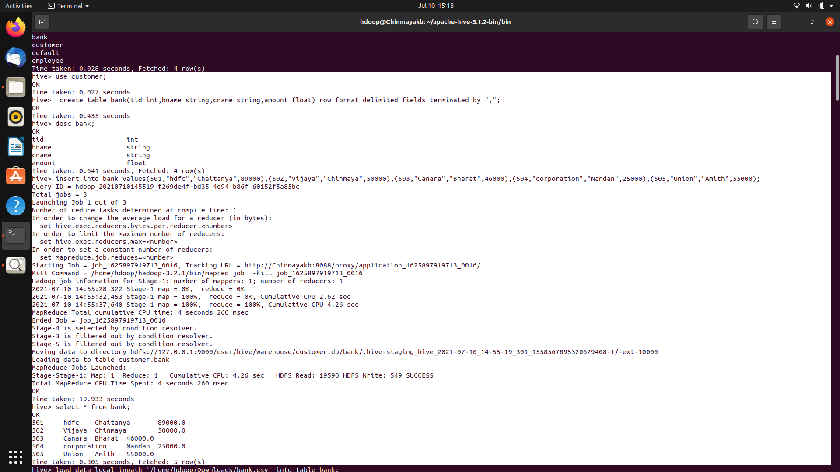

4)Import the values using CSV
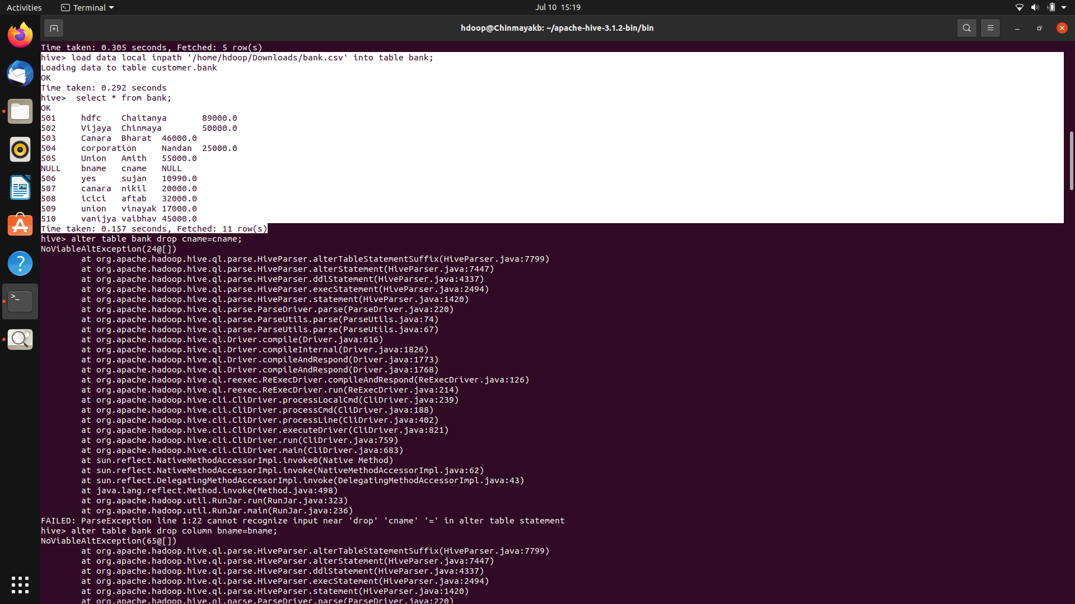

5)Query operation,groupby,aggregate,orderby and having clause views
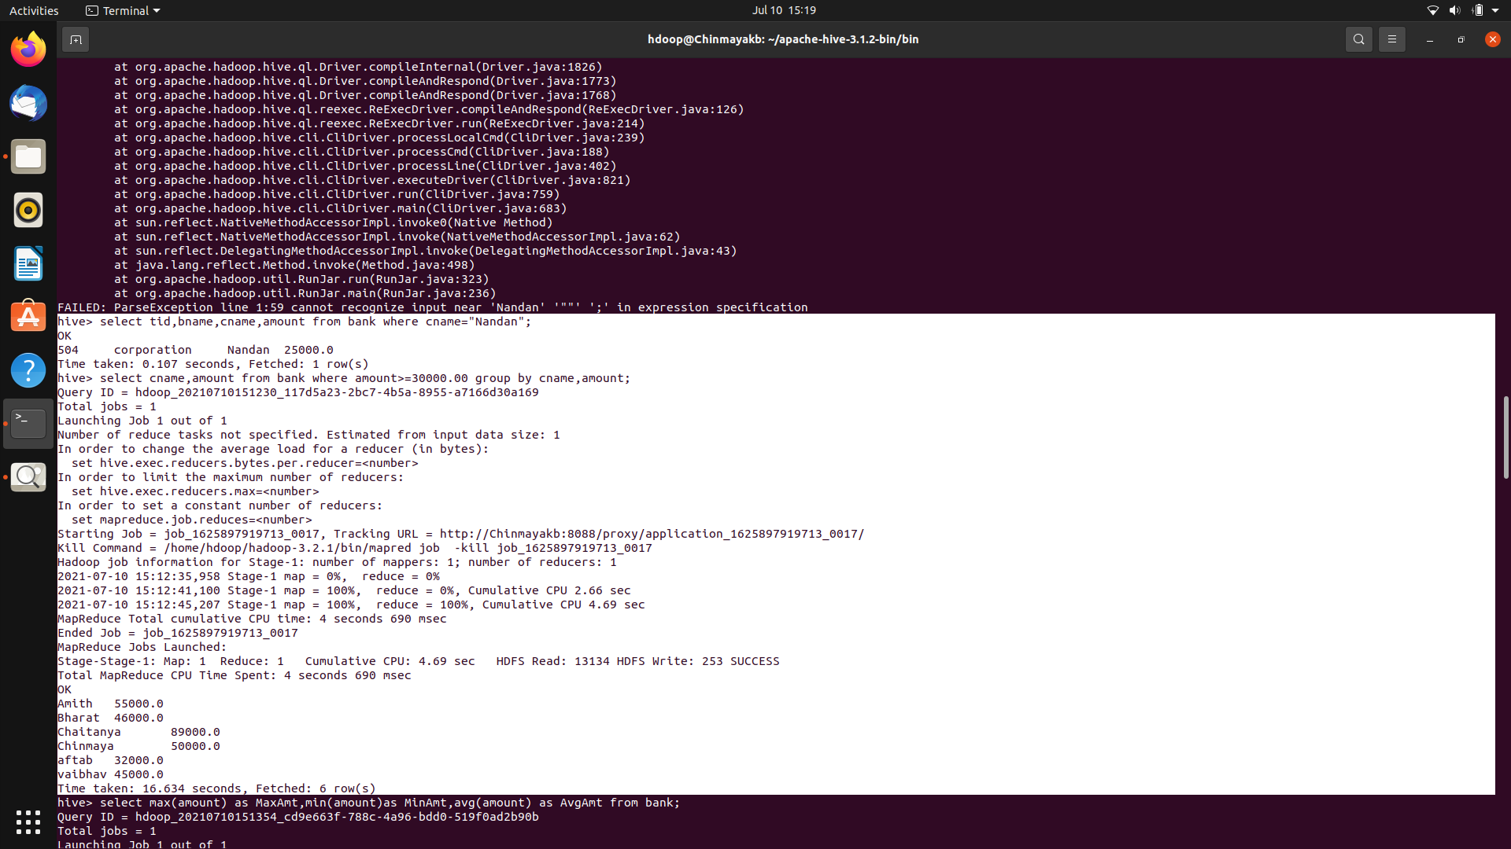
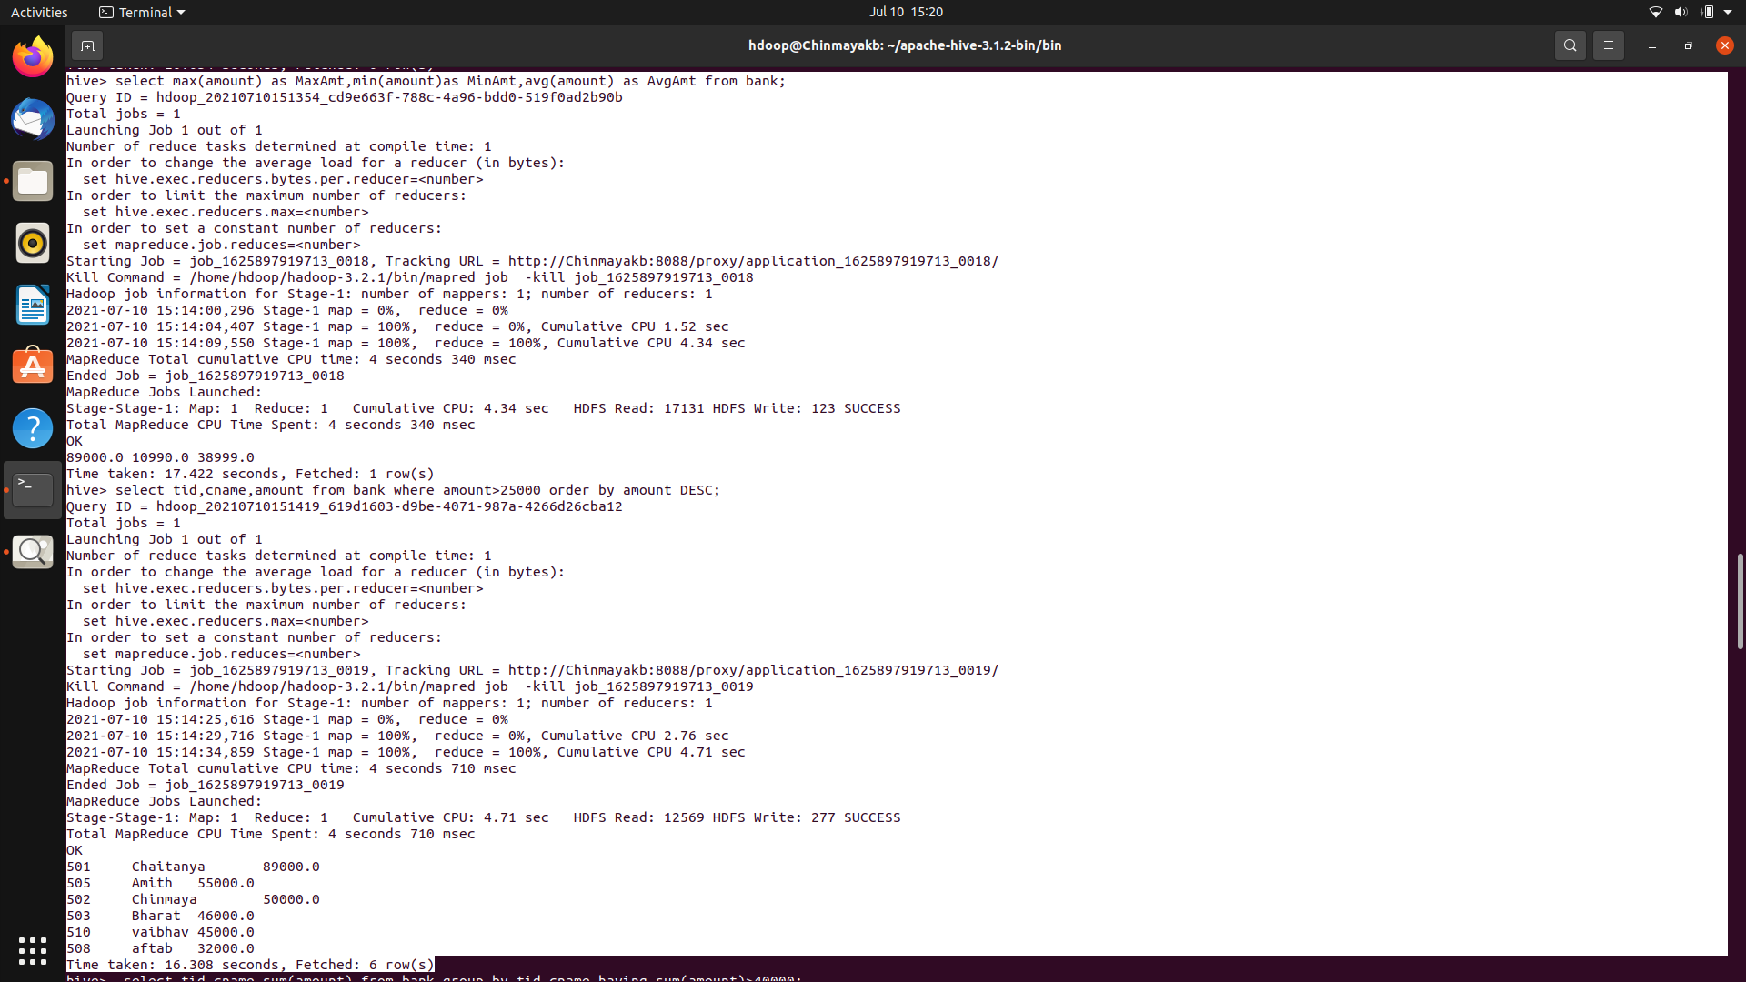

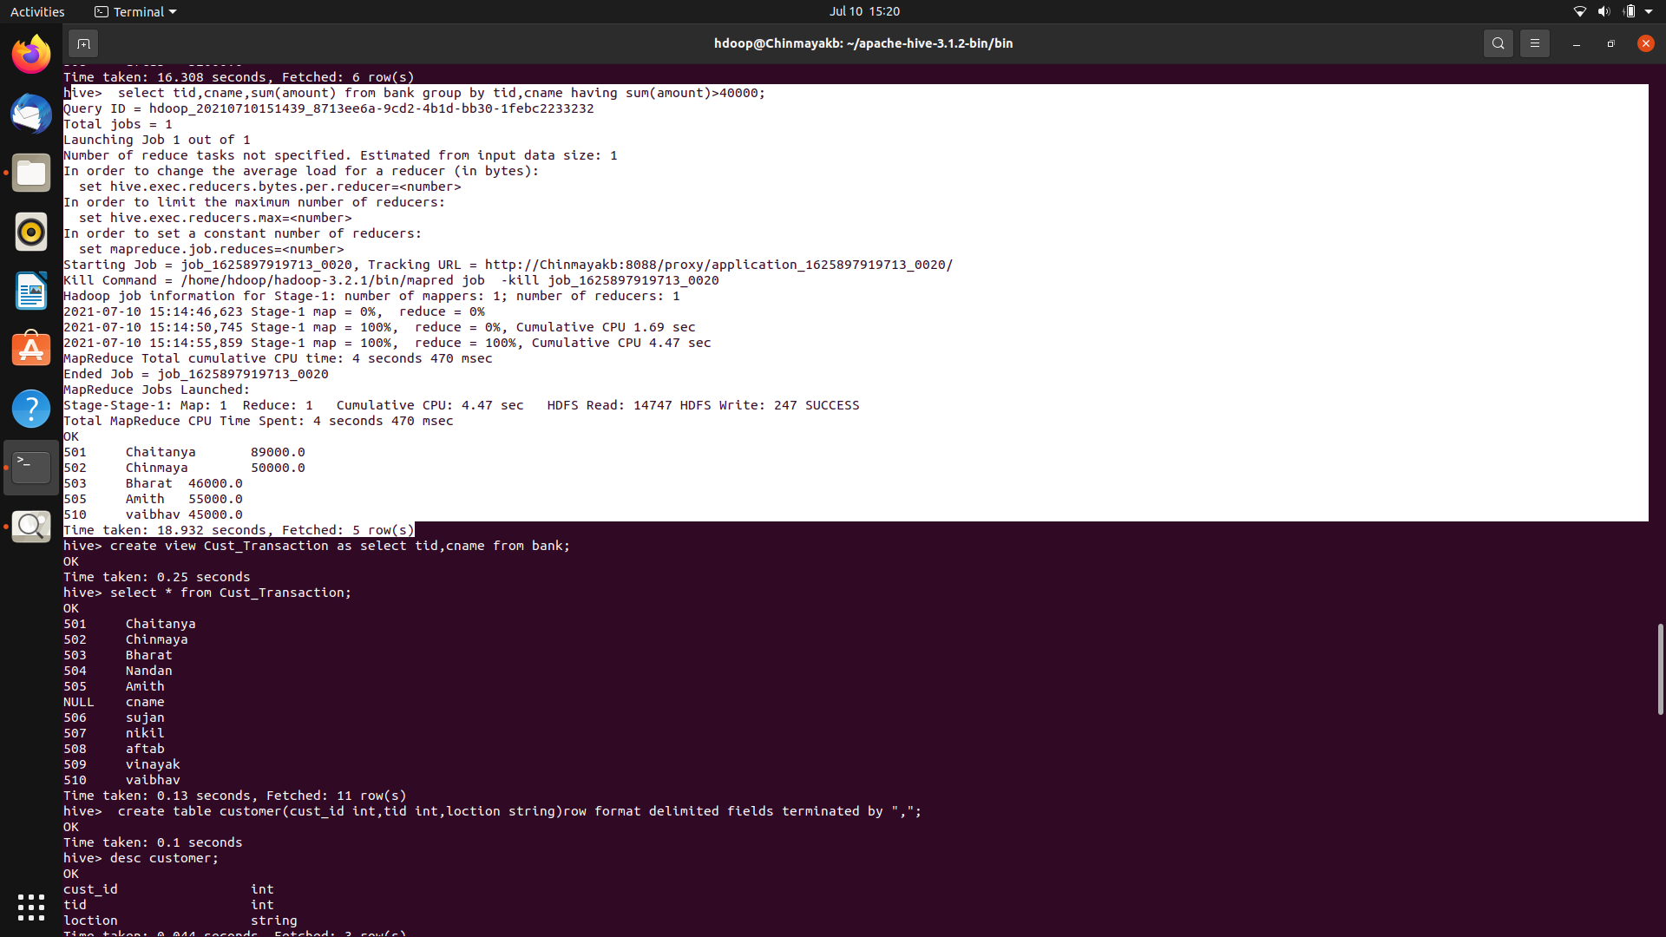

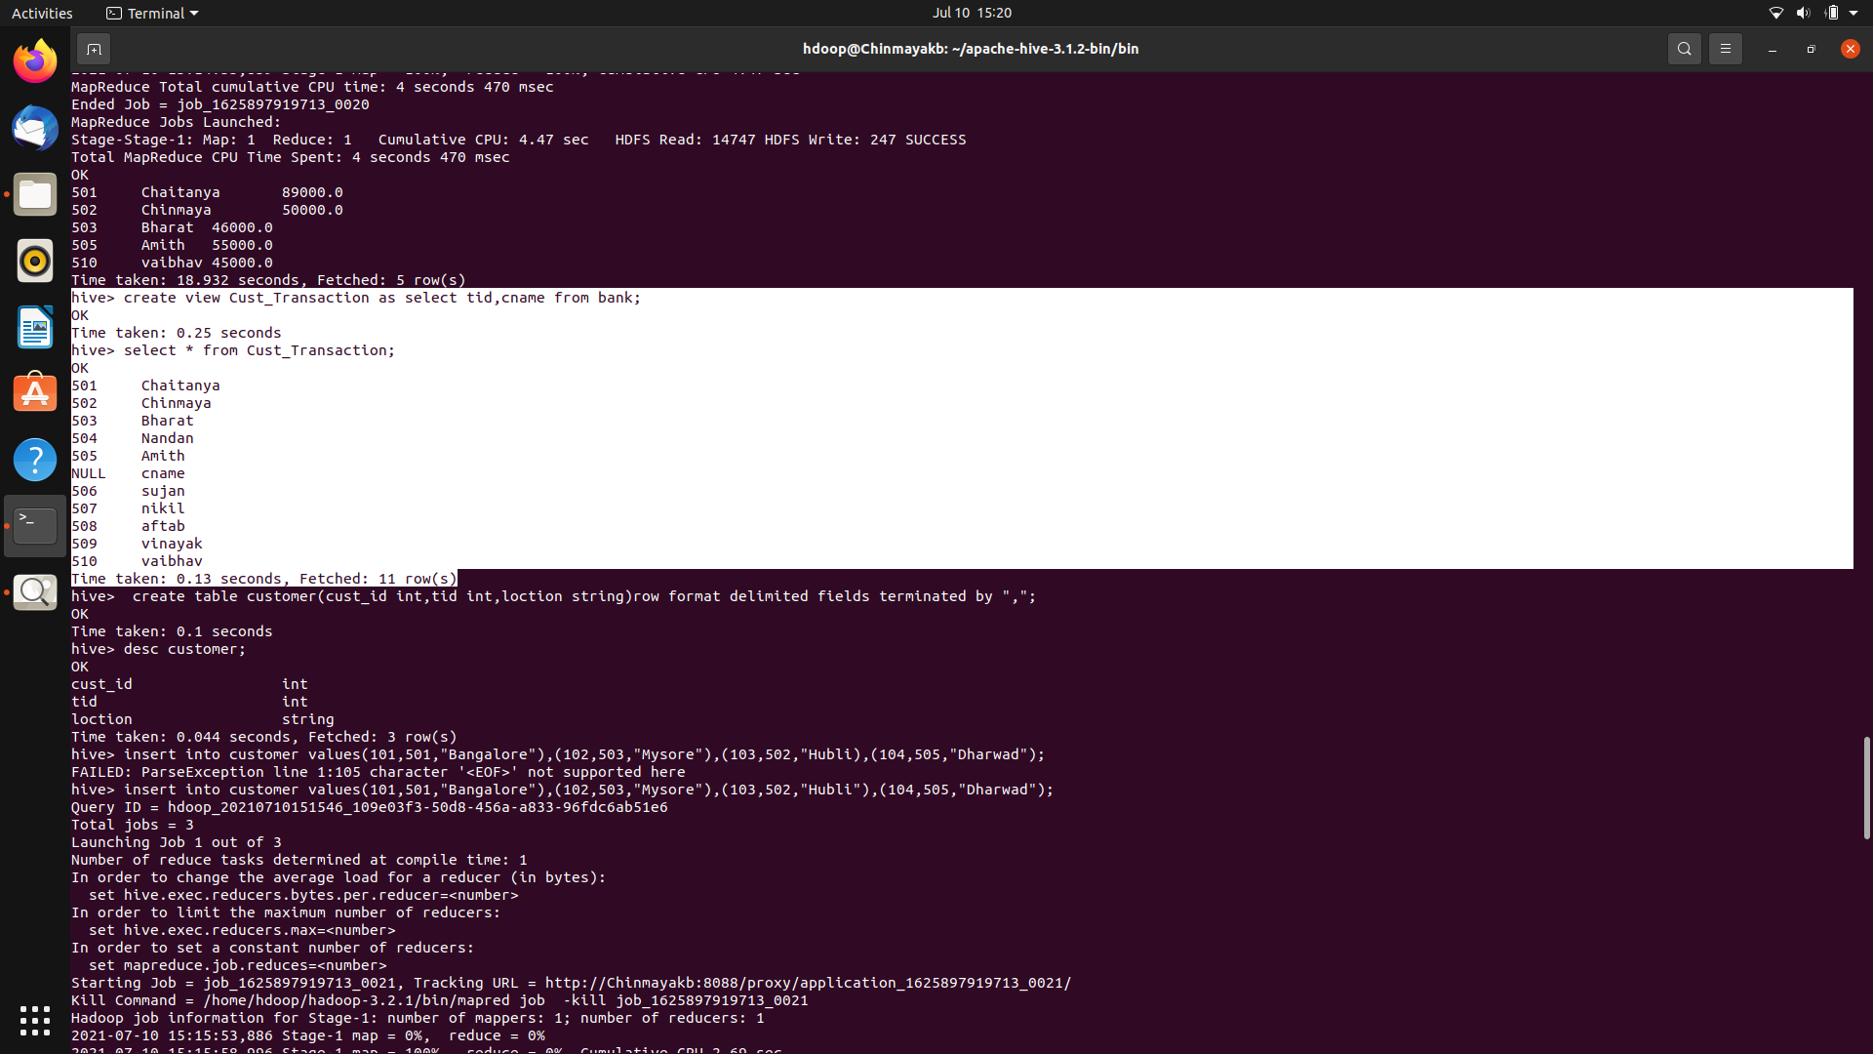

6)Create one more table
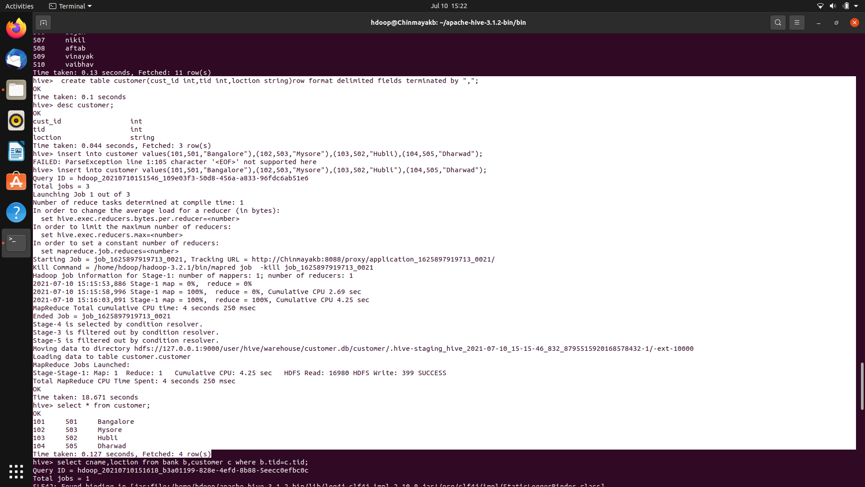
7)Experiment using join operation

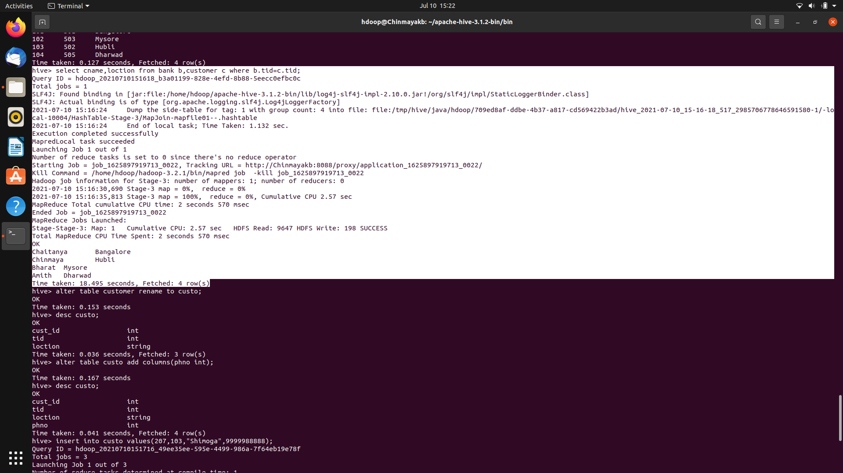
8)Alter operation
