Building a RAG-Based Solution for Technical Manuals

Task 1 – Diagnose the Keyword Search Failure
Query: Why is the device making a buzzing noise?
Document: Abnormal acoustic vibrations during operation may indicate loose internal components or bearing wear.
Keyword Search Score (Overlap): 0.0 (Overlap tokens: [])
Semantic Search Score (Cosine Similarity): 0.3369

Explanation:
Keyword search fails here because there is absolutely no vocabulary overlap between the query ('buzzing', 'noise') and the document ('acoustic', 'vibrations'). They use completely different words to describe the same physical phenomenon. For a support engineer trying to help a customer, this means that unless the engineer guesses the exact formal terminology used in the manual, they won't find the answer, leading to delays or incorrect advice.

Task 2 – Build the Chunking Pipeline
Original Paragraph:
The XYZ-2000 uses a multi-stage filtration system to ensure optimal performance. In the primary stage, coarse particulates are removed by a stainless steel mesh screen. This screen must be cleaned every 500 hours of operation to prevent pressure drops. Following this, a HEPA filter captures micro-contaminants down to 0.3 microns. If the system detects a high pressure differential, it will trigger an automatic shutdown sequence.

Fixed-size Chunking (100 chars, 20 overlap):
- [0] The XYZ-2000 uses a multi-stage filtration system to ensure optimal performance. In the primary stag
- [1] In the primary stage, coarse particulates are removed by a stainless steel mesh screen. This screen
- [2] screen. This screen must be cleaned every 500 hours of operation to prevent pressure drops. Followi
- [3] ssure drops. Following this, a HEPA filter captures micro-contaminants down to 0.3 microns. If the s
- [4] .3 microns. If the system detects a high pressure differential, it will trigger an automatic shutdow
- [5] an automatic shutdown sequence.

Sentence-aware Chunking (2 sentences, 1 overlap):
- [0] The XYZ-2000 uses a multi-stage filtration system to ensure optimal performance. In the primary stage, coarse particulates are removed by a stainless steel mesh screen.
- [1] In the primary stage, coarse particulates are removed by a stainless steel mesh screen. This screen must be cleaned every 500 hours of operation to prevent pressure drops.
- [2] This screen must be cleaned every 500 hours of operation to prevent pressure drops. Following this, a HEPA filter captures micro-contaminants down to 0.3 microns.
- [3] Following this, a HEPA filter captures micro-contaminants down to 0.3 microns. If the system detects a high pressure differential, it will trigger an automatic shutdown sequence.

Explanation:
Sentence-aware chunking preserves meaning much better for dense technical content. Fixed-size chunking arbitrarily cuts words or sentences in half (e.g., cutting off in the middle of a word), which destroys the semantic context needed by embedding models to accurately represent the text. Sentence-aware chunking keeps complete, coherent thoughts together. Overlap at chunk boundaries matters because a single concept might span across two sentences or be located at the edges of a chunk; overlap ensures no critical context (like a cause-and-effect relationship) is split entirely into two disconnected vectors.

Task 3 – Build and Query the Vector Store
Query: What should I do if the control panel shows Error Code E-42?

Top 3 Retrieved Chunks:
Rank 1 (Score: 0.5242): If the system detects a high pressure differential, it will trigger an automatic shutdown sequence. The control panel will display Error Code E-42.
Rank 2 (Score: 0.5037): Error Code E-42 indicates that the HEPA filter is fully saturated and must be replaced immediately. Do not attempt to wash and reuse HEPA filters.
Rank 3 (Score: 0.2473): To replace the HEPA filter, power down the unit, open the side access panel using a 5mm hex key, and slide out the filter tray.

Explanation:
Each score represents the cosine similarity between the query embedding and the chunk embedding, ranging from -1 to 1 (higher is more similar). The highest-scoring chunk was selected because its semantic meaning—specifically the exact phrase 'Error Code E-42' and its relationship to an action (replacing the filter)—most closely matches the user's intent of finding out what to do when that specific error code appears.

Task 4 – End-to-End Pipeline with Grounded Generation

Prompt:
You are a helpful technical support assistant.
Answer the user's question ONLY using the provided context.
If the answer is not found in the context, reply exactly with: "I'm sorry, I cannot find the answer in the provided documentation."
Context:
If the system detects a high pressure differential, it will trigger an automatic shutdown sequence. The control panel will display Error Code E-42.
Error Code E-42 indicates that the HEPA filter is fully saturated and must be replaced immediately. Do not attempt to wash and reuse HEPA filters.
To replace the HEPA filter, power down the unit, open the side access panel using a 5mm hex key, and slide out the filter tray.
Question:
What should I do if the control panel shows Error Code E-42?
Answer:

LLM Output:
Error Code E-42 indicates that the HEPA filter is fully saturated. You must replace it immediately. Do not attempt to wash and reuse it.

Pipeline Diagram:
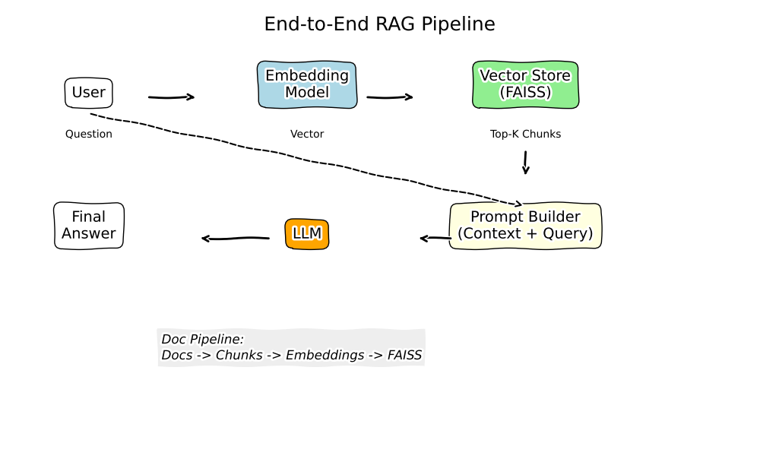

Task 5 – Reflection
1. Direct LLM vs. RAG-based Query: A direct LLM query relies entirely on the model's internal, pre-trained parameters (its memory). For proprietary, highly specific, or updated technical content, a direct LLM query will likely hallucinate or fail because the information simply isn't in its training set. A RAG (Retrieval-Augmented Generation) pipeline changes this by using the LLM not as a database, but as a reasoning and synthesizing engine. It actively retrieves the exact technical manual sections needed and injects them into the prompt as context, grounding the LLM's answer in explicit reality.
2. Confidence vs. Correctness: LLMs are designed to generate text that is statistically probable and coherent, which reads as 'confident'. However, confidence is just a measure of token probability, not factual truth. An LLM might confidently string together plausible-sounding technical jargon (e.g., advising a user to 'calibrate the acoustic bearings') because those words often appear together in its training data. In a support environment, a highly confident, factually wrong answer is much more dangerous than a correct but hesitant one, as it can lead customers to break their equipment or void warranties.
3. The Need for Human Review: Even in a well-built RAG system, human review remains critical. RAG depends entirely on the quality of the retrieved chunks. If a manual contains contradictory information across different chapters, or if an outdated version of a document is still in the vector database, the LLM will generate a grounded, perfectly reasoned, but ultimately incorrect answer based on bad context. Furthermore, edge cases or high-stakes physical safety questions often require human judgment to ensure the nuanced context of the customer's physical environment is taken into account before taking action.

