**Table of Contents**

### Page No.

### Chapter 1. Introduction

1. Introduction to the System 4
2. Problem Definition 4
3. Aim 5
4. Objective 5
5. Goal 6
6. Need of System 6

### Chapter 2. Hardware and Software requirement

1. Introduction 8
2. System environment 8
3. Software requirement 9
4. Hardware requirements 10

### Chapter 3. System Analysis

1. Purpose 12
2. Project Scope 12
3. Existing System 13
4. Proposed System 14
5. System Description 15

### [Chapter 4.Implementation issues](#chap 8)

1. Python 17
2. HTML 18
3. Cascading style sheet(CSS) 19
4. Javscript 20
5. Bootstrap 21
6. Sqlite 22

**Chapter 5. System Design**

1. Introduction 23
2. Conceptual Design 24
3. ER-Diagram 25
4. Logical Design 26
5. Physical Design 27
6. Data Flow Diagram of **“Diabetes Prediction System”** 28

### [Chapter 6.User Screens](#chap 8) 29-45

### [Chapter 7.Coding](#chap 8) 46-77

[**Chapter 8. Conclusion**](#chap 9)

1. Features of “**Diabetes Prediction System**” 78
2. Benefits Accrued from “**Diabetes Prediction System**” 79
3. Limitations of “**Diabetes Prediction System**” 80

Bibliography

**CHAPTER # 1**

**Introduction**

*Contents:*

* Introduction
* Problem Definition
* Aim
* Objective
* Goal
* Need of System

**Introduction to the System:**

The Diabetes Prediction System using Support Vector Machine is a machine learning project implemented as a Python Django web application with a SQLite database. The system focuses on predicting the likelihood of a person having diabetes based on various parameters such as pregnancies, glucose levels, skin thickness, insulin levels, body mass index (BMI), diabetes pedigree function, and age. The system consists of two main modules: user and admin. The user module allows users to sign up, log in, make diabetes predictions, view their prediction history, edit their profile information, change their password, and log out. The admin module enables the administrator to log in, access the dashboard to view user and prediction result counts, view the prediction history, view registered users, change the password, and log out. By utilizing the power of Support Vector Machine, this system aims to provide accurate predictions and assist individuals in identifying their risk for diabetes. It offers a user-friendly interface and facilitates efficient management of user accounts and prediction data.

**Problem Definition:**

The problem addressed by the Diabetes Prediction System using Support Vector Machine is the accurate prediction of diabetes in individuals. Diabetes is a prevalent and chronic disease that affects millions of people worldwide. Early detection and timely intervention are crucial for managing the condition and preventing complications. However, diagnosing diabetes can be challenging due to the complex interplay of various risk factors and symptoms. The system aims to overcome this challenge by utilizing Support Vector Machine, a powerful machine learning algorithm, to analyze relevant parameters such as pregnancies, glucose levels, skin thickness, insulin levels, BMI, diabetes pedigree function, and age. By accurately predicting the likelihood of diabetes, the system can assist healthcare professionals and individuals in making informed decisions about preventive measures, lifestyle modifications, and appropriate medical interventions.

**Aim:**

The aim of the Diabetes Prediction System using Support Vector Machine is to develop a reliable and accurate machine learning-based system that can predict the likelihood of diabetes in individuals. The system utilizes the Support Vector Machine algorithm to analyze various parameters such as pregnancies, glucose levels, skin thickness, insulin levels, BMI, diabetes pedigree function, and age. By providing accurate predictions, the system aims to assist healthcare professionals and individuals in identifying individuals at risk of diabetes at an early stage. This can facilitate timely intervention, personalized preventive measures, and effective management of the disease, ultimately leading to improved health outcomes and a better quality of life for individuals affected by diabetes.

**Objective:**

The objectives of the Diabetes Prediction System using Support Vector Machine are as follows:

1. Develop an accurate prediction model: Build a robust machine learning model using Support Vector Machine algorithm that can effectively analyze the input parameters and predict the likelihood of diabetes in individuals.
2. Improve prediction accuracy: Continuously optimize and fine-tune the model to enhance its prediction accuracy by utilizing appropriate feature selection, parameter tuning, and data preprocessing techniques.
3. User-friendly interface: Design a user-friendly interface for both users and administrators, ensuring ease of use and seamless navigation through the system.
4. Secure data management: Implement robust data management techniques to ensure the confidentiality and privacy of user data. Employ encryption and access control mechanisms to protect sensitive information.
5. User module functionalities: Provide user modules such as signup, login, prediction, viewing prediction history, editing profile, changing password, and logout to facilitate a smooth user experience.
6. Admin module functionalities: Develop admin modules including login, dashboard with user and prediction result counts, viewing prediction history, viewing registered users, changing password, and logout for efficient management and monitoring of the system.
7. Performance evaluation and optimization: Conduct comprehensive testing and evaluation of the system to measure its performance, identify any bottlenecks or areas of improvement, and optimize the system accordingly.
8. Scalability and extensibility: Design the system to be scalable, allowing for the accommodation of a growing user base and potential expansion of functionalities in the future.
9. Integration and deployment: Ensure smooth integration of the system with the Python Django web framework and SQLite database. Deploy the system on a reliable and secure server to ensure its availability and accessibility.
10. Documentation and support: Provide comprehensive documentation and user support to guide users and administrators in utilizing the system effectively and resolving any issues or queries that may arise.

By achieving these objectives, the Diabetes Prediction System using Support Vector Machine aims to provide an efficient and accurate tool for diabetes prediction, contributing to early detection, effective management, and improved healthcare outcomes for individuals at risk of diabetes.

**Top of Form**

**Goal:**

The goal of the Diabetes Prediction System using Support Vector Machine is to develop a reliable and accurate machine learning model that can effectively predict the likelihood of diabetes in individuals based on their input parameters. The system aims to assist healthcare professionals in early detection and prevention of diabetes, allowing for timely interventions and improved patient care. By leveraging the power of Support Vector Machine algorithm, the system strives to achieve high prediction accuracy and provide valuable insights for diabetes risk assessment. Additionally, the system aims to offer a user-friendly interface for both users and administrators, ensuring ease of use and efficient management of the system. Ultimately, the goal is to enhance healthcare outcomes, promote proactive health management, and contribute to the overall well-being of individuals at risk of diabetes.

**Need of the System:**

The need for the Diabetes Prediction System using Support Vector Machine arises from the increasing prevalence of diabetes worldwide and the importance of early detection and prevention. The system addresses the following needs:

1. **Early Detection**: The system helps in the early detection of diabetes by analyzing various parameters and predicting the likelihood of an individual developing the disease. This enables timely intervention and treatment, leading to better health outcomes.
2. **Risk Assessment**: The system provides a risk assessment for individuals, allowing them to understand their susceptibility to diabetes. This information empowers individuals to make informed decisions about their lifestyle, diet, and preventive measures to reduce the risk of developing diabetes.
3. **Efficient Screening**: Healthcare professionals can use the system to efficiently screen a large number of individuals for diabetes risk. By leveraging the power of machine learning and Support Vector Machine algorithm, the system automates the screening process, saving time and resources.
4. **Personalized Care**: The system enables healthcare professionals to provide personalized care based on the individual's predicted risk. It helps in tailoring treatment plans, lifestyle recommendations, and preventive strategies to meet the specific needs of each patient, promoting better health management.
5. **Data-Driven Insights**: The system generates valuable insights from the data, identifying the most significant parameters contributing to diabetes risk. These insights can aid researchers, healthcare providers, and policymakers in understanding the disease patterns, developing targeted interventions, and formulating effective public health strategies.
6. **User-Friendly Interface**: The system offers a user-friendly interface for both users and administrators, making it easy to navigate, input data, view predictions, and manage the system. This ensures accessibility and usability, catering to individuals with varying levels of technical expertise.

Overall, the system fulfills the need for accurate and efficient prediction of diabetes risk, facilitating early detection, personalized care, and proactive health management. It plays a crucial role in combating the growing burden of diabetes and improving the overall health outcomes of individuals at risk.

**CHAPTER # 2**

**Hardware and Software Requirements**

*Contents:*

##### Introduction

* System environment
* Software requirement
* Hardware requirements

**Introduction:**

In this chapter we mentioned the software and hardware requirements, which are necessary for successfully running this system. The major element in building systems is selecting compatible hardware and software. The system analyst has to determine what software package is best for the **“Diabetes Prediction System”** and, where software is not an issue, the kind of hardware and peripherals needed for the final conversion.

**System Environment:**

After analysis, some resources are required to convert the abstract system into the real one.

The hardware and software selection begins with requirement analysis, followed by a request for proposal and vendor evaluation.

Software and real system are identified. According to the provided functional specification all the technologies and its capacities are identified. Basic functions and procedures and methodologies are prepared to implement. Some of the Basic requirements such as hardware and software are described as follows: -

**Hardware and Software Specification**

**Software Requirements:**

* Technology: Python Django
* IDE : Pycharm/Atom
* Client Side Technologies: HTML, CSS, JavaScript , Bootstrap
* Server Side Technologies: Python
* Data Base Server: Sqlite
* Operating System: Microsoft Windows/Linux

**Hardware Requirements:**

* Processor: Pentium-III (or) Higher
* Ram: 64MB (or) Higher
* Hard disk: 80GB (or) Higher

**CHAPTER # 3**

**System Analysis**

*Contents:*

##### Purpose

* Project Scope
* Existing System
* Proposed System
* System Overview

### Purpose:

The purpose of the Diabetes Prediction System using Support Vector Machine is to utilize machine learning techniques, specifically the Support Vector Machine algorithm, to predict the likelihood of an individual developing diabetes. The system aims to assist healthcare professionals and individuals in assessing the risk of diabetes early on, enabling timely interventions, personalized care, and preventive measures.

The primary purpose of the system can be summarized as follows:

1. Early Detection: The system aims to identify individuals who are at high risk of developing diabetes at an early stage. By analyzing various parameters and patterns from input data, the system provides predictions that can help in the early detection and prevention of diabetes-related complications.
2. Risk Assessment: The system assesses the individual's risk of developing diabetes based on their demographic and health-related parameters. This allows healthcare professionals to provide personalized recommendations, lifestyle modifications, and interventions to manage and reduce the risk of diabetes.
3. Support Decision-Making: The system provides healthcare professionals with a data-driven tool to support their decision-making process. By considering multiple factors and utilizing the power of the Support Vector Machine algorithm, the system offers accurate predictions that can aid in clinical decision-making and treatment planning.
4. Patient Empowerment: The system empowers individuals by providing them with insights into their potential risk of diabetes. It encourages individuals to take proactive steps towards preventive measures, such as adopting a healthy lifestyle, monitoring their health parameters, and seeking appropriate medical advice.
5. Research and Public Health: The system generates valuable data and insights that can contribute to research on diabetes, risk factors, and disease management. The collected data can be analyzed to identify trends, patterns, and correlations, helping in the formulation of effective public health strategies and policies related to diabetes prevention and control.

In summary, the purpose of the Diabetes Prediction System using Support Vector Machine is to leverage machine learning algorithms to predict diabetes risk, facilitate early detection, support personalized care, and empower individuals in managing their health effectively.

**Project Scope:**

The scope of the Diabetes Prediction System using Support Vector Machine is significant in the healthcare industry. The system can be adopted by hospitals, clinics, and healthcare providers to assist in diabetes risk assessment and preventive care. Additionally, pharmaceutical companies and research institutions can leverage the system for data analysis and research on diabetes risk factors. The system's application extends to public health organizations and policymakers for developing targeted interventions and strategies to combat the increasing prevalence of diabetes. Overall, the system has a broad market scope and can make a substantial impact in the healthcare and diabetes management sectors.

**Existing System:**

The existing manual system for diabetes diagnosis involves a time-consuming and subjective process of evaluating symptoms and conducting physical examinations. Our proposed Diabetes Prediction System overcomes these limitations by automating the diagnosis using machine learning algorithms, specifically Support Vector Machine (SVM). By analyzing relevant features such as age, glucose levels, BMI, and family history, our system provides accurate and objective predictions, leading to early detection of diabetes. This data-driven approach improves the accuracy of diagnosis, reduces the chances of misdiagnosis, and allows for timely intervention and management. Additionally, our web-based application ensures accessibility to healthcare professionals and patients, regardless of their geographical location, thereby improving healthcare outcomes.

**Proposed System:**

The proposed system for the Diabetes Prediction System using Support Vector Machine is a machine learning-based web application developed using Python Django framework with a SQLite database. The system aims to predict the likelihood of an individual developing diabetes based on various parameters such as pregnancies, glucose levels, skin thickness, insulin levels, BMI, diabetes pedigree function, and age. Users can register, log in, make predictions, view their prediction history, and update their profile. The system provides a user-friendly interface for diabetes risk assessment, empowering individuals to take proactive measures for disease prevention and management.

**System Overview:**

Diabetes Prediction System divided in two main modules:

1. **Admin module**
2. **User module**

### **Admin Module details**

1. **Login**: The admin can log in to the system using their credentials.
2. **Dashboard**: The admin can access a dashboard that provides an overview of the system, including user counts and prediction results count.
3. **View Prediction History**: The admin can view the prediction history of all users, allowing them to track and analyze predictions made by users.
4. **View Registered Users**: The admin can view a list of registered users in the system, providing insights into the user base.
5. **Change Password**: The admin has the ability to change their password for security purposes.
6. **Logout**: The admin can log out of the system to end their session securely.

### User Module

1. **Signup:** Users can create an account by providing their details and registering in the system.
2. **Login:** Users can log in to the system using their credentials.
3. **Prediction:** Users can input their health parameters, such as Pregnancies, Glucose level, Skin Thickness, Insulin level, BMI, Diabetes Pedigree Function, and Age, to obtain a prediction of their likelihood of having diabetes.
4. **View Prediction History:** Users can view their prediction history, which provides a record of their previous predictions and their corresponding results.
5. **Edit Profile:** Users have the ability to update and modify their profile information, such as their personal details and contact information.
6. **Change Password:** Users can change their password for enhanced security.
7. **Logout:** Users can log out of the system to end their session securely.

**CHAPTER # 4**

**Implementation issues**

**HTML -**

HTML (Hypertext Markup Language) is the standard markup language used to create web pages. It is a structured language that allows developers to define the structure of content on a webpage using tags, attributes, and elements. HTML provides a way for web browsers to interpret and display content in a structured and organized manner.

**CSS -**

CSS (Cascading Style Sheets) is a style sheet language used for describing the presentation of a document written in HTML. It enables developers to separate the structure of a webpage from its presentation. CSS allows developers to define the visual appearance of a webpage, such as font styles, colors, and layout.

**JavaScript -**

JavaScript is a high-level, interpreted programming language used to create interactive web pages. It is a client-side scripting language that allows developers to add dynamic elements and behavior to web pages. JavaScript can manipulate HTML and CSS in real-time, making web pages more responsive and engaging.

**Bootstrap -**

Bootstrap is a free and open-source CSS framework that is widely used to create responsive and mobile-first web pages. It provides pre-built CSS styles and JavaScript plugins that developers can use to create professional-looking web pages quickly and easily. Bootstrap is compatible with all modern web browsers and devices.

**Python -**

Python is a high-level, general-purpose programming language used to create a wide range of applications. It is a popular language for web development, scientific computing, data analysis, artificial intelligence, and many other areas. Python is known for its simplicity, readability, and easy-to-learn syntax.

**Django -**

Django is a free and open-source web framework written in Python. It follows the model-view-controller (MVC) architectural pattern and is designed to help developers build web applications quickly and easily. Django provides a number of built-in features, such as an object-relational mapper (ORM), automatic admin interface, and URL routing, that simplify web application development.

**Sqlite -**

SQLite is a lightweight, serverless, and self-contained relational database management system. It is widely used in web applications and mobile apps, as it requires minimal configuration and administration. SQLite is compatible with all major programming languages and provides a simple and efficient way to store and retrieve data.

**Support Vector Machine –**

The Diabetes Prediction System uses Support Vector Machine (SVM) as the machine learning technique. SVM is a supervised learning algorithm that analyzes data and identifies patterns to make predictions. It is particularly well-suited for classification tasks, such as predicting the presence or absence of diabetes in this case.

SVM works by creating a hyperplane that separates the data into different classes based on their features. It aims to find the optimal hyperplane that maximizes the margin between classes, allowing for better generalization and accuracy in predictions. SVM can handle both linear and non-linear data by using different kernel functions to transform the data into higher-dimensional spaces.

In the Diabetes Prediction System, SVM is trained on a dataset that includes features such as pregnancies, glucose level, skin thickness, insulin level, BMI (body mass index), diabetes pedigree function, and age. These features are used to build a predictive model that can classify new instances as either diabetic or non-diabetic.

By using SVM, the system can learn complex relationships between the input features and the target variable (diabetes status). It can handle datasets with a high number of features and can adapt to different data distributions. SVM is known for its ability to handle both small and large datasets and provide robust predictions.

Overall, the use of SVM in the Diabetes Prediction System enables accurate classification of individuals based on their health parameters, facilitating early detection and proactive management of diabetes.

**Dataset Used –**

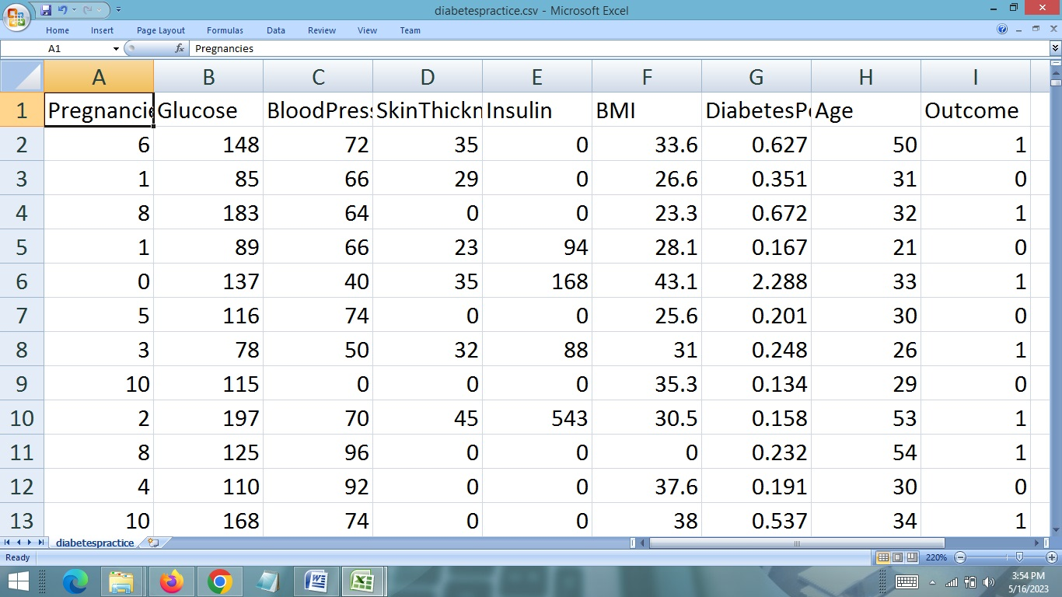

**CHAPTER # 5**

**System Design**

*Contents:*

* Use case diagram
* Class Diagram
* Sequence Diagram
* Data flow diagram

**Use Case Diagram:**

* Use case diagram consists of use cases and actors and shows the interaction between them. The key points are:
* The main purpose is to show the interaction between the use cases and the actor.
* To represent the system requirement from user’s perspective.
* The use cases are the functions that are to be performed in the module.

**Use Case Diagram Admin**

**Admin**

­­­

**Use Case Diagram - User**

**User**

**DFD (Data Flow Diagram)**

**DFD Level 1**

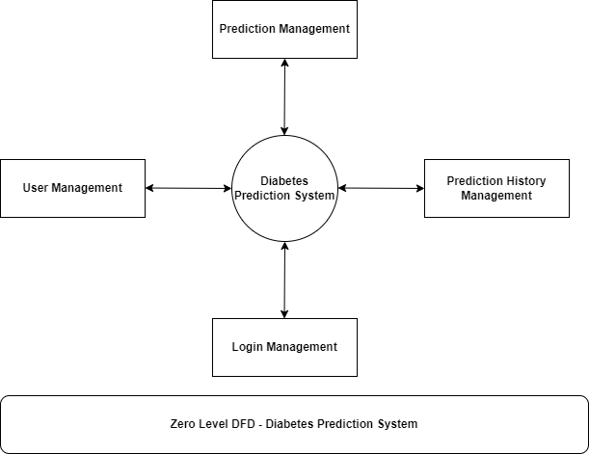

**DFD Level 2**

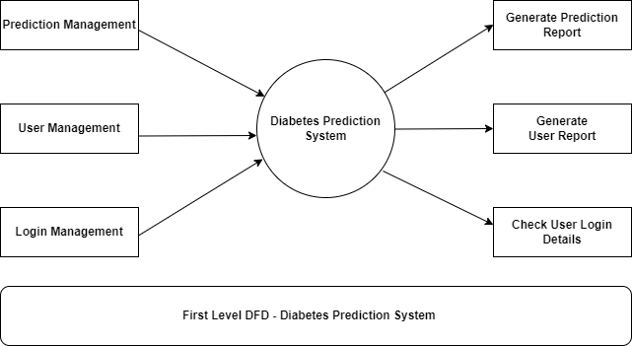

**ER DIAGRAM**

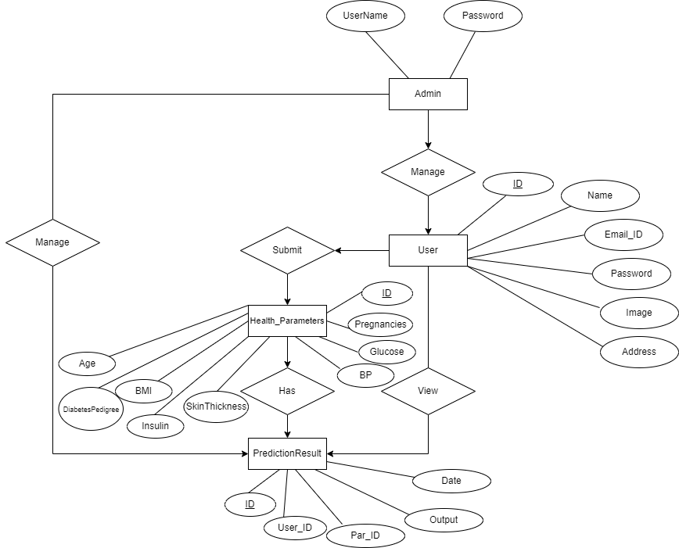

**Sequence Diagram For Administrator:-**

**Administrator**

**Success:hide()**

**Login**

**Application**

**Database**

**Login**

**:Request**

**:Validate()**

**:executeQuery()**

**Response**

**Show Result**

**Failed:show()**

Fig.5.4

**Sequence Diagram For User:-**

**User**

**Success:hide()**

**Login**

**Application**

**Database**

**Login**

**:Request**

**:Validate()**

**:executeQuery()**

**Response**

**Show Result**

**Failed:show()**

**:**

Fig.5.5

**CHAPTER # 6**

**Output screens**

**HOME PAGE**

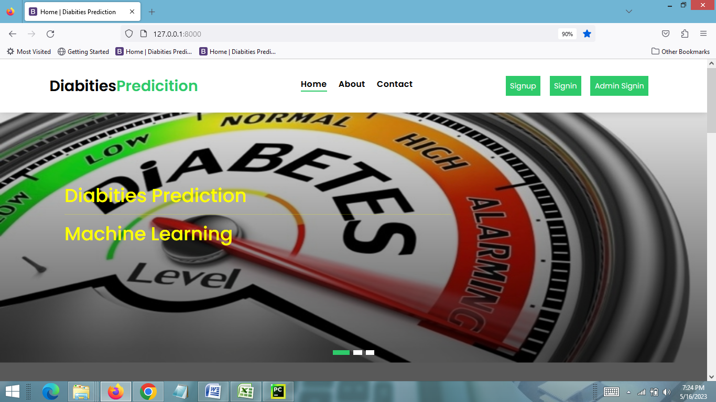

**USER REGISTRATION PAGE**

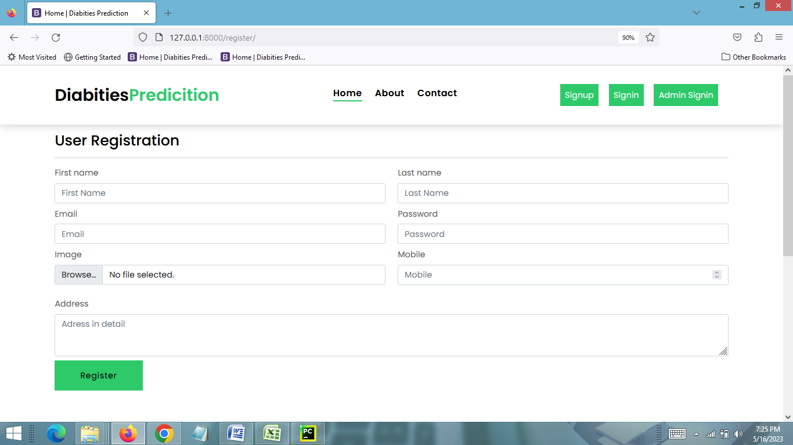

**USER LOGIN PAGE**

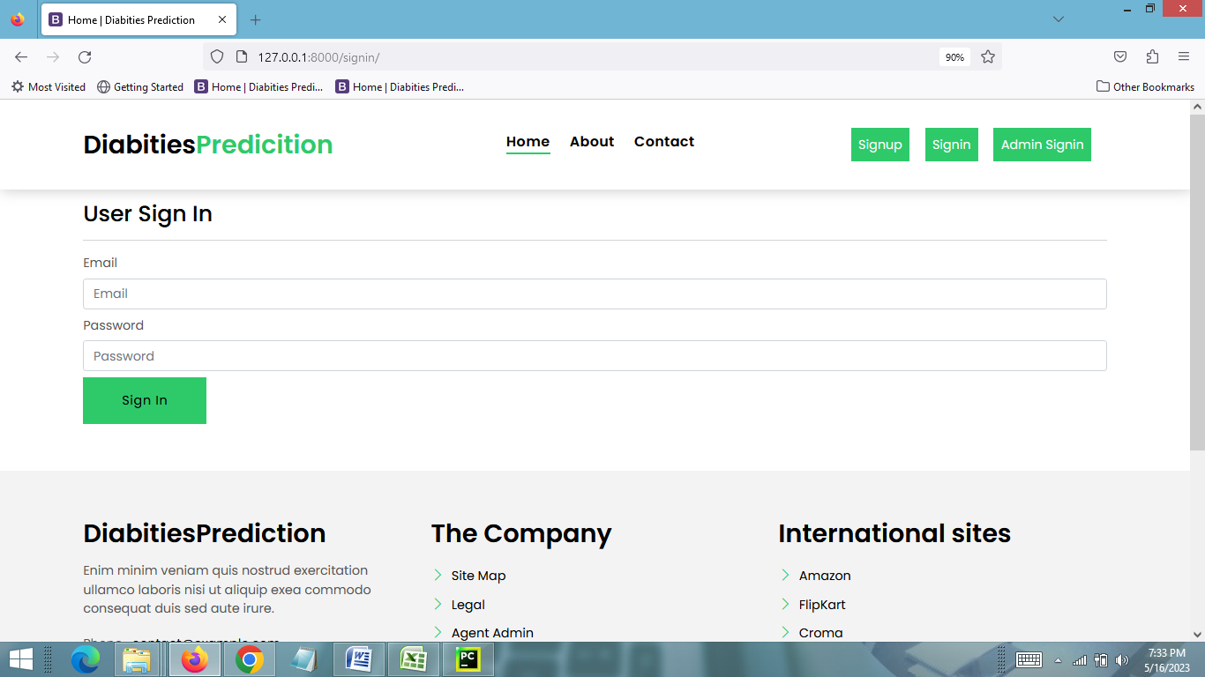

**USER HOME PAGE**

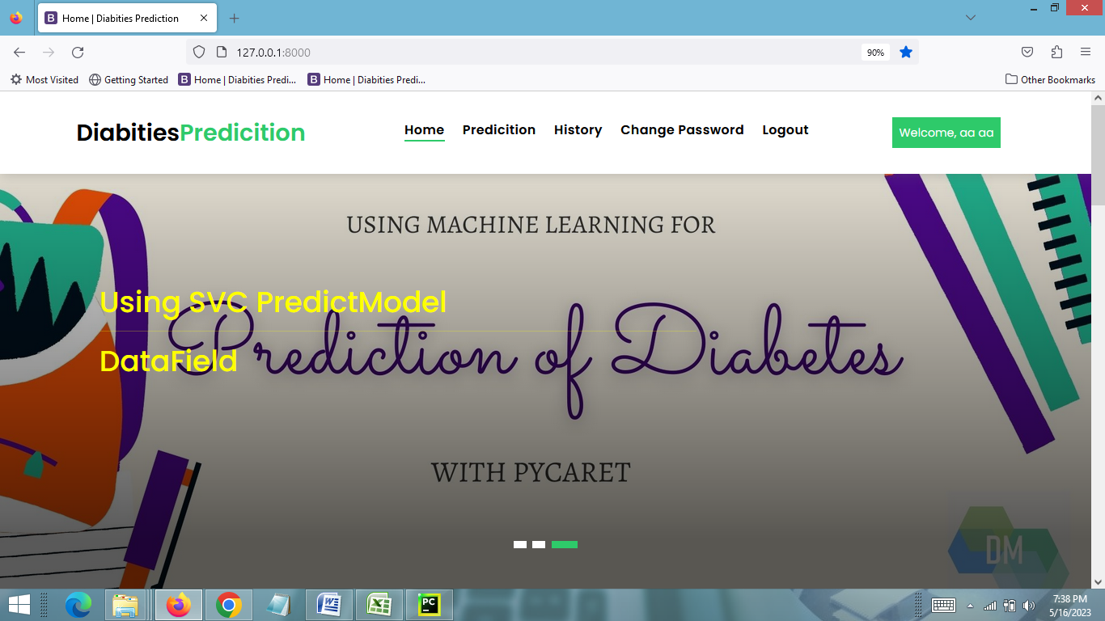

**PREDICTION PAGE**

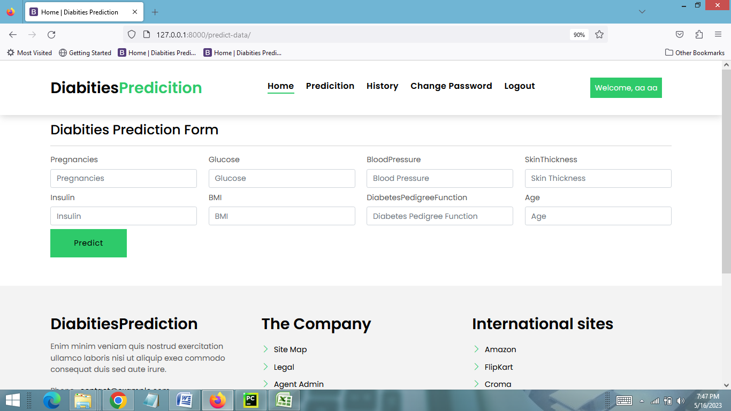

**PREDICTION RESULTS PAGE**

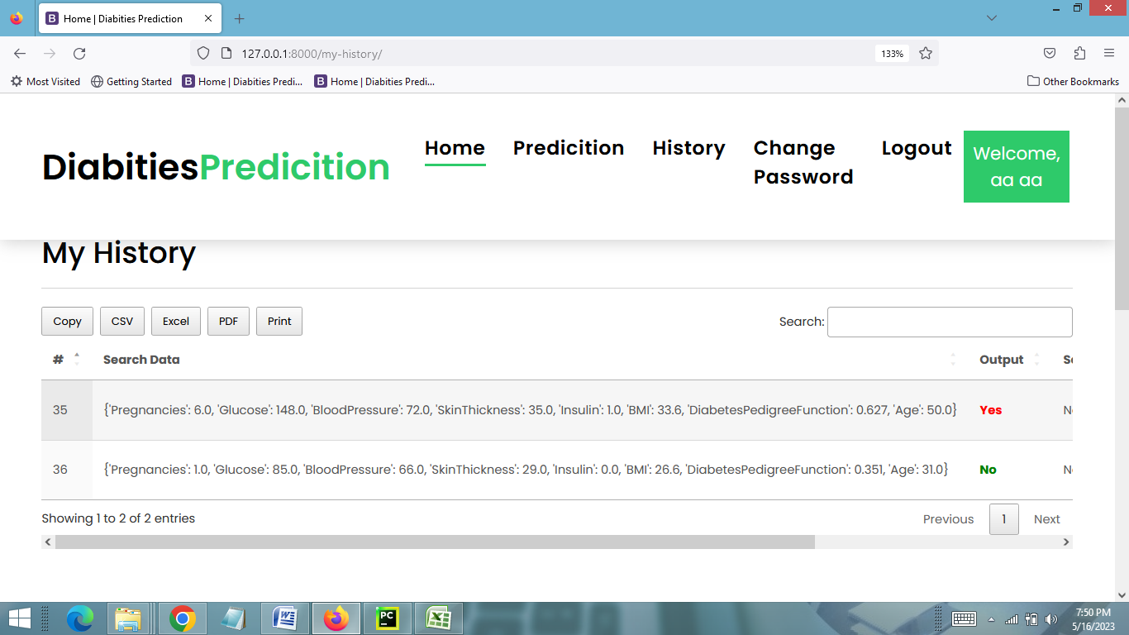

**CHANGE PASSWORD PAGE**

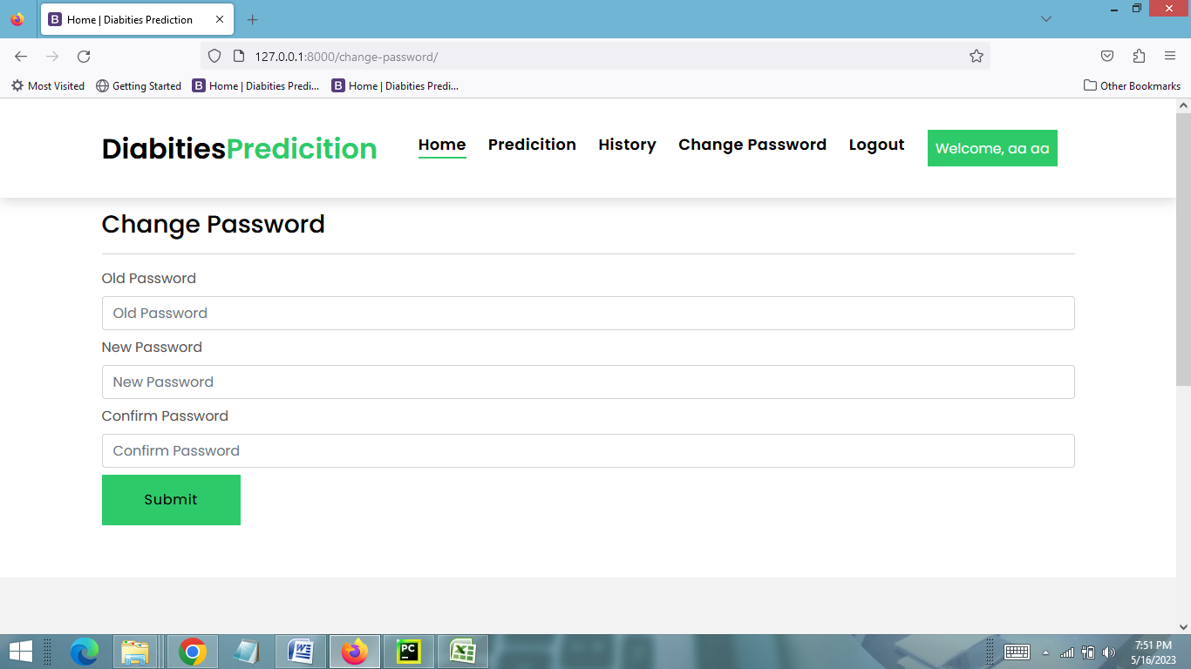

**PROFILE PAGE**

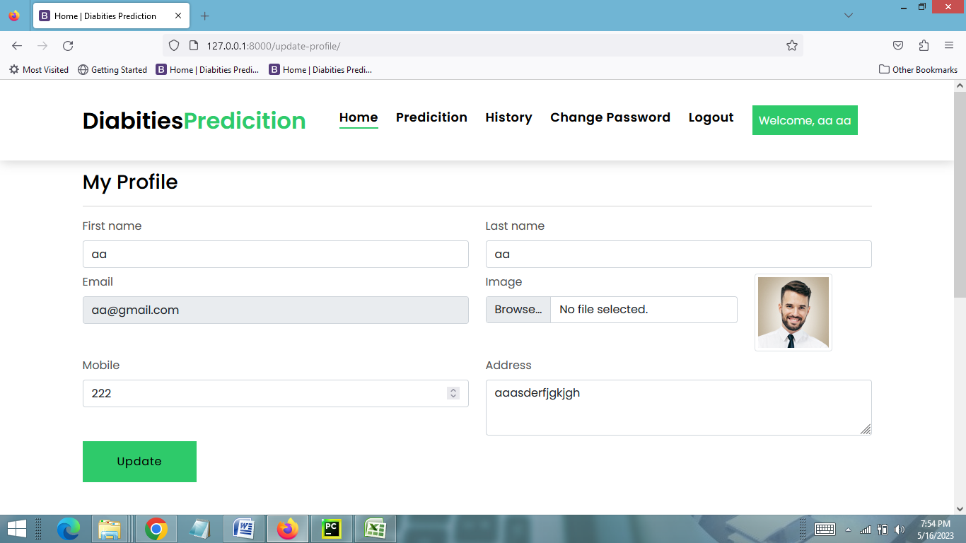

**ADMIN LOGIN PAGE**

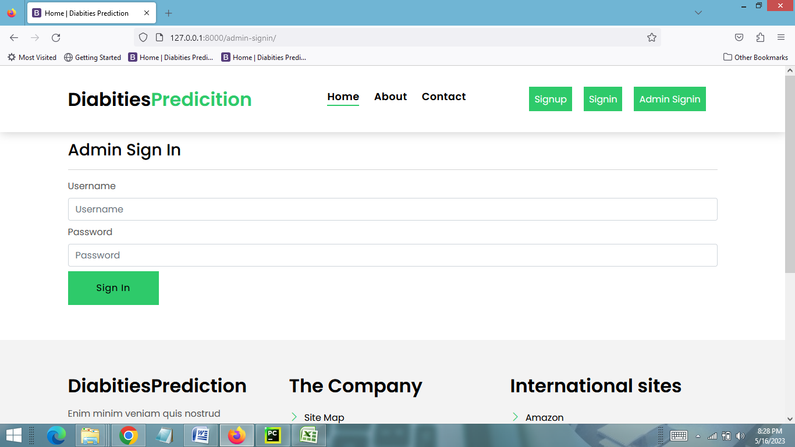

**ADMIN HOME PAGE**

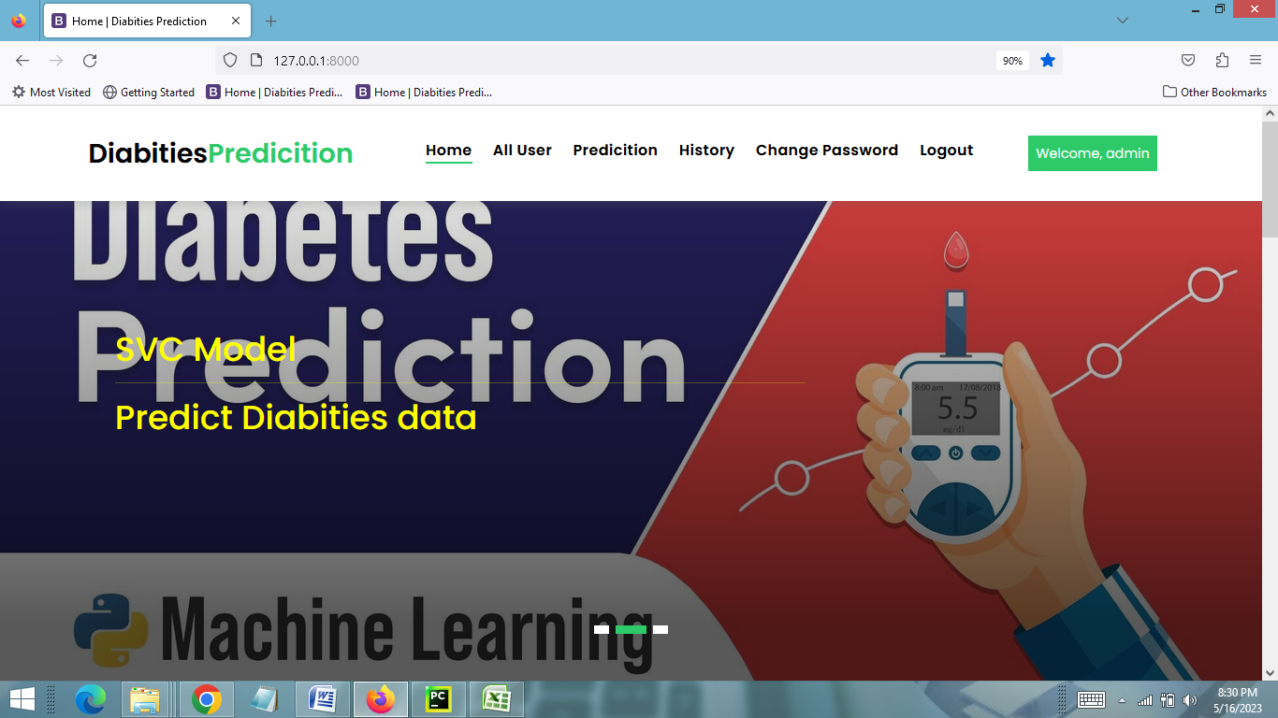

**VIEW ALL USERS PAGE**

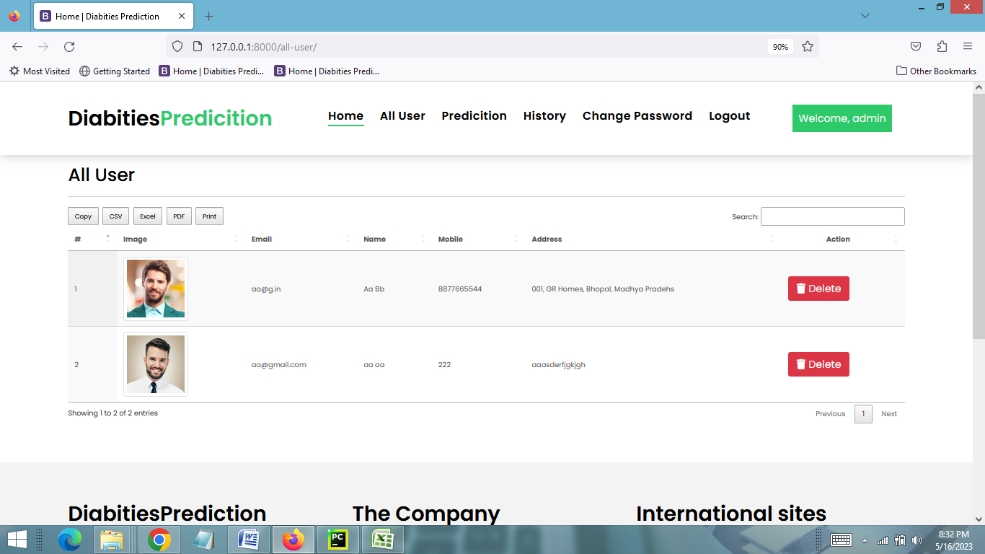

**VIEW PREDICTION HISTORY PAGE**

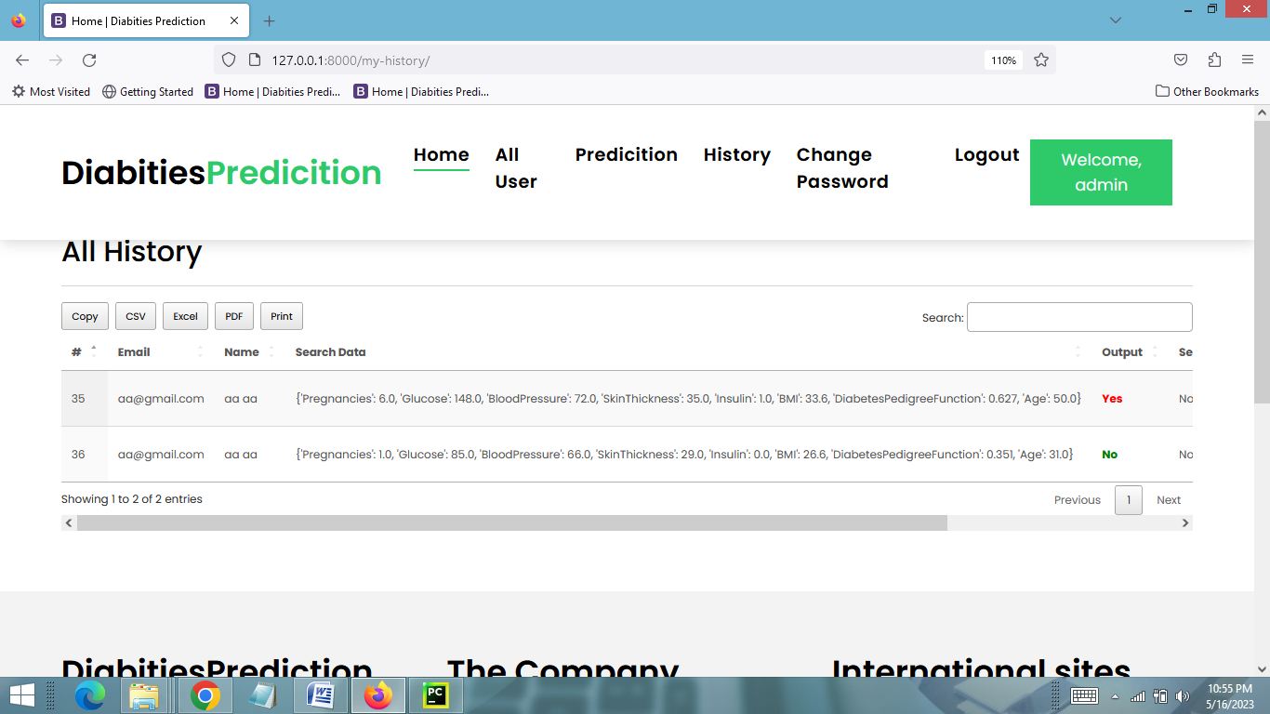

**CHAPTER # 7**

***Coding***

**HOME PAGE CODING**

**{% extends 'base.html' %}**

**{% load static %}**

**{% block body %}**

**<!-- ======= Intro Section ======= -->**

**<div class="intro intro-carousel swiper position-relative">**

**<div class="swiper-wrapper">**

**<div class="swiper-slide carousel-item-a intro-item bg-image" style="background-image: url({% static 'assets/img/slider-1.png' %});background-size: 100% 720px;">**

**<div class="overlay overlay-a"></div>**

**<div class="intro-content display-table">**

**<div class="table-cell">**

**<div class="container">**

**<div class="row">**

**<div class="col-lg-8">**

**<div class="intro-body">**

**<h1 style="color:yellow">Diabities Prediction**

**<hr> Machine Learning**

**</p>**

**<h1 class="intro-title mb-4 ">**

**</h1>**

**<p class="intro-subtitle intro-price">**

**</p>**

**</div>**

**</div>**

**</div>**

**</div>**

**</div>**

**</div>**

**</div>**

**<div class="swiper-slide carousel-item-a intro-item bg-image" style="background-image: url({% static 'assets/img/slide-2.jpg' %})">**

**<div class="overlay overlay-a"></div>**

**<div class="intro-content display-table">**

**<div class="table-cell">**

**<div class="container">**

**<div class="row">**

**<div class="col-lg-8">**

**<div class="intro-body">**

**<h1 style="color:yellow">SVC Model<hr>**

**Predict Diabities data**

**</h1>**

**<h1 class="intro-title mb-4">**

**</h1>**

**<p class="intro-subtitle intro-price">**

**</p>**

**</div>**

**</div>**

**</div>**

**</div>**

**</div>**

**</div>**

**</div>**

**<div class="swiper-slide carousel-item-a intro-item bg-image" style="background-image: url({% static 'assets/img/slide-3.jpg' %});">**

**<div class="overlay overlay-a"></div>**

**<div class="intro-content display-table">**

**<div class="table-cell">**

**<div class="container">**

**<div class="row">**

**<div class="col-lg-8">**

**<div class="intro-body">**

**<h1 style="color:yellow">Using SVC PredictModel<hr>**

**DataField**

**</h1>**

**<h1 class="intro-title mb-4">**

**</h1>**

**<p class="intro-subtitle intro-price">**

**</p>**

**</div>**

**</div>**

**</div>**

**</div>**

**</div>**

**</div>**

**</div>**

**</div>**

**<div class="swiper-pagination"></div>**

**</div><!-- End Intro Section -->**

**<main id="main">**

**<!-- ======= Services Section ======= -->**

**<section class="section-services section-t8">**

**<div class="container">**

**<div class="row">**

**<div class="col-md-12">**

**<div class="title-wrap d-flex justify-content-between">**

**<div class="title-box">**

**<h2 class="title-a">Our Services</h2>**

**</div>**

**</div>**

**</div>**

**</div>**

**<div class="row">**

**<div class="col-md-4">**

**<div class="card-box-c foo">**

**<div class="card-header-c d-flex">**

**<div class="card-box-ico">**

**<span class="bi bi-cart"></span>**

**</div>**

**<div class="card-title-c align-self-center">**

**<h2 class="title-c">Machine Learning</h2>**

**</div>**

**</div>**

**<div class="card-body-c">**

**<p class="content-c">**

**we scrape website data and find best value for you.**

**</p>**

**</div>**

**<div class="card-footer-c">**

**<a href="#" class="link-c link-icon">Read more**

**<span class="bi bi-chevron-right"></span>**

**</a>**

**</div>**

**</div>**

**</div>**

**<div class="col-md-4">**

**<div class="card-box-c foo">**

**<div class="card-header-c d-flex">**

**<div class="card-box-ico">**

**<span class="bi bi-calendar4-week"></span>**

**</div>**

**<div class="card-title-c align-self-center">**

**<h2 class="title-c">Diabities Prediction</h2>**

**</div>**

**</div>**

**<div class="card-body-c">**

**<p class="content-c">**

**We all predict and provide you best value for you.**

**</p>**

**</div>**

**<div class="card-footer-c">**

**<a href="#" class="link-c link-icon">Read more**

**<span class="bi bi-calendar4-week"></span>**

**</a>**

**</div>**

**</div>**

**</div>**

**<div class="col-md-4">**

**<div class="card-box-c foo">**

**<div class="card-header-c d-flex">**

**<div class="card-box-ico">**

**<span class="bi bi-card-checklist"></span>**

**</div>**

**<div class="card-title-c align-self-center">**

**<h2 class="title-c">Provide Best Prediction</h2>**

**</div>**

**</div>**

**<div class="card-body-c">**

**<p class="content-c">**

**We provide link at the same point you can buy feel free after prediction.**

**</p>**

**</div>**

**<div class="card-footer-c">**

**<a href="#" class="link-c link-icon">Read more**

**<span class="bi bi-chevron-right"></span>**

**</a>**

**</div>**

**</div>**

**</div>**

**</div>**

**</div>**

**</section><!-- End Services Section -->**

**<section class="section-agents section-t8">**

**<div class="container">**

**<div class="row">**

**<div class="col-md-12">**

**<div class="title-wrap d-flex justify-content-between">**

**<div class="title-box">**

**<h2 class="title-a">Our Teams</h2>**

**</div>**

**<div class="title-link">**

**<a href="#">All Teams**

**<span class="bi bi-chevron-right"></span>**

**</a>**

**</div>**

**</div>**

**</div>**

**</div>**

**<div class="row">**

**<div class="col-md-4">**

**<div class="card-box-d">**

**<div class="card-img-d">**

**<img src="{% static 'assets/img/team1.png' %}" style="width:400px;height:400px" alt="" class="img-d img-fluid">**

**</div>**

**<div class="card-overlay card-overlay-hover">**

**<div class="card-header-d">**

**<div class="card-title-d align-self-center">**

**<h3 class="title-d">**

**<a href="agent-single.html" class="link-two">Margaret Sotillo**

**<br> Escala</a>**

**</h3>**

**</div>**

**</div>**

**<div class="card-body-d">**

**<p class="content-d color-text-a">**

**Sed porttitor lectus nibh, Cras ultricies ligula sed magna dictum porta two.**

**</p>**

**<div class="info-agents color-a">**

**<p>**

**<strong>Phone: </strong> +54 356 945234**

**</p>**

**<p>**

**<strong>Email: </strong> agents@example.com**

**</p>**

**</div>**

**</div>**

**<div class="card-footer-d">**

**<div class="socials-footer d-flex justify-content-center">**

**<ul class="list-inline">**

**<li class="list-inline-item">**

**<a href="#" class="link-one">**

**<i class="bi bi-facebook" aria-hidden="true"></i>**

**</a>**

**</li>**

**<li class="list-inline-item">**

**<a href="#" class="link-one">**

**<i class="bi bi-twitter" aria-hidden="true"></i>**

**</a>**

**</li>**

**<li class="list-inline-item">**

**<a href="#" class="link-one">**

**<i class="bi bi-instagram" aria-hidden="true"></i>**

**</a>**

**</li>**

**<li class="list-inline-item">**

**<a href="#" class="link-one">**

**<i class="bi bi-linkedin" aria-hidden="true"></i>**

**</a>**

**</li>**

**</ul>**

**</div>**

**</div>**

**</div>**

**</div>**

**</div>**

**<div class="col-md-4">**

**<div class="card-box-d">**

**<div class="card-img-d">**

**<img src="{% static 'assets/img/team2.png' %}" style="width:400px;height:400px" alt="" class="img-d img-fluid">**

**</div>**

**<div class="card-overlay card-overlay-hover">**

**<div class="card-header-d">**

**<div class="card-title-d align-self-center">**

**<h3 class="title-d">**

**<a href="agent-single.html" class="link-two">Stiven Spilver**

**<br> Darw</a>**

**</h3>**

**</div>**

**</div>**

**<div class="card-body-d">**

**<p class="content-d color-text-a">**

**Sed porttitor lectus nibh, Cras ultricies ligula sed magna dictum porta two.**

**</p>**

**<div class="info-agents color-a">**

**<p>**

**<strong>Phone: </strong> +54 356 945234**

**</p>**

**<p>**

**<strong>Email: </strong> agents@example.com**

**</p>**

**</div>**

**</div>**

**<div class="card-footer-d">**

**<div class="socials-footer d-flex justify-content-center">**

**<ul class="list-inline">**

**<li class="list-inline-item">**

**<a href="#" class="link-one">**

**<i class="bi bi-facebook" aria-hidden="true"></i>**

**</a>**

**</li>**

**<li class="list-inline-item">**

**<a href="#" class="link-one">**

**<i class="bi bi-twitter" aria-hidden="true"></i>**

**</a>**

**</li>**

**<li class="list-inline-item">**

**<a href="#" class="link-one">**

**<i class="bi bi-instagram" aria-hidden="true"></i>**

**</a>**

**</li>**

**<li class="list-inline-item">**

**<a href="#" class="link-one">**

**<i class="bi bi-linkedin" aria-hidden="true"></i>**

**</a>**

**</li>**

**</ul>**

**</div>**

**</div>**

**</div>**

**</div>**

**</div>**

**<div class="col-md-4">**

**<div class="card-box-d">**

**<div class="card-img-d">**

**<img src="{% static 'assets/img/team3.png' %}" style="width:400px;height:400px" alt="" class="img-d img-fluid">**

**</div>**

**<div class="card-overlay card-overlay-hover">**

**<div class="card-header-d">**

**<div class="card-title-d align-self-center">**

**<h3 class="title-d">**

**<a href="agent-single.html" class="link-two">Emma Toledo**

**<br> Cascada</a>**

**</h3>**

**</div>**

**</div>**

**<div class="card-body-d">**

**<p class="content-d color-text-a">**

**Sed porttitor lectus nibh, Cras ultricies ligula sed magna dictum porta two.**

**</p>**

**<div class="info-agents color-a">**

**<p>**

**<strong>Phone: </strong> +54 356 945234**

**</p>**

**<p>**

**<strong>Email: </strong> agents@example.com**

**</p>**

**</div>**

**</div>**

**<div class="card-footer-d">**

**<div class="socials-footer d-flex justify-content-center">**

**<ul class="list-inline">**

**<li class="list-inline-item">**

**<a href="#" class="link-one">**

**<i class="bi bi-facebook" aria-hidden="true"></i>**

**</a>**

**</li>**

**<li class="list-inline-item">**

**<a href="#" class="link-one">**

**<i class="bi bi-twitter" aria-hidden="true"></i>**

**</a>**

**</li>**

**<li class="list-inline-item">**

**<a href="#" class="link-one">**

**<i class="bi bi-instagram" aria-hidden="true"></i>**

**</a>**

**</li>**

**<li class="list-inline-item">**

**<a href="#" class="link-one">**

**<i class="bi bi-linkedin" aria-hidden="true"></i>**

**</a>**

**</li>**

**</ul>**

**</div>**

**</div>**

**</div>**

**</div>**

**</div>**

**</div>**

**</div>**

**</section><!-- End Agents Section -->**

**<!-- ======= Testimonials Section ======= -->**

**<section class="section-testimonials section-t8 nav-arrow-a">**

**<div class="container">**

**<div class="row">**

**<div class="col-md-12">**

**<div class="title-wrap d-flex justify-content-between">**

**<div class="title-box">**

**<h2 class="title-a">Testimonials</h2>**

**</div>**

**</div>**

**</div>**

**</div>**

**<div id="testimonial-carousel" class="swiper">**

**<div class="swiper-wrapper">**

**<div class="carousel-item-a swiper-slide">**

**<div class="testimonials-box">**

**<div class="row">**

**<div class="col-sm-12 col-md-6">**

**<div class="testimonial-img">**

**<img src="{% static 'assets/img/team1.png' %}" style="width:300px;height:300px" alt="" class="img-fluid">**

**</div>**

**</div>**

**<div class="col-sm-12 col-md-6">**

**<div class="testimonial-ico">**

**<i class="bi bi-chat-quote-fill"></i>**

**</div>**

**<div class="testimonials-content">**

**<p class="testimonial-text">**

**Best Value gives this website.**

**</p>**

**</div>**

**<div class="testimonial-author-box">**

**<img src="{% static 'assets/img/team1.png' %}" alt="" class="testimonial-avatar">**

**<h5 class="testimonial-author">Albert & Erika</h5>**

**</div>**

**</div>**

**</div>**

**</div>**

**</div><!-- End carousel item -->**

**<div class="carousel-item-a swiper-slide">**

**<div class="testimonials-box">**

**<div class="row">**

**<div class="col-sm-12 col-md-6">**

**<div class="testimonial-img">**

**<img src="{% static 'assets/img/team2.png' %}" style="width:300px;height:300px" alt="" class="img-fluid">**

**</div>**

**</div>**

**<div class="col-sm-12 col-md-6">**

**<div class="testimonial-ico">**

**<i class="bi bi-chat-quote-fill"></i>**

**</div>**

**<div class="testimonials-content">**

**<p class="testimonial-text">**

**Best Value gives this website.**

**</p>**

**</div>**

**<div class="testimonial-author-box">**

**<img src="{% static 'assets/img/team2.png' %}" alt="" class="testimonial-avatar">**

**<h5 class="testimonial-author">Pablo & Emma</h5>**

**</div>**

**</div>**

**</div>**

**</div>**

**</div><!-- End carousel item -->**

**</div>**

**</div>**

**<div class="testimonial-carousel-pagination carousel-pagination"></div>**

**</div>**

**</section><!-- End Testimonials Section -->**

**</main><!-- End #main -->**

**{% include 'footer.html' %}**

**{% endblock %}**

**REGISTRATION PAGE CODING**

**{% extends 'base.html' %}**

**{% load static %}**

**{% block body %}**

**<section class="section-services section-t8">**

**<div class="container">**

**<h3>User Registration</h3><hr>**

**<div class="form">**

**<form class="form-a" action="" method="post" enctype="multipart/form-data">**

**{% csrf_token %}**

**<div class="row">**

**<div class="col-md-6 mb-2">**

**<div class="form-group">**

**<label class="pb-2" for="Type">First name</label>**

**<input type="text" class="form-control form-control-a" placeholder="First Name" name="first_name">**

**</div>**

**</div>**

**<div class="col-md-6 mb-2">**

**<div class="form-group">**

**<label class="pb-2" for="Type">Last name</label>**

**<input type="text" class="form-control form-control-a" placeholder="Last Name" name="last_name">**

**</div>**

**</div>**

**<div class="col-md-6 mb-2">**

**<div class="form-group">**

**<label class="pb-2" for="Type">Email</label>**

**<input type="email" class="form-control form-control-a" placeholder="Email" name="username">**

**</div>**

**</div>**

**<div class="col-md-6 mb-2">**

**<div class="form-group">**

**<label class="pb-2" for="Type">Password</label>**

**<input type="password" class="form-control form-control-a" placeholder="Password" name="password">**

**</div>**

**</div>**

**<div class="col-md-6 mb-2">**

**<div class="form-group">**

**<label class="pb-2" for="Type">Image</label>**

**<input type="file" class="form-control form-control-a" name="image">**

**</div>**

**</div>**

**<div class="col-md-6 mb-2">**

**<div class="form-group">**

**<label class="pb-2" for="Type">Mobile</label>**

**<input type="number" class="form-control form-control-a" name="mobile" placeholder="Mobile">**

**</div></div><div class="col-md-12 mb-2">**

**<div class="form-group mt-3">**

**<label class="pb-2" for="bedrooms">Address</label>**

**<textarea class="form-control form-control-a" name="address" placeholder="Adress in detail"></textarea>**

**</div>**

**</div>**

**<div class="col-md-12">**

**<button type="submit" class="btn btn-b">Register</button>**

**</div>**

**</div>**

**</form>**

**</div>**

**</div>**

**{% include 'footer.html' %}**

**{% endblock %}**

**SIGN IN PAGE CODING**

**{% extends 'base.html' %}**

**{% load static %}**

**{% block body %}**

**<section class="section-services section-t8">**

**<div class="container">**

**<h3>User Sign In</h3><hr>**

**<div class="form">**

**<form class="form-a" action="" method="post" enctype="multipart/form-data">**

**{% csrf_token %}**

**<div class="row">**

**<div class="col-md-12 mb-2">**

**<div class="form-group">**

**<label class="pb-2" for="Type">Email</label>**

**<input type="email" class="form-control form-control-a" placeholder="Email" name="username">**

**</div>**

**</div>**

**<div class="col-md-12 mb-2">**

**<div class="form-group">**

**<label class="pb-2" for="Type">Password</label>**

**<input type="password" class="form-control form-control-a" placeholder="Password" name="password">**

**</div>**

**</div>**

**<div class="col-md-12">**

**<button type="submit" class="btn btn-b">Sign In</button>**

**</div>**

**</div></form></div></div>**

**{% include 'footer.html' %}**

**{% endblock %}**

**PREDICTION PAGE**

**{% extends 'base.html' %}**

**{% load static %}**

**{% block body %}**

**<section class="section-services section-t8">**

**<div class="container">**

**<h3>Diabities Prediction Form</h3><hr>**

**<div class="form">**

**<form class="form-a" action="" method="post" enctype="multipart/form-data">**

**{% csrf_token %}**

**<div class="row">**

**<div class="col-md-3 mb-2">**

**<div class="form-group">**

**<label class="pb-2" for="Type">Pregnancies</label>**

**<input type="text" class="form-control form-control-a" placeholder="Pregnancies" name="Pregnancies" required>**

**</div>**

**</div>**

**<div class="col-md-3 mb-2">**

**<div class="form-group">**

**<label class="pb-2" for="Type">Glucose</label>**

**<input type="text" class="form-control form-control-a" placeholder="Glucose" name="Glucose" required>**

**</div>**

**</div>**

**<div class="col-md-3 mb-2">**

**<div class="form-group">**

**<label class="pb-2" for="Type">BloodPressure</label>**

**<input type="text" class="form-control form-control-a" placeholder="Blood Pressure" name="BloodPressure" required>**

**</div>**

**</div>**

**<div class="col-md-3 mb-2">**

**<div class="form-group">**

**<label class="pb-2" for="Type">SkinThickness</label>**

**<input type="text" class="form-control form-control-a" placeholder="Skin Thickness" name="SkinThickness" required>**

**</div>**

**</div>**

**<div class="col-md-3 mb-2">**

**<div class="form-group">**

**<label class="pb-2" for="Type">Insulin</label>**

**<input type="text" class="form-control form-control-a" name="Insulin" placeholder="Insulin" required>**

**</div>**

**</div>**

**<div class="col-md-3 mb-2">**

**<div class="form-group">**

**<label class="pb-2" for="Type">BMI</label>**

**<input type="text" class="form-control form-control-a" name="BMI" placeholder="BMI" required>**

**</div>**

**</div>**

**<div class="col-md-3 mb-2">**

**<div class="form-group">**

**<label class="pb-2" for="Type">DiabetesPedigreeFunction</label>**

**<input type="text" class="form-control form-control-a" name="DiabetesPedigreeFunction" placeholder="Diabetes Pedigree Function" required>**

**</div>**

**</div>**

**<div class="col-md-3 mb-2">**

**<div class="form-group">**

**<label class="pb-2" for="Type">Age</label>**

**<input type="text" class="form-control form-control-a" name="Age" placeholder="Age" required>**

**</div>**

**</div>**

**<div class="col-md-12">**

**<button type="submit" class="btn btn-b">Predict</button>**

**</div>**

**</div>**

**</form>**

**<div class="container">**

**{% if output == "Yes" %}**

**<h4 align="center" style="color:red">Yes, you have Diabetes symptoms. Please contact with doctor.</h4><hr>**

**{% elif output == "No" %}**

**<h4 align="center" style="color:green">Great, you have no symptoms.</h4><hr>**

**{% endif %}**

**</div>**

**</div>**

**</div>**

**{% include 'footer.html' %}**

**{% endblock %}**

**VIEW PREDICTION HISTORY PAGE CODING**

**{% include 'base.html' %}**

**{% load static %}**

**{% block body %}**

**<link rel="stylesheet" href="https://cdnjs.cloudflare.com/ajax/libs/font-awesome/6.2.0/css/all.min.css" integrity="sha512-xh6O/CkQoPOWDdYTDqeRdPCVd1SpvCA9XXcUnZS2FmJNp1coAFzvtCN9BmamE+4aHK8yyUHUSCcJHgXloTyT2A==" crossorigin="anonymous" referrerpolicy="no-referrer" />**

**<style>**

**#active {**

**border-radius: 50%;**

**}**

**#inactive {**

**border-radius: 50%;**

**}**

**#active:hover {**

**cursor: default !important;**

**}**

**#inactive:hover {**

**cursor: default !important;**

**}**

**img {**

**width: 60px;**

**height: 60px;**

**}**

**.table-responsive{**

**font-size:11px;**

**}**

**.material-symbols-outlined**

**{**

**font-size:14px;**

**}**

**td{**

**padding:0px;**

**}**

**</style>**

**<section class="section-services section-t8">**

**<div class="container">**

**<h3>{% if request.user.is_staff %}All{% else %}My{% endif %} History</h3><hr>**

**<div class="table-responsive">**

**<table id="example1" class="display nowrap" style="width: 100%">**

**<thead>**

**<tr>**

**<th>#</th>**

**{% if request.user.is_staff %}**

**<th>Email</th>**

**<th>Name</th>**

**{% endif %}**

**<th>Search Data</th>**

**<th>Output</th>**

**<th>Search Date</th>**

**<th style="text-align: center">Action</th>**

**</tr>**

**</thead>**

**<tbody>**

**{% for i in history %}**

**<tr>**

**<td>{{i.id}}</td>**

**{% if request.user.is_staff %}**

**<td>{{i.user.username}}</td>**

**<td>{{i.user.first_name}} {{i.user.last_name}}</td>**

**{% endif %}**

**<td>**

**{{i.search_data}}**

**</td>**

**<td {% if i.output == 'Yes' %}style="color:red;font-weight:bold" {% else %}style="color:green;font-weight:bold"{% endif %}>**

**{{i.output}}**

**</td>**

**<td>{{i.created}}</td>**

**<td>**

**<a href="/delete-history/{{i.id}}/" title="Delete History" class="btn btn-danger" onclick="return confirm('Are your sure?')"><i class="fas fa-trash" aria-hidden="true"></i> Delete</a>**

**</td>**

**</tr>**

**{% endfor %}**

**</tbody>**

**</table>**

**</div>**

**</div>**

**{% include 'footer.html' %}**

**{% include 'tablecdn.html' %}**

**{% endblock %}**

**EDIT PROFILE PAGE CODING**

**{% extends 'base.html' %}**

**{% load static %}**

**{% block body %}**

**<section class="section-services section-t8">**

**<div class="container">**

**<h3>My Profile</h3><hr>**

**<div class="form">**

**<form class="form-a" action="" method="post" enctype="multipart/form-data">**

**{% csrf_token %}**

**<div class="row">**

**<div class="col-md-6 mb-2">**

**<div class="form-group">**

**<label class="pb-2" for="Type">First name</label>**

**<input type="text" class="form-control form-control-a" placeholder="First Name" name="first_name" value="{{request.user.first_name}}">**

**</div>**

**</div>**

**<div class="col-md-6 mb-2">**

**<div class="form-group">**

**<label class="pb-2" for="Type">Last name</label>**

**<input type="text" class="form-control form-control-a" placeholder="Last Name" name="last_name" value="{{request.user.last_name}}">**

**</div>**

**</div>**

**<div class="col-md-6 mb-2">**

**<div class="form-group">**

**<label class="pb-2" for="Type">Email</label>**

**<input type="email" class="form-control form-control-a" placeholder="Email" name="username" value="{{request.user.username}}" readonly>**

**</div>**

**</div>**

**{% comment %} <div class="col-md-6 mb-2">**

**<div class="form-group">**

**<label class="pb-2" for="Type">Password</label>**

**<input type="password" class="form-control form-control-a" placeholder="Password" name="password">**

**</div>**

**</div> {% endcomment %}**

**<div class="col-md-4 mb-2">**

**<div class="form-group">**

**<label class="pb-2" for="Type">Image</label>**

**<input type="file" class="form-control form-control-a" name="image">**

**</div>**

**</div>**

**<div class="col-md-2 mb-2">**

**<div class="form-group">**

**<img src="{% if request.user.register_set.all.0.image %}{{request.user.register_set.all.0.image.url}}{% endif %}" class="img-thumbnail">**

**</div>**

**</div>**

**<div class="col-md-6 mb-2">**

**<div class="form-group">**

**<label class="pb-2" for="Type">Mobile</label>**

**<input type="number" class="form-control form-control-a" name="mobile" placeholder="Mobile" value="{{request.user.register_set.all.0.mobile}}">**

**</div>**

**</div>**

**<div class="col-md-6 mb-2">**

**<div class="form-group">**

**<label class="pb-2" for="bedrooms">Address</label>**

**<textarea class="form-control form-control-a" name="address" placeholder="Adress in detail">{{request.user.register_set.all.0.address}}</textarea>**

**</div>**

**</div>**

**<div class="col-md-12">**

**<button type="submit" class="btn btn-b">Update</button>**

**</div>**

**</div>**

**</form>**

**</div>**

**</div>**

**{% include 'footer.html' %}**

**{% endblock %}**

**CHANGE PASSWORD PAGE CODING**

**{% extends 'base.html' %}**

**{% load static %}**

**{% block body %}**

**<section class="section-services section-t8">**

**<div class="container">**

**<h3>Change Password</h3><hr>**

**<div class="form">**

**<form class="form-a" action="" method="post" enctype="multipart/form-data">**

**{% csrf_token %}**

**<div class="row"><div class="col-md-12 mb-2"> <div class="form-group">**

**<label class="pb-2" for="Type">Old Password</label>**

**<input type="password" class="form-control form-control-a" placeholder="Old Password" name="old-password">**

**</div> </div>**

**<div class="col-md-12 mb-2"><div class="form-group">**

**<label class="pb-2" for="Type">New Password</label>**

**<input type="password" class="form-control form-control-a" placeholder="New Password" name="new-password">**

**</div></div><div class="col-md-12 mb-2"><div class="form-group">**

**<label class="pb-2" for="Type">Confirm Password</label>**

**<input type="password" class="form-control form-control-a" placeholder="Confirm Password" name="confirm-password">**

**</div></div>**

**<div class="col-md-12">**

**<button type="submit" class="btn btn-b">Submit</button>**

**</div> </div>**

**</form>**

**</div> </div>**

**{% include 'footer.html' %}**

**{% endblock %}**

**ADMIN LOGIN PAGE CODING**

**{% extends 'base.html' %}**

**{% load static %}**

**{% block body %}**

**<section class="section-services section-t8">**

**<div class="container">**

**<h3>Admin Sign In</h3><hr>**

**<div class="form">**

**<form class="form-a" action="" method="post" enctype="multipart/form-data">**

**{% csrf_token %}**

**<div class="row">**

**<div class="col-md-12 mb-2">**

**<div class="form-group">**

**<label class="pb-2" for="Type">Username</label>**

**<input type="text" class="form-control form-control-a" placeholder="Username" name="username">**

**</div>**

**</div>**

**<div class="col-md-12 mb-2">**

**<div class="form-group">**

**<label class="pb-2" for="Type">Password</label>**

**<input type="password" class="form-control form-control-a" placeholder="Password" name="password">**

**</div>**

**</div>**

**<div class="col-md-12">**

**<button type="submit" class="btn btn-b">Sign In</button>**

**</div></div></form></div></div>**

**{% include 'footer.html' %}**

**{% endblock %}**

**VIEW ALL REG. USERS PAGE CODING**

**{% include 'base.html' %}**

**{% load static %}**

**{% block body %}**

**<link rel="stylesheet" href="https://cdnjs.cloudflare.com/ajax/libs/font-awesome/6.2.0/css/all.min.css" integrity="sha512-xh6O/CkQoPOWDdYTDqeRdPCVd1SpvCA9XXcUnZS2FmJNp1coAFzvtCN9BmamE+4aHK8yyUHUSCcJHgXloTyT2A==" crossorigin="anonymous" referrerpolicy="no-referrer" />**

**<style>**

**#active {**

**border-radius: 50%;**

**}**

**#inactive {**

**border-radius: 50%;**

**}**

**#active:hover {**

**cursor: default !important;**

**}**

**#inactive:hover {**

**cursor: default !important;**

**}**

**img {**

**width: 60px;**

**height: 60px;**

**}**

**.table-responsive{**

**font-size:11px;**

**}**

**.material-symbols-outlined**

**{**

**font-size:14px;**

**}**

**td{**

**padding:0px;**

**}**

**</style>**

**<section class="section-services section-t8">**

**<div class="container">**

**<h3>All User </h3><hr>**

**<div class="table-responsive">**

**<table id="example1" class="display nowrap" style="width: 100%">**

**<thead>**

**<tr>**

**<th>#</th>**

**<th>Image</th>**

**<th>Email</th>**

**<th>Name</th>**

**<th>Mobile</th>**

**<th>Address</th>**

**<th style="text-align: center">Action</th>**

**</tr>**

**</thead>**

**<tbody>**

**{% for i in data %}**

**<tr>**

**<td>{{i.id}}</td>**

**<td><img src="{{i.image.url}}" class="img-thumbnail" style="width:100px;height:100px"/></td>**

**<td>{{i.user.username}}</td>**

**<td>{{i.user.first_name}} {{i.user.last_name}}</td>**

**<td>{{i.mobile}}</td>**

**<td>{{i.address}}</td>**

**<td>**

**<a href="/delete-user/{{i.id}}/" title="Delete History" class="btn btn-danger" onclick="return confirm('Are your sure?')"><i class="fas fa-trash" aria-hidden="true"></i> Delete</a>**

**</td>**

**</tr>**

**{% endfor %}**

**</tbody>**

**</table>**

**</div>**

**</div>**

**{% include 'footer.html' %}**

**{% include 'tablecdn.html' %}**

**{% endblock %}**

**Testing**

Testing of the Diabetes Prediction System using Support Vector Machine involves various steps to ensure its functionality, accuracy, and reliability. Here are some key aspects of testing for this system:

1. Unit Testing: Individual components and functions of the system, such as data preprocessing, feature selection, and model training, are tested to verify their correctness and performance.
2. Integration Testing: Different modules of the system, such as user interface, prediction engine, and database connectivity, are integrated and tested to ensure seamless communication and proper functioning.
3. Functional Testing: The system is tested against predefined functional requirements to verify if it performs the intended tasks accurately. This includes testing user registration, login, prediction generation, viewing prediction history, and profile management.
4. Performance Testing: The system's performance is evaluated under varying load conditions to assess its responsiveness and stability. This includes measuring response times, resource utilization, and system behavior with increasing numbers of concurrent users or prediction requests.
5. Accuracy Testing: The accuracy of the prediction model is assessed by comparing the system's predictions against known ground truth values. A separate dataset with known diabetes outcomes is used to validate the system's accuracy, precision, recall, and F1-score.
6. Security Testing: The system is tested for vulnerabilities and security risks, such as SQL injection, cross-site scripting, and unauthorized access. Measures like input validation, data encryption, and user authentication are validated.
7. Usability Testing: The system's user interface and overall user experience are evaluated by involving representative users to ensure ease of use, intuitive navigation, and clear presentation of information.
8. Compatibility Testing: The system is tested on different platforms, browsers, and devices to ensure compatibility and consistent functionality across a range of environments.
9. Error Handling Testing: Various error scenarios, such as incorrect inputs, network failures, or database errors, are simulated to verify that the system handles exceptions gracefully and provides appropriate error messages to users.

Thorough testing ensures that the Diabetes Prediction System using Support Vector Machine functions as intended, provides accurate predictions, and delivers a reliable user experience.

**CHAPTER # 8**

**Advantages & Limitations**

**Advantages of “Diabetes Prediction System”:**

1. Accurate predictions: The system utilizes Support Vector Machine (SVM) to provide accurate predictions of diabetes risk based on input parameters such as glucose levels, BMI, and age.
2. Efficient feature selection: SVM helps in selecting the most relevant features, reducing dimensionality and improving prediction performance.
3. Handling non-linear relationships: SVM can capture complex patterns and non-linear relationships in the data, leading to improved prediction accuracy.
4. Robustness to outliers: SVM is less sensitive to outliers, making the system more resilient to noisy or inconsistent data.
5. Interpretability: SVM provides support vectors that aid in understanding the factors influencing the prediction outcome.
6. Scalability: The system is scalable and can handle large datasets efficiently.
7. User-friendly interface: The system offers an intuitive interface for easy registration, input of health parameters, and obtaining diabetes risk predictions.
8. Personalized recommendations: The system provides tailored recommendations and interventions based on the prediction outcomes, promoting proactive management of diabetes.

**Limitations of “Diabetes Prediction System”:**

Some of the limitations of the Diabetes Prediction System using Support Vector Model are:

1. Data quality dependency: Accuracy of predictions relies on high-quality and complete input data.
2. Sensitivity to feature scaling: Proper feature scaling is required for optimal SVM performance.
3. Lack of interpretability: SVM models are often seen as black box models, making interpretation challenging.
4. Handling missing data: SVM algorithms struggle with missing data and require imputation techniques.
5. Computational intensity: Training and optimizing SVM models can be computationally demanding.
6. Binary classification limitation: SVM models are designed for binary classification, requiring modifications for multiple classes.
7. Regular model updates: Model updates are necessary to maintain accuracy and relevance.
8. Ethical considerations: Privacy and security measures must be implemented to protect user data.

**CHAPTER # 8**

**Future Scope**

**FUTURE SCOPE**

The future scope of the Diabetes Prediction System using Support Vector Machine can include the following:

1. Incorporation of additional features for improved prediction accuracy.
2. Ensemble methods to enhance the system's performance.
3. Integration with wearable devices and health tracking apps for real-time data collection.
4. Personalized risk assessment based on individual characteristics and lifestyle factors.
5. Long-term disease monitoring and personalized interventions.
6. Development of a mobile application for remote monitoring and personalized feedback.
7. Collaboration with healthcare professionals through electronic health record integration and telemedicine platforms.
8. Continuous model improvement to stay up-to-date with advancements.
9. Integration with public health initiatives for population-level insights and preventive measures.
10. Research and data sharing to advance diabetes prediction and management.

**CONCLUSION**

In conclusion, the Diabetes Prediction System using Support Vector Machine is a valuable tool in the field of healthcare. It leverages the power of machine learning and data analysis to predict the likelihood of diabetes in individuals. The system offers advantages such as high accuracy, efficient analysis of large datasets, and user-friendly interfaces for both users and administrators. However, it is important to acknowledge the limitations of the system, such as its dependence on accurate and comprehensive datasets and the need for continuous updates to stay relevant. It is crucial to prioritize privacy and security when handling patient data and to comply with relevant regulations and ethical considerations. The future scope of the system lies in incorporating advanced algorithms, integrating with other healthcare technologies, and personalizing risk assessments and interventions. By continuously improving and updating the system, we can work towards better diabetes management and prevention, ultimately improving the overall health and well-being of individuals.

**Bibliography**

**BIBLIOGRAPHY**

* Wikipedia
* <https://panjwanitutorials.com/>
* <https://www.geeksforgeeks.org/python-django/>
* <https://www.javatpoint.com>
* <https://www.python.org/>
* <https://www.tutorialspoint/>
* **REFERENCE BOOKS**

### Two scoops of Django for 1.11 by Daniel Greenfeld’s and Audrey Greenfield

### Lightweight Django by Elman and Mark Lavin