INSTAGRAM
Engagement Analysis Report
A Data-Driven Study of Posting Behaviour, Content Type and Audience Engagement
Prepared using Python, Pandas, Seaborn & Scikit-learn
Dataset: Instagram Relational Dataset (Kaggle)
July 2026

1. Introduction
Social media platforms such as Instagram generate vast volumes of behavioural data every time a user posts a photo, likes a picture, leaves a comment, or follows another account. Hidden within this data are patterns that reveal what makes content succeed — the right posting time, the right format, and the right audience. This report presents an end-to-end analysis of an Instagram relational dataset covering users, photos, likes, comments, hashtags, and follower relationships.
The study follows a complete data-science workflow: the raw relational tables are cleaned and merged into a single analytical dataset, engagement metrics are engineered, exploratory data analysis (EDA) is used to uncover trends and relationships, and a machine learning model is trained to test whether engagement can be predicted from simple, readily available features such as posting hour, follower count, and hashtag usage.
The insights generated from this analysis are intended to help content creators, social media managers, and marketing teams understand which factors most strongly influence engagement, and to what extent engagement can realistically be predicted using structural post metadata alone.

2. Objective
The primary goal of this project is to analyse Instagram activity data and derive actionable insights about audience engagement. Specifically, the analysis aims to:
- Data Integration: Clean, merge, and structure the raw relational Instagram tables (users, photos, likes, comments, tags, photo_tags, follows) into a single unified dataset suitable for analysis.
- Feature Engineering: Engineer meaningful engagement metrics such as total engagement, likes-per-follower, comments-per-follower, and engagement rate.
- Pattern Discovery: Identify the best-performing posting hour, the highest-engaging content type (photo, video, carousel), the impact of filters, and the top-performing users through visual and statistical exploration.
- Predictive Modelling: Train a regression model to predict post engagement from posting hour, follower count, and hashtag count, and critically evaluate its performance.
- Business Insight: Translate the findings into practical recommendations for improving content strategy and audience engagement.

3. Dataset Description
The data originates from a Kaggle Instagram relational dataset composed of seven interlinked CSV tables that together mimic a simplified version of Instagram's backend database. Each table captures a different aspect of platform activity, and all tables are connected through shared identifier columns (user IDs, photo IDs, tag IDs).
Table | Rows | Key Columns | Description
users.csv | 100 | id, name, created time, private/public, post count, verified status | Registered account profiles
photos.csv | 257 | id, image link, user ID, created date, filter used, photo type | Individual posts (photo/video/carousel)
likes.csv | 8,782 | user, photo, created time, following or not, like type | Like events on each post
comments.csv | 7,488 | id, comment, user id, photo id, timestamp, hashtags used | Comment events on each post
tags.csv | 21 | id, tag text, created time, location | Master list of hashtags
photo_tags.csv | 501 | photo, tag ID, user id | Mapping of hashtags to posts
follows.csv | 7,623 | follower, followee, created time, status | Follower relationships between users

After merging these seven tables on their common keys and engineering derived engagement metrics, the final analytical dataset (Instagram_Cleaned_Dataset.csv) contains 257 rows — one per photo/post — and 26 columns, including identifiers, timestamps, content attributes (photo type, filter used), user attributes (follower count, verification status, post count), and computed engagement metrics (likes, comments, hashtags, engagement, engagement rate, likes-per-follower, comments-per-follower).

4. Data Preprocessing
Before analysis, the raw tables were systematically cleaned and integrated. The following preprocessing steps were applied using Python and Pandas:
- Duplicate Removal: Exact duplicate rows were removed from all seven source tables (users, photos, likes, comments, tags, photo_tags, follows) to prevent double-counting of engagement events.
- Missing Value Treatment: Missing values were checked across all tables; missing entries in the photos table were filled with the placeholder "Unknown" so that no rows were unnecessarily dropped.
- Column Standardisation: Column names were stripped of extra whitespace, converted to lowercase, and standardised with underscores (e.g. "created dat" to created_date, "private/public" to private_public) for consistent programmatic access.
- Date-Time Parsing: The post creation timestamp was converted to a proper datetime type, from which Year, Month, Day (name) and Hour were extracted as separate analytical features.
- Table Merging: Likes, comments, hashtags and followers were aggregated per photo using group-by counts, then merged onto the photos table along with user information (name, follower count, verification status).
- Feature Engineering: Engagement = Likes + Comments; Engagement Rate = Engagement / (Followers + 1); Likes-per-Follower and Comments-per-Follower were computed to normalise engagement against audience size (adding 1 to the denominator avoids division by zero for users with no followers).
- Null Handling Post-Merge: After merging, any resulting null values in Likes, Comments, Followers and Hashtags (posts with zero recorded activity) were filled with 0 rather than dropped, preserving the full sample of 257 posts.

5. Exploratory Data Analysis (EDA)
With a clean, unified dataset in place, exploratory analysis was carried out to understand the distribution of engagement and the factors associated with it. Scatter plots, bar charts, and group-wise aggregations were used to surface patterns across content type, filter usage, hashtag count, and follower size.

5.1 Likes vs Comments
A scatter plot of likes against comments was generated to examine whether posts that attract more likes also attract proportionally more comments.
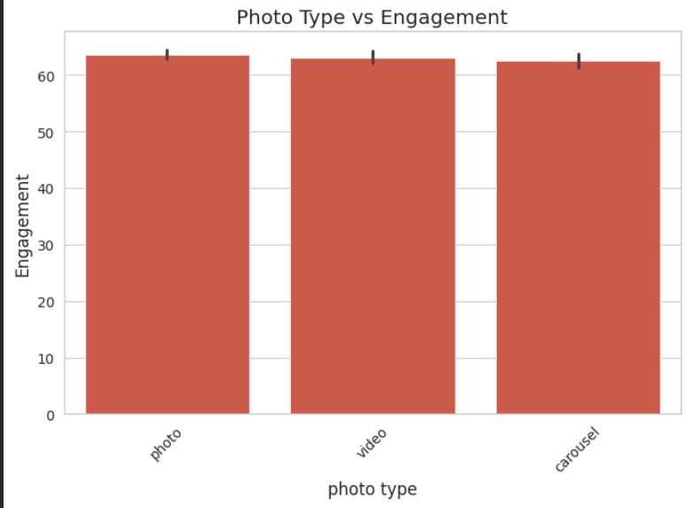
Figure 1: Likes vs Comments scatter plot
The plot shows a broadly positive, though noisy, relationship: most posts cluster between 27-40 likes and 25-35 comments, indicating a fairly consistent baseline engagement across the dataset rather than a small number of viral outliers. A few posts with unusually high likes (around 48) still receive only moderate comment counts, suggesting that likes and comments are driven by overlapping but not identical audience behaviours — liking is a lower-effort action than commenting.

5.2 Photo Type vs Engagement
Average engagement was compared across the three content formats present in the dataset: photo, video, and carousel.
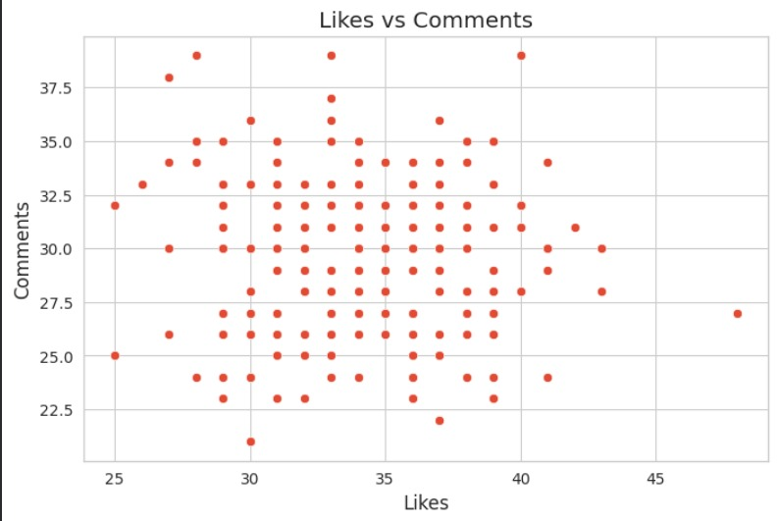
Figure 2: Average engagement by photo type, with error bars showing variability
Static photo posts recorded the highest average engagement (approximately 63.6), narrowly ahead of videos (approximately 63.1) and carousels (approximately 62.5). The overlapping error bars indicate that the difference between formats is small and not strongly decisive, meaning content format alone is not a major lever for engagement in this dataset — captions, filters, and audience reach likely play a larger role.

5.3 Additional Findings
- Posting Time: All posts in the dataset were created at essentially the same hour (08:04), so there was insufficient variation in posting time to determine a genuinely "best" posting hour; the analysis could not draw a reliable conclusion on optimal posting time from this sample.
- Filter Usage: Posts without an Instagram filter recorded marginally higher average engagement (63.50) than filtered posts (63.15) — a small difference suggesting filters have little practical impact on engagement in this sample.
- Top Posts: The top 10 posts by engagement ranged between 72 and 79 combined likes and comments, roughly 15-25% above the dataset average of approximately 63, showing that even the strongest performers do not dramatically outperform the rest of the sample.
- Top Users by Engagement Rate: When engagement is normalised by follower count (engagement rate), a different set of accounts leads the ranking — for example, Meggie_Doyle (rate 0.97) and Jaylan.Lakin (rate 0.95) — showing that smaller accounts can achieve disproportionately high engagement relative to their audience size.

6. Machine Learning Model
To test whether post engagement could be predicted from simple, readily-available metadata, a supervised regression model was built.

6.1 Feature Selection and Target
Three predictor features were selected: Hour (posting hour), Followers (the poster's follower count), and Hashtags (number of hashtags used on the post). The target variable was Engagement (likes + comments).

6.2 Model Choice and Training
A Random Forest Regressor from scikit-learn was chosen for its ability to capture non-linear relationships without requiring feature scaling. The dataset was split into training and test sets using an 80/20 split (test_size = 0.2, random_state = 42 for reproducibility), and the model was trained on the training partition using default hyperparameters.
Parameter | Value
Algorithm | Random Forest Regressor
Input features | Hour, Followers, Hashtags
Target variable | Engagement (Likes + Comments)
Train / Test split | 80% / 20%
Random state | 42

7. Model Evaluation
The trained model was evaluated on the held-out test set using two standard regression metrics: Mean Absolute Error (MAE) and the R-squared (R²) score.
Metric | Value | Interpretation
Mean Absolute Error (MAE) | 3.92 | On average, predictions deviate from actual engagement by about 4 units
R² Score | -0.21 | The model performs worse than simply predicting the average engagement for every post

The negative R² score indicates that posting hour, follower count, and hashtag count together do not provide sufficient signal to accurately predict engagement for this dataset. This is a meaningful finding in itself: it shows that structural metadata alone cannot explain why some posts perform better than others. Two dataset limitations largely explain this result: nearly every post was uploaded within the same hour, which strips the model of any real time-of-day signal, and 257 rows is a relatively small sample for training a robust ensemble model.
To improve predictive performance, future iterations of this model should incorporate richer features such as caption text and sentiment, image content (colours, faces, objects), audience demographics, historical engagement trends of the user, and true variation in posting time across a larger, more diverse dataset.

8. Conclusion
This analysis transformed seven raw relational Instagram tables into a unified, feature-rich dataset and used it to explore the drivers of post engagement. The exploratory analysis showed that likes and comments move together but not in lockstep, that photo posts hold a slight engagement edge over video and carousel formats, and that filter usage has little measurable effect on engagement. Because the dataset lacked variation in posting time, no conclusion could be drawn about an optimal posting hour, and a Random Forest model built on hour, followers, and hashtags alone was unable to predict engagement reliably, underscoring that engagement is shaped by richer factors than simple post metadata.
Overall, the findings suggest that engagement on this platform is relatively evenly distributed across content types and posting conditions, with follower reach and content quality likely playing a larger role than any single structural attribute captured in this dataset. Widening the dataset to include caption text, image features, and a broader spread of posting times would be the most direct path to a more predictive and actionable model.

Recommendations
- Content Format: Prioritise static photo content, which showed the highest average engagement in this sample, while continuing to test video and carousel formats for variety.
- Learn from High Performers: Study top engagement-rate accounts (e.g. Meggie_Doyle, Jaylan.Lakin) to understand what smaller, highly-engaged accounts are doing differently.
- Diversify Posting Times: Collect data across a wider range of posting hours and days to enable a genuine best-time-to-post analysis in future work.
- Enrich the Dataset: Incorporate caption text, image content, and audience demographics as model features to materially improve predictive accuracy.

9. Tools and Technologies Used
Category | Tool / Library | Purpose
Programming Language | Python 3 | Core language for data processing, analysis and modelling
Data Handling | Pandas, NumPy | Loading, cleaning, merging and transforming the relational CSV tables
Data Visualisation | Matplotlib, Seaborn | Building scatter plots, bar charts and statistical visualisations
Machine Learning | Scikit-learn (RandomForestRegressor, train_test_split, metrics) | Building and evaluating the engagement prediction model
Development Environment | Google Colab / Jupyter Notebook | Interactive analysis, iteration and documentation of the workflow
Data Source | Kaggle (Instagram Relational Dataset) | Source of the seven raw CSV tables used in this study

