Wireshark Lab:  802.11 WiFi v8.1  Supplement to Computer Networking: A Top-Down Approach, 8th ed., J.F. Kurose and K.W. Ross  “Tell me and I forget. Show me and I remember. Involve me and I understand.” Chinese proverb  © 2005-2023, J.F Kurose and K.W. Ross, All Rights Reserved | 

In this lab, we’ll investigate the 802.11 wireless network protocol. Before beginning this lab, you might want to re-read Section 7.3 in the text. Since we’ll be delving a bit deeper into 802.11 than is covered in the text, you might want to check out “A Technical Tutorial on the 802.11Protocol,” by Pablo Brenner (Breezecom Communications), http://www.sss-mag.com/pdf/802_11tut.pdf And, of course, there is the “bible” of 802.11 - the 4,379-page standard itself, “ANSI/IEEE Std 802.11-2020,” available here. But we’ve extracted out section 9.2.4.1 from the specification, and added in a handy cheat-sheet for 802.11 Wireshark display filters, here, both of which will be very useful for this lab.

In this lab, we’ll capture a trace from a wireless 802.11 WiFi interface on our computer/laptop. Here are the actions taken, assuming you’re already connected to a WiFi network (which we’ll refer to as your home network), when trace collection starts:
- Make an HTTP request to http://gaia.cs.umass.edu/wireshark-labs/alice.txt
- Make a request to http://www.cs.umass.edu
- Disconnect from your home network
- (optional step) Try to connect to another 802.11 wireless network whose beacon advertisements are being received, and for which you do not have access, and therefore your connection attempt will fail.
- Connect again (successfully) to you home network.

Figure 1 shows the general setup for this 802.11 Wireshark lab.

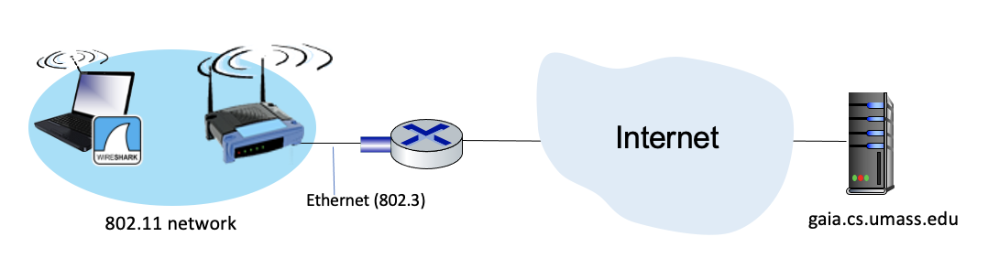
Figure 1: An 802.11 network, connected to a router, connected to the Internet

As usual, we’ve provided a trace file of captured 802.11 frames for you to analyze in case you are not able to take the actions above. If you’re doing this lab as part of a class, your teacher will provide details about how to hand in assignments, whether written or in an LMS. The questions below assume you are analyzing this provided trace (in particular, with respect to access point (AP) names, and timings in the trace). Of course, you’re encouraged to gather your own trace, taking the five actions above, and answering the questions below from your own trace.

1. Getting Started

Let’s take a look at our trace file. This trace was collected using on a computer in the home network of one of the authors, consisting of a Linksys 802.11g combined access point/router, with two wired PCs and one wireless host PC attached to the access point/router. The author is fortunate to have other access points (APs) in neighboring houses available as well, so we’ll see a lot of frames that we’re not interested in for this lab, such as beacon frames advertised by a neighbor’s AP. You’ll find the following wireless host activities in the trace file:
- The host is already associated with the 30 Munroe St AP when the trace begins.
- At t = 24.8282, the host makes an HTTP request to http://gaia.cs.umass.edu/wireshark-labs/alice.txt. The IP address of gaia.cs.umass.edu is 128.119.245.12.
- At t=32.8259, the host makes an HTTP request to http://www.cs.umass.edu, whose IP address is 128.119.240.19.
- At t = 49.5836, the host disconnects from the 30 Munroe St AP by issuing a DHCP Release message.
- At t=63.0592 the host associates again with the 30 Munroe St AP.

Once you have downloaded the trace, you can load it into Wireshark and view the trace using the File pull down menu, choosing Open, and then selecting the Wireshark_801_11.pcapng trace file. The resulting display should look like Figure 2.

There are lots of captured frames in this trace, so we’ll use display filters to display just selected types of frames as we analyze this trace. A handy reference for Wireshark Display filters for 802.11 frames is at http://gaia.cs.umass.edu/wireshark-labs/wireshark_802.11_filters_-_reference_sheet.pdf.

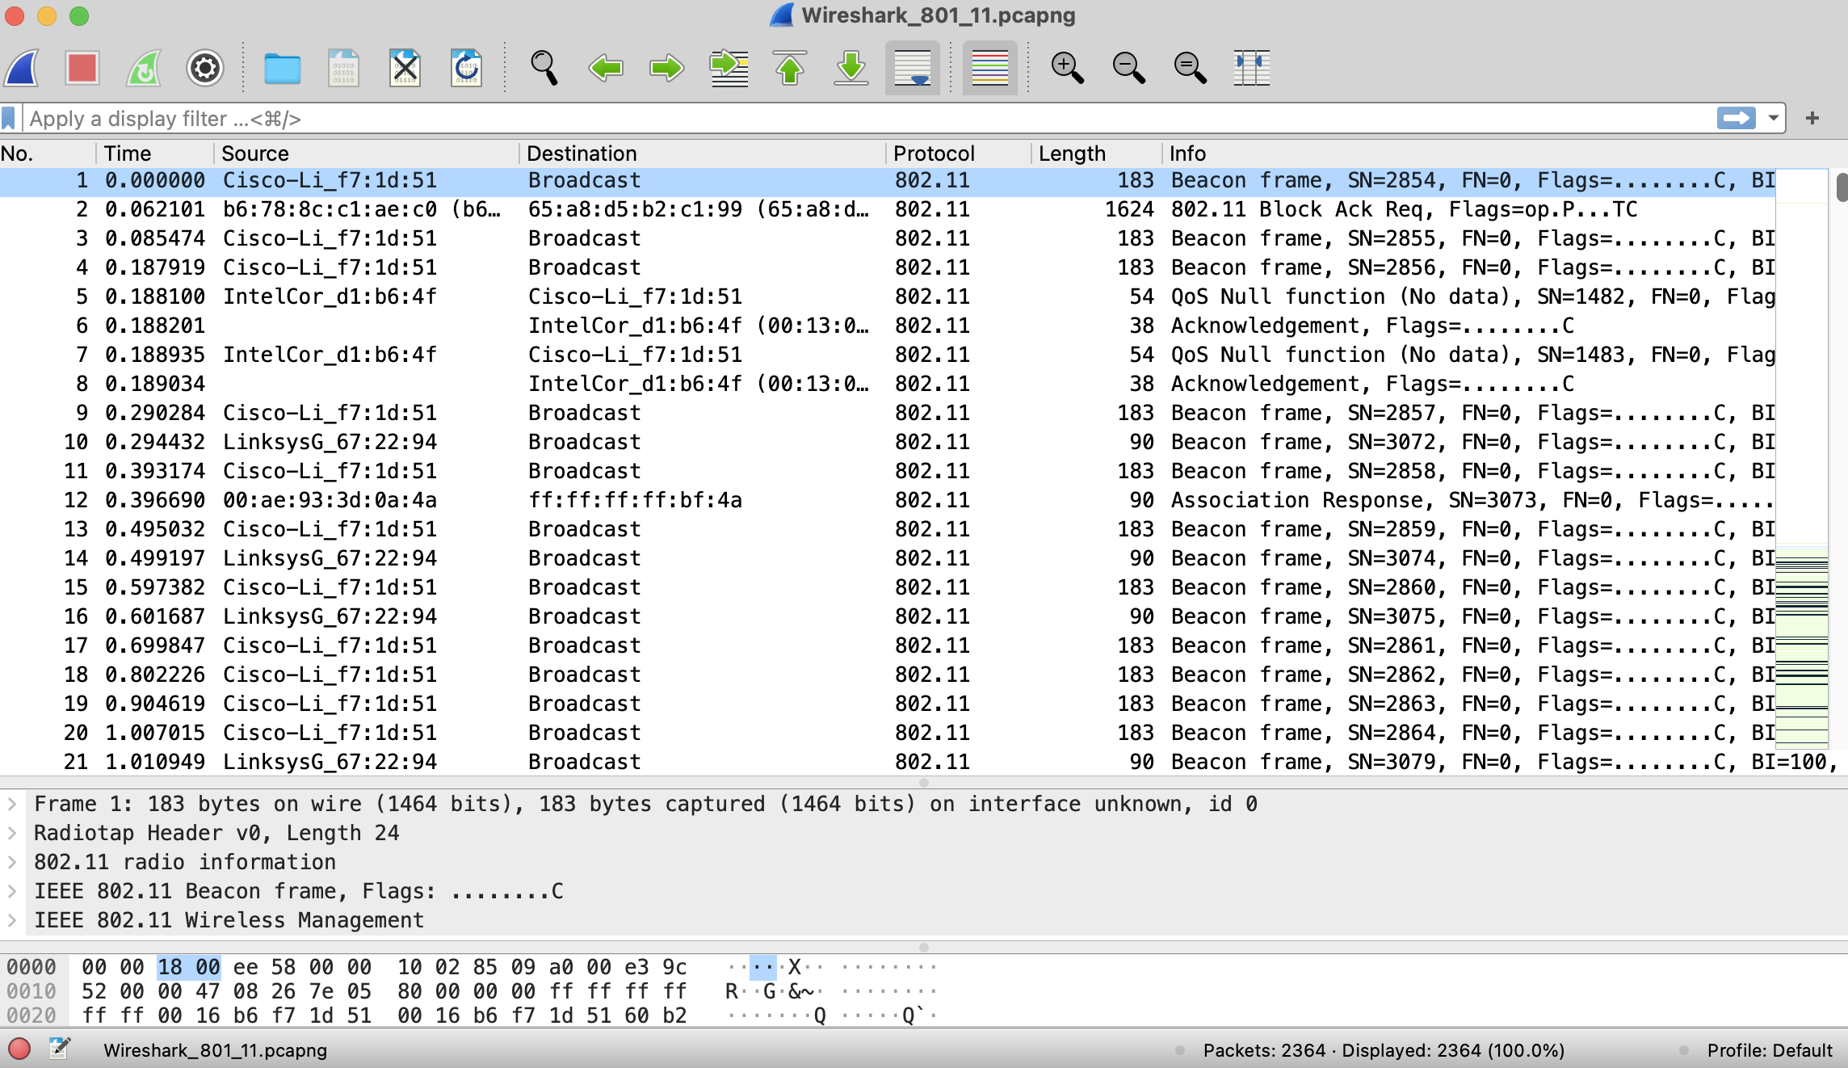

Figure 2: Wireshark window, after opening the Wireshark_801_11.pcapng file

2. Beacon Frames

First, let’s take a look at 802.11 beacon frames. Recall that beacon frames are used by an 802.11 AP to advertise its existence. Let’s use our 802.11 filter cheat-sheet (here): enter wlan.fc.type_subtype == 8 into Wireshark’s display filter window, so that Wireshark only displays beacon frames (which have an 802.11 subtype of 8). Your Wireshark window should look similar to Figure 3.

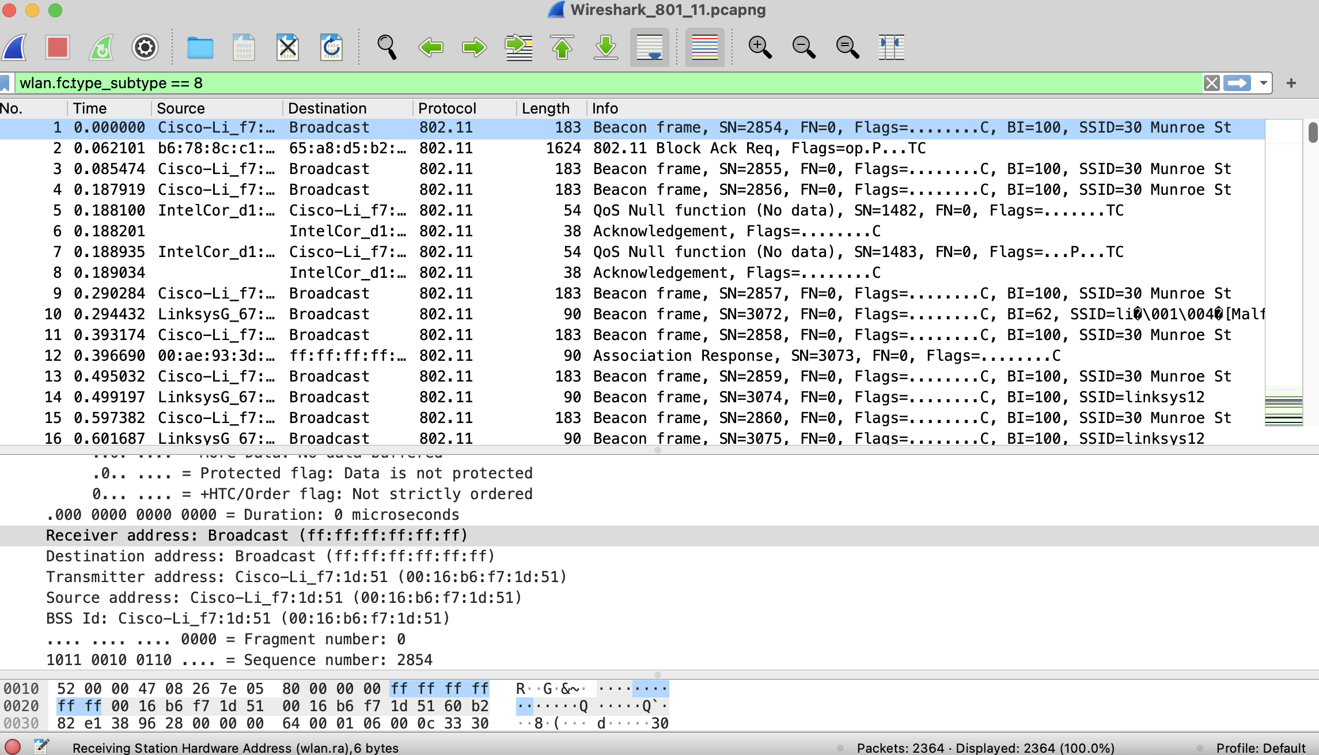

Figure3: Wireshark window, showing beacon frames

To answer some of the questions below, you’ll want to look at the details in the Info field in the rightmost column of the Wireshark display; to answer other questions you’ll need to dig into the “802.11 Protocol” frame and subfields in the middle Wireshark window.

- What are the SSIDs of the two access points that are issuing most of the beacon frames in this trace? [Hint: look at the Info field. To display only beacon frames, neter wlan.fc.type_subtype == 8 into the Wireshark display filter].

ANS:
Tag: SSID parameter set: "30 Munroe St" Source: CiscoLinksys_f7:1d:51
Tag: SSID parameter set: "linksys12" Source: LinksysGroup_67:22:94

- What 802.11 channel is being used by both of these access points [Hint: you’ll need to dig into the radio information in an 802.11 beacon frame]

ANS:
Channel: 6
Channel: 6

Now let’s take a look at the beacon frame sent at t=0.085474.

- What is the interval of time between the transmissions of beacon frames from this access point (AP)? (Hint: this interval of time is contained in a field within the beacon frame itself).

ANS:
Beacon Interval: 0.102400 [Seconds]
- What (in hexadecimal notation) is the source MAC address on the beacon frame from this access point? Recall from Figure 7.13 in the text that the source, destination, and BSS are three addresses used in an 802.11 frame. For a detailed discussion of the 802.11 frame structure, see section 9.2.3-9.2.4.1in the IEEE 802.11 standards document, excerpted here.

ANS:
Source address: CiscoLinksys_f7:1d:51 (00:16:b6:f7:1d:51)

- What (in hexadecimal notation) is the destination MAC address on the beacon frame from 30 Munroe St??

ANS:
Destination address: Broadcast (ff:ff:ff:ff:ff:ff)

- What (in hexadecimal notation) is the MAC BSS ID on the beacon frame from 30 Munroe St?

ANS:
BSS Id: CiscoLinksys_f7:1d:51 (00:16:b6:f7:1d:51)

- The beacon frames from the 30 Munroe St access point advertise that the access point can support four data rates and eight additional “extended supported rates.” What are these rates? [Note: the traces were taken on a rather old AP].

ANS:
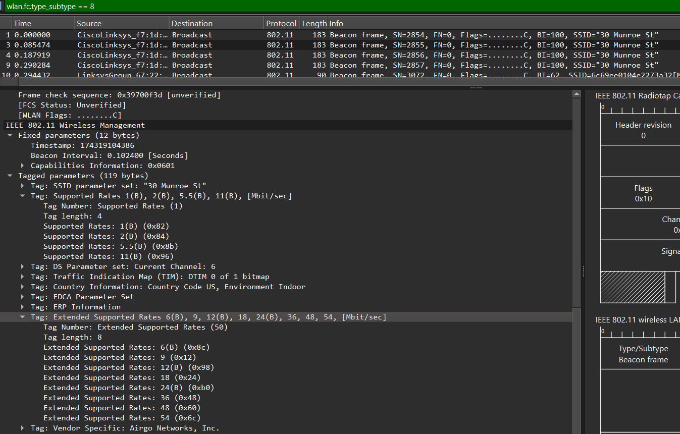

Tag: Supported Rates 1(B), 2(B), 5.5(B), 11(B), [Mbit/sec]
Tag Number: Supported Rates (1)
Tag length: 4
Supported Rates: 1(B) (0x82)
Supported Rates: 2(B) (0x84)
Supported Rates: 5.5(B) (0x8b)
Supported Rates: 11(B) (0x96)

Tag: Extended Supported Rates 6(B), 9, 12(B), 18, 24(B), 36, 48, 54, [Mbit/sec]
Tag Number: Extended Supported Rates (50)
Tag length: 8
Extended Supported Rates: 6(B) (0x8c)
Extended Supported Rates: 9 (0x12)
Extended Supported Rates: 12(B) (0x98)
Extended Supported Rates: 18 (0x24)
Extended Supported Rates: 24(B) (0xb0)
Extended Supported Rates: 36 (0x48)
Extended Supported Rates: 48 (0x60)
Extended Supported Rates: 54 (0x6c)

3. Data Transfer

Since the trace starts with the host already associated with the AP, let’s next look at data transfer over an 802.11 association before looking at AP association/disassociation. Recall that in this trace, at t = 24.82, the host makes an HTTP request to http://gaia.cs.umass.edu/wireshark-labs/alice.txt. The IP address of gaia.cs.umass.edu is 128.119.245.12. Then, at t=32.82, the host makes an HTTP request to http://www.cs.umass.edu.

- Find the 802.11 frame containing the SYN TCP segment for this first TCP session (that downloads alice.txt) at t=24.8110. What are three MAC address fields in the 802.11 frame? Which MAC address in this frame corresponds to the wireless host (give the hexadecimal representation of the MAC address for the host)? To the access point? To the first-hop router? What is the IP address of the wireless host sending this TCP segment? What is the destination IP address for the TCP syn segment?

ANS:
Destination address: CiscoLinksys_f4:eb:a8 (00:16:b6:f4:eb:a8)
Source address: Intel_d1:b6:4f (00:13:02:d1:b6:4f)
BSS Id: CiscoLinksys_f7:1d:51 (00:16:b6:f7:1d:51)

The source MAC address corresponds to the wireless device sending the SYN packet.

Access point: BSSID.: CiscoLinksys_f7:1d:51 (00:16:b6:f7:1d:51)

Source Address: 192.168.1.109
Destination Address: 128.119.245.12

- Does the destination IP address of this TCP SYN correspond to the host, access point, first-hop router, or the destination web server?

ANS:
Destination web server.

- Find the 802.11 frame containing the SYNACK segment for this TCP session received at t=24.8277 What are three MAC address fields in the 802.11 frame? Which MAC address in this frame corresponds to the host? To the access point? To the first-hop router? Does the sender MAC address in the frame correspond to the IP address of the device that sent the TCP segment encapsulated within this datagram? (Hint: review Figure 6.19 in the text if you are unsure of how to answer this question, or the corresponding part of the previous question. It’s particularly important that you understand this).

ANS:
Destination address: 91:2a:b0:49:b6:4f (91:2a:b0:49:b6:4f)
Source address: CiscoLinksys_f4:eb:a8 (00:16:b6:f4:eb:a8)
BSS Id: CiscoLinksys_f7:1d:51 (00:16:b6:f7:1d:51)

Destination MAC address in this frame corresponds to the host.

Access point: source MAC address.

First hop: 91:2a:b0:49:b6:4f (91:2a:b0:49:b6:4f)

3. Disassociation/Authentication/Association

Recall from Section 7.3.1 in the text that a host must first associate with an access point before sending data. Association in 802.11 is performed using the ASSOCIATE REQUEST frame (sent from host to AP, with a frame type 0 and subtype 0, see Section 7.3.3 in the text) and the ASSOCIATE RESPONSE frame (sent by the AP to a host with a frame type 0 and subtype of 1, in response to a received ASSOCIATE REQUEST). And before an association is performed, the host and AP must agree on the form that authentication that will be used when the host associated with the AP; this agreement is done using the AUTHENTICATION frame.

Recall that our trace began with our host already associated with an access point. Around t=49 the host disassociates from the access point, waits a bit, and then again re-authenticates and re-associates with the access point

- What two actions are taken (i.e., frames are sent) by the host in the trace just after t=49, to end the association with the 30 Munroe St AP that was initially in place when trace collection began? (Hint: one is an IP-layer action, and one is an 802.11-layer action).

ANS:

IP – layer action

1733 49.583615 192.168.1.109 192.168.1.1 DHCP 390 DHCP Release - Transaction ID 0xea5a526

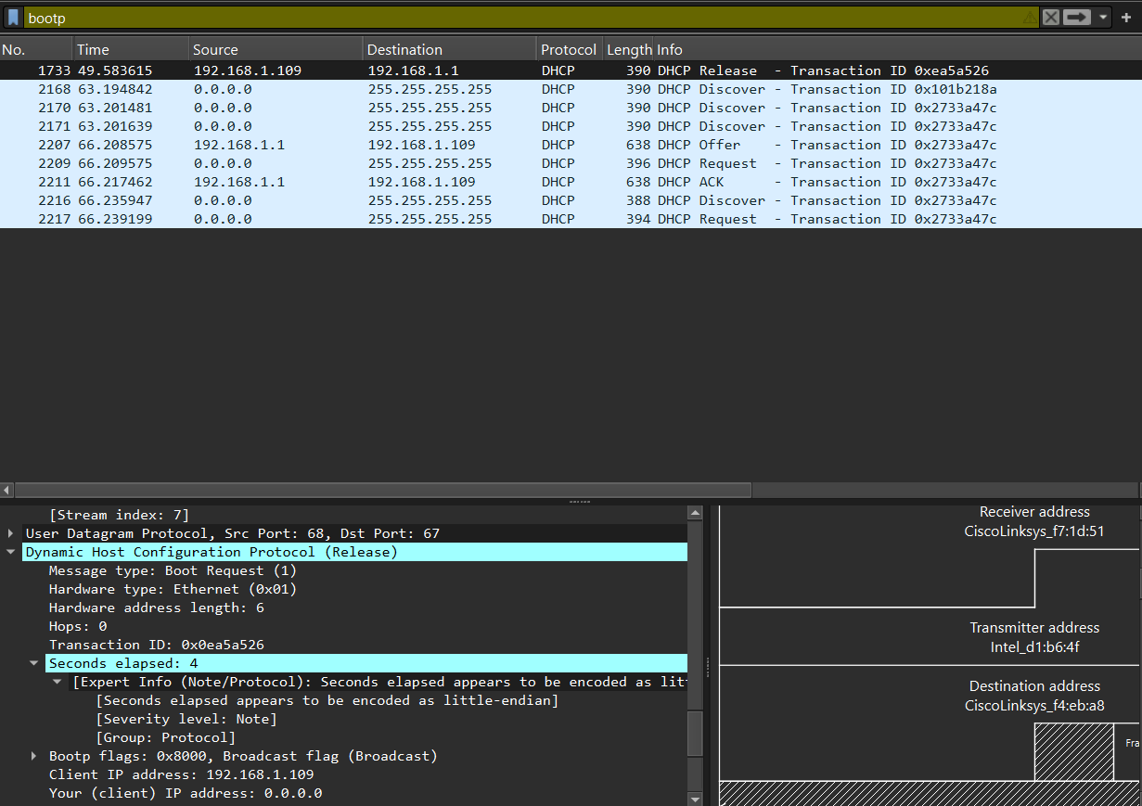

DHCP – release

802.11-layer action

1735 49.609617 Intel_d1:b6:4f CiscoLinksys_f7:1d:51 802.11 54 Deauthentication, SN=1605, FN=0, Flags=........C

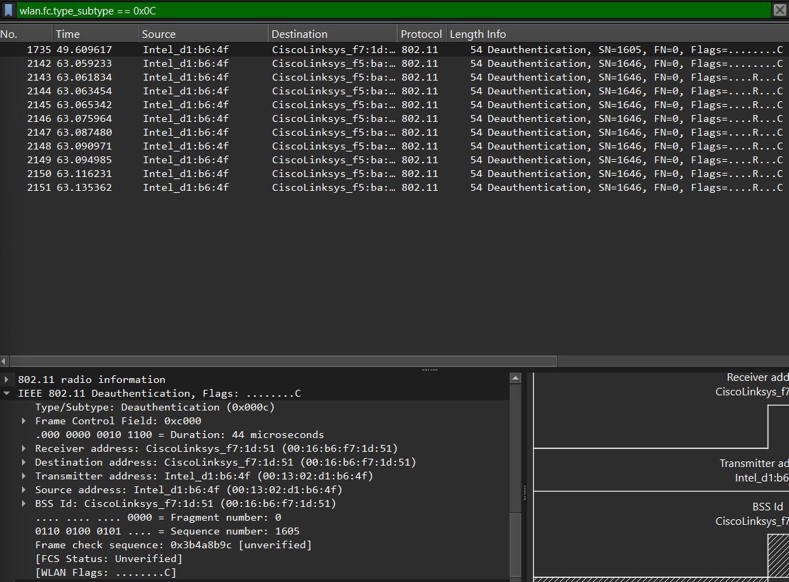
IEEE 802.11 Deauthentication, Flags: ........C
Type/Subtype: Deauthentication (0x000c)

Now let’s look at the process of authenticating and associating with an access point. We’ll look at four specific frames captured at the times shown in Figure 4.

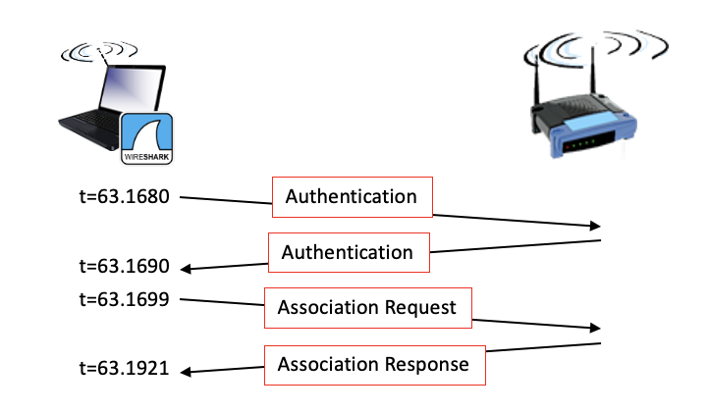
Figure 4: Authentication and Association

- Let’s look first at AUTHENTICATION frames. At t = 63.1680, our host tries to associate with the 30 Munroe St AP. Use the Wireshark display filter wlan.fc.subtype == 11 to show AUTHENICATION frames sent from the host to and AP and vice versa. What form of authentication is the host requesting?

ANS:
Authentication Algorithm: Open System (0)

- What is the Authentication SEQ value (authentication sequence number) of this authentication frame from host to AP?

ANS:
Authentication SEQ: 0x0001

- The AP response to the authentication request is received at t = 63.1690. Has the AP accepted the form of authentication requested by the host?

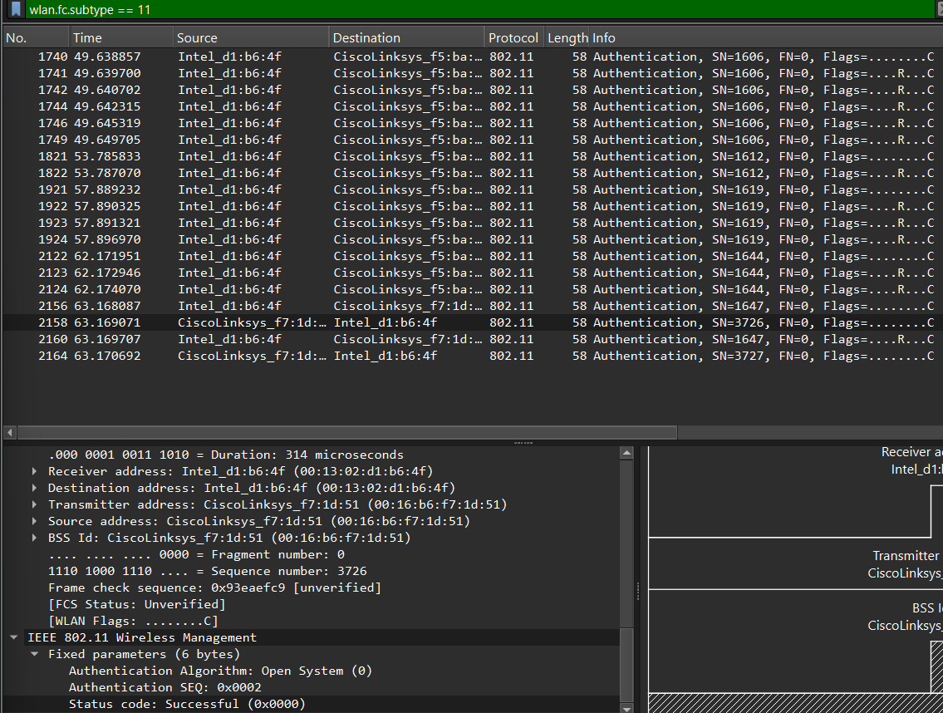
Status code: Successful (0x0000)

- What is the Authentication SEQ value of this authentication frame from AP to Host?

ANS:
Authentication SEQ: 0x0002

Now let’s look at the ASSOCIATION REQUEST sent at t = 63.1699 and ASSOCIATION RESPONSE received at t = 63.1921. Note that you can use the filter expression wlan.fc.subtype < 2 and wlan.fc.type == 0 to display ASSOCIATION REQUEST and RESPONSE frames.
- What rates are indicated in the frame as SUPPORTED RATES. Do not include in your answers below any rates that are indicates as EXTENDED SUPPORTE RATES.

ANS:
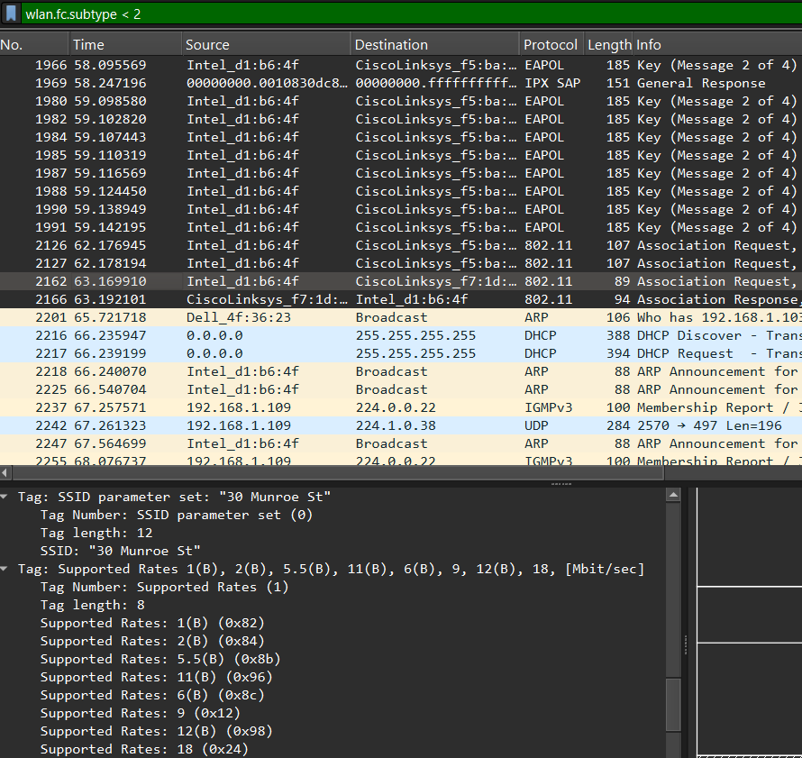

Tag: Supported Rates 1(B), 2(B), 5.5(B), 11(B), 6(B), 9, 12(B), 18, [Mbit/sec]
Tag Number: Supported Rates (1)
Tag length: 8
Supported Rates: 1(B) (0x82)
Supported Rates: 2(B) (0x84)
Supported Rates: 5.5(B) (0x8b)
Supported Rates: 11(B) (0x96)
Supported Rates: 6(B) (0x8c)
Supported Rates: 9 (0x12)
Supported Rates: 12(B) (0x98)
Supported Rates: 18 (0x24)

- Does the ASSOCIATION RESPONSE indicate a Successful or Unsuccessful association response?

ANS:
Status code: Successful (0x0000)

- Does the fastest (largest) Extended Supported Rate the host has offered match the fastest (largest) Extended Supported Rate the AP is able to provide?

ANS:

Extended Supported Rate of the host:
Tag: Extended Supported Rates 24(B), 36, 48, 54, [Mbit/sec]
Tag Number: Extended Supported Rates (50)
Tag length: 4
Extended Supported Rates: 24(B) (0xb0)
Extended Supported Rates: 36 (0x48)
Extended Supported Rates: 48 (0x60)
Extended Supported Rates: 54 (0x6c)

Extended Supported Rate the AP:
Tag: Extended Supported Rates 6(B), 9, 12(B), 18, 24(B), 36, 48, 54, [Mbit/sec]
Tag Number: Extended Supported Rates (50)
Tag length: 8
Extended Supported Rates: 6(B) (0x8c)
Extended Supported Rates: 9 (0x12)
Extended Supported Rates: 12(B) (0x98)
Extended Supported Rates: 18 (0x24)
Extended Supported Rates: 24(B) (0xb0)
Extended Supported Rates: 36 (0x48)
Extended Supported Rates: 48 (0x60)
Extended Supported Rates: 54 (0x6c)

Therefore, the fastest (largest) Extended Supported Rate the host has offered matches the fastest (largest) Extended Supported Rate the AP is able to provide.

References to figures and sections are for the 8th edition of our text, Computer Networks, A Top-down Approach, 8^{h} ed., J.F. Kurose and K.W. Ross, Addison-Wesley/Pearson, 2020. Our authors’ website for this book is http://gaia.cs.umass.edu/kurose_ross You’ll find lots of interesting open material there..
If you’re unable to run Wireshark on a live network connection, you can download the zip file http://gaia.cs.umass.edu/wireshark-labs/wireshark-traces-8.1.zip and extract the trace file Wireshark_801_11.pcapng.
For the author’s class, when answering the following questions with hand-in assignments, students print out the GET and response messages (see the introductory Wireshark lab for an explanation of how to do this) and indicate where in the message they’ve found the information that answers a question. They do this by marking paper copies with a pen or annotating electronic copies with text in a colored font. There are LMS modules for teachers that allow students to answer these questions online and have answers auto-graded for these Wireshark labs at http://gaia.cs.umass.edu/kurose_ross/lms.htm

