Occupational Health Referral Analytics
Chinmayee Surwade | Independent portfolio project | 6 October 2026

Business problem
A fictional occupational health provider serves four employers. Operations wants to find delayed appointments, missing reports and no-shows without exposing individual medical information. This project connects a synthetic referral API to reporting data and defines consistent BI measures. No professional healthcare delivery or real stakeholder meeting is claimed.

Architecture
Paginated local REST API → Python validation and rejection log → PostgreSQL reporting views → Apache Superset and Power BI. DBeaver supports SQL inspection. A SQLite route allows API and pipeline checks without Docker. The project is a code-and-delivery portfolio; native BI setup awaits local execution.

Executed results
1,203 records received; 1,200 accepted; 3 rejected. Open backlog: 486; overdue reports: 90; no-show rate: 14.55%; mean wait: 10.81 calendar days; mean issued-report turnaround: 5.92 days. Synthetic snapshot only; not business improvements.
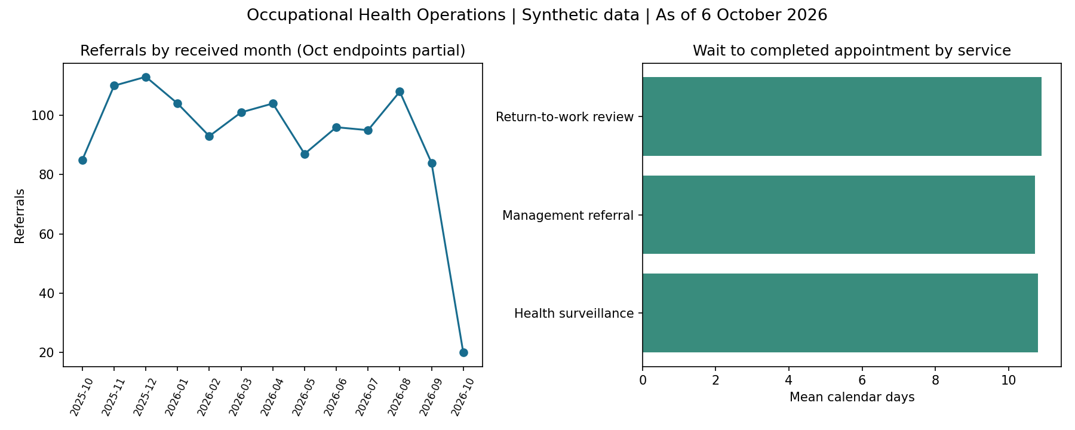
Python-generated preview from executed data. This is not a Superset or Power BI screenshot.

Metric contract
One row represents one referral and its current appointment outcome. Backlog is non-cancelled referrals with no issued report. Overdue means completed but not reported, strictly more than 5 calendar days after completion. No-show rate uses completed + no-show appointments as denominator. Average wait uses completed appointments only; average report turnaround uses issued reports only. Receipt-date filters select a referral cohort, not a historical backlog date. Fixed snapshot is 6 October 2026.

Requirements and acceptance
Requirements.csv lists eight requirements and UAT.csv links each acceptance test. Source_to_Target.csv documents nested JSON mappings. Same employer, service and received-date filters must be applied when comparing tools. Operational views omit employee identifiers; real tenant isolation and clinical security are outside this demo.

Discovery questions and simulated decisions
Ask operations: when is a referral considered closed? Ask clinicians: calendar or working-day turnaround? Ask IT: what authentication, pagination and update contract exists? Ask employers: which aggregated views are needed? Assumed decisions: report issuance closes referrals; cancelled referrals excluded from backlog; 5 calendar days is the local demo threshold; source contains current status only. These are authored assumptions, not actual meeting notes.

Two-sprint Agile delivery
Sprint 1: refine definitions, build API ingestion, validate records and create SQL model. Sprint 2: create native dashboards, reconcile totals, run client walkthrough and UAT. Import Jira_Import.csv, map Issue Type/Summary/Description/Priority/Labels, assign owners and acceptance evidence. Definition of done: reviewed code, metric agreement, SQL/BI reconciliation, passing relevant tests and documented limitations. Jira import and ceremonies have not been performed.

SPOC and competing priorities
Example simulation: operations requests an overdue report list while an employer requests a monthly dashboard. Prioritise the report backlog because it affects current service delivery; confirm scope and date with both owners; log dependency on API completion; give a delivery estimate and daily update. If report counts differ, compare snapshot, filters, grain, duplicates, null handling and refresh order before changing the metric.

Change request example
If the client changes the SLA to working days, do not simply change 5 to another number. Add a calendar/holiday table and jurisdiction assumptions, revise SQL and DAX consistently, assess historical results and retest the boundary cases. Log the change and obtain metric-owner acceptance before publishing.

Validation and handover
Executed: bearer authentication, pagination, quarantine, duplicate-free reruns, 503 retries and failure atomicity through API/SQLite. PostgreSQL, Docker, native Superset and Power BI were not run in this build environment. Complete U06–U11 locally, save screenshots and record actual results. Do not mark those tests passed based on the Python preview. The test suite verifies API/pipeline behavior; native BI and access checks remain separate.

Interview explanation
I built an independent occupational health analytics project using synthetic data. I fetched paginated JSON through a REST API, flattened and validated it in Python, quarantined bad records and checked duplicate-free loads. I prepared PostgreSQL reporting views and shared metric definitions for Superset and Power BI. I can explain the data-quality checks and demonstrate the tested pipeline; native dashboard experience should be claimed after completing the local setup.

Learning route
Start with the Python-only route and explain the rejection log. Next connect PostgreSQL through DBeaver, inspect SQL and run EXPLAIN. Then create Superset charts and Power BI measures using the same reporting view. Finally run a peer walkthrough, complete UAT and export dashboard evidence. Sources and exact commands are in README.md and BI_Setup.md.

