**Day 5**

**Tool Used**

**Wireshark** : Wireshark is used to capture and analyze real-time network traffic at a microscopic level.

**Process :-**

* Open wireshark.
* Select your network type (e.g., ethernet/wifi).
* Start monitoring by clicking blue icon in the top menu.
* Simultaneously, open browser and run one website.

(e.g., [www.flipkart.com](http://www.flipkart.com), [www.google.com](http://www.google.com))

* After a minute, press the red button to stop the packet capturing.
* HTTP :

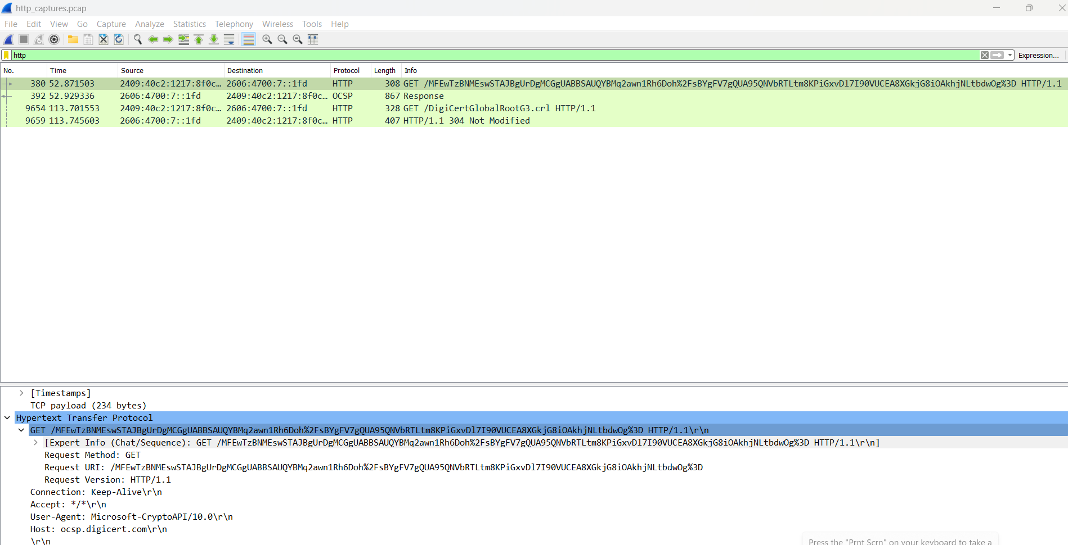

* DNS

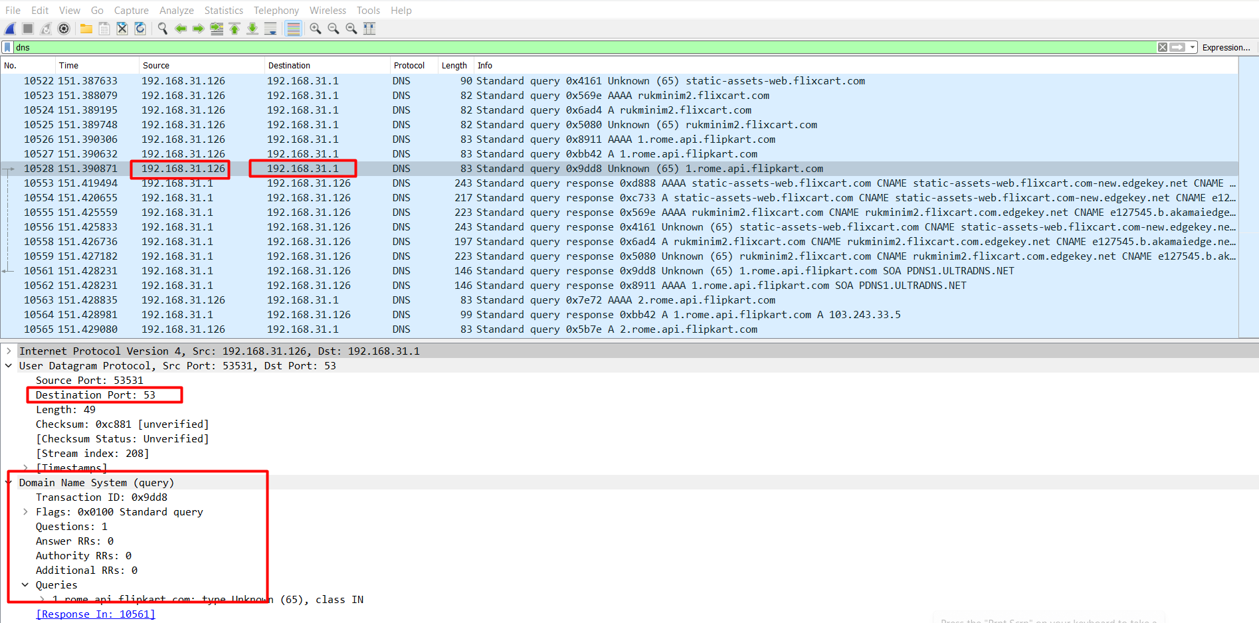

* TCP

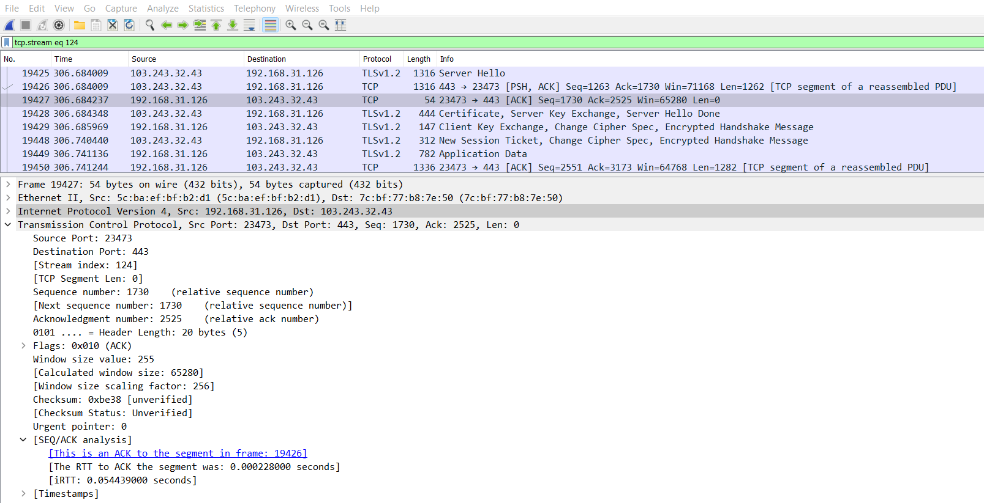

| **Protocol** | **Port(s)** | **Example Packet Info** | **Purpose/Description** |
| --- | --- | --- | --- |
| DNS | 53 | Src: 192.168._._,  Dst: 192.168.31.1 | Resolves domain names to IP addresses. |
| HTTP | 80 | Src: 192.168._._,  Dst: 192.168._,_ | Transfers unencrypted web data between client/server. |
| TCP | Many | Src: 192.168._._,  Dst: 103.243.32.43 | Transport protocol, ensures reliable delivery. |