**Day 7**

**Tool Used :-**

* **Google Chrome**

**Objective :-**

* **Learn to spot and remove potentially harmful browser extensions.**

**Screenshots :-**

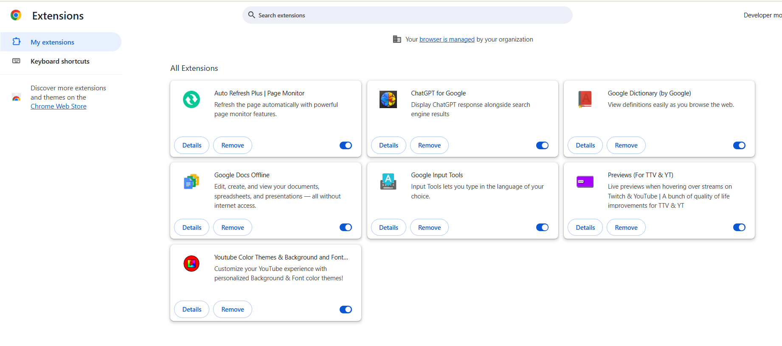

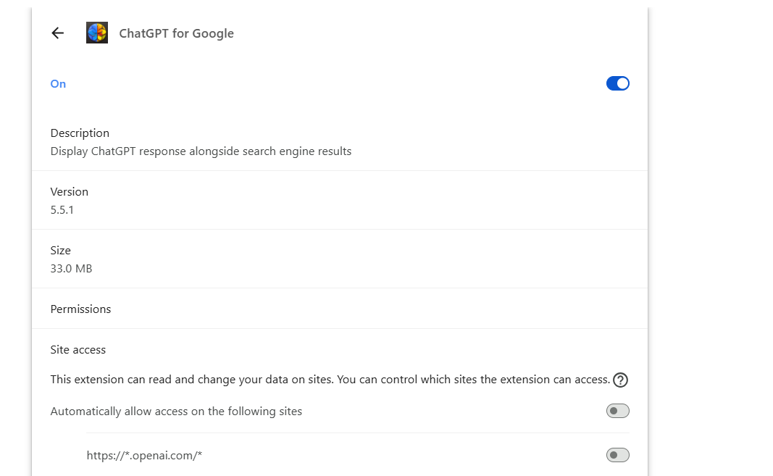

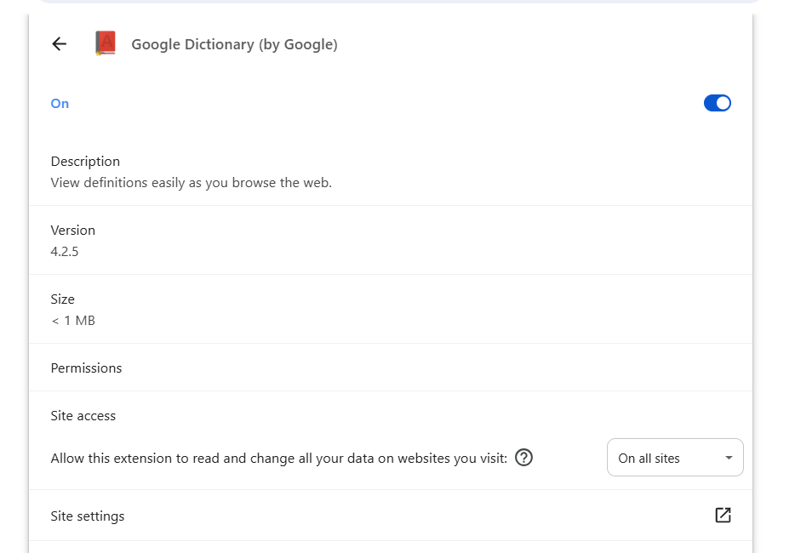

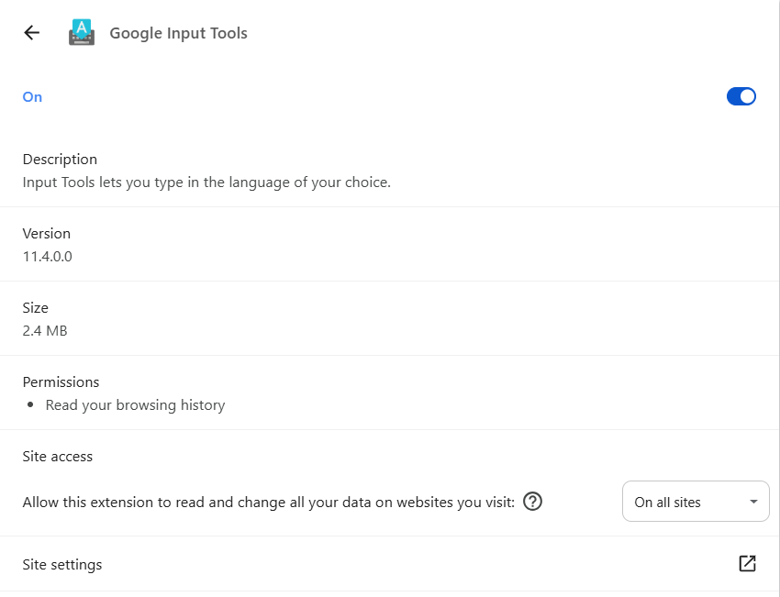

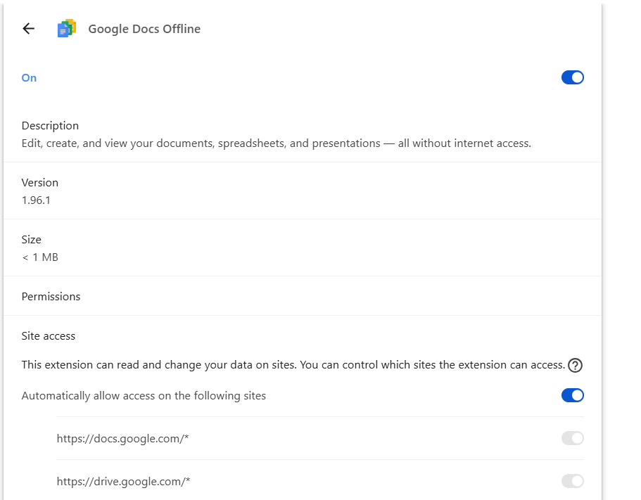

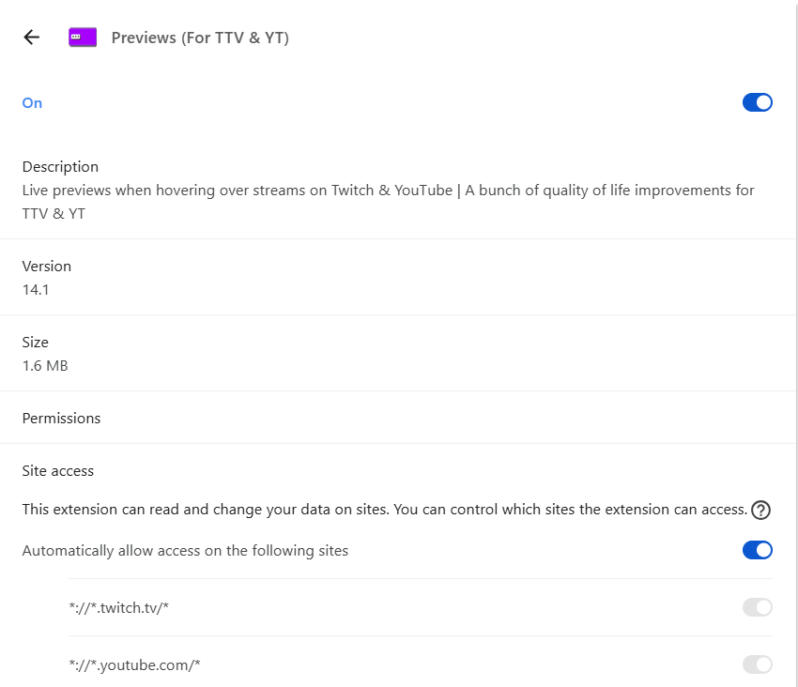

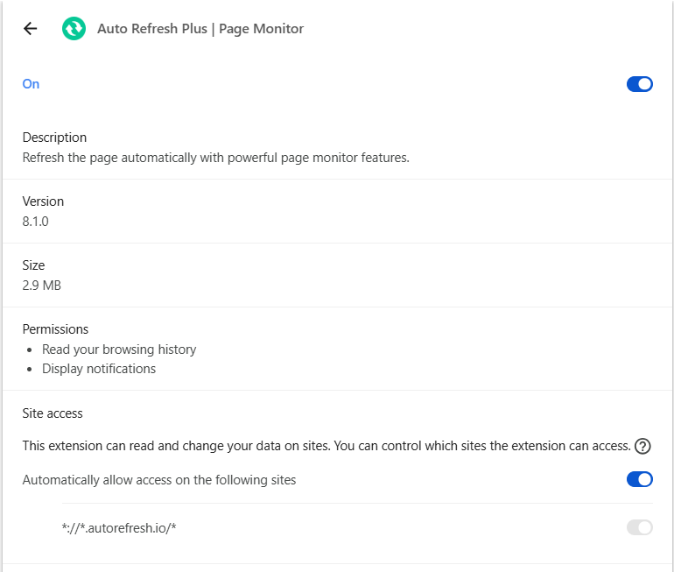

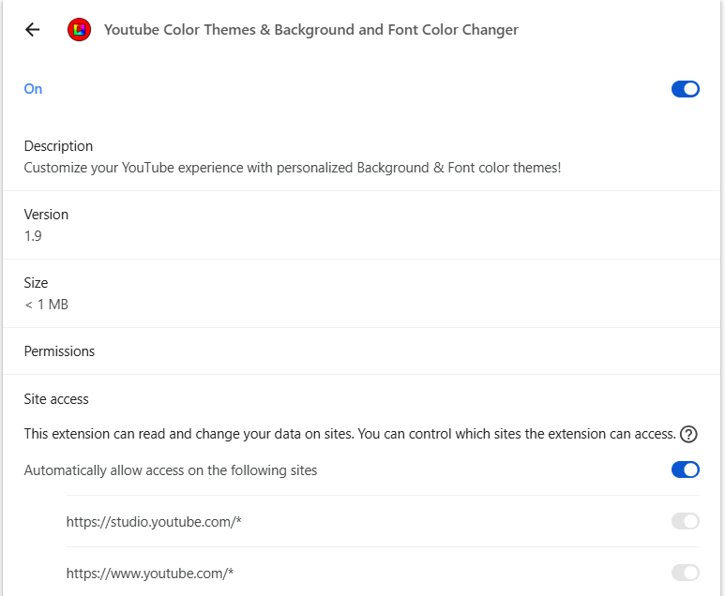

**Extensions and their Uses :-**

* **ChatGPT for Google :-**

The "ChatGPT for Google" add-on shows answers generated by ChatGPT's AI naturally in line with search results on pages of Google and other supported search engines, including Bing and DuckDuckGo, to expand a user's search and deliver a more nuanced experience.

* **Google Dictionary :-**

The Google Dictionary extension enables double-click word definition, pronunciation, and origin to appear in a pop-up bubble or click on the extension icon in the toolbar to see the full definition while web browsing. In addition to those functionality, Google Dictionary offers history for words you looked up, automatic translation of foreign words, and it supports multiple languages. All of which make it an excellent tool for students, professionals, and language learners alike, to have a better understanding of words and to expand their vocabularies.

* **Google Input Tools :-**

The Google Input Tools Chrome OS extension allows you to type in the language of your choice while using Chrome OS. The main distinctions between the two Chrome extensions which Google Input Tools offers - one as an application to be installed, and the other as a Chrome OS extension, are: Feature. Chrome extension. Chrome OS extension.

* **Google Docs Offline :-**

The Google Docs Offline extension allows you to create, edit, and comment on Google Docs, Sheets, and Slides files when you do not have an internet connection by using browsers like Chrome and Microsoft Edge. It allows offline use of Google Workspace files by making them accessible on your device, and it will sync any changes back to Google Drive when the device comes back online.

* **Previews :-**

A "Previews extension" is a broad term for a browser add-on that can show pre-rendered or summarized content when you hover over a link or an image. With this type of extension, you get a snapshot of the linked content without requiring you to click away.

* **Auto Refresh Plus :-**

Auto Refresh Plus is a browser extension for Google Chrome and other browsers that refreshes webpages and tab automatically at intervals selected by the user, allowing the user to stay current with dynamic/basic content, monitor content for changes, or just visit a webpage without having to refresh manually.

* **YouTube Color :-**

A YouTube color extension, like Theme & Color Changer for Youtube™ or Customizer YouTube™, allows users to customize their YouTube experience by altering the color theme of the YouTube website. These extensions typically come with a few options: custom color schemes, presets, changing the colors of background or font elements, including background images, and applying borders. Some even offer ad blocking.

**Extensions which I removed :-**

* YouTube Color
* Auto Refresh Plus
* Previews

I am not using this extensions. That’s why I removed it.

**These are some Malicious Extensions on Chrome Web Store :-**

