**Day 8**

**Tool Used :-**

* **Proton VPN**

**Objective :-**

* **Understand the role of VPNs in protecting privacy and secure communication.**

**Screenshots :-**

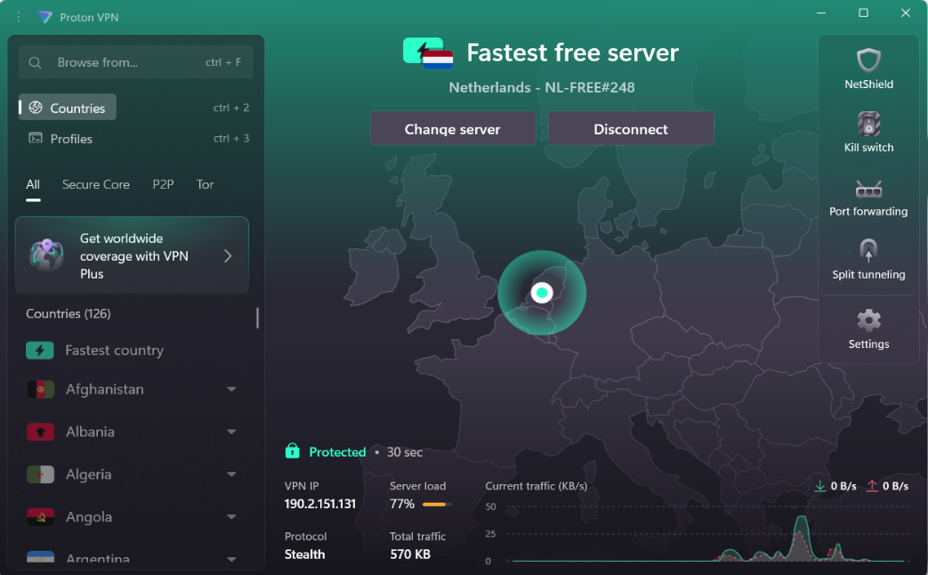

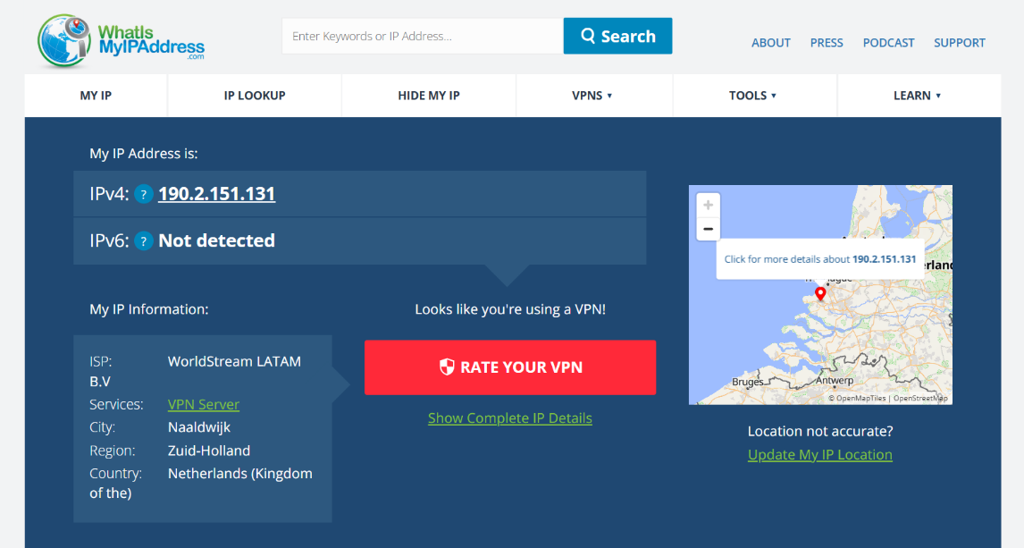

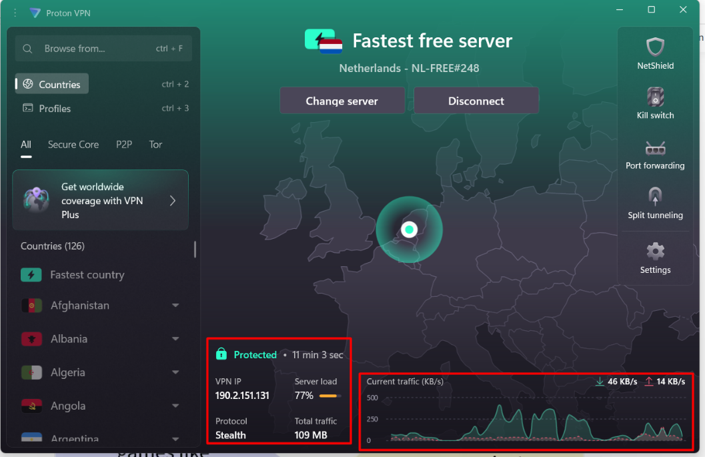

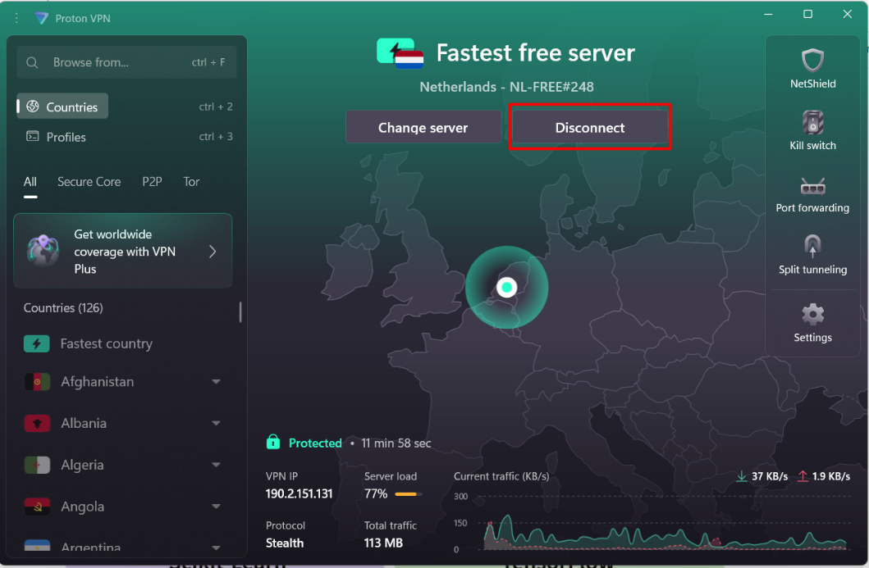

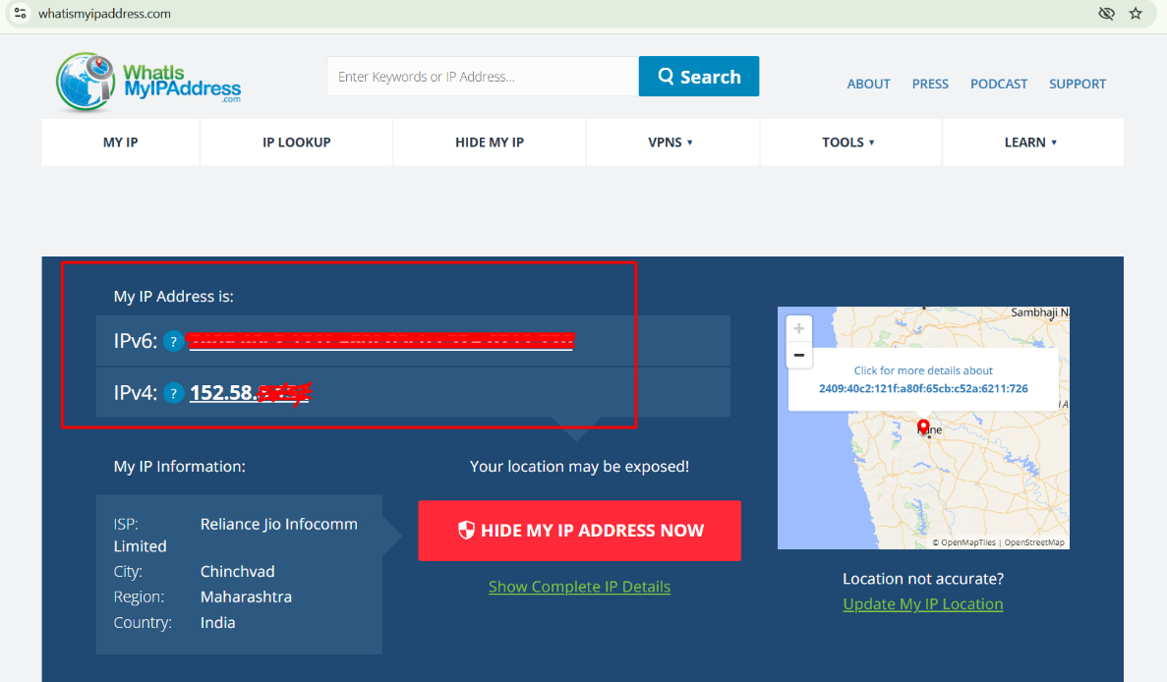

**Encryption and Privacy Features :-**

* **Proton VPN:**

Employs strong AES-256 and ChaCha20 encryption, VPN protocols such as OpenVPN and WireGuard, and their own Stealth protocol, all of which provide privacy against even the most sophisticated attacks.

Has a secure “no-logs” policy that is independently audited, as well as a kill switch which blocks internet access should the VPN connection drop.

**Benefits and Limitation :-**

* **Benefits :**

1. Encrypt all internet traffic, protecting data from hackers on public Wi-Fi and ISPs.security
2. Hide real IP addresses, masking identity and enabling bypassing geo-blocks.protonvpn+1
3. Provide tools for safer torrenting, streaming, and private browsing.security+1

* **Limitations :**

1. Free VPN tiers may have data caps (Windscribe: 10GB/month) or limited server locations (ProtonVPN: 5 free countries).protonvpn+1
2. Potential speed reduction due to routing traffic through remote servers.security
3. Not all websites/services are guaranteed to work as intended (some may block VPN traffic), and VPNs cannot protect from endpoint malware or phishing attacks.security