**Project Final Report**

# **Executive Summary**

* The project is a sensor hub system using Leopard Gecko board integrated with application ranging from digital Compass using magnetometer, metal detection using LC Sensor to ambient light, sensor temperature notification with alter of proximity of objects. It is an amalgamation of different sensors having variant applications to be operated in low power with Alert Points set in EEPROM emulated on flash.

# **Sensors Integrated**

* To integrate following sensors creating a monitoring hub

# **Internal Sensors**

* + Inductive Sensor
  + Temperature Sensor
  + Ambient Light Sensor (Not Combined with LC ),separately working

# **External Sensors**

* + Magnetometer –GY 271 HMC5883L
  + Proximity Sensor

# **Implemented**

# **External Sensors**

* + Magnetometer –GY 271 HMC5883L was implemented by using an I2C interface .I have tried to capture X-axis, Y-axis and Z-axis from registers of this sensors. It operation is set in Single mode to capture values after four seconds in Timer interrupt .It provides two’s compliment values in two 8 bit registers MSB and LSB for each axis . These values have been converted from -180 deg to +180 deg for each of the axis and displayed in following format:
  + **X: +XXX,+YYY,+ZZZ** or **X: -XXX,-YYY,-ZZZ .** The – values are displayed correctly and set correctly.
  + Proximity Sensor –Si110EK was implemented using a Interrupt based interface when an object is detected ,a GPIO pin is pulled low and an Alert popped to mobile application such as “Intruder Alert”

# **Internal Sensors**

* + Temperature Sensor – It is an on board sensor, to capture ambient temperature which is converted to human readable value using ADCs and floating conversion. This project implementation adds setting of Alert points for this sensor.
  + LC Sensor – It is an on board sensor, to detect proximity of a metal object. A calibration has been done initially where a threshold has been set while initial boot up of the code. When a metal is in its proximity and reaches above this threshold a pop of “Metal detected“ pops on the application

# **Implemented Commands process**

Commands for Setting Maximum, Minimum, Status for each Magnetometer and Temperature Sensor is having following:

1. STATUS – **Ret<Sensor>**
   1. To check status and display reading of sensors on Application
   2. Mag – For Magnetometer
   3. Temp –For Temperature Sensor
2. Set alert point – **Set<Sensor>=Min,Max**
   1. Sensor – Name is specified as in Ret command
   2. Min –value to set minimum value
   3. Max-value to set Maximum value
   4. It sets this value in emulated EEPROM

* The process followed for splitting commands
* End character of a command is detected by - “\n”.
* Code waits for segregates Ret and Set to set different set of commands
* For setting values “=” acts a parsing character
* For separating Min and Max values “,” is used as delimiter
* Both negative and positive values are allowed through this application.
* Separation of Ret and Set , to segregate commands and types

# **Obstacles**

* Ambient Light Sensor – Ambient Sensor was implemented at start of project implementation. Due to addition of LC sensor whose debugging took lot of time , integration of this two sensors was discontinued. As with combination of this two sensors did not work correctly. The firmware sets a threshold value for Ambient sensor and uses PCNT to count
* Low power Energy – If code tries to move controller into EM2, the Temperature values and Magnetometer status values are affected .As I2C is operable only in EM1.

*This should not be reason for non – completion of work but load of another course I could not give time to this segment of work.

# **Screen shots of Energy Profiler**

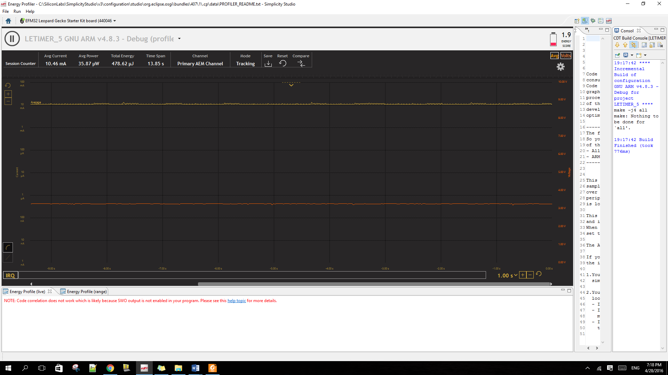

Fig1.1 Energy Profiler with all sensors and BLE

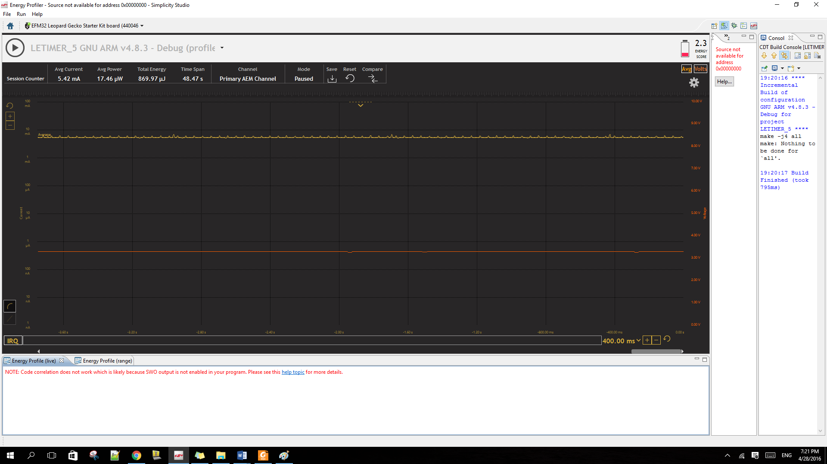

Fig1.2 Energy Profiler with all sensors and removed BLE



Fig1.2 Energy Profiler with proximity sensor removed and

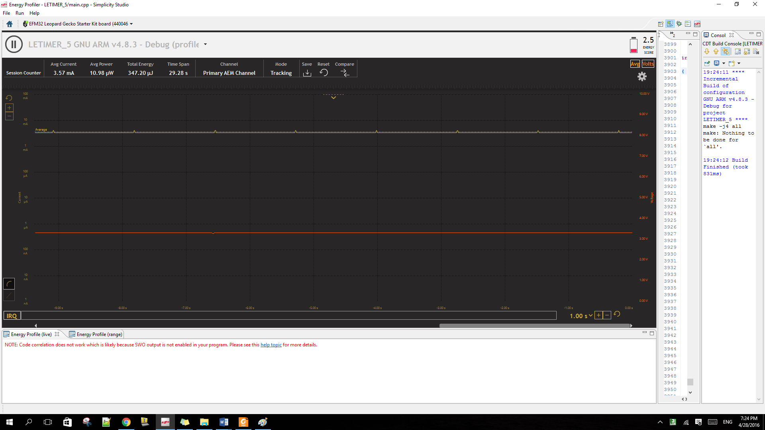

# **Test Cases**

Some of the cases are not failed completely .However it is not partially incorrect for negative scenarios and I was not able to check it exhaustively. The negative value scenarios are updated and read correctly, however there is an issue in comparison of these values. Therefore I have marked it as Failed

|  |  |  |  |  |  |
| --- | --- | --- | --- | --- | --- |
| **Sensor** | **S.no** | **Sub** | **Test Case** | **Required Result** | **Pass /Fail** |
| Temperature  Sensor | 1 | 1.1 | RetTemp | It should reply with real time temperature in following format : XX.X C | P |
|  |  | 1.2 |  | For Negative Temperature display : -XX.X C | Not tested(failed) |
|  |  | 1.3 |  | For Single Temperature display :-0X.X C | P |
|  |  | 1.4 | Message printed should not overwrite alert from other sensors |  | Fail |
|  | 2 | 2.1 | RetUnkown | Error Command!!! | P |
|  | 3 | 3.1 | SetTemp=Min,Max | 1)Set minimum temperature as Min and Maximum as Max(XX) barrier  2) reply with Done | P |
|  |  | 3.2 | SetTemp=MinC,MaxC | Error Command!!! | P |
|  |  |  |  |  |  |
|  | 4 | 4.1 | If Temperature <  Min temp set | 1)Temperature below Min set= XX.XX C | P |
|  |  | 4.2 | If Temperature  > Max temp set | 1)Temperature above Max set= XX.XX C | P |
|  |  | 4.3 | If Temperature > Min  and < Max | No Message |  |
|  |  | 5.4 | Message printed should not overwrite alert from other sensors |  | Fail |
|  | 6 | 6.1 | Check of Energy with BLE |  |  |
|  |  | 6.2 | Check of Energy without BLE |  |  |
|  | 7 | 7 | Set or Ret | Error Command | Fail |
|  |  |  |  |  |  |
| Indutive  Sensor | 1 | 1.1 | If Oscillations >  Threshold | Metal Detected |  |
| Magnetometer | 1 | 1.1 | RetMag | It should reply with real time axis information in following format : XXX deg,  YYY deg,  ZZZ deg  (with positive and negative signs) | P |
|  |  | 1.2 | Message printed should not overwrite alert from other sensors |  | F |
|  | 2 | 2.1 | RetUnkown | Error Command!!! | F |
|  | 3 | 3.1 | SetMagX=Min,Max | 1)Set minimum and Maximum degree of Mag as X for X axis as minimum barrier  2) reply with Done | P |
|  |  | 3.2 | SetMagX=X.XX,Max | Error Command!!! | P |
|  |  | 3.3 | SetMagX=Min,Max (iF Min <=Max) | Error Command!!! | P |
|  | 5 | 5.1 | If X axis degree  < Min X-axis set | 1)X-axis inclination below Min set= X deg | P |
|  |  | 5.2 | If X axis degree  > Max X-axis set | 1)X-axis inclination above Max set= X deg | P |
|  |  | 5.3 | If X axis degree > Min and < Max | No Message | P |
|  |  | 5.4 | The above with Negative values |  | Fail |
|  |  |  |  |  |  |
| Display of degrees | 16 | 16.1 | Display of Degrees should be in +DDD or –DDD format |  | P |
|  |  |  | For Single digit: DD format |  | P |
|  |  |  | For Double digit: DD format |  | P |
|  |  |  | For negative : -DDD format |  | P |
|  |  |  | For positive:  +DDD format |  | P |
| The Above set of test cases executed for each Axis Y and Z |  |  |  |  |  |
|  |  |  |  |  |  |
| EEPROM Emulation | 1 | 1.1 | Alert points are written on required page |  | P |
|  |  | 1.2 | Read from EEPROM successful |  | P |
|  |  | 1.3 | Able to read correct alert point for required sensor |  | P |
|  | 2 | 2.1 | Each page written correctly |  | Not Tested |
|  |  | 2.2 | Erase of Previous page when next page written |  |  |
|  | 3 | 2.1 | Check of Energy with BLE |  | Done |
|  |  | 2.2 | Check of Energy without BLE |  | Done |
|  |  | 2.3 | Check of Energy with BLE and Gesture Sensor |  | Done |
|  |  | 2.4 | Check of Energy without BLE and Gesture Sensor |  | Done |
|  | 4 |  | Negative value for above cases | Partially working | Fail |
| Proximity Sensor | 1 | 1 | Object detected | “Intruder Alert” Message | P |
|  |  |  |  |  |  |

# **Learnings**

The Project helped me to understanding the complexity in integrating different sensors and dependences involved in same. It also pointed out that both internal and external sensor integration is a challenging task with lot of dependences from pin selection to configuration. I got an exposure to I2C protocol while integrating Magnetometer and parsing of commands from BLE app which I worked excessively on.