Application Based Learning – Individual Task
Module 1: Foundations of AI – Historical Milestones

Introduction to Artificial Intelligence
Artificial Intelligence (AI) is a branch of computer science that focuses on designing and developing systems capable of performing tasks that typically require human intelligence. These tasks include learning from experience, reasoning, problem-solving, decision-making, language understanding, and visual perception. AI systems aim to simulate human cognitive abilities through algorithms, data, and computational models.
The concept of Artificial Intelligence dates back to the mid-20th century when researchers began exploring whether machines could think and behave like humans. Early work in AI was influenced by developments in mathematics, logic, neuroscience, and computer engineering. Over time, AI evolved from theoretical discussions into practical technologies used in everyday life.
Today, AI plays a crucial role across multiple industries. It powers virtual assistants, recommendation systems, autonomous vehicles, medical diagnosis tools, fraud detection systems, and smart search engines. With advancements in machine learning, deep learning, and big data, AI systems are now capable of analysing vast amounts of information and improving their performance over time.
The history of Artificial Intelligence is marked by significant milestones, including foundational theories, breakthrough algorithms, periods of rapid growth, and phases of reduced funding known as “AI winters.” Understanding these milestones helps in analyzing how AI has progressed from simple rule-based systems to modern generative and intelligent technologies.
This project presents a historical timeline of major developments in Artificial Intelligence, highlighting key contributions, technological breakthroughs, and their impact on the evolution of intelligent systems.

Major Milestones in Artificial Intelligence
Year/ Period | Milestone | Significance
1950 | Turing Test Proposed | Introduced the concept of evaluating machine intelligence
1956 | Dartmouth Conference | Marked the birth of Artificial Intelligence as a field
1958 | Perceptron Developed | Early neural network capable of learning from data
1960s | Symbolic AI Programs | Machines performed logical reasoning and problem solving
1970s | First AI Winter | Decline in AI research funding and interest
1980s | Expert Systems | AI used for decision-making in industries
Late 1980s–1990s | Second AI Winter | Reduced progress due to system limitations
2000s | Machine Learning Growth | Rise of data-driven AI approaches
2010s | Deep Learning Revolution | Major breakthroughs in vision and language processing
Present | AI in Everyday Life | AI widely used in real-world applications

Explanation of Each Milestone
1950 – Turing Test Proposed
In 1950, Alan Turing introduced the concept of the Turing Test in his paper “Computing Machinery and Intelligence.” The test was designed to answer the question, “Can machines think?” It evaluates whether a machine can imitate human responses in conversation so well that a human judge cannot distinguish it from a real person. This idea laid the theoretical foundation for Artificial Intelligence.

1956 – Dartmouth Conference
The Dartmouth Conference, held in 1956, officially marked the birth of Artificial Intelligence as a field of study. The term “Artificial Intelligence” was coined during this conference. Researchers believed that machines could simulate aspects of human intelligence such as reasoning and learning. This event formally established AI research.

1958 – Perceptron Developed
In 1958, Frank Rosenblatt developed the Perceptron, an early neural network model. It was designed to learn from input data and classify information. Although limited in capability, it introduced the concept of machine learning and inspired later developments in neural networks.

1960s – Symbolic AI Programs
During the 1960s, AI research focused on symbolic reasoning. Programs like the Logic Theorist and General Problem Solver demonstrated that computers could solve problems using logical rules. This period showed early success in machine-based reasoning but struggled with real-world complexity.

1970s – First AI Winter
In the 1970s, AI research faced a decline due to unmet expectations and technical limitations. Early systems failed to handle complex real-world problems, and computational power was insufficient. As a result, funding and interest decreased significantly. This period became known as the First AI Winter.

1980s – Expert Systems
The 1980s saw the rise of expert systems, which used rule-based reasoning to mimic human experts in specific domains. These systems were applied in medicine and engineering. Although successful in limited areas, they were difficult to maintain and scale.

Late 1980s–1990s – Second AI Winter
The limitations of expert systems and high expectations once again led to disappointment. AI projects became expensive and difficult to maintain. Funding declined, leading to another slowdown known as the Second AI Winter.

2000s – Machine Learning Growth
In the 2000s, AI experienced a revival due to the availability of large datasets (big data) and improved computational power. Machine learning algorithms became more effective in identifying patterns from data. This marked the beginning of modern AI development.

2010s – Deep Learning Revolution
The 2010s witnessed major breakthroughs in deep learning, a subset of machine learning using multi-layered neural networks. Technologies such as Convolutional Neural Networks (CNNs) and Recurrent Neural Networks (RNNs) improved image recognition, speech processing, and natural language understanding.

Present – AI in Everyday Life
Today, Artificial Intelligence is integrated into daily life. It is used in recommendation systems, search engines, healthcare, autonomous vehicles, and digital assistants. AI has become a central technology shaping modern society and innovation.

Timeline Representation of AI History
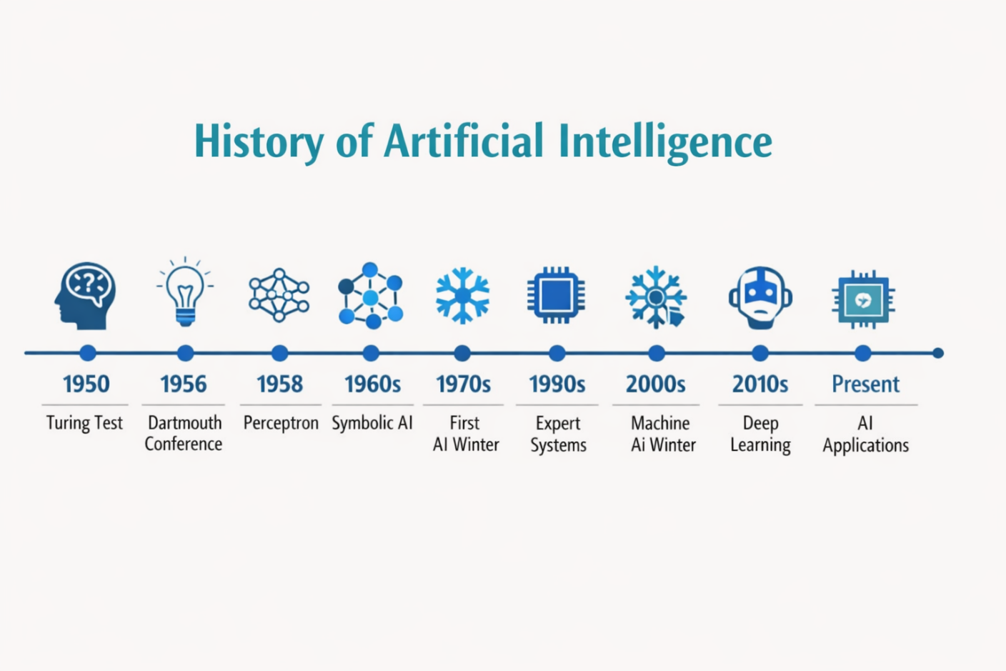

Conclusion
Artificial Intelligence has evolved significantly from its theoretical foundations in the 1950s to becoming a transformative technology in the modern world. From the introduction of the Turing Test and the Dartmouth Conference to the development of neural networks, expert systems, and deep learning, AI has experienced periods of rapid growth as well as challenges such as the AI winters. Each milestone has contributed to shaping AI into a powerful tool capable of learning, reasoning, and solving complex problems.
Today, AI plays a vital role in various sectors including healthcare, finance, education, transportation, and communication. The historical journey of AI demonstrates how advancements in algorithms, data availability, and computational power have driven its progress. Understanding this evolution helps in appreciating current AI technologies and preparing for future innovations in the field.

References
- Fundamentals of Artificial Intelligence and Machine Learning – Module 1 Notes, Srinivas University.
- Stuart Russell & Peter Norvig, Artificial Intelligence: A Modern Approach, Pearson Education.
- Ian Goodfellow, Yoshua Bengio & Aaron Courville, Deep Learning, MIT Press.
- Research articles and educational resources on Artificial Intelligence history.

